A manual on using Open Data Kit (ODK) Collect

[For agronomic data collection]



Aug 2013

CIMMYT – SARO

Singh Durbar Plaza,

Kathmandu, Nepal

**Table of Contents**

1. Brief introduction of ODK: 2

2. How does ODK collect look on your device? 2

Image 1: ODK Icon on the device 2

3. Before using ODK collect: 3

Image 2: Disabled GPS icon & Image 3: Enabled GPS icon 3

Image 4: Internet mobile data icon (disabled) 4

4. Using ODK Collect: 4

Image 6: Interface of ODK Collect 1.3 4

Image 7 : Screenshot of ODK Collect with different forms 5

Image 8: Unchecked forms in ODK Collect & Image 9: Checked forms in ODK Collect 5

Image 10: Notification of successful downloads of forms 6

5. Filling the data in the form: 6

Image 11: Screenshot of data collector’s id 7

Image 12: Entering imaginary data (a) 8

6. Capturing photo: 8

Image 14: Screen for taking picture on ODK Collect 9

Image 15: Setting low camera resolution 9

7. Capturing GPS Coordinates 10

Image 16: Getting GPS coordinates 10

8. Sending filled up forms 10

Image 17: Screenshot of the end of form 11

Image 18: Renaming the filled up form 11

9. Sending Finalized Form: 12

Image 19: Sending finalized form 12

10. Some FAQs: 13

# Brief introduction of ODK:

Open Data Kit (ODK) is a free and open-source set of tools which help organizations author, field, and manage mobile data collection solutions[1]. ODK provides a platform to:

* Build a data collection form for survey [ODK Build, xls form, purcforms etc]
* Collect data using the ODK form and send it to a server. [ODK collect: an android application]
* Aggregate data in a server and export data to csv format (e.g. excel file), google fusion table, google map.

# How does ODK Collect look on your device?

Somewhere on the device screen, you will see the icon of the ODK Collect just like in the following image (red circled). It means the ODK Collect application has already been installed on your device.

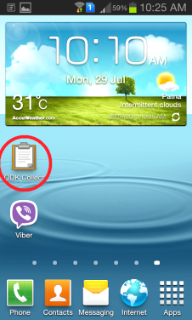

### **Image 1: ODK Icon on the device**

* 1. If you are still unable to locate the ODK collect icon or not sure of whether it has been installed on your device, go to Settings > Storage > Applications. This will show all the installed applications on your device.
  2. If ODK Collect has not been installed on your device, visit Samsung PLAY STORE from your device and search for ODK Collect and download it. But you have to configure the server’s URL. [Please mail me for further instructions if your device has not ODK collect.]

# Before using ODK collect:

* 1. Please make sure that you have enabled the mobile data and GPS keys on your device. Simply scroll down the screen from the top using your finger and you will get the following image:

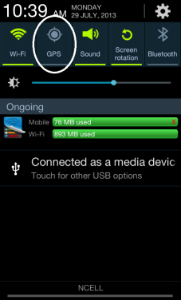 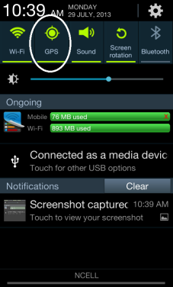

Image 2: Disabled GPS icon Image 3: Enabled GPS icon

Tap on the GPS icon and it will turn to greenish color that means GPS key is enabled.

After enabling the GPS Key, scroll the key panel to the left and you will notice the “mobile data” key as below:

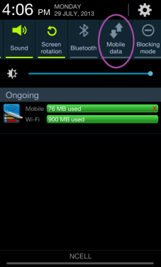 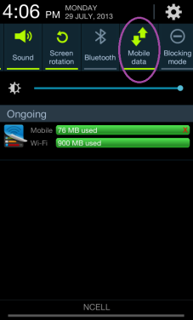

Image 4: Internet mobile data icon (disabled) Image 5: Internet mobile data icon (enabled)

Note: Internet connectivity is required to track GPS coordinates and send the ODK forms once they are completely filled in.

# Using ODK Collect:

* 1. Once you have activated both the keys, tap on the ODK Collect icon. You will see the following image: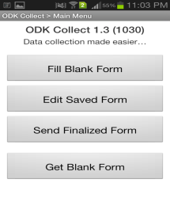

### Image 6: Interface of ODK Collect 1.3

4.2 Tap on “Fill Blank Form” that will take you to new screen depicting different forms as follows:

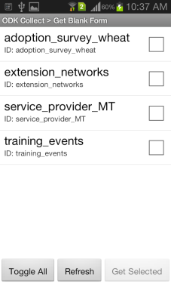

### Image 7 : Screenshot of ODK Collect with different forms

* + 1. If you are unable to find these forms then go to “Get Blank Form”. Wait for some seconds as it will connect to the server to fetch the forms. You will get the following image at first and select the desired form (in the second image, all forms have been selected):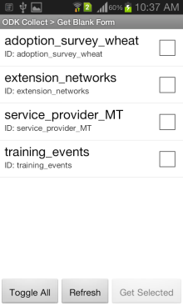 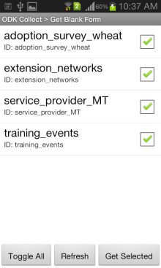

### Image 8: Unchecked forms in ODK Collect Image 9: Checked forms in ODK Collect

* + 1. Once you have selected the desired form, you will see the following image:

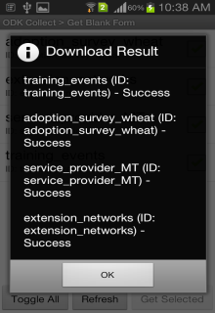

### Image 10: Notification of successful downloads of forms

The selected forms can now be found in “Fill Blank Forms” section. In the device screen, you can see four different forms under the following names:

* 1. Adoption_survey_wheat: for data collection of wheat, based on final format of excel sheet
  2. Extension_networks: for data collection of agriculture machinery dealers
  3. Service_provider_MT: for data collection of service providers on machine transplanter
  4. Training_events: for data collection of different training events organized under CSISA Project

These four different forms have been developed using ODK Build, excel files and xml. These forms are still in testing phase. You are requested to provide with your feedbacks on these forms. It could be anything like which attribute worked well and which did not, need of adding any other attributes, or whole amendment in the forms.

# Filling the data in the form:

In order to show an example, “service_provider_MT” has been used over here. You will see the following image where you need to fill in after you tap on the form “service_provider_MT” under the “Fill Blank Form” section:

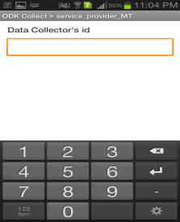

### Image 11: Screenshot of data collector’s id

This field asks you to enter the numeric id of the data collector (you). The numeric codes for each project personnel are assigned as follows:

|  |  |
| --- | --- |
| Name | Numeric Id |
| Dr Virender Kumar | 01 |
| Mr Anurag Ajay | 02 |
| Mr Anurag Kumar | 03 |
| Mr Dilshad Gani | 04 |
| Ms Madhulika Singh | 05 |
| Dr Mukesh Chahar | 06 |
| Dr Pankaj | 07 |
| Mr Prabhat Kumar | 08 |
| Ms Pratibha Kumari | 09 |
| Dr Rajeev Kumar | 10 |
| Mr Raman Sharma | 11 |
| Mr Ravikanth | 12 |
| Mr Vinod Srivastava | 13 |
| Mr Vipin Kumar | 14 |
| Mr Bidhan Mahapatra | 15 |
| Ms Swetapadma D. Satpathy | 16 |
| Ms Swati Nayak | 17 |
| Mr Wasim Iftikar | 18 |
| Mr Naba Kisore Parida | 19 |
| Mr Vivek Kumar | 20 |
| Mr Alok Kumar | 21 |
| Mr Amit Mishra | 22 |
| Mr Sunil Kumar | 23 |
| Mr Himanshu Sahoo | 24 |
| Dr Poornima Ravi Shankar | 25 |

As this field has been marked as compulsory, you need to enter the codes provided with. You all are requested to remember your respective codes.

You can opt for two different methods to fill up the form:

* 1. Feeding imaginary data:

For the testing purpose, you can fill in the form fields with imaginary or hypothetical data but the fields for “Data Collector’s id” should be your real code and the “Full name or name” field for the respondent should be filled in with the word “test” or “testing” as the image below:

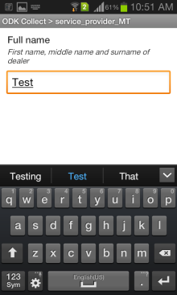 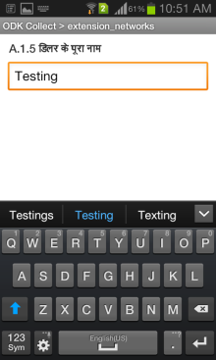

Image 12: Entering imaginary data (a) Image 13: Entering imaginary data (b)

* 1. Feeding real data:

You can feed real data on respective forms when you visit to the trial or demonstration sites. You can try filling the forms interacting with the farmers and also asking their feedbacks or comments on the use of ODK for surveying them.

# Capturing photo:

In order to capture photo, you need to configure the camera resolution into low value. Click on the text box “Take picture” and it will lead to camera screen as follows:

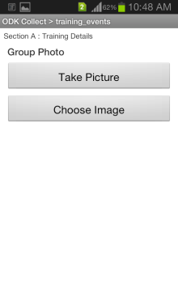

### Image 14: Screen for taking picture on ODK Collect

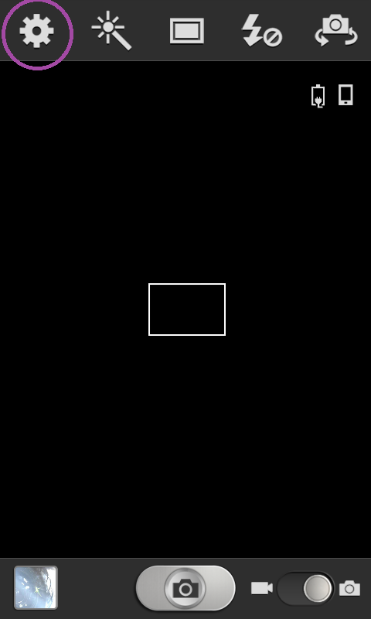 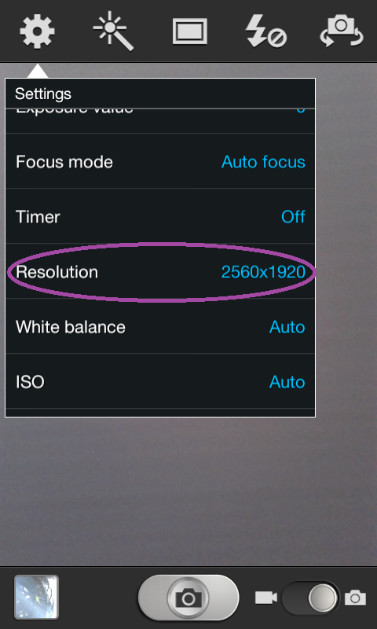 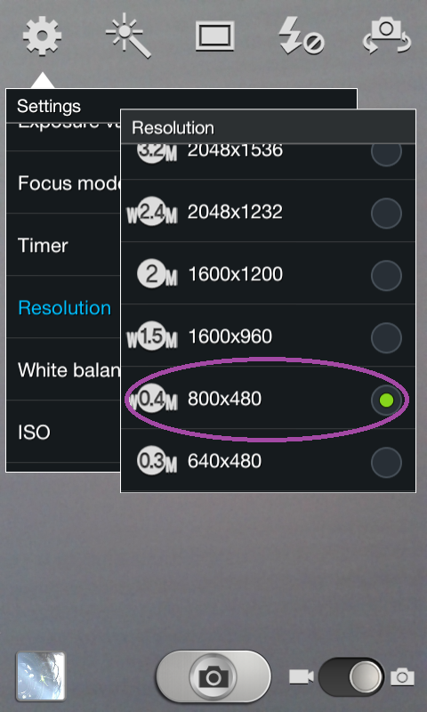

### Image 15: Setting low camera resolution

Click on the topmost wheel bar left icon and scroll down until “RESOLUTION” tab appears. Change the resolution into 800 X 480 or lower than that. The resolution of the camera is proportional to the file size of the picture which in turn can affect the dataset from sending it to the server.

# Capturing GPS Coordinates

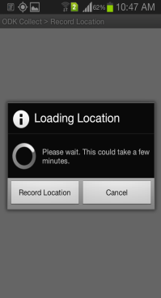 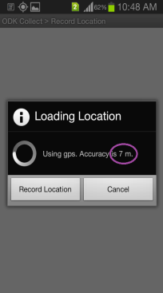 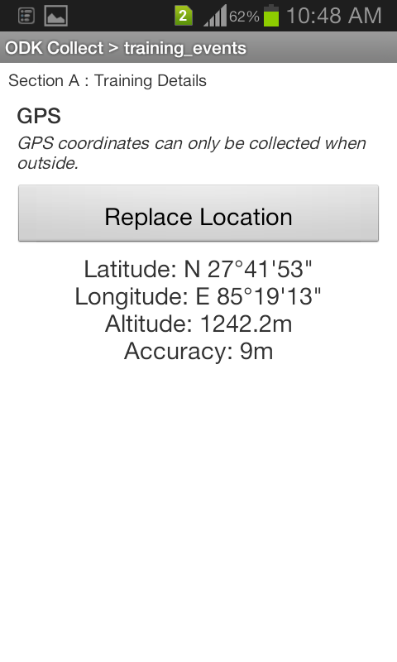

### Image 16: Getting GPS coordinates

You will have to wait for some minutes in order to capture the coordinates depending upon the internet connectivity. Please make sure that GPS ACCURACY is at least 5 meters.

# Sending filled up forms

Once you are done with filling the form, ODK collect will lead you to the following screen:

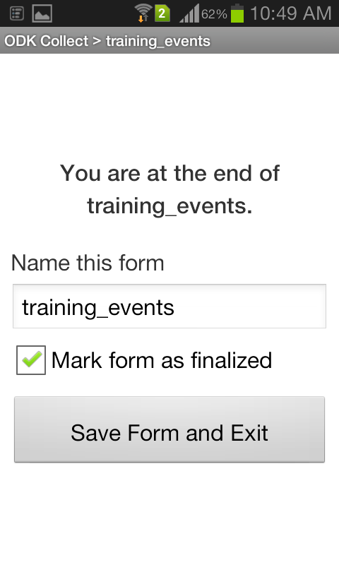

### Image 17: Screenshot of the end of form

The form, by default, will be named as the original form. In order to have the same name for different forms you can rename the form as:

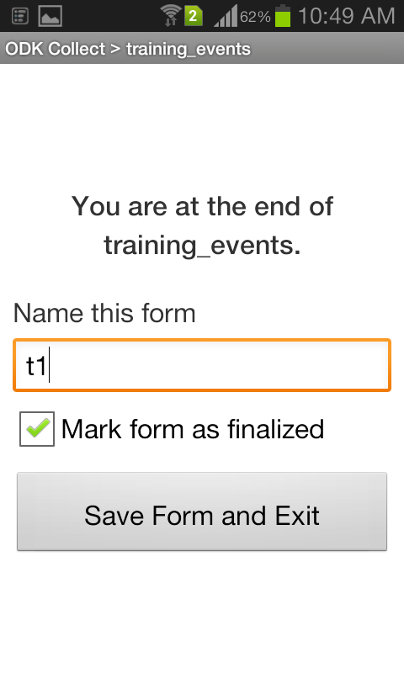

### Image 18: Renaming the filled up form

For e.g. The form under training_events has been renamed as “t1”. Similarly, for “service_provider_MT” form, you can rename as “sp1” for the first form and “sp2”, “sp3” and so on for the consecutive forms.

Once you click on “SAVE FORM AND EXIT”, it will automatically be stored at

* 1. “SEND FINALIZED FORM” if you check on the check box named “MARK FORM AS FINALIZED”
  2. “EDIT SAVED FORM” if you uncheck the “MARK FORM AS FINALZED”

If you have unchecked the “MARK FORM AS FINALIZED” and felt that you need to some editions in the dataset then click on the “EDIT SAVED FORM” and edit as per required.

# Sending Finalized Form:

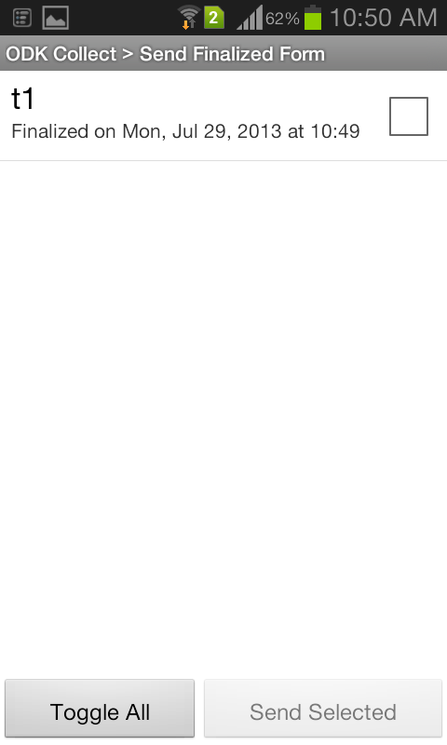 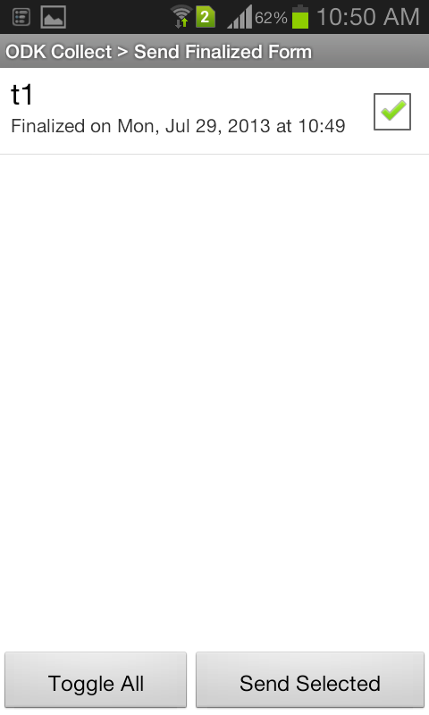

### Image 19: Sending finalized form

In the “Send Finalized Form” section, you will see the renamed forms lined up (in case of multiple forms). In image 19, there is only one unchecked form. Check on the form and tap on “SEND SELECTED” to send it to the server. If there are multiple filled up forms then tap on “TOGGLE ALL” and then on “SEND SELECTED”. This will take some minutes depending on the number and size of forms as well as on the connectivity of the mobile internet. Other options in case of limited connectivity could be to store all the filled up forms in the “SEND FINALIZED FORM” and send them all on availability of good internet connection.

The sent forms from the ODK Collect will be stored in the google appspot server ([www.csisabihar.appspot.com](http://www.csisabihar.appspot.com)) where you can visualize all the sent forms into interfaces like google map and google fusion table. You can also export the CSV (comma separated values) files into excel sheet for the analysis. We encourage you to visit the aforementioned appspot server site and have a look on the datasets after you send them from the ODK Collect.

# Some FAQs:

**Q1. Are these the only things about ODK?**

Ans: Certainly not. Whatever explained here is just a part of the big picture and only focused on the operation of ODK Collect. If you wish go deeper on ODK, you can visit to [www.opendatakit.org](http://www.opendatakit.org) and it’s google group.

**Q2. Why ODK for field based data collection?**

Ans: Open Data Kit (ODK) helps to reduce the time, cost and data processing errors associated with paper based surveys. It is a combination of questionnaire development, filling up and making ready for data analysis into different file formats. So, it has been sought to achieve the same objectives here in CSISA Project. In addition, it is free of cost to operate (until you feel the need to have some large storage capacity for server).

**Q3. Has ODK been used before for agronomic data collection?**

Ans: Based upon the existing literature on ODK, we can say that it has mostly been used for household survey on different projects ranging from sanitation, irrigation projects to election campaign surveillance projects and yes, agriculture survey too. The geographical coverage of ODK use ranges from Central Africa to South Asia including Bangladesh and India. We believe CSISA project will be the first of its kind to collect agronomic data in India using ODK.

**Q4. How many datasets can ODK handle?**

Ans: It depends upon the type of device used, server storage configuration and also on the way of handling large number of datasets. Devices provided to you by the project office (SAMSUNG GRAND QUATTRO) should work fine and we have successfully sent eight files simultaneously from a single device. Literatures on ODK have a mention of collecting around fifteen thousand datasets (and could be much more) for a single survey.

**Q5. The four forms uploaded in ODK collect do not seem to cover all the attributes on that specific topic.**

Ans: It could be true. Whatever you learn while feeding the data in those forms, you may feel some attributes or say, columns are missing and need to add one more. Even you might think of having one more forms for data collection. Please feel free to provide your suggestions in this regard. Those forms could be edited with addition or reduction of attributes after seeking consultation with the major project personnel.

**Q6. What could be the things that are needed to mention when I provide suggestions on ODK Collect?**

Ans: Great question! It could be anything on your genuine experience while using ODK collect in the field. But we would appreciate if you provide some elaborated experiences on practical issues like response of farmers, dealers, the environment needed to capture data, battery consumption, screen resolution on broad day light and also the need on edition of those forms.

**Q7. Will ODK work for CSISA Project?**

Ans: It entirely depends upon fellow scientists like you. What will work and what will not, it is you who will provide us the feedbacks and guide us to take the next step. Please remember, this is an experimental phase for ODK collect implementation. And we are looking for “learning” in the “mistakes”, not for mistakes in our learning.

asocrai@hotmail.com

1. www.opendatakit.org