# CyberWay Work List

## 1. Architecture Design

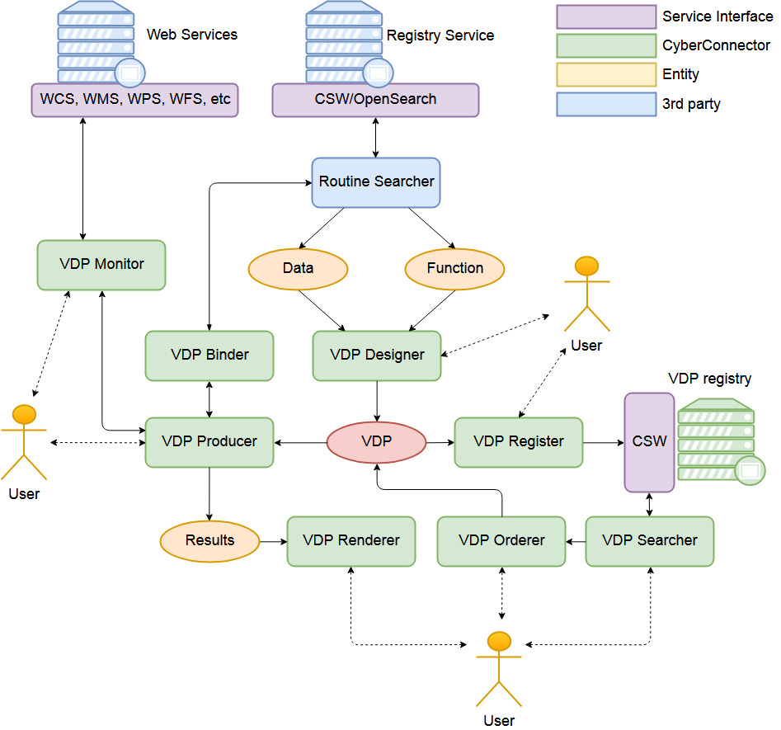

Figure 1. Framework of CyberConnector

Figure 2. Connection with participants’ building blocks

## 2. Project Implementation

#### 2.1 Case 1

Contact David for OSU details:

#### 2.2 Case 2

Contact Ben for COLA details:

Cash, Benjamin

Research Scientist, Ctr Ocean-Land-Atmosphere Studies (COLA), Atmospheric, Oceanic and Earth Sciences

287 Research Hall, Ffx, MSN: 6C5

Phone: **(703) 993-5744** Show Fax Number

Email: [**bcash@gmu.edu**](mailto:bcash@gmu.edu)

Model result comparison

EarthObservation vs ModelAssimulatedResults

Big data challenge how to reduce, pyramid

UCAR perabytes of data: hard to manipulate,

1. teleconnection between polar and tropical area or use data mining to discover teleconnection in certain phenomenons, come up with a hypothesis, create model, generate results for prediction, modeling and cross validation. System accesses model results to do teleconnection studies. Scientific problem: 1) hyphthesis in teleconnection, how to prove and validate; 2) facts in teleconnection, how to discover. Use CyberWay to facilitate these two facets of researches.

2. 1) Collect required Earth observation, automatically. Users can search and preprocess the datasets via CyberConnector. (mandotary, agreed item in contract) 2) intercomparison among different models. It need access model results. (secondary); follow the recent feeds from the super computing centers around the world. Historical validation and future prediction.

3. Reanalysis from Arctic data assimulation. Ask David.

**Aim#1**: Integrate at least three EarthCube building blocks (BCube, GeoWS, CHORDS) and as more as possible. Multiple components system. System of systems.

**Aim#2**: Useful and helpful in science use cases to meet Earth science challenges. Supposed to be general purpose system, but we demonstrate with four specific cases.

* CyberConnector Catalog need connect to BCube, CHORDS, GeoWS, and CWIC.
* Catalog COLA data served by GrADS Data Server (GDS).
* Catalog static Polar Reanalysis Data in UCAR.

How to talk to the catalogs while archiving the COLA and reanalysis data?

Ziheng Sun: BCube to CyberConnector

Juozas: CHORDS to CyberConnector

Chen Zhang: GeoWS to CyberConnector