**CyberWay Monthly Telecon Minutes**

2:00-3:00 PM Oct 8 2018

website: <http://cube.csiss.gmu.edu/CyberWay>

github: <https://github.com/CSISS/CyberWay>

**1. Roll Call of Participants**

David Bromwich, Steve Browdy, Ben Cash, Liping Di, Ziheng Sun, Eugene Yu, Sheng-hung Wang, Juozas Gaigalas, Chen Zhang

**2. Agenda**

- CSISS reports the progress to PI/Co-Is

- David talk about the teleconnection plan

**3. Subgroup status & action item report**

1) CSISS

Ziheng Sun reported the latest progress of the development work and demonstrated CyberConnector COVALI and Geoweaver. The description of COVALI: “*COVALI aims to enable inter-comparison and validation across models. Two common approaches to evaluate models are model output inter-comparison and confronting models with observations to provide validation. For inter-comparison, it is necessary to find matching model outputs, retrieve the data, and, because different models typically produce different parameter estimates in different formats and resolutions, bring the outputs of multiple models into a compatible format and spatial and temporal resolution. Both inter-comparison and validation present similar challenges in data discovery, access, and interoperability. All these challenges can be addressed easily with COVALI.*”

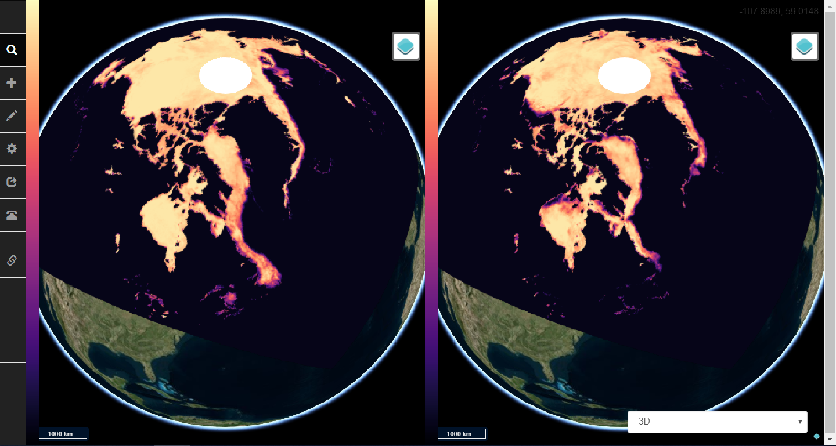

Figure 1. COVALI

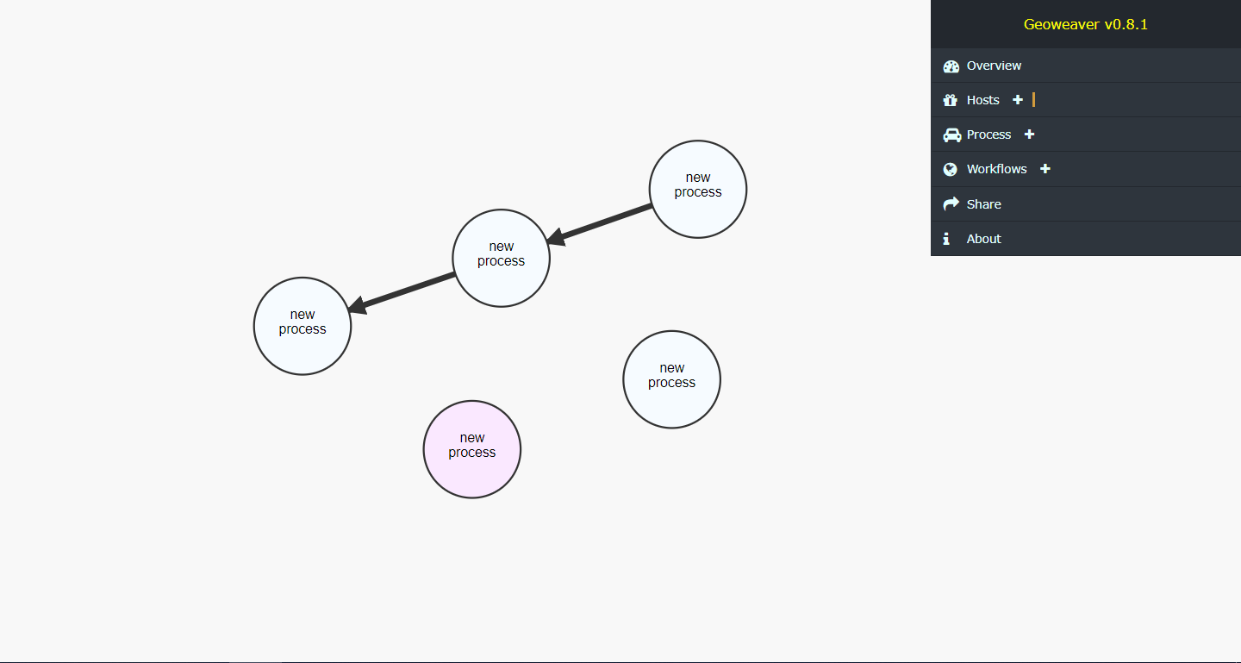

Figure 2. Geoweaver

2) OSU&COLA

David and Ben conducted a deep and productive discussion on COLA recent teleconnection results and concluded with a practical plan which CyberWay team could work together on in the next year. The research content is approximately about the teleconnection between Arctic region/tropical pacific area and west coast rainfall/California drought. The study window is initially locked to be the recent 2015~2016 as we have data available in both regions for that period. The temporal scale is monthly or seasonal. CyberWay tools including COVALI and Geoweaver should be able to put together those required data, get them into the same grid/projection, compare them side by side, compute the difference, and help give birth to some new scientific discoveries at the end of this project. David and Ben will meet offline to discuss more towards a more precise plan. Please let us know if you have problem in hosting telecons.

Prof. Liping Di suggested using deep learning in the teleconnection analysis may be another good idea for discovering new things. But our scientists don’t have related experiences and we will see if something could be done about it when time allowed.

**4. Next Agenda**

Continue the discussion on the four cases in the proposal. Specificly:

1) New demo of COVALI and Geoweaver

2) Progress of BCube broker/crawler development

3) OSU&COLA data manipulation

4) Plan on correlation experiment between polar region and California datasets