**CyberWay Monthly Telecon Minutes**

1:00-2:00 PM Jan 14 2018

website: <http://cube.csiss.gmu.edu/CyberWay>

github: <https://github.com/CSISS/CyberWay>

**1. Roll Call of Participants**

Steve Browdy, Ben Cash, Sheng-hung Wang, Juozas Gaigalas, Ziheng Sun

**2. Agenda**

- Communicate team progresses

- Steve talk about BCube and service checker

- Ben and Sheng-hung talk on teleconnection experiment

**3. Subgroup status & action item report**

1) OMS Tech, Inc

Dr. Steve Browdy reported the progress on broker, crawler and status checker. HighRanks(?) is a open-source broker software derived from BCube and can be reused by us. Steve will try to deploy one instance for this project. It will not support all the metadata formats so we have to double check which data repositories in the Ben’s list can be supported by the broker. We need inspect what options are available on each data source like Thredds Data Server, OGC web services, etc. Check out their open interactive protocols. GeoDAB is a backup plan and will not be a ideal one for this project. Crawler is running on a AWS Microsoftware server and should be available on next meeting. One problem is where the two components are going to be used in COVALI. Two step search will be required. All the interactions between CyberConnector and BCube should use one way (e.g., OpenSearch).

2) CSISS

Dr. Ziheng Sun reported the latest progress of the development work and demonstrated CyberConnector COVALI. We have supported the north polar region projection. ASR products can be displayed in COVALI now.

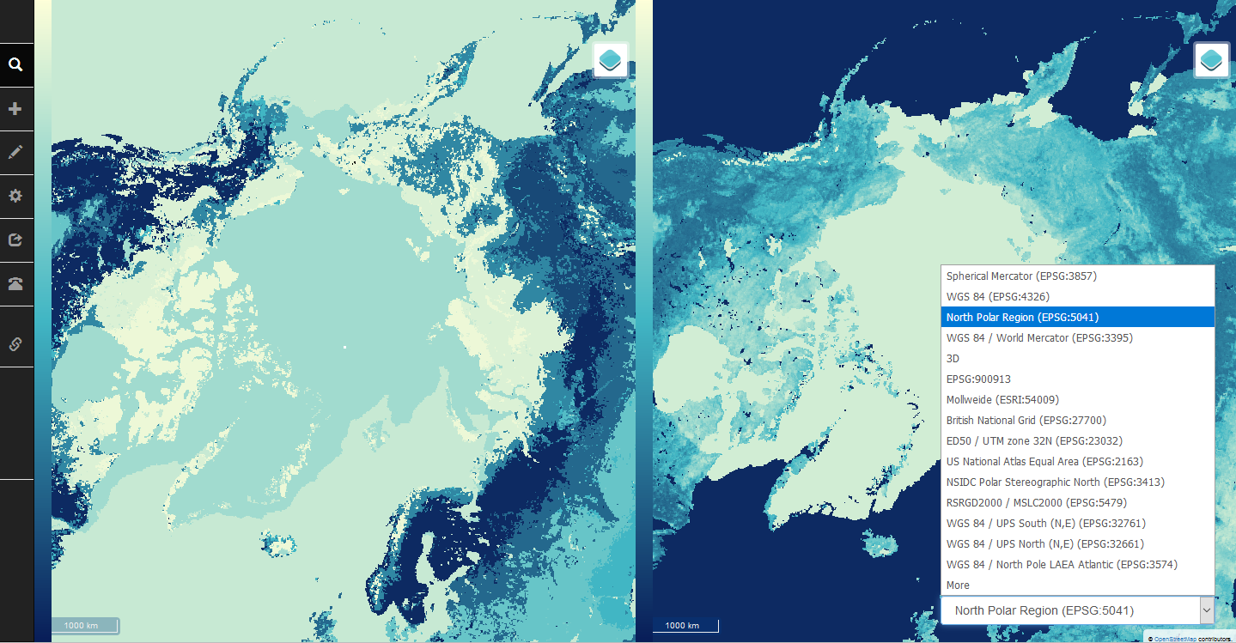

The repo of COVALI on GitHub is: <http://github.com/CSISS/cc>

3) COLA

Dr. Ben Cash is working on generating monthly average products from 6-hourly data for the teleconnection experiment.

4) OSU

Dr. Sheng-hung Wang is expecting the monthly data from COVALI. He suggests that variable name should appear explicitly on the map in COVALI, and also check if it is possible to rotate the map (which is a special need by polar scientists).

**4. Next Agenda**

Continue the discussion on the four cases in the proposal. Specificly:

1) Progress of BCube broker/crawler development (a possible presentation by Steve)

2) Integration of BCube, GeoWS, CHORDS, and CyberConnector

3) OSU&COLA&CSISS collaboration efforts on teleconnection experiment