**CyberWay Monthly Telecon Minutes**

1:00-2:00 PM Feb 11 2018

website: <http://cube.csiss.gmu.edu/CyberWay>

github: <https://github.com/CSISS/CyberWay>

**1. Roll Call of Participants**

Ben Cash, Sheng-hung Wang, Juozas Gaigalas, Ziheng Sun, Eugene Yu, Chen Zhang

**2. Agenda**

- Communicate team progresses

- Ben and Sheng-hung talk on teleconnection experiment

- Ziheng Sun report the development progress of COVALI

**3. Subgroup status & action item report**

1) COLA

Ben has successfully generated monthly average datasets and transferred them to Sheng-hung. The files are transformed into usable format, put into the same grids, and merged by averaging process. Last week, Ben has coordinated COLA system administrator, Tom, with CSISS to discuss installing CyberConnector onto COLA server. CyberConnector has actually been installed already, but has no external link. Tom is working on security issues to configure the network route to redirect the traffic between outside and CyberConnector in a more secure network channel.

2) OSU

Sheng-hung has received the files from Ben and sort out the files to prepare for the collaborated teleconnection experiments. Total 13 variables are retrieved while the precipitation field might be missing. Ben asked Sheng-hung to send a wish list of the required variables and will take care of that. Sheng-hung will look into the changes in PTCI, MLP, SST, high-elevation temperature, etc.

3) CSISS

Dr. Ziheng Sun reported the latest progress of the development work and demonstrated CyberConnector COVALI. We have involved EarthCube CHORDS to retrieve and visualize the real-time field observations from CHORDS field sensors. CHORDS has an official instance (<http://portal.chordsrt.com/>) and many other instances deployed by its user community.

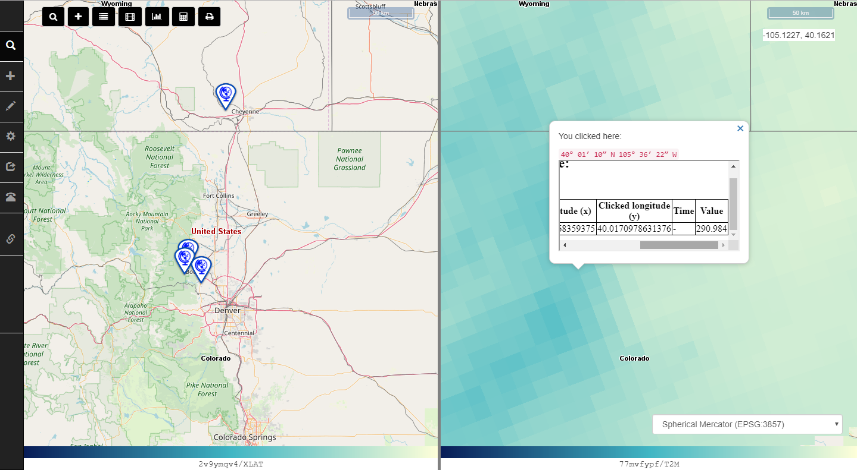

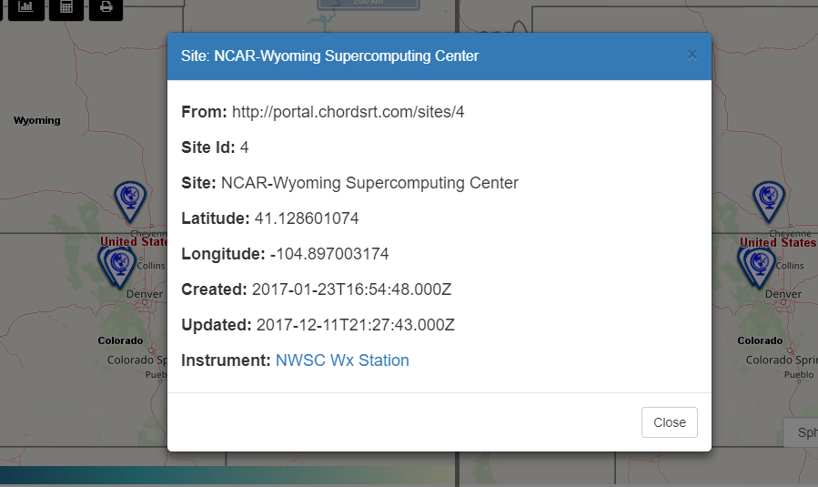

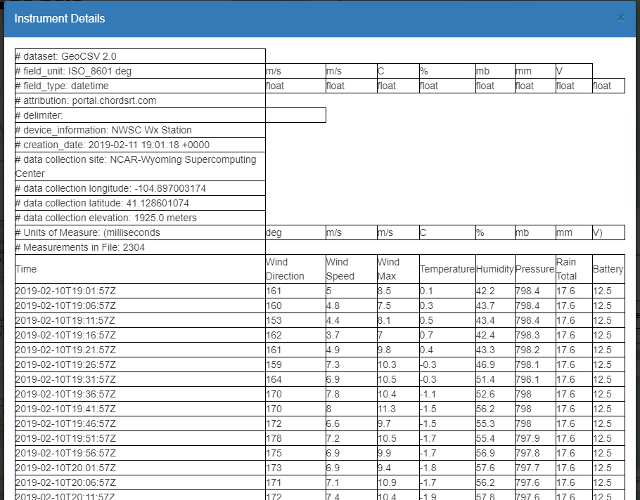

We have registered all the ASR version 2 products in our catalog. Now ASRv2 can be searched and downloaded via COVALI. COVALI is the only granule-level search service provider for this product at present.

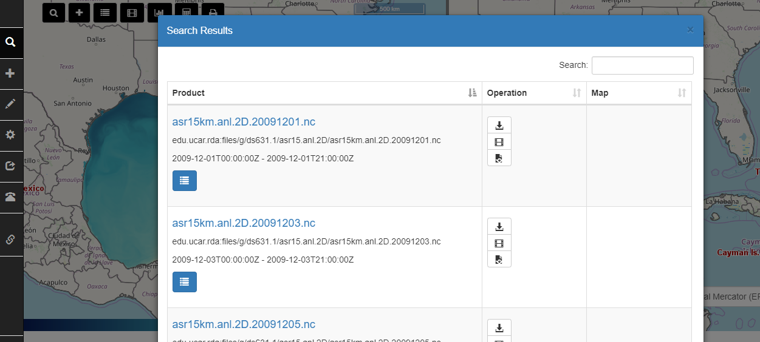

These changes have been uploaded onto GitHub: <http://github.com/CSISS/cc>

**4. Next Agenda**

Continue the discussion on the four cases in the proposal. Specificly:

1) Progress of BCube broker/crawler development (a possible presentation by Steve)

2) Integration of BCube, GeoWS, CHORDS, and CyberConnector

3) OSU&COLA&CSISS collaboration efforts on teleconnection experiment