**CyberWay Monthly Telecon Minutes**

1:00-2:00 PM March 11 2018

website: <http://cube.csiss.gmu.edu/CyberWay>

github: <https://github.com/CSISS/CyberWay>

**1. Roll Call of Participants**

Ben Cash, Sheng-hung Wang, Ziheng Sun, Juozas Gaigalas, Eugene Yu, Chen Zhang

**2. Agenda**

- Communicate team progresses

- Ben and Sheng-hung talk on teleconnection experiment

- Ziheng Sun report the system development progress

**3. Subgroup status & action item report**

1) OSU

Dr. Sheng-hung Wang has drafted the overall framework for teleconnection experiment (Fig. 2) and brought up several issues for discussion. The study periods are 2012~2015, and 2015~2016 NDJFM (five months) as two separate cases. Nino index uses Nino 3 and 4 separately might be better than Nino 3.4. The output format could be netCDF and GRIB, which should be compliant to CF convention. The results are calculated anomly or original simulated dynamics.

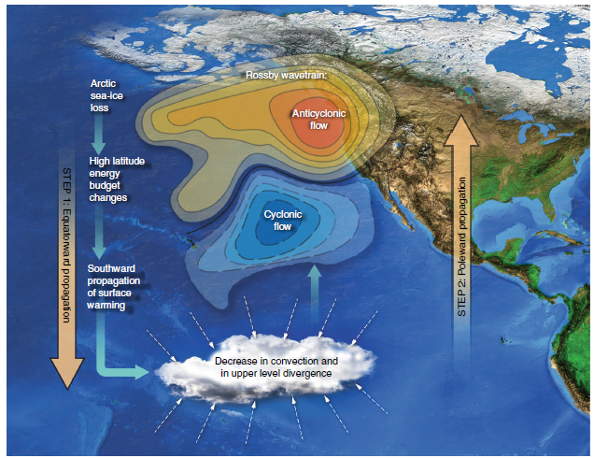

Fig. 1 Schematics of two-step teleconnection (cited from *Cvijanovic, Ivana, et al. "Future loss of Arctic sea-ice cover could drive a substantial decrease in California’s rainfall." Nature communications 8.1 (2017): 1947*)

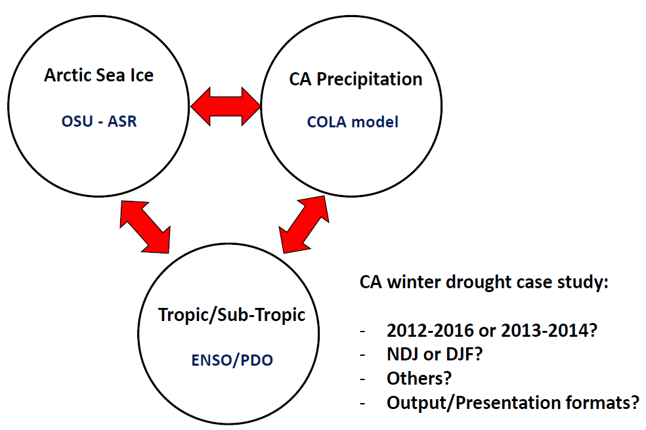

Fig. 2 The architecture of our telecon experiment

2) COLA

Dr. Ben Cash has successfully published the teleconnection paper on Journal of Climate. Worked on subseting and averaging precipitation and required variables from 6-hourly into monthly data. The original dataset is around 30TB. The Python in UCAR processing facility seems have some issues in running Ben’s script for parallel processing. Will transfer the files to COLA server as a backup plan if the problems in UCAR cannot be solved in reasonable time range. Tried COVALI on COLA server. COVALI is very promising for interactive display and exploratory. It is lack of data manipulation function at this point. Future improvements could be made by adding essential functionality module like colar bar automtic resetting, difference calculation by wrapping CDO, NCO, GrADS, etc. The python version of NCO (PyNCO Stable) and GrADS (GrADSPy Beta) has been released and could be reused in this project.

3) CSISS

Dr. Ziheng Sun has reported the latest progress of development of COVALI. We are working on developing the functionality module by reusing CDO, NCO, and GrADS. An instance of COVALI has been installed on COLA server. The data loading and rendering modules have been tested thoroughly on both the ASR files from UCAR and the demo files provided by Ben.

Another thing which we forget to mention is that we are working on integrating GeoWS IRIS web services to directly retrieve and visualize solid Earth observation from IRIS sensor network (Fig. 3).

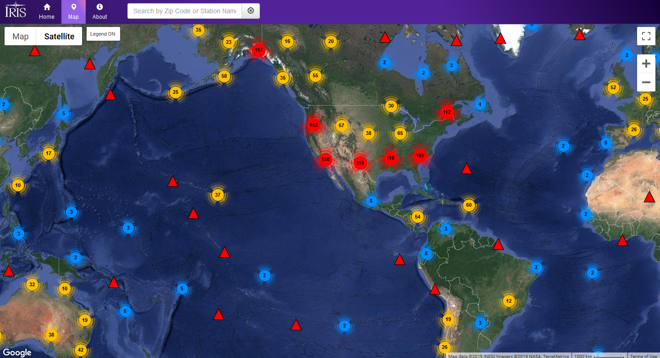

Fig. 3 IRIS sensor network

**4. Next Agenda**

Continue the discussion on the four cases in the proposal. Specificly:

1) Integration of BCube, GeoWS, CHORDS, and CyberConnector

2) OSU&COLA&CSISS collaboration efforts on teleconnection experiment