CyberWay Monthly Telecon Minutes

Jan 8 2018

1. Roll Call of Participants

Ben Cash, Chen Zhang, Eugene Yu, Steve Browdy, Sheng-hung Wang, Ziheng Sun, Ze Deng

2. Agenda

Discuss the architecture design of CyberWay.

3. Subgroup status & action item report

3.1 GMU CSISS

Dr. Ziheng Sun reported the initial architecture of CyberWay and asked for suggestions. Open the field for discussion.

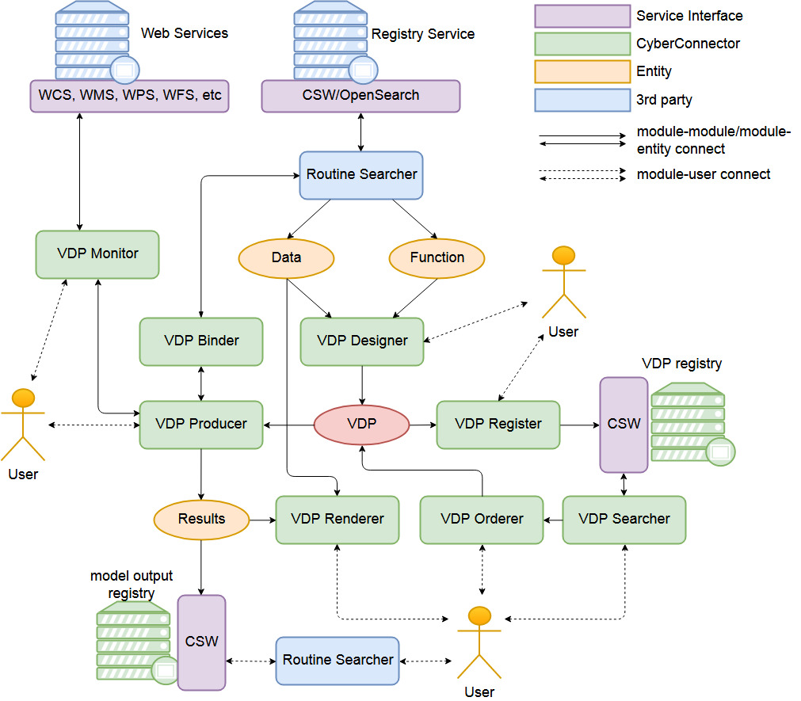

3.2 BCube

Dr. Steve Browdy descrbied the framework of Bcube and prospected how to integrate the capabilities of Bcube into CyberWay. The broker and crawler should be located in the design. The interaction between the two Bcube components and CyberConnector modules should be explicit. FGDC status checker is suggested to enhance the ability of VDP binder and VDP monitor to build tolerance merchanism for corrupted services.

Steve suggests the VDP results could be functions/scripts instead of real data products, if the dataset is too big to move around for web services. Users can run the functions/scripts on the data themselves. That is a brilliant idea. It is a data-centered processing framework. We need evaluate the feasibility of this idea in CyberWay.

3.3 GMU COLA

Dr. Ben Cash reported the progress of COLA in teleconnection and discussed the way to clip their datasets into CyberWay. It seems the COLA data center needs extra processing ability like slicing, subsetting or comparing. We need think about how to bring in the data and make efficient processing. Currently, Ben is writing his own script and run locally. The way to remotely access and process COLA data is still mostly in the mist. We’d better address that in next telecon.

3.4 OSU

Dr. Wangshung Wang reported the progress of model intercomparison and provided the links for downloading data from UCAR RDA server. The role of OSU is scientist user. CyberWay need listen to their requirements on cyberinfrastructure facilities, and make them work in a friendly and simple way. OSU currently need select variables from netcdf dataset on UCAR RDA server, subset or combine the data of different periods such as timestamp, long-term, weekly, monthly, or yearly, and perform comparison with model assimulated outputs.

4. Next Agenda

Continue the discussion on the four cases in the proposal. Specificly:

1) the integration of Bcube and CyberConnector

2) the way to remotely access and efficiently process COLA datasets for teleconnection

3) the streamlined process for ASR model

4) interface design for intercomparison and model validation