**CyberWay Monthly Telecon Minutes**

2:00-3:00 PM Feb 12 2018

website: <http://cube.csiss.gmu.edu/CyberWay>

github: <https://github.com/CSISS/CyberWay>

**1. Roll Call of Participants**

Liping Di, Ben Cash, Chen Zhang, Eugene Yu, Steve Browdy, Sheng-hung Wang, Ziheng Sun, Ze Deng

**2. Agenda**

Discuss the architecture design of CyberWay.

**3. Subgroup status & action item report**

*3.1 GMU CSISS*

Dr. Liping Di restated the project objective and the detailed direction for the development in system building and scientific problem solving of next step. Dr. Ziheng Sun introduced the general progress of CSISS. CSISS has made all the resources and people in place for system development. Open the field for discussion.

Dr. Liping Di gave out a remindar on the upcoming EarthCube all hands meeting (June 6-8, Alex) which everyone might should register. <https://www.earthcube.org/ecahm2018>

*3.2 GMU COLA*

Dr. Ben Cash gave a detailed presentation about his datasets and models. He showed the specific directories, data files, control files, command lines, software, rendered graphics, variables and fields. The data type is GRIB, and the software has **GrADS** (COLA, very popular) and **wgrib** (NOAA, work on machines from 386 to Cray supercomputer).

(ATTN: This paragraph is based on my note and understanding. If I am wrong, please correct me.) GrADS need **control files (CTL)**, which are similar to a bootstrap for the system to know everything about the data file. Control file is also a very good entry of point for other people to retrieve data metadata. The size of control files is much less than the data files so the control files should be easier to be moved around or stored in different directories from data files. Generating control files for GRIB files is automatically by command like grib2ctl.pl.

Ben will check if there is any existing catalog service in COLA to remotely querying and downloading, although the service may be slow due to the big size of the datasets.

COLA data center in GMU will open accounts for CSISS participants.

*3.3 OSU*

Dr. Wangshung Wang reported the progress and resent the links for downloading data from **NCAR RDA** server. The data products of OSU are in NetCDF and stored by NCAR Research Data Archive (RDA). To access that data, user account must be created, and it is easy to set up. The data products are in very good shape and RDA provides a series of web services along. The ASRv2 products are available via **TDS** (**Thredds Data Service**) as shown in the Fig. 1. Besides, RDA also offers **CSW** to search the archived data. ASRv2 should be searchable right now.

*3.4 BCube*

Dr. Steve Browdy introduced the progress from Bcube. The deployment of broker and crawler is in progress. FGDC status checker is also doing well. Everything is proceeding normally. The connection between Bcube and CyberConnector should have no big problem if conducted via standard interfaces. The servers and source codes are in place already.

**4. Next Agenda**

Continue the discussion on the four cases in the proposal. Specificly:

1) the integration of Bcube and CyberConnector

2) the way to remotely access and efficiently visualize COLA datasets

3) the streamlined process for ASR model products

4) interface design for intercomparison and model validation

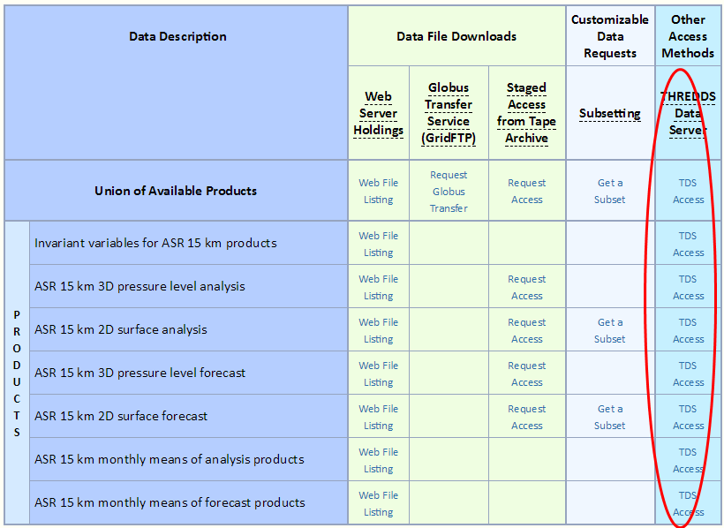

Figure 1. ASRv2 products on NCAR RDA website