**CyberWay Monthly Telecon Minutes**

2:00-3:00 PM May 14 2018

website: <http://cube.csiss.gmu.edu/CyberWay>

github: <https://github.com/CSISS/CyberWay>

**1. Roll Call of Participants**

Steven F. Browdy, Ben Cash, Juozas Gaigalas, Ziheng Sun, Sheng-hung Wang, Eugene Yu, Chen Zhang

**2. Agenda**

Report sub-group progresses in CyberWay and discuss the plan for next step development.

**3. Subgroup status & action item report**

*3.1 GMU CSISS*

Dr. Ziheng Sun reported the progress of CSISS. CyberConnector COVALI is what we have promised to demo in the last monthly meeting. It is a web-based system dedicated for Earth science model inter-comparison and validation. There are two maps aligned side by side and synchronized. Whatever actions are made on one map, the other map will duplicate the same thing at the same time. COVALI is supposed to be capable of overlaying multiple data rendering services such as WMS, WCS, WFS, and SOS and also allowing scientists to upload their local data (either model results or raw observations). COVALI also provides functions to calculate the difference between the left and the right. There are settings menu providing the customization to the interface subjective to user preferences. The supported data formats now are limited to NetCDF, GRIB, HDF, and GeoTiff, according to the requirements from COLA and OSU.

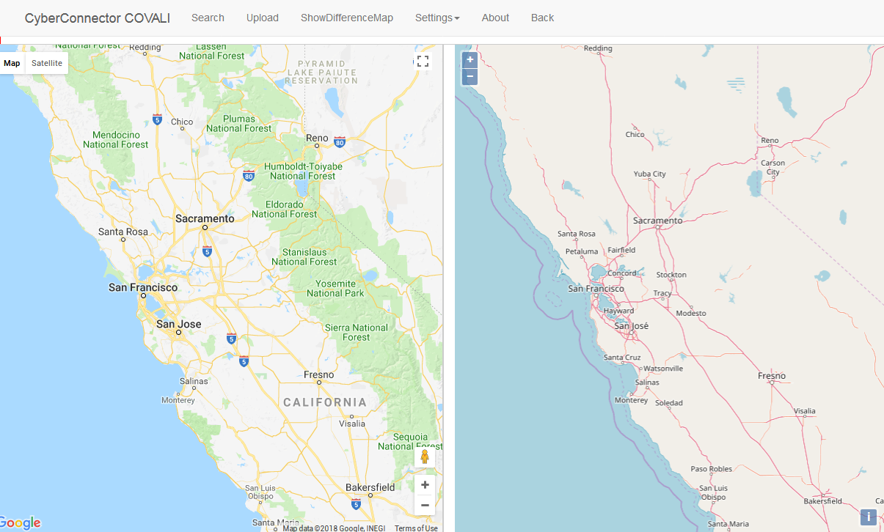

Figure 1. COVALI prototype interface for discussion

Sheng-hung comments that the projection should be flexible as the polar researches are mostly using different spatial reference systems than the web mecator. Steven comments we should think about how to integrate the function of BCube broker into the data search module in the interface. When CyberConnector can’t find the matched records, it probably need extend the search scope via broker. The maps should also support rotation so that scientists can examine the data from their comfortable angle. Ben suggests it is better to enable the modification of the data units or scale so scientists can compare data in the consistent grid or unit. 3D data and software is rare in atmospheric domain. As for the uploading, Steven is concerned about the file maximum limit and also how to handle in the situation for distributed processing.

*3.2 GMU COLA*

Dr. Ben Cash reports COLA progress on the climate model research. Ben mentioned several workflow softwares which are actually used in the climate research community. They are:

CYLC: <https://cylc.github.io/cylc/>

NCAR CESM: <http://www.cesm.ucar.edu/working_groups/Atmosphere/amwg-diagnostics-package/index.html>

We are going to take a deep look at these software and analyze their advantage and how they are so successful in driving scientists to be engaged and enlarge its user community. We will learn from them and create a general practical solution as universal as possible for not only the proposed scientific use cases, but also the models in other Earth science domains.

*3.3 OSU*

Dr. Sheng-hung Wang reported that the version 2 of ASR model and products are released and available in UCAR. The link and reference are posted. Juozas will provide an alternative way for Sheng-hung to upload some of their datasets to CyberConnector server.

3.4 OMS

Dr. Steven Browdy works on redeploying crawler and broker into new instance VMs while the old ones seem not working. Steven plans to demo some of the functions in next monthly meeting and also come with thoughts on the architecture design and the plan we carry out the integration.

**4. Next Agenda**

Continue the discussion on the four cases in the proposal. Specificly:

1) 25 mins: Steve presentation

2) COVALI progress

3) teleconnection model progress

4) polar research rules