**CyberWay Monthly Telecon Minutes**

2:00-3:00 PM June 11 2018

website: <http://cube.csiss.gmu.edu/CyberWay>

github: <https://github.com/CSISS/CyberWay>

**1. Roll Call of Participants**

Ben Cash, Chen Zhang, Eugene Yu, Juozas Gaigalas, Sheng-hung Wang, Ziheng Sun

**2. Agenda**

Discuss the prototype of CyberConnector subsystems: COVALI and Geoweaver.

**3. Subgroup status & action item report**

*3.1 GMU CSISS*

Dr. Ziheng Sun demonstrated a prototype of COVALI which is a subsystem in CyberConnector for data visualization and model validation. COVALI will allow scientists to search or upload their model results and compare to other model results or raw observations.

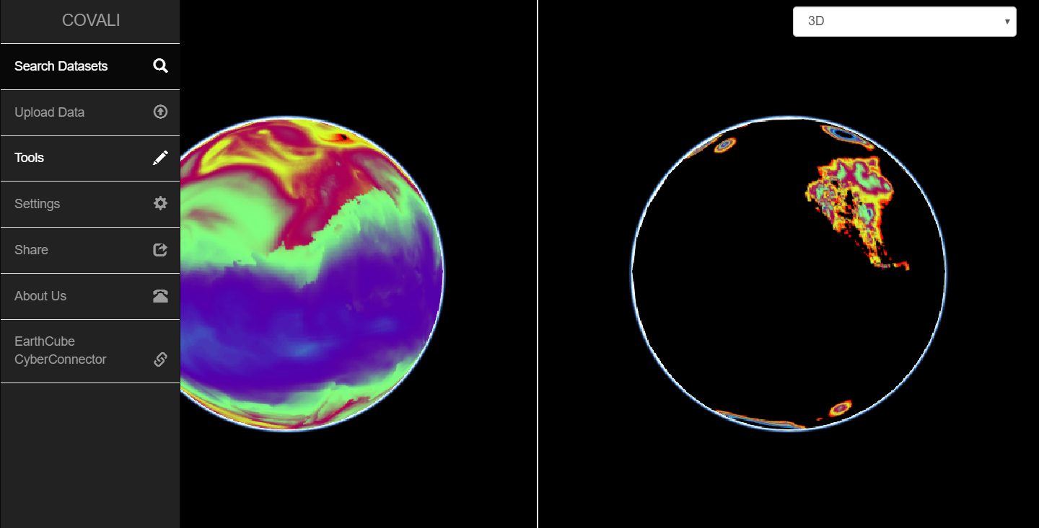

Fig.1 COVALI

Ziheng also addressed the vision of a new model builder, Geoweaver, which will allow scientists to build their model in a familiar way in the browsers and manage them in one-stop mannar. The processes in Geoweaver will be visualized in graphics so scientists have intuitive understanding and easier control on their models and model runs.

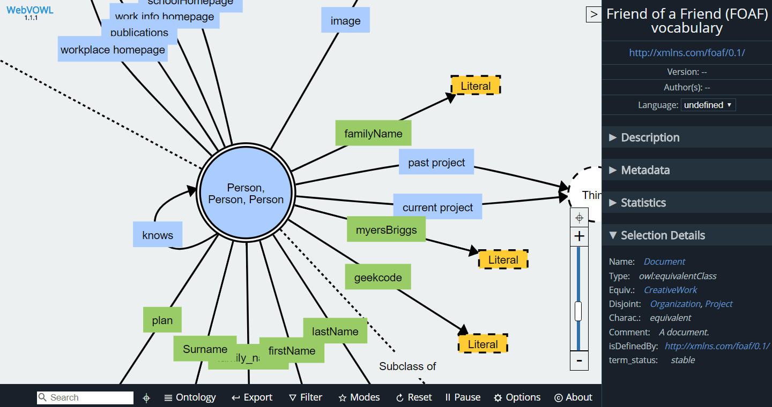

Fig.2. Blueprint of Geoweaver (a Earth Science Model Builder tool based on compound processes)

*3.2 GMU COLA & OSU*

Dr. Ben Cash and Dr. Sheng-hung Wang gave advices on how to improve COVALI:

* Enable checking the value of a place by clicking on it
* Enable checking the variable description stored in GRIB
* Show legend for both maps
* Enable contour line style rendering
* Ability to show map underneath (boundaries)
* Animated data in time
* Calculate difference map
* Spatial analysis by point, bounding box or polygon
* Showing the altitude, longitude, and label boxes which are useful but not critical.

Dr. Sheng-hung Wang reported that he has worked with Juozas and uploaded some sample datasets onto CSISS server, and reviewed the progress of CSISS and gave advices on improving the system to be favorable by polar scientists. He gave a list of links about the usual way they are comfortable to conduct research:

<http://polarmet.osu.edu/nwp_ohio/00Z/plot001_f96.gif>

<http://polarmet.osu.edu/nwp_ohio/00Z/plot001_f96.gif>

<http://polarmet.osu.edu/nwp_ohio/00Z/plot004_f78.gif>

<http://www2.mmm.ucar.edu/wrf/users/docs/user_guide_V3.9/ARWUsersGuideV3.9.pdf> (page 30)

COVALI should be able to display maps in a similar way while granting scientists more options to interact with the maps, rather than just a static map.

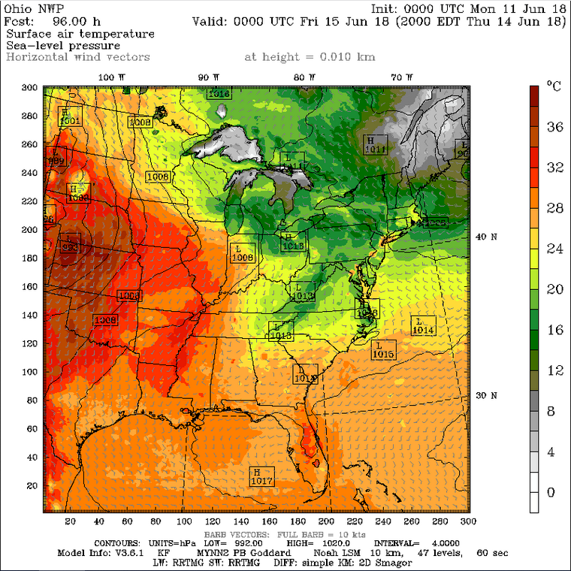

Fig. 3 The layout that scientists are familiar with

**4. Next Agenda**

Continue the discussion on the four cases in the proposal. Specificly:

1) Steve introduces BCube and thoughts on architecture

2) New demo of COVALI and Geoweaver

3) OSU&COLA data manipulation

4) Plan on teleconnection experiment on CyberConnector