**CyberWay Monthly Telecon Minutes**

2:00-3:00 PM July 9 2018

website: <http://cube.csiss.gmu.edu/CyberWay>

github: <https://github.com/CSISS/CyberWay>

**1. Roll Call of Participants**

Steve Browdy, Ben Cash, Chen Zhang, Eugene Yu, Sheng-hung Wang

**2. Agenda**

- Presentation and demonstration by Steve Browdy on BCube

- Progress check with each group.

**3. Subgroup status & action item report**

**Steve Browdy -**

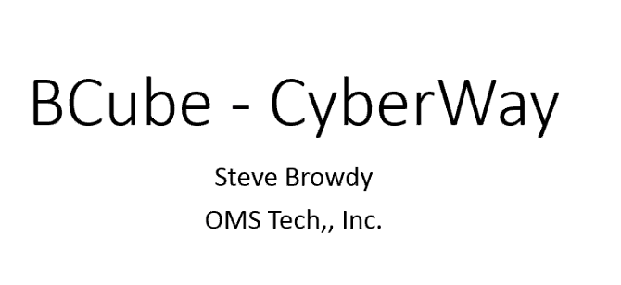

* BCube is not the same as GeoDAB
* It has components tow work with BCube Broker, NSIDC Crwler, and Status Checker
* FGDC Service Status Checker
  + Results of test: ULR, current speed, current score,

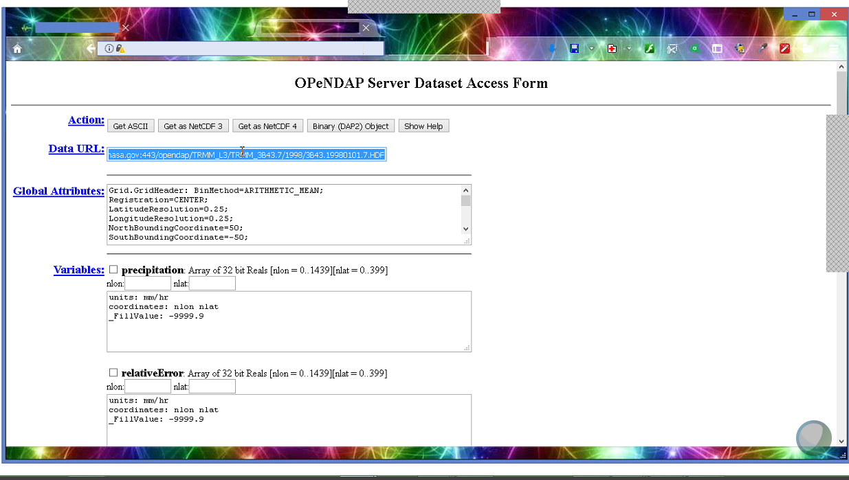

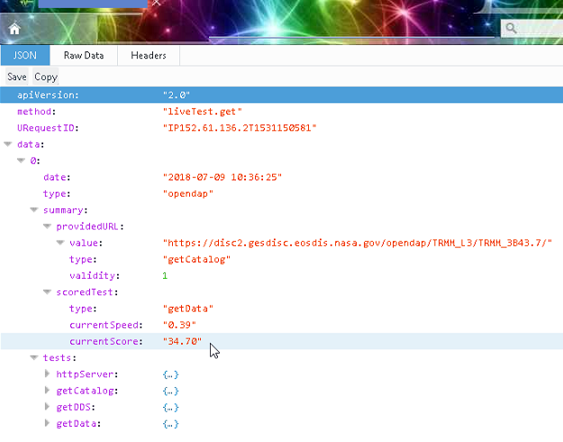

Change of the architecture:

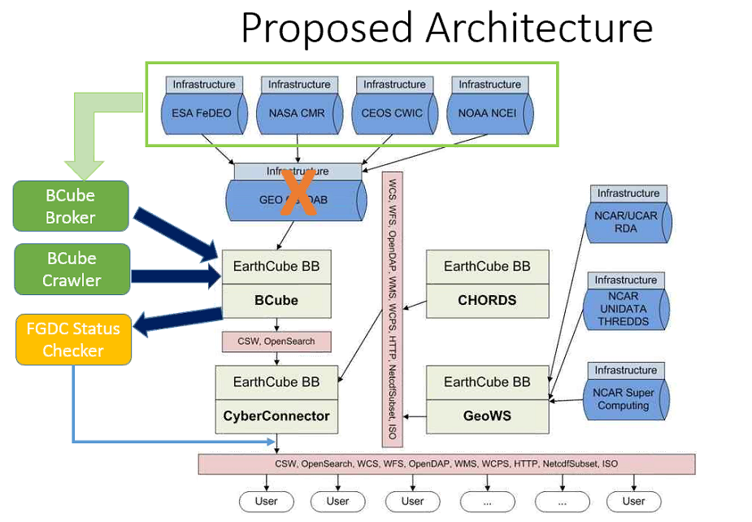

Data may not work due to service breaking: to connect with service status checker.

Actions:

* Steve is going to find out some specific answers for the mechanism on GeoDAB/BCUBE, support of ftp beyond http, authentication, level of status check
* Steve is going to send his slide to the group
* Eugene will check with Professor Liping Di about the process to do the annual report and communicate with the group on preparing the annual report.