**CyberWay Monthly Telecon Minutes**

2:00-3:00 PM Aug 13 2018

website: <http://cube.csiss.gmu.edu/CyberWay>

github: <https://github.com/CSISS/CyberWay>

**1. Roll Call of Participants**

Steve Browdy, Ziheng Sun, Eugene Yu, Sheng-hung Wang

**2. Agenda**

- Progress check with each group.

- Annual report.

**3. Subgroup status & action item report**

1) CSISS

Ziheng Sun reported the latest progress of COVALI. The “Add Data” module has been ready.

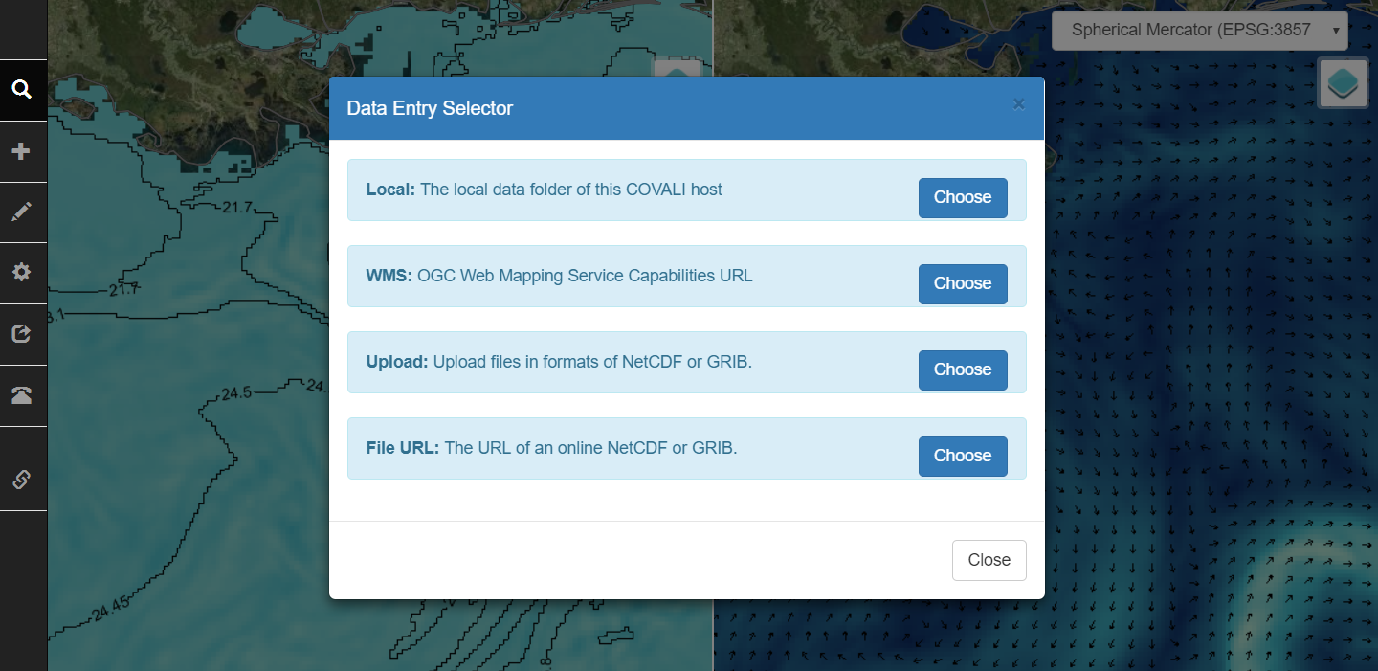

The dialog of “Search Data” is ready.

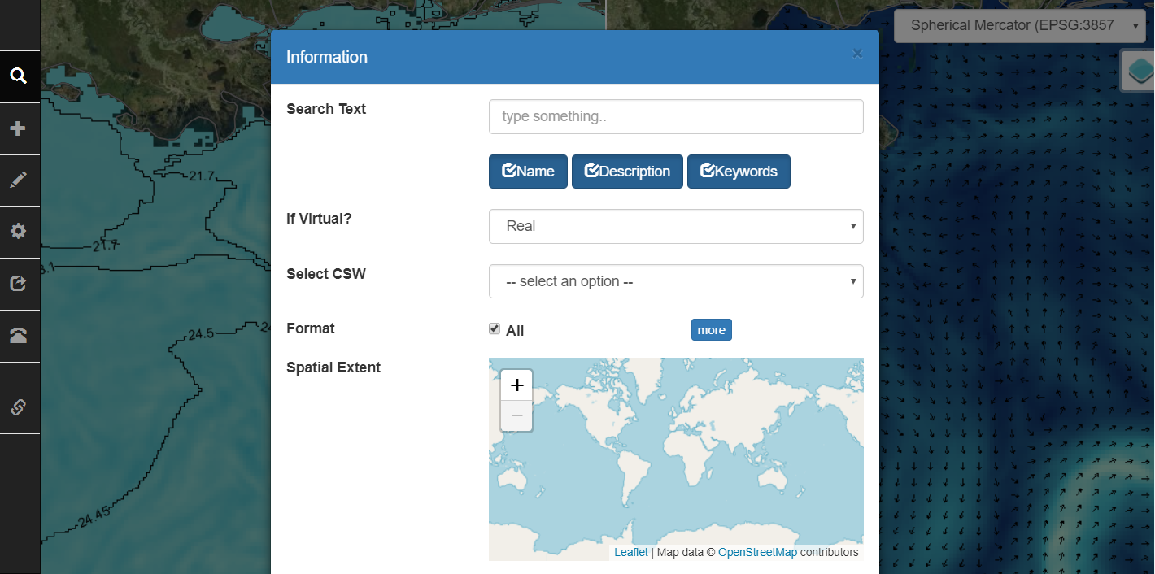

The layer control panel is ready.

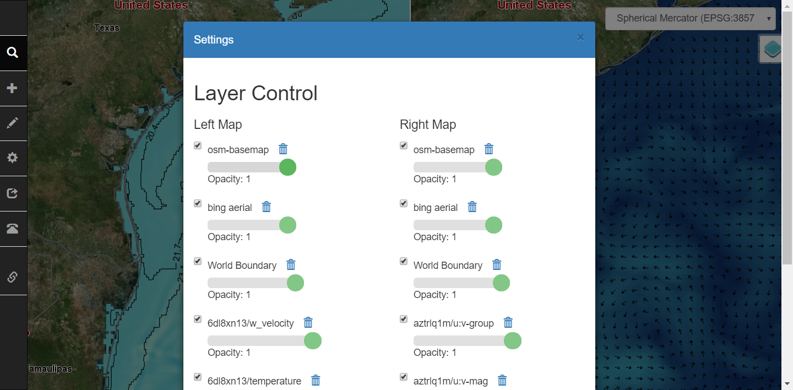

The search criterias include keyword, format, spatial extent, time extent, and the records number on each page.

2) BCube

Steven Browdy further introduced the progress of BCube and is working on deploying BCube broker and crawler to enable the search of the four catalogs at dataset level. The interface between COVALI searcher and BCube would be OpenSearch or CSW. The collaborative test between BCube and COVALI searcher is supposed to be carried out once the BCube deployment is ready.

3) OSU

Sheng-hung Wang gave advice on the architecture and the interface design of COVALI, and discussed the future implementation of new functions.

**4. Next Agenda**

Continue the discussion on the four cases in the proposal. Specificly:

1) Steve introduces BCube progress

2) New demo of COVALI and Geoweaver

3) OSU&COLA data manipulation

4) Plan on teleconnection experiment on CyberConnector