**CyberWay Monthly Telecon Minutes**

2:00-3:00 PM Sep 10 2018

website: <http://cube.csiss.gmu.edu/CyberWay>

github: <https://github.com/CSISS/CyberWay>

**1. Roll Call of Participants**

Steve Browdy, Ben Cash, Ziheng Sun, Eugene Yu, Sheng-hung Wang, Juozas Gaigalas, Chen Zhang

**2. Agenda**

- Progress check with each group.

- Work planning for next year.

**3. Subgroup status & action item report**

1) CSISS

Ziheng Sun reported the latest progress of CyberConnector COVALI. CSISS has been working on polishing and adding new functions to the system. The legend for each layer is added on the left side of the map. The colorbar shows the expanding of values from bottom to the top. Users could click the legend to pop up a style manager to change the rendering styles. The style manager supports changing the palette, min/max values and styles.

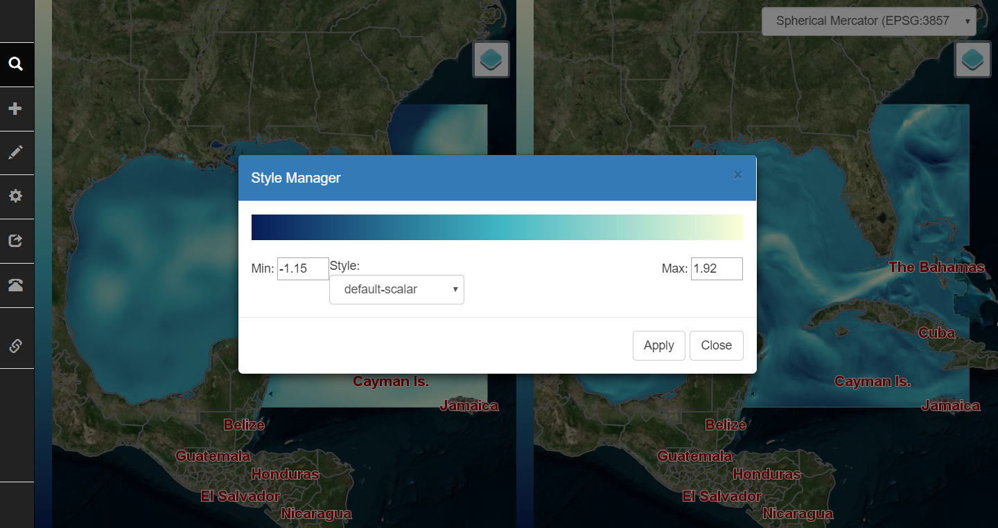

The search dialog lists three catalog: local public files, CSISS catalog for UCAR thredds server, and the BCube broker. The first two are completed. The BCube broker client is waiting for the ready of BCube from Steve.

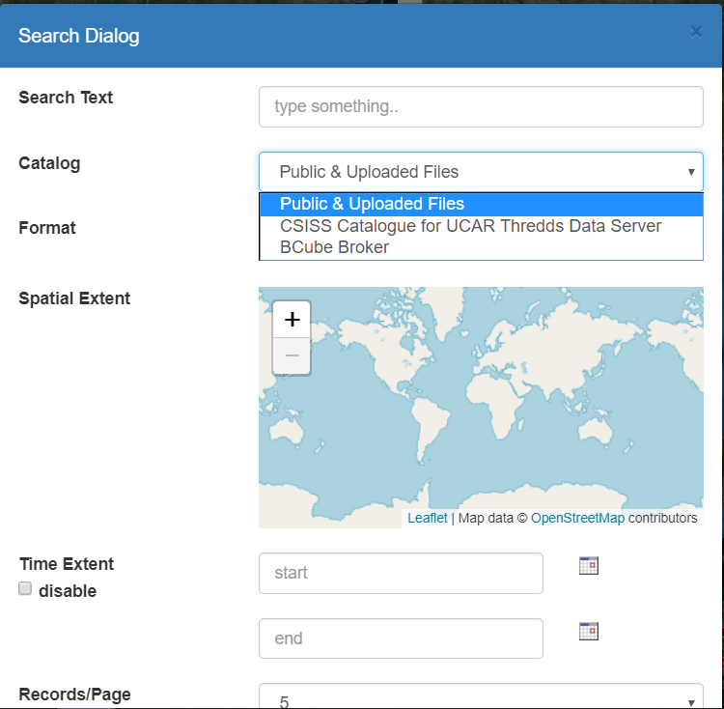

2) BCube

Steve Browdy introduced the progress of status checker and BCube. He is preparing the status checker documents. Right now he is waiting for response from BCube broker people to establish a BCube broker instance. If that way doesn’t go through, we would go to Plan B which is using GeoDAP as broker and crawler. We only need create a program to bridge into it. But we won’t go Plan B unless the initial plan has no chance to be carried out.

3) OSU

Sheng-hung Wang gave progress on the correlation experiment between polar region and California drought and provides the information about UCAR RDA server and ASR products. The RDA service is using the tape system to achive data, so it is not going to be like UCAR thredds to directly access data. NCDC (<http://ncdc.noaa.gov>) dataset is a very important source for both OSU and COLA products.

4) COLA

Ben Cash reported the progress of the teleconnection paper which talks about the possible connection between California drought and south Africa. Give many advices on the development of CyberConnector from the perspective of users. Firstly, a switch disconnecting the left map from right map should be added to make scientists able to observe the data on different scales from left to right at the same time. Secondly, Ben and Sheng-hung conduct a general overview on most workflows in their research and conclude several essential functions that almost every workflow must have: regridding, interpolation to single point (if you have station point data and want to compare to model data or other station data), averaging over spatial and temporal extent, slicing data via time, coverting daily data to monthly or in reverse. It makes sense to make these steps as automatically as possible. Conventional tools for doing these work include ncl, GrADS, pygrads (GrADS for python, in beta), etc. CyberConnector is going to reuse these tools instead of developing new ones (which is impossible for us).

**4. Next Agenda**

Continue the discussion on the four cases in the proposal. Specificly:

1) Steve introduces BCube broker progress

2) New demo of COVALI and Geoweaver

3) OSU&COLA data manipulation

4) Plan on correlation experiment between polar region and California datasets