[SCHOOL LOGO - paste from the supplied template]
School of Computing and Information Technology
CSIT321 - Project
User Manual

Project Topic: [CSIT-26-S3-XX]
(Human-in-the-Loop Intrusion Detection Dashboard)
Group Number: FYP-26-S3-13
Assessor: [TO BE COMPLETED]
Supervisor: [TO BE COMPLETED]

Name | UOW ID | SIM Email
Glenn Ang | [UOW ID] | [SIM email]
[Name] | [UOW ID] | [SIM email]
[Name] | [UOW ID] | [SIM email]
[Name] | [UOW ID] | [SIM email]
[Name] | [UOW ID] | [SIM email]
[Name] | [UOW ID] | [SIM email]

Document Control
Title: User Manual
Document Name: FYP-26-S3-13 Preliminary User Manual, Version 0.4

Record of Revision
Date | Description | Section affected | Changes made by | Version after revision
12 Sep 2026 | First draft: introduction, installation, key features, and the sixteen initial GUIs | 1–4 | Glenn | 0.1
14 Sep 2026 | Updated from the built console: the web interface is running, so section 4 shows screenshots of the real screens (workstation, overview and IP address page added); installation uses the pinned Python 3.11 environment | 1–4 | Glenn | 0.2
15 Sep 2026 | Sign-in is now real: three accounts with passwords replace the role picker, section 4.1 and the login screenshot updated | 4.1 | Glenn | 0.3
16 Sep 2026 | Test counts corrected against the suites as actually run. Python suite: the built v0.3 said 411 and the source had since been edited to 427; the suite reports 445. Interface suite: stated as 126, measured at 132. Both counts verified by running python -m pytest and npm test. No screen or procedure changed. | 1, 5 | Claude | 0.4

Table of Contents
Right-click and choose Update Field if this does not fill in automatically.

(1) Introduction
This Preliminary User Manual takes a first-time user from a fresh clone to a running system, and then through the screens they will actually use. It stays practical: install, first run, first verdict.

(1.1) What this manual covers
- Initial installation on Windows and macOS.
- First-time configuration and building the demo database.
- A tour of the interface: the analyst workstation and queue, one alert's evidence, the feedback loop
and its guardrails, and the administrator and evaluator views.

(1.2) What we assume about the readers
- Basic familiarity with opening a terminal and running simple commands.
- The reader can clone a repository from GitHub and open it in an editor.
- No security-operations background is assumed. Where a term matters — evidence class, *queue
band, guardrail* — the manual explains it at the point of use.

(1.3) Scope and purpose
This project is a network intrusion detection dashboard with a human in the loop. Signature rules and a machine-learning classifier score recorded network flows; an analyst reviews the resulting alerts, and their verdicts re-rank future alerts inside safety limits the analyst cannot override.
This manual covers initial installation, initial configuration, and the initial GUIs only. It is not a complete operator's guide.
What is built. The detection pipeline, the feedback loop, the guardrails, the persistence layer,
the evaluation harness, the API and the web console are built and tested. Every screen in
section 4 is a screenshot of the running console against the demo database, taken automatically, so
every score, rule and figure in it is the system's own. The one exception is marked where it appears.

(2) The initial installation instructions

(2.1) Prerequisites
System requirements
- Python 3.11. The tested library versions are pinned in requirements.txt for this version.
Another Python can resolve different versions — on our development machine Python 3.12 picked a FastAPI and Starlette pair that fails at start-up — so create the environment from 3.11.
- Node.js 18 or newer, for the web console.
- Git, to clone the repository.
- Roughly 2 GB of free disk space for the model, the sample data and the demo database.
Main Python packages (exact versions in requirements.txt)
Package | Used for
pydantic | the data contracts every component validates against
xgboost | the 8-class classifier
scikit-learn, numpy, pandas | training and evaluation
fastapi, uvicorn | the API the console talks to
pytest | the test suite

(2.2) Backend set-up
Every Python command runs from the hitl-ids folder — the one containing apps, packages and pyproject.toml. From anywhere else the API fails with No module named 'apps'.
Windows (Command Prompt)
git clone https://github.com/CSIT-321/CSIT321-Human-in-the-loop_IDS.git
cd CSIT321-Human-in-the-loop_IDS\hitl-ids
py -3.11 -m venv .venv
.venv\Scripts\activate
python --version
python -m pip install -r requirements.txt
python --version must print 3.11. If py -3.11 is not found (py -0p lists the versions the launcher knows), use the full path to a Python 3.11 python.exe in its place.
macOS / Linux
git clone https://github.com/CSIT-321/CSIT321-Human-in-the-loop_IDS.git
cd CSIT321-Human-in-the-loop_IDS/hitl-ids
python3.11 -m venv .venv
source .venv/bin/activate
python -m pip install -r requirements.txt
Activate the environment in every new terminal before running Python commands.
Check the install before going further
python -m pytest
Expect 445 passed, 0 skipped.
Build the demo database
The database is not committed — it is 42 MB and fully regenerable. Build it once, and again before every demonstration, because verdicts recorded on it are permanent:
python scripts/run_detection.py
This scores 5,000 recorded flows through the signature rules, the model and the fusion layer, and writes data/demo.db in about 21 seconds: 5,000 flows in, 5,000 alerts out.
Run the API (leave this terminal open)
python -m uvicorn apps.api.main:app
http://localhost:8000/api/health confirms which database is being served, and http://localhost:8000/docs lists every operation interactively.

(2.3) Frontend set-up
In a second terminal:
cd hitl-ids/apps/web
npm install
npm run dev
Open http://localhost:5173. The development server forwards /api to the API on port 8000, so both servers must be running: if the API is not, the pages load but every panel reports that it cannot reach the API.
Optional checks, from the same folder: npm test runs the 132 interface tests, and npm run e2e plays the whole demonstration in a real browser against its own copy of the database.

(3) Key features
- Two detectors, kept separate on purpose. Signature rules give a checkable reason; the model
gives coverage. Their outputs are never averaged — a rule's verdict and a probability are not the same kind of evidence, so the system reports which kind it has rather than blending them into one misleading number.
- Every flow becomes an alert, including the ones nothing flagged. They form the bottom of the
queue and the denominator of every measurement.
- A ranked queue, not a list. Alerts sit in bands — Tier 2 candidate, corroborated, model-only,
nothing-flagged — and are ordered within a band by score.
- An analyst workstation: the queue, the selected alert and its context in one view, with
keyboard triage, claim-and-close status actions and a notes thread.
- Explanations, not scores alone. Every model prediction carries a TreeSHAP explanation naming
the measurements that drove it. All 5,000 pass an additivity check, meaning the explanation accounts for the prediction exactly.
- Context from the recording only: an overview of when traffic was captured and who talked most,
and a page per IP address. No geolocation or threat-intelligence panels, because the recording holds none.
- Analyst feedback that actually changes the queue. A verdict adjusts the alert's operational
score and — once three analysts agree — carries to the alerts like it.
- Guardrails the analyst cannot override. Caps on how far one verdict may move a score, floors
under Critical and Infiltration alerts, and a rule that a signature-backed alert can never be decayed by feedback at all. Every intervention is shown to the analyst in words.
- An append-only audit trail, enforced by the database rather than by convention.
- A three-arm evaluation — no feedback, scripted feedback, and guardrails disabled — so every
claim is a delta against a control rather than an assertion.
- Three roles: security analyst, system administrator, evaluator.

(4) Initial GUIs of our project
Every screen below is a screenshot of the running console, captured against a disposable copy of the demo database. Screens are shown in the order a demonstration visits them.

(4.1) Sign in — one account per view
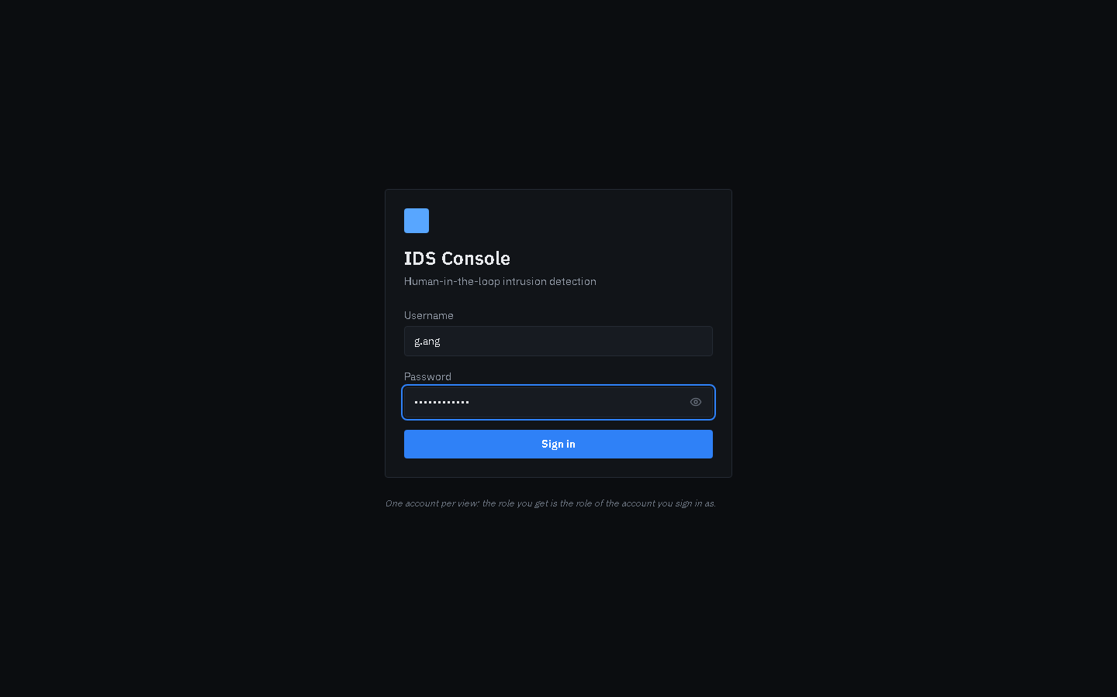
Sign in
The first screen. The user signs in with a username and password; the account decides which views are available. The system ships with three accounts, one per role:
Account | Password | View
g.ang | analyst-demo | Security analyst — the workstation and queue
admin | admin-demo | System administrator — status, guardrails, audit trail
evaluator | evaluator-demo | Evaluator — scenarios and three-arm comparisons

Sign-in is real: passwords are checked against bcrypt hashes, the server issues a signed token, and every request carries it — a user cannot reach another role's views by choosing a role, because there is no role to choose. Only an administrator can change the guardrail settings, for example. To see another view, sign out and sign in as that account's user; a sign-in lasts eight hours.

(4.2) The analyst workstation
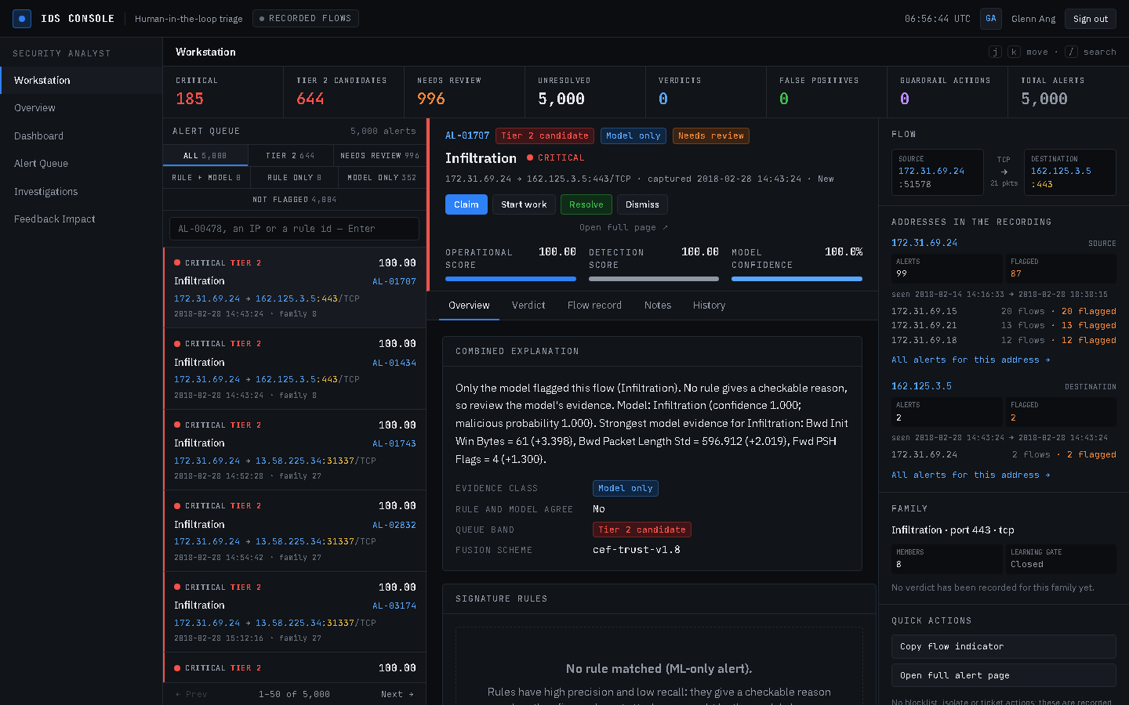
Analyst workstation
Where an analyst lands and spends a shift. Three columns: the alert queue on the left, the selected alert in the centre, and its context on the right. Above them, a strip of counts — Critical, Tier 2 candidates, needs review, unresolved, verdicts, false positives, guardrail actions and total alerts — and a Recorded flows badge, because these are recorded lab flows, not a live feed.
Tabs above the queue filter it by band; the search box finds a record, an address or a rule; j and k move through the list and the centre follows.

(4.3) Working an alert in the workstation
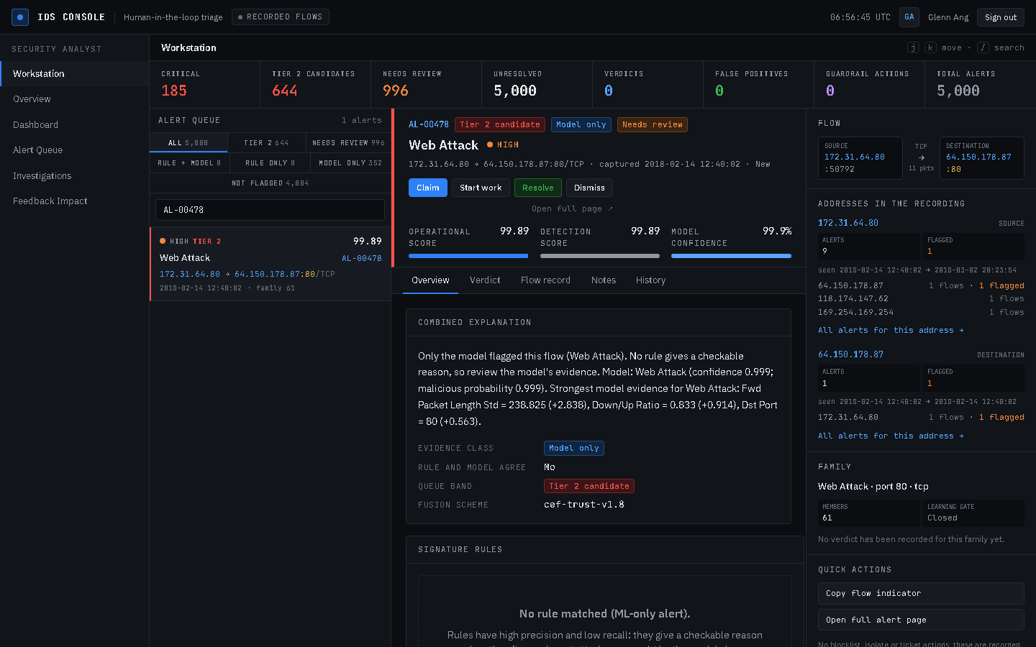
An alert in the workstation
AL-00478 selected. The header shows its band, evidence and severity, and three meters: the operational score (feedback moves it), the detection score (fixed) and the model's confidence. The context rail draws the flow, shows what the recording holds about both addresses, and summarises the alert's family.
Claim, Start work, Resolve and Dismiss manage the alert's status and owner. They are written to the audit trail and never move a score: status is workflow, and only a verdict is a judgement.

(4.4) Notes
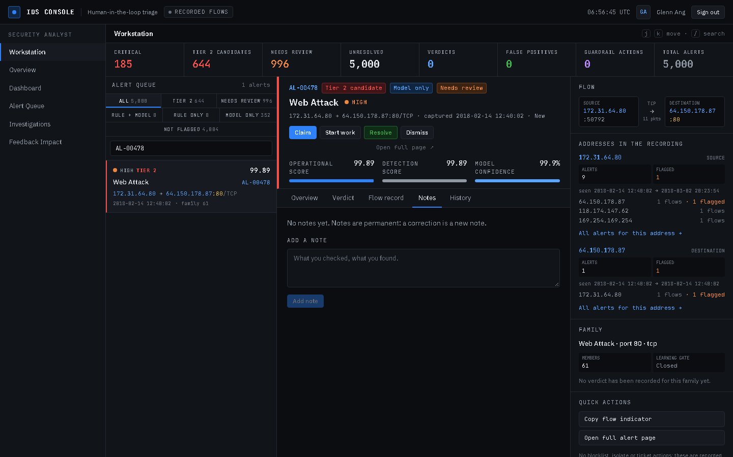
Alert notes
Each alert keeps a notes thread with the author and time on every note. Notes are permanent — a correction is a new note — because an investigation record that can be edited is not a record.

(4.5) Analyst dashboard
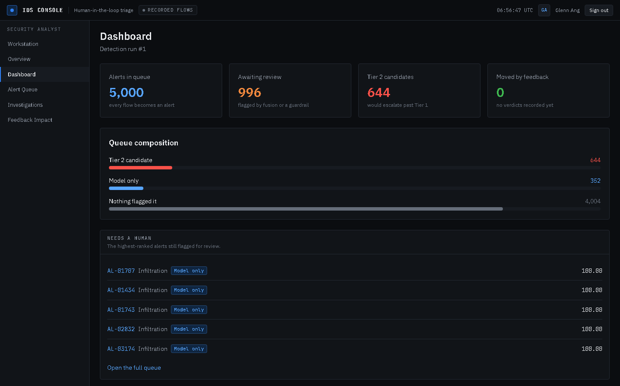
Analyst dashboard
A summary of the current detection run: how many alerts exist, how many are flagged for review, how many would escalate past Tier 1, and how many have been moved by human feedback so far. Queue composition shows where the alerts sit; Needs a human lists the highest-ranked alerts still awaiting review. "Moved by feedback" reads 0 until somebody records a verdict.

(4.6) Overview
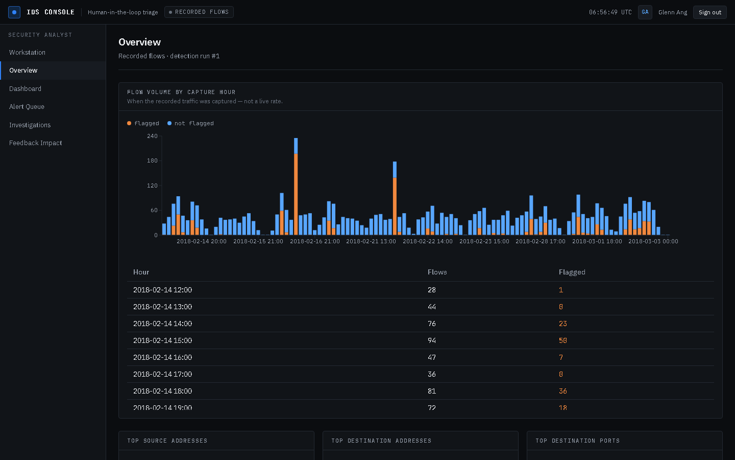
Overview
When the recorded traffic was captured and who took part in it. The histogram has one bar per hour of the recording, with the flagged share at its base; below it are the busiest source and destination addresses, the busiest destination ports, alerts by predicted class, the verdicts in force, triage status and guardrail interventions. Every chart is repeated as a table.

(4.7) One IP address
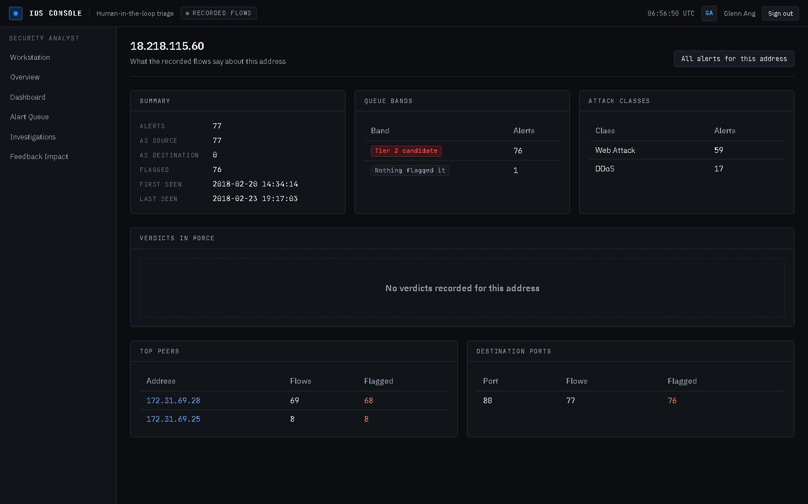
IP address page
Everything the recorded flows say about one address — here 18.218.115.60, the source of the Web Attacks the demonstration opens on: its alert count, how many were flagged, when it was first and last seen, its queue bands, attack classes and verdicts, its top peers and destination ports. Each peer opens its own page, and All alerts for this address opens the workstation searched for it.

(4.8) The alert queue
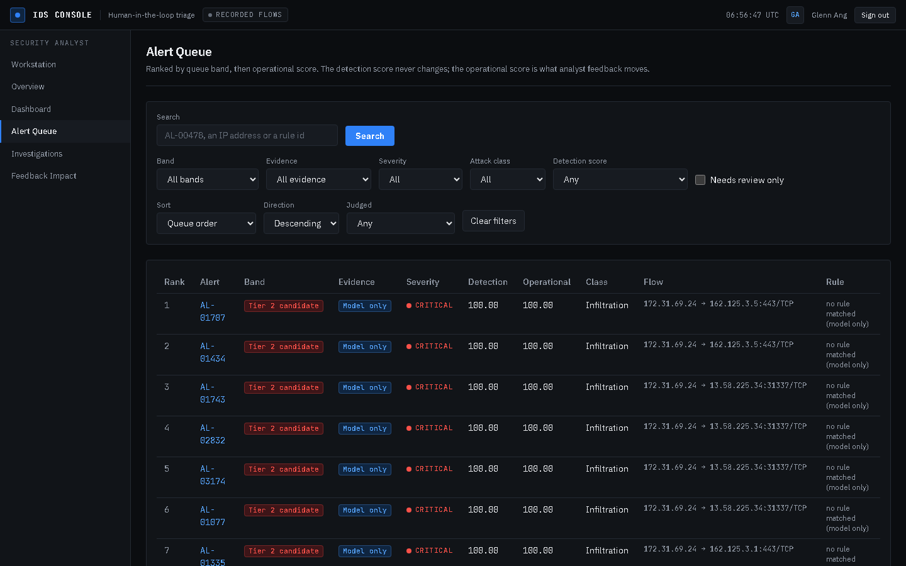
Alert queue
The full ranked table of 5,000 alerts. Each row shows the queue band, the alert reference, both score columns, the predicted class, the flow and which rule fired.
The two score columns matter. Detection is what the detectors produced and never changes. Operational is what analyst feedback moves. Showing both is what makes the human's effect visible. Filters narrow the queue by band, evidence, severity and class, and live in the address bar, so a filtered view survives a refresh.

(4.9) Alert detail — the four evidence panels
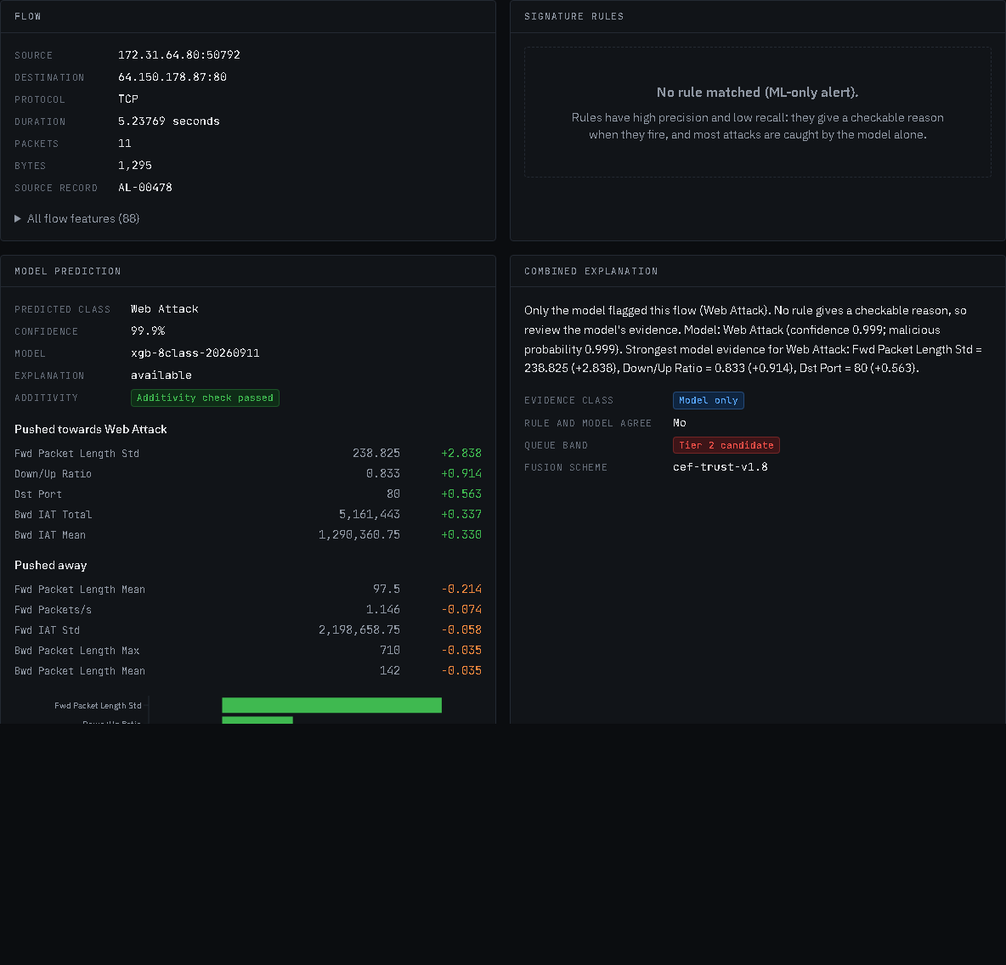
Alert detail
Everything the system knows about one alert, in four panels.
- Flow — what actually crossed the wire.
- Signature rules — what a hand-written rule could confirm. Here nothing matched, and the panel
says so rather than showing an empty box.
- Model prediction — the class, the confidence, and the measurements that pushed the prediction
towards its class and away from it. Showing only the supporting evidence would be advocacy rather than explanation.
- Combined explanation — why the alert sits where it does, in a sentence the analyst can repeat
in a handover.
The model is 99.9% sure AL-00478 is a Web Attack. It is in fact benign. The panels inform the decision; they do not make it.

(4.10) Signature evidence
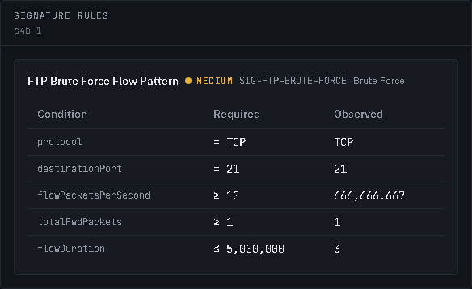
Signature evidence
When a rule does fire — here on AL-01958 — the panel lists every clause the rule requires beside the value this flow actually had. An analyst can check the match in seconds without trusting anything. The rules have high precision and low recall: they are there to give a reason, not to catch everything.

(4.11) Recording a verdict
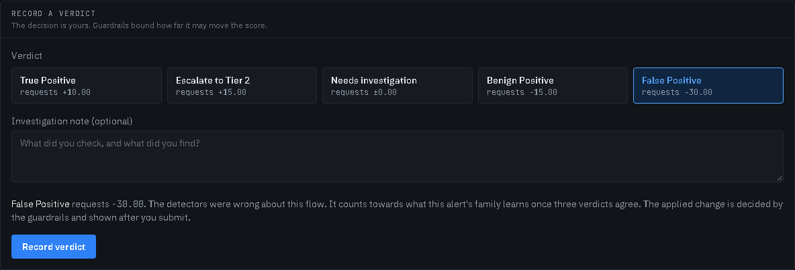
Record a verdict
Five verdicts, with the closing labels security teams use: True Positive, Escalate to Tier 2, Needs investigation, Benign Positive and False Positive. Each shows the score change it requests before the analyst commits, and an optional note is recorded alongside. A new verdict replaces the previous one rather than stacking on it.

(4.12) The score adjustment chain
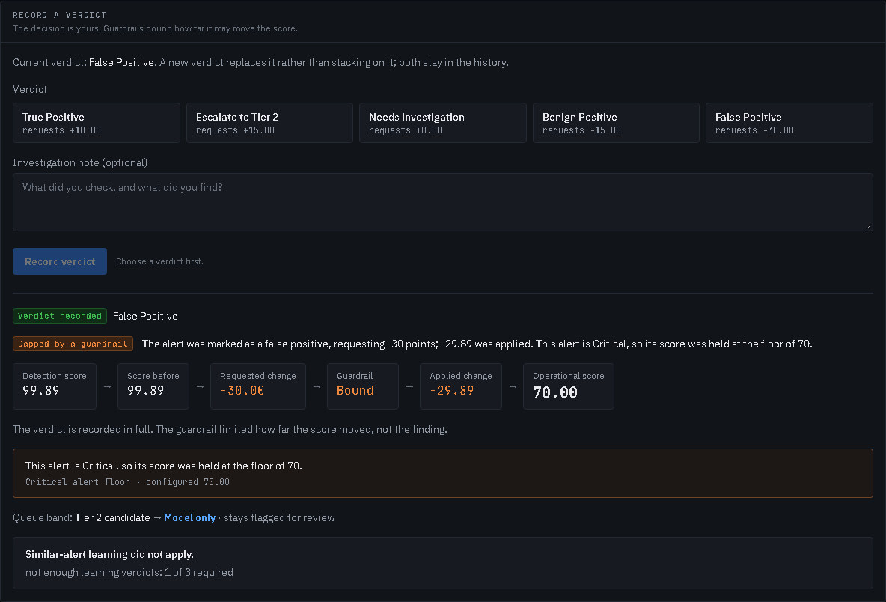
Score adjustment
The screen the project turns on. It shows the whole chain — the detection score, what the analyst requested, which guardrail bound the change, what was actually applied, and the resulting operational score.
Here the analyst asked for −30 on AL-00478 at 99.89. The alert is Critical, so the floor held it at 70, and the guardrail explains itself in a sentence rather than a code. The verdict was still recorded in full: the guardrail limited the score change, not the analyst's finding.

(4.13) When a guardrail refuses outright
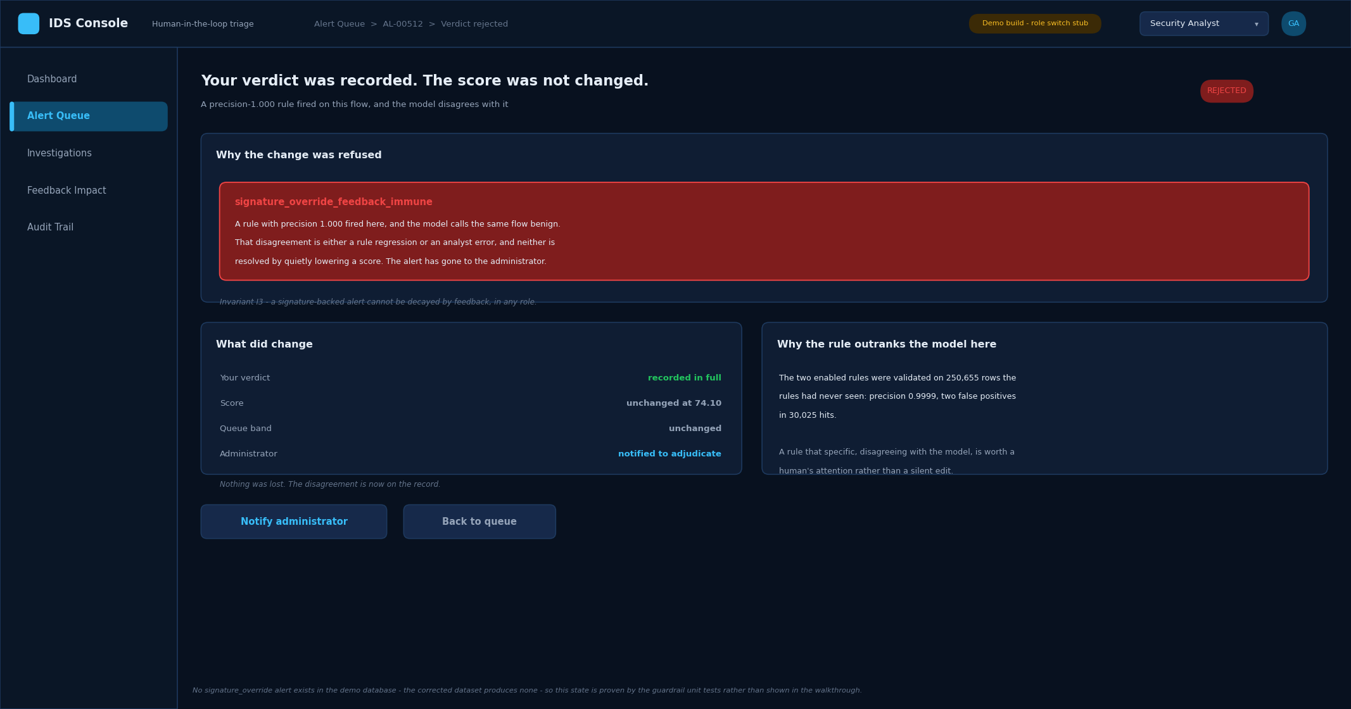
Guardrail refusal (design wireframe)
This one screen is a design wireframe, not a screenshot: the demo dataset contains no alert that only a signature rule flagged, so the refusal can never be triggered on it. The behaviour is covered by the test suite.
Some changes are refused rather than capped. Where a very high-precision rule has fired and the model disagrees with it, feedback cannot lower the score at all — the disagreement is either a rule regression or an analyst error, and neither is resolved by quietly editing a number. The alert goes to the administrator instead, and the verdict is still recorded.

(4.14) What your feedback taught the queue
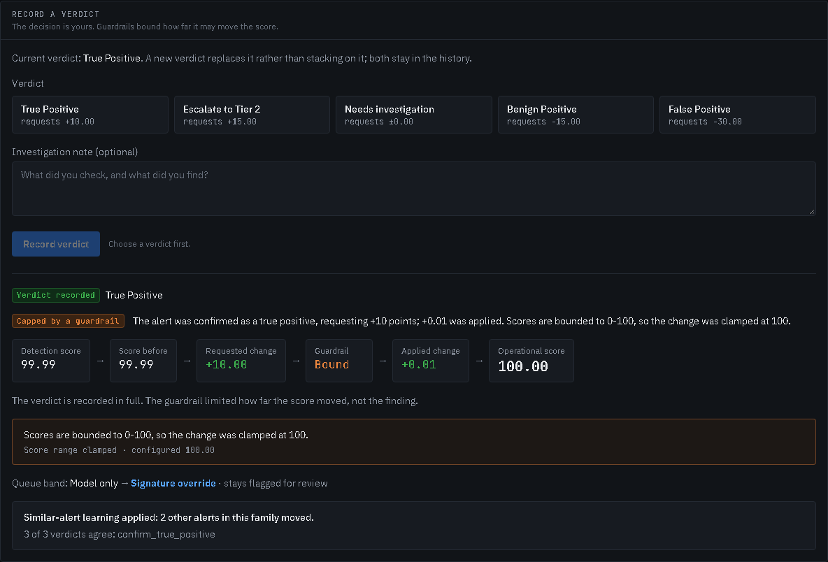
Similar-alert learning
The project's central claim, made visible. Alerts are grouped into families by attack class, destination port, protocol and matched rule. Once three agreeing verdicts are recorded in a family, its learning is applied to the other members. Here the third True Positive in a Port Scan family moved two alerts nobody had judged.
Learning that leaks past its family is not learning, it is drift: alerts outside the family do not move. The caution is real and measured, though — because a family is a coarse key, the mechanism can promote a benign alert along with its family.

(4.15) Verdict history
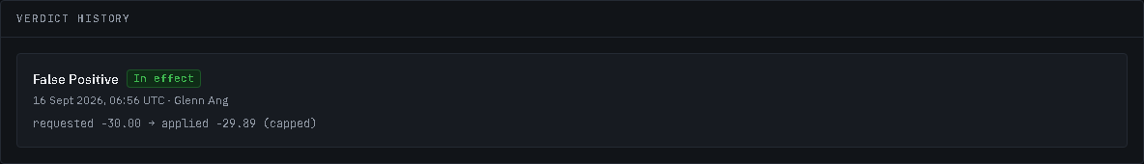
Verdict history
Every verdict ever recorded for an alert, oldest first, including the ones since replaced. Nothing is edited and nothing is deleted; a correction is a new verdict that supersedes the old one, and both remain visible.

(4.16) Feedback impact
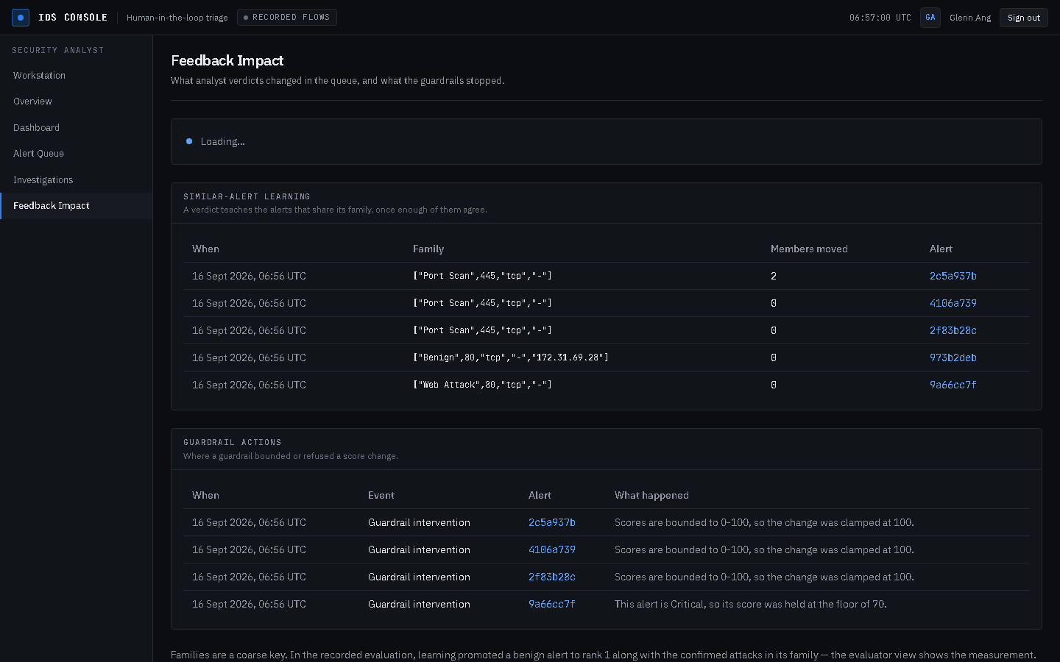
Feedback impact
What the analysts' verdicts changed across the queue — which families learned and which alerts moved — and what the guardrails stopped. The companion Investigations page lists every verdict recorded, newest first.

(4.17) Administrator — system status
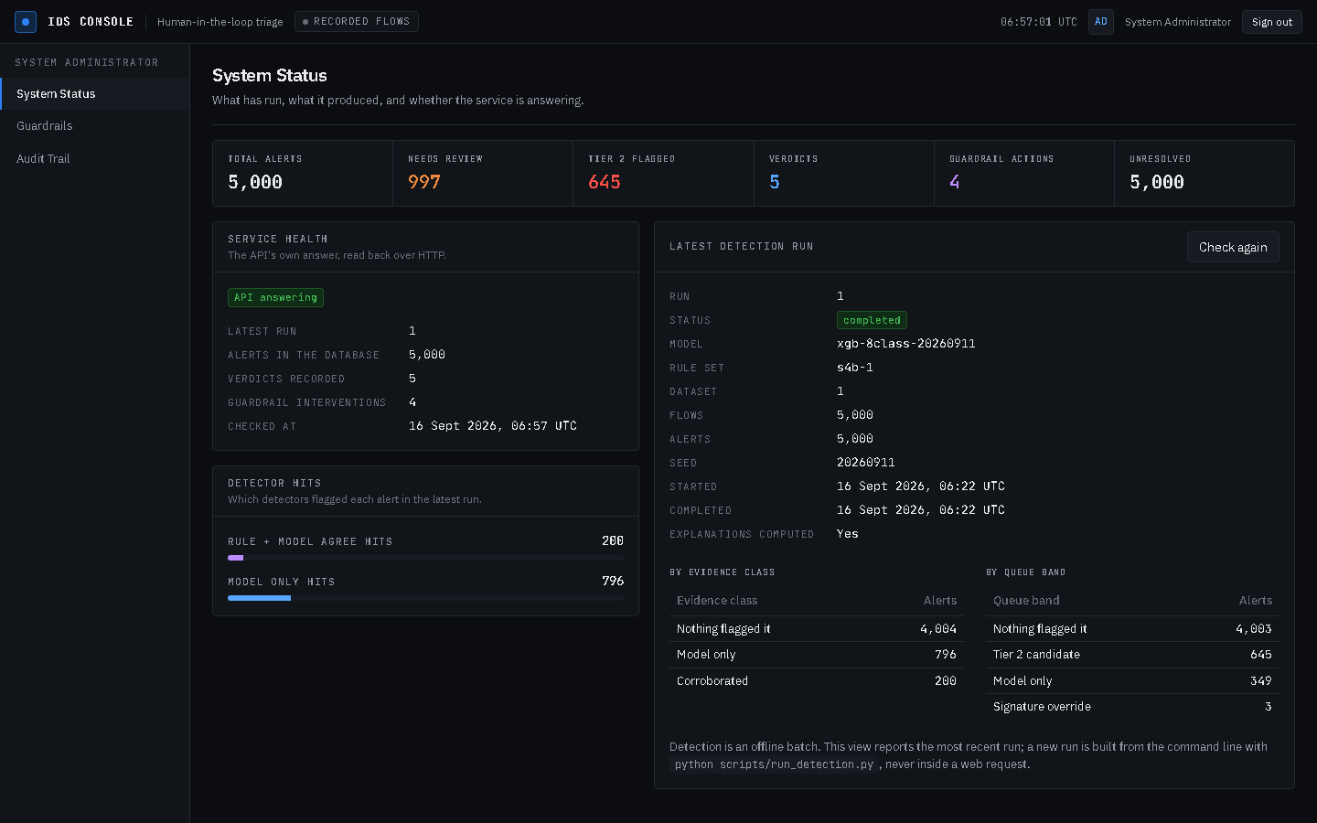
System status
The administrator's landing view. A row of operations figures, whether the API is answering, which detectors flagged the alerts of the latest run, and that run's provenance — model version, rule-set version, dataset, seed — everything a replay would need. Check again reports the latest run; a new run is built from the command line, never inside a web request.

(4.18) Administrator — guardrail configuration
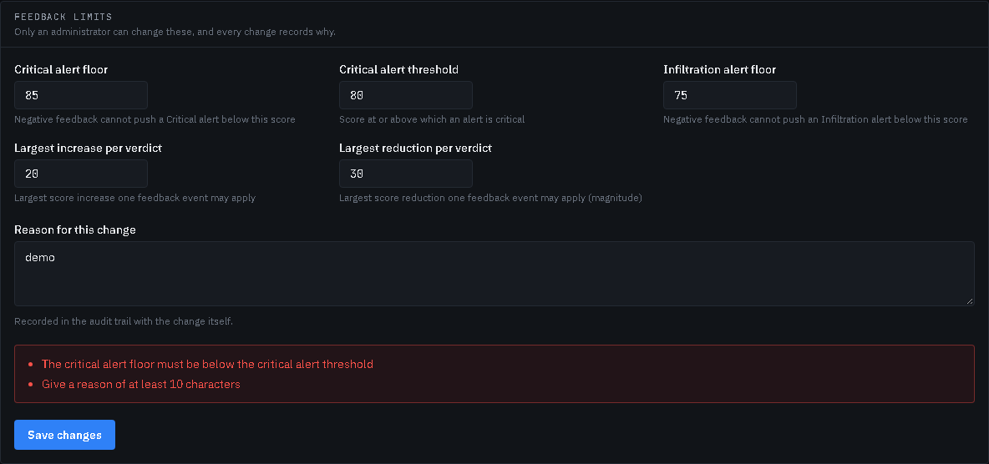
Guardrail configuration
The five settings that bound what analyst feedback may do, each with its own explanation, and the settings the pipeline enforces but feedback cannot move. A written reason is required, because the audit entry should record why, not only what. The form refuses an inconsistent change before it is sent — here a critical floor above the critical threshold.

(4.19) Administrator — audit trail
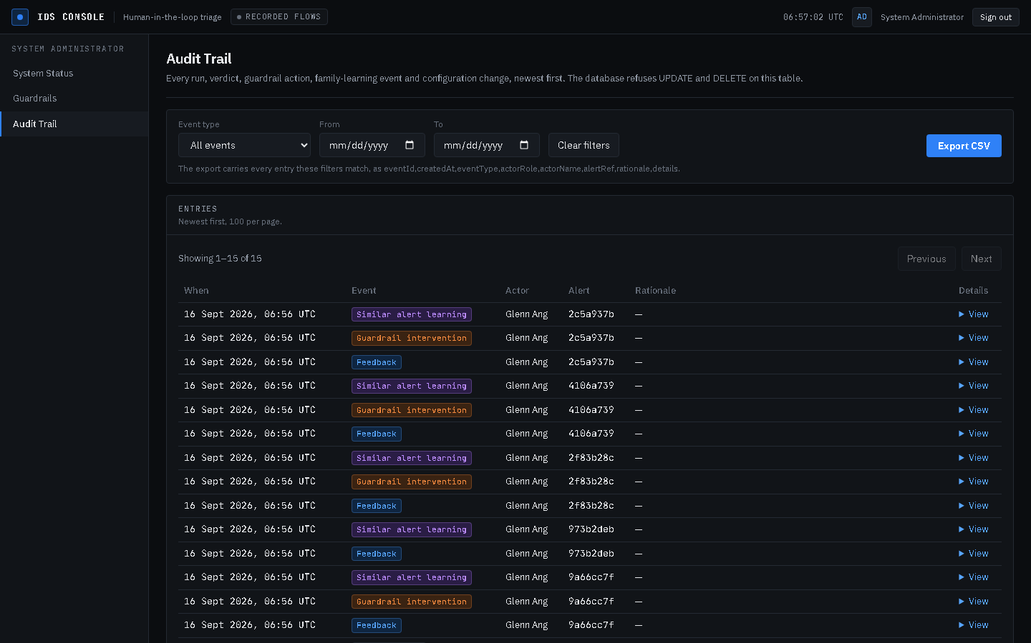
Audit trail
Every detection run, verdict, guardrail action, family-learning event, status change and configuration change, newest first, filterable by type and date, and exportable as CSV. The table is append-only at the database: UPDATE and DELETE both raise.

(4.20) Evaluator — evaluation runs
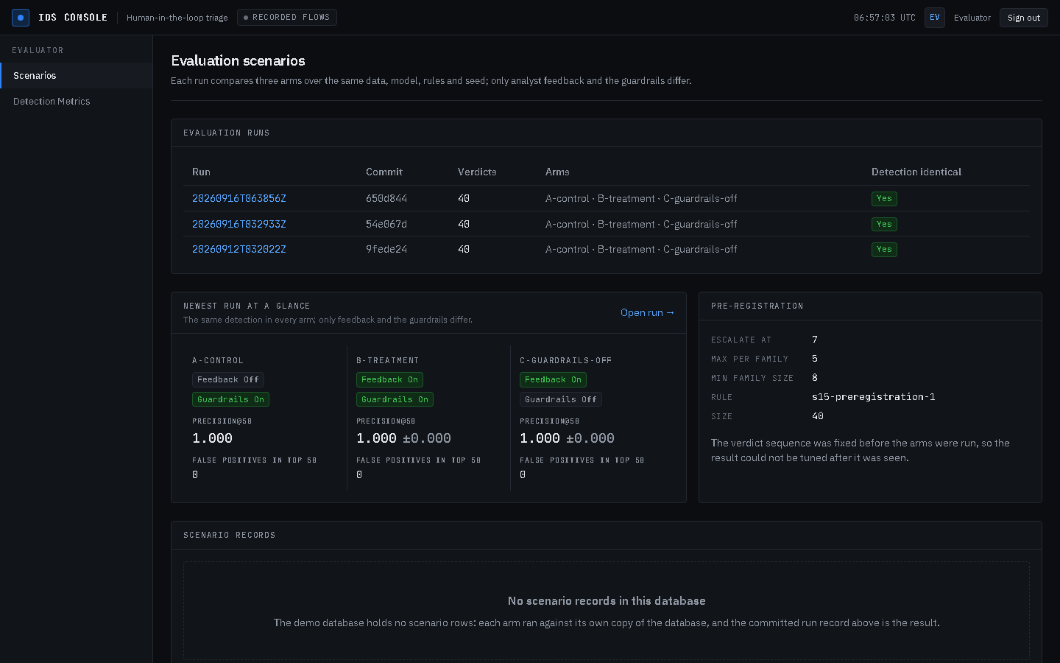
Evaluation scenarios
The evaluator's entry screen: the recorded three-arm runs, the newest run's three arms side by side, and its pre-registration — the verdict sequence was fixed before any arm ran, so the result could not be tuned after it was seen.

(4.21) Evaluator — one run
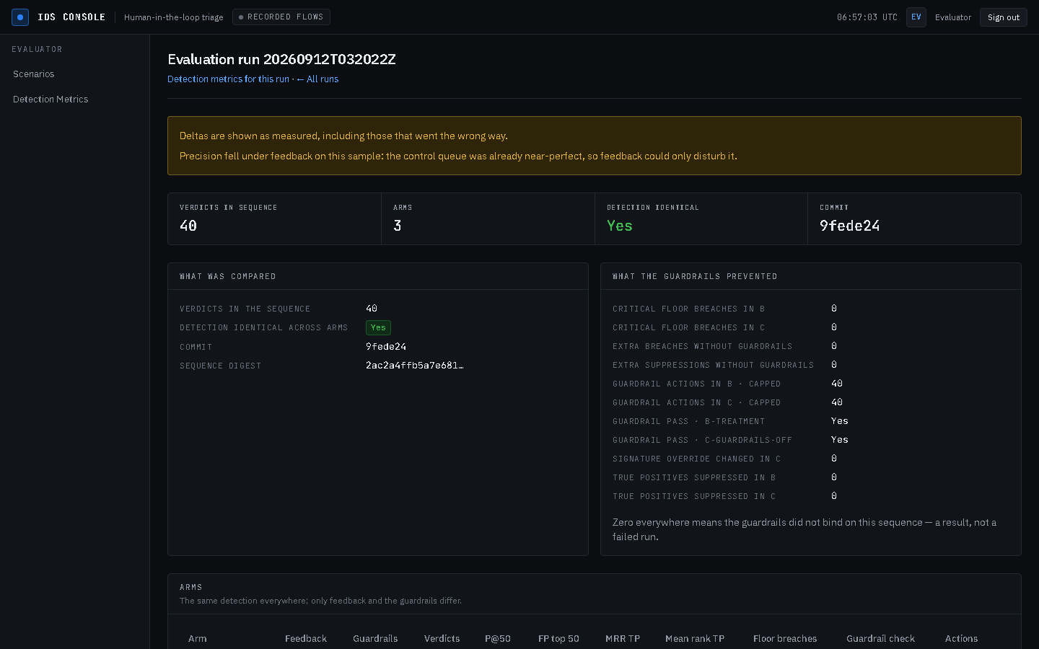
Evaluation run
The reason the project can make claims rather than assertions. Three arms run over identical data, model, rules and seed; only the feedback and the guardrails differ.
The deltas are shown as measured, in whichever direction they went. On this sample the remaining deltas are negative but small — precision@200 −0.010 and mean true-positive rank −0.515 — because the control queue was already almost perfect. The precision@50 fall of 0.020 that an earlier build reported is gone: the severity-first queue order removed it. The screen says so before the reader reaches the table.

(4.22) Evaluator — detection metrics
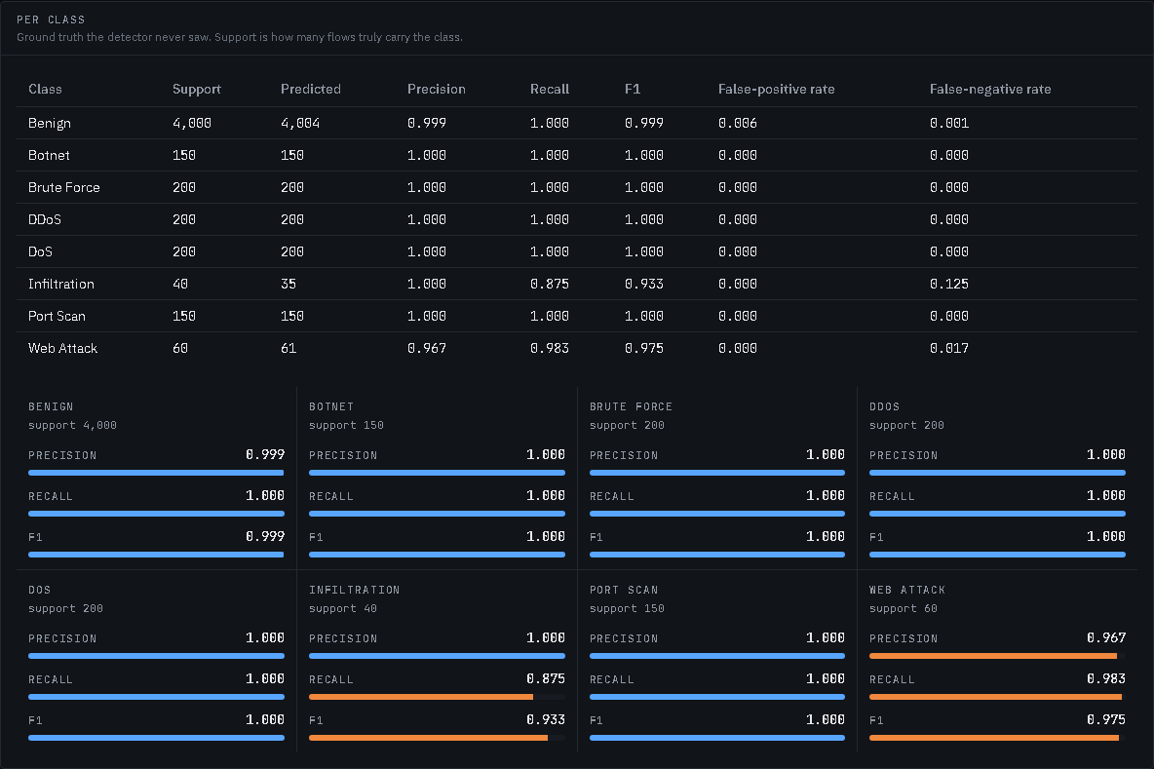
Detection metrics per class
Per-class precision, recall, F1 and error rates, measured against ground truth that the system itself never sees, with a panel per class so the imperfect ones — Infiltration and Web Attack — stand out.
Two cautions sit on the screen rather than in a footnote. Score saturation explains why a promotion can have nowhere to go. And the headline macro F1 of 0.988 is flagged as a property of the test dataset, where one tool generated each attack class, not a claim about real traffic.

Reproducing the figures
The screenshots in section 4 are captured from the running console, not drawn by hand, so they stay true as the system changes. From hitl-ids/apps/web, with HITL_PYTHON pointing at the project's Python 3.11:
GUIDE_CAPTURE=1 npx playwright test capture-guide
This starts its own API on a disposable copy of the demo database, walks the demonstration, and writes the images to docs/img/demo-guide/. The one wireframe (4.13) is generated from the database with python scripts/make_wireframes.py 09.

