**Happier Hiking Requirements**

**This document includes the entire Requirements list as well as user stories and UML sequence diagrams.**

|  |  |  |  |
| --- | --- | --- | --- |
| **ID** | **Date added** | **Priority** | **Description** |
| REQ1 | 11/8/15 | ESSENTIAL | The app shall allow for user registration, requiring an email address and a password. |
| REQ2 | 11/9/15 | LOW | Users should be able to add pictures from hikes |
| REQ3 | 11/10/15 | HIGH | The app shall allow the user to comment on a trail and rate the trail |
| REQ4 | 11/8/15 | ESSENTIAL | The App will communicate securely with the Database |
| REQ5 | 11/9/15 | ESSENTIAL | The App will implement Google Map API’s in an Activity to Display trails. |
| REQ6 | 11/9/15 | HIGH | The app should be able to geolocate |
| REQ7 | 11/10/15 | ESSENTIAL | The system will populate local trails received from the server to the map and draw them. |
| REQ8 | 11/10/15 | HIGH | The application will display information about a trail when it is selected from the map (pictures, ratings, difficulty, comments) |
| REQ9 | 11/8/15 | ESSENTIAL | The Application will implement an Apache Tomcat Java Servlet to store information on hiking trails |
| REQ10 | 11/10/15 | HIGH | The app should take no longer than 2 seconds to load the next page |
| REQ11 | 11/10/15 | LOW | The map should not take longer than 2 seconds to reload after a user has changed the view of the map |
| REQ12 | 11/10/15 | LOW | It should not take any user more then 1 hour to completely learn how to use the app |
| REQ13 | 11/10/15 | HIGH | The app should not fail 95% of the time and should have a reboot time under 1 minute when it does fail |
| REQ14 | 11/10/15 | HIGH | The app should be compatible with even the most up to date phones and versions of google maps |
| REQ15 | 12/09/15 | HIGH | The app should store the user login information and login automatically |

**User Stories for Each Requirement:**

|  |  |
| --- | --- |
| **UC-1** | **User Registration** |
| **Related To Requirement:** | **REQ1** |
| **Initiating Actor** | **The User** |
| **Actor’s Goal** | **To register to use the application** |
| **Preconditions** | **User has started the application** |
| **Postconditions** | **User is able to register to use the application** |
| **Failed End Conditions** | **The user is not able to register to use the application, and the user cannot use the application** |
| **Flow of events for main success scenario:** | |
| * **User starts the application** * **User Clicks the "Register" button**   **←   The system changes to the register page**   * The user enters in their chosen username and password to be used for the app   **←   System checks if username is available, if it is, it saves their username and password to the database**  **←   App prompts to the screen that the user has successfully registered for the app**   * **User is able to use their new login information to log into the app** | |

|  |  |
| --- | --- |
| **UC-2** | **Upload a picture of the hike** |
| **Related To Requirement:** | **REQ2** |
| **Initiating Actor** | **The User** |
| **Actor’s Goal** | **To load a picture onto the app** |
| **Preconditions** | **User is logged into app, has chosen a hike** |
| **Postconditions** | **Picture is shown on the app** |
| **Failed End Conditions** | **User not logged in, picture does not show up after on app** |
| **Flow of events for main success scenario:** | |
| * **User logs into app** * **User selects hike to load picture onto** * **User loads picture onto hike**   **←   System checks if user is logged in**  **←   System loads picture into database**  **←   App updates new pictures of hike, including new picture**   * **User see’s picture on the hike** | |

|  |  |
| --- | --- |
| **UC-3** | **Add a comment to a hike** |
| **Related To Requirement:** | **REQ3** |
| **Initiating Actor** | **The User** |
| **Actor’s Goal** | **To add a comment on a hike** |
| **Preconditions** | **User is logged into app, has chosen a hike** |
| **Postconditions** | **New comment is shown on the app** |
| **Failed End Conditions** | **User not logged in, comment does not show up after on app** |
| **Flow of events for main success scenario:** | |
| * **User logs into app** * **User selects hike to comment on** * **User adds the new comment to the hike**   **←   System checks if user is logged in**  **←   System loads comment into database**  **←   App updates new comments for the hike, showing the new comment**   * **User see’s the new comment on the hike** | |

|  |  |
| --- | --- |
| **UC-4** | **App will communicate securely with the database** |
| **Related To Requirement:** | **REQ4** |
| **Initiating Actor** | **The Application** |
| **Actor’s Goal** | **To communicate securely with the database** |
| **Preconditions** | **Application needs to be started** |
| **Postconditions** | **Application is able to pass information to and from the database** |
| **Failed End Conditions** | **The Application is not able to connect to the database, or the connection is not secure** |
| **Flow of events for main success scenario:** | |
| * **User starts the application** * **User Clicks the "Register" button**   **←   The system changes to the register page**   * The user enters in their chosen username and password to be used for the app   **←   System checks if username is available, if it is, it saves their username and password to the database**  **←   App prompts to the screen that the user has successfully registered for the app**   * **User is able to use their new login information to log into the app** | |

|  |  |
| --- | --- |
| **UC-5** | **App will show google Maps API's to show the trails of the hike** |
| **Related To Requirement:** | **REQ5** |
| **Initiating Actor** | **The Application** |
| **Actor’s Goal** | **To properly display the hikes on the app using google Maps API** |
| **Preconditions** | **Application needs to be started, user needs to be logged in** |
| **Postconditions** | **Application will properly display the map and the trails on the map** |
| **Failed End Conditions** | **The map does not load correctly, the map loads correctly but the trails are not shown on the map** |
| **Flow of events for main success scenario:** | |
| * **User logs into the application**   **←   The system changes pages to the .MapsActivity page**  **←   System loads the google Maps API**  **←   System communicates with the server to load the trails from the database**  **←   System maps out the trails from the database onto the map**   * **User is able to see the map and the trails on the map** | |

|  |  |
| --- | --- |
| **UC-6** | **The app should be able to geo locate** |
| **Related To Requirement:** | **REQ6** |
| **Initiating Actor** | **The User** |
| **Actor’s Goal** | **To geo locate their location on the mapp** |
| **Preconditions** | **Application needs to be started, user needs to be logged in** |
| **Postconditions** | **Application will properly display the map and where the user is on the map** |
| **Failed End Conditions** | **The map does not load correctly, the map loads but cannot locate where the user is on the map** |
| **Flow of events for main success scenario:** | |
| * **User logs into the application**   **←   The system changes pages to the .MapsActivity page**  **←   System loads the google Maps API**  **←   System finds where the user is located**  **←   System displays the user's location on the map**   * **User is able to see the map and where they are on the app** | |

|  |  |
| --- | --- |
| **UC-8** | **The application will display information about a trail when it is selected from the map (pictures, ratings, difficulty, comments)** |
| **Related To Requirement:** | **REQ8** |
| **Initiating Actor** | **The User** |
| **Actor’s Goal** | **To load the information about the hike** |
| **Preconditions** | **Application needs to be started, user needs to be logged in, User needs to choose a hike** |
| **Postconditions** | **Application will show the user information about their chosen hike** |
| **Failed End Conditions** | **The application does not load information correctly, or the app loads the incorrect information about the hike** |
| **Flow of events for main success scenario:** | |
| * **User chooses a hike from the .MapsActivity page**   **←   The system realizes the chosen hike and loads the .hikeDisplay page**  **←   System communicated with the server to load the information about the chosen hike**  **←   System takes that information and displays it to the user in the new page**   * **User is able to see the information about the hike** | |

|  |  |
| --- | --- |
| **UC-9** | **The Application will implement an Apache Tomcat Java Servlet to store information on hiking trails** |
| **Related To Requirement:** | **REQ9** |
| **Initiating Actor** | **The Application** |
| **Actor’s Goal** | **To implement the Java Servlet to store information** |
| **Preconditions** | **Application needs to be started, user needs to be logged in** |
| **Postconditions** | **Application will use the Servlet to store information about the hike** |
| **Failed End Conditions** | **The application does not connect correctly to the Servlet** |
| **Flow of events for main success scenario:** | |
| * **The application is started by the user**   **←   The system tries to connect to the servlet to bring in information about the hike**  **←   System gets information from the server and stores it onto the servlet**   * **Application is able to user Servlet to store information** | |

UML Scenario Diagrams

Requirement #3

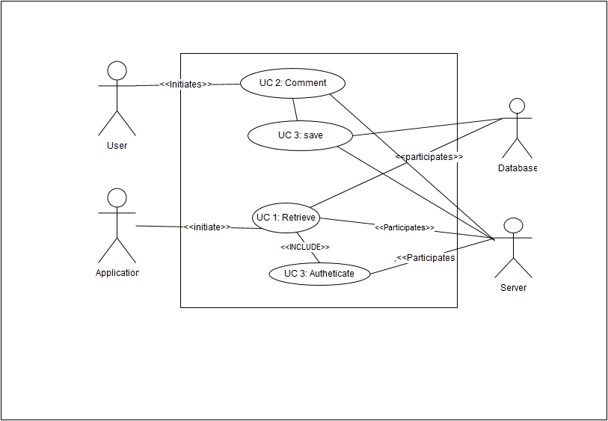

Requirements #6

