
BOL
100 - 110 W Columbia St
Schuylkill Haven, PA 17972
Phone 941-866-3089
Evans Load ID {{efj_pro}}

Pickup At: Deliver To: Description: Solar Panels

Boviet – NC Plant 1225 Sugg Parkway
GREENVILLE, NC 27834
Piedra Solar
161 Farm to Market 2777
Mexia, TX 7667

{{box_one}} | {{piedra_box}} | Piedra Solar
Wattage {{wattage}} | PalletCount {{pallet_count}} | PieceCount {{piece_count}} | Weight 38,000lbs

Order Notes:

NO OVERNIGHT PARKING ON SITE - Drivers should wait at nearest truck stop for appt.

Recommended: Love's Travel Stop, 299 I-45, Fairfield, TX 75840

PPE required on site: Steel toe boots, hard hat, safety glasses, reflective vest, long pants, minimum 4" sleeves

DO NOT GO IN MORE THAN 30 MINUTES FROM APPT TIME.

Please advise drivers to avoid coming from HWY 84 due to high speeds. MAX speed of 10 MPH











Arrival Time Started Completed
Del Appt: {{delivery_date}} {{delivery_time}}
BELOWTO BE COMPLETED AT DELIVERY ONLY
Trailer Number:
Arrival Time Started Completed
PU Appointment: {{pickup_date}} {{pickup_time}}
You are allowed 3 hours to complete loading / unloading. Detention time will be assessed in 1/4 hour increments thereafter.

All terms and conditions our rules tariff apply. See Rules tariff at www.Evansdelivery.com

Piedra Solar

Freestone County, Texas
161 Farm to Market 2777
Mexia, Texas 76667

Times:

Site times are from 7:00 am to 4:00 pm CST Monday thru Friday.
(Lunch 1100/1130)
Construction truck traffic shall not arrive at the project entrance prior to 7:00 am or more than 30min prior their scheduled appointment time.
These times are subject to change due to civil twilight.
Deliveries will not be allowed on weekends or holidays and may be subject to other local restrictions.
All Deliveries must be scheduled and will be unloaded accordingly.
It is NOT first come first serve.

Requirements:
- Appointments- Please notify via phone or email (2) days in advance of arrival. (See Site Contacts on page 2)

- Driver Check In- All trucks shall enter the site at the main gate, unless directed otherwise by the Coordinator. All delivery drivers will be required to check-in at the Laydown Yard with site personnel prior to field dispatch for unloading and leave all loads secure and strapped until directed to remove them.
(See page 4 for route information and location Project Site)

- Paperwork- Driver’s must arrive with the following:
  - a copy the Drivers Instructions. (this form)
  - 2 physical copies the BOL. (One to keep, one for the unloading team)
    - DIGITAL COPIES WILL NOT BE ACCEPTED

- Personal Protective Equipment- All drivers must wear Personal Protective Equipment (PPE) at all times while not inside their truck. This includes:
  - Steel toe or composite safety boots or shoes
  - Hard hat w/ Safety glasses
  - Reflective safety vest or similar reflective coat/jacket
  - Long pants / Shirt with 4’’ minimum sleeves
  - Gloves if handling or working with materials

Site Contacts:

Contact | Contact Name | Job Title | Phone # | Email Address
Primary | Dalphnee' Lincoln | Construction Coordinator | 423-660-7856 | Dalphnee.Lincoln@Signalenergy.com
Secondary/ Spanish | Leandra Valdez | General Foreman | 423-602-3756 | Leandra.valdez@signalenergy.com
*Contact Dalphnee Lincoln for scheduling deliveries*
Calls will be answered from 6:00 a.m. till 4:00 p.m. CST - Monday thru Friday only.

Unloading Schedule:
Free time for unloading shall not be less than Three (3) hours and shall begin at their scheduled appointment time. No detention charges shall accrue for time waiting due to missing a scheduled delivery time. Drivers arriving are required to check-in with Site Personnel. Deliveries not scheduled through Construction Coordinator may be turned away or be required to wait for next available delivery slot.

Safety Requirements:
- PPE- All drivers must wear Personal Protective Equipment while on the Piedra Solar site. (See Delivery Requirements Above)
- Passengers/Pets- All passengers must remain in vehicles. Absolutely no pets are allowed outside of vehicle.
- Speed Limit- Drivers are to travel at a maximum speed of 10 mph while traveling on the Piedra Solar job site or speed indicated on posted signs. Note: if you are causing dust please slow down and while passing the workers 5 mph.
- Cell phone operation – Absolutely no cell phone operation, verbal or text, is permitted while operating vehicles on site.
- Seat belts – All drivers are required to wear seat belts while operating vehicles on site.

- Trash – Signal Energy has very strict trash removal requirements for protection wildlife. All trash, including biodegradable material such as food waste, must be properly disposed in a covered trash receptacle or taken out from site.

Weapons and Alcohol are strictly prohibited.

- Weather Event- If there is a storm and lightning stand down is called, please STAY in your truck until ALL CLEAR is called out.

- No Overnight Parking- Trucks are prohibited from parking overnight onsite. Please look for local truck stops in the area and return the following working day 30 minutes prior to your appointment time.
- Penalties- Drivers and Shippers must adhere to the Rules and Regulations of the Project’s Site. This includes but is not limited to site delivery times, speed limits and PPE. Failure to follow site rules can lead to refusal load and driver banned from sites.
Important Notice:
Delivery traffic MUST stay on designated roads. Use the site entrance from Highway 90 and turn into the Site gate shown in the image to the right.

Follow the 4 mile access road to arrive into the laydown area. This is the only authorized route to enter project. Must use designated routes entering and leaving project.

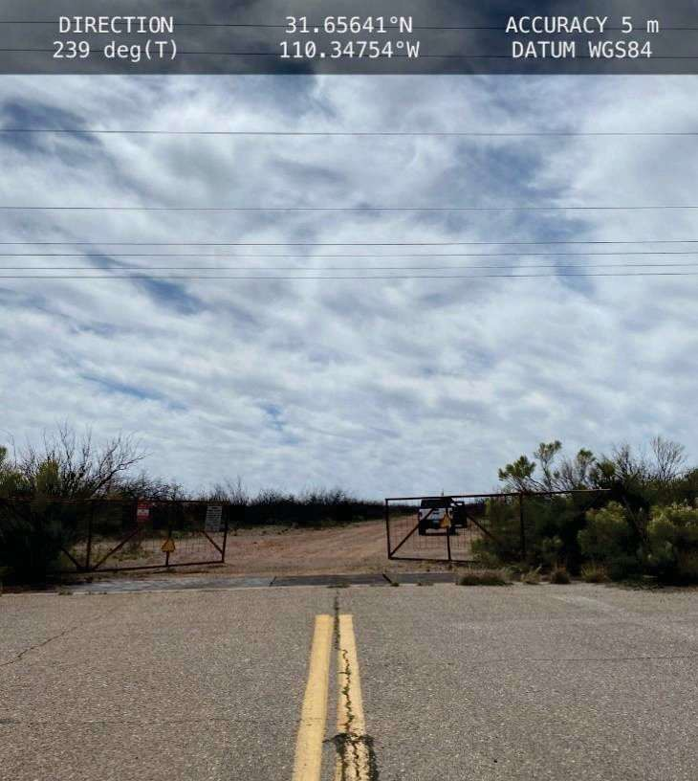

Follow Directions and Use Maps Below.
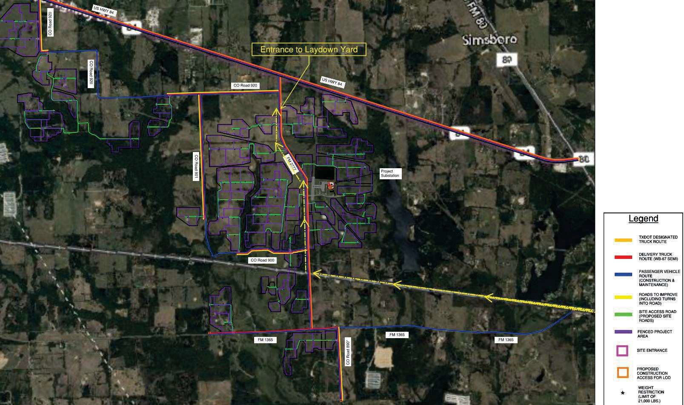
Deliveries to Piedra Solar

Arrival
Head North on Farm to Market 2777 from HWY 1365 for approximately 1 mile. Turn right into the site entrance.
Look for the site entrance signs to the Piedra site. Driver must check in with site personnel and await further instructions. No trucks shall go beyond the laydown without an escort.
Exiting from Piedra Solar

DEPARTURE

Escort will bring driver back to Access Road to leave the same way as they arrived.

