New Plant Disease Detection

Insert Subtitle Here

FirstName Surname†  
 Department Name  
 Institution/University Name  
 City State Country  
 email@email.com

FirstName Surname  
 Department Name  
 Institution/University Name  
 City State Country  
 [email@email.com](mailto:email@email.com)

FirstName Surname  
 Department Name  
 Institution/University Name  
 City State Country  
 email@email.com

ABSTRACT

This paper will explore the classification of plant images to identify new plant diseases using a machine learning model.

The dataset was obtained from Kaggle and consists of over 87,000 rgb images of healthy and diseased crop leaves labeled by plant and disease type in 38 different classes.

CCS CONCEPTS

• Artificial Intelligence • Machine Learning   • Image Classification

1 Introduction

The problem we will examine is a supervised multi-class image classification problem. The goal is to investigate which supervised machine learning models will give the best results in classifying the images from our dataset in the predefined categories.

2 Existing Work

|  |  |
| --- | --- |
| Plant Desease Classifictaion-VGG16  https://www.kaggle.com/wiwidsetiawan/plant-desease-classifictaion-vgg16 | Example of classification using the VGG16 pre trained model |
| Fork of Plant Diseases Classification Using incep3  https://www.kaggle.com/vimaladit/fork-of-plant-diseases-classification-using-incep3 | Example of classification using the Inception Version 3 pre trained model |
|  |  |
|  |  |

3 Methodology

3.1 Data Preparation

3.2 Data Preprocessing

train_datagen = ImageDataGenerator(rescale=1./255,

shear_range=0.2,

zoom_range=0.2,

width_shift_range=0.2,

height_shift_range=0.2,

fill_mode='nearest')

valid_datagen = ImageDataGenerator(rescale=1./255)

batch_size = 48

training_set = train_datagen.flow_from_directory(dataDirTrain,

target_size=(224, 224),

batch_size=batch_size,

class_mode='categorical')

3.3 Data Exploration

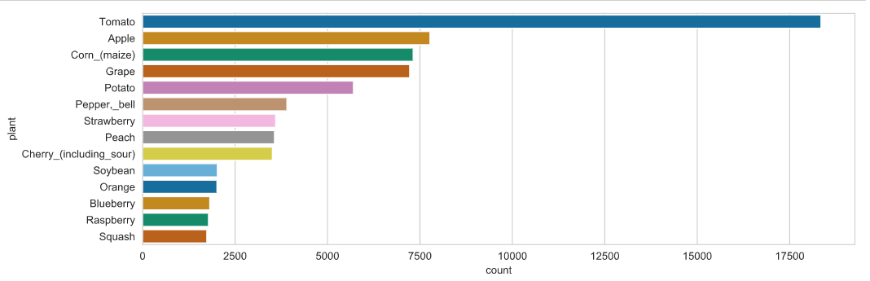

Figure 1: Number of images by plant

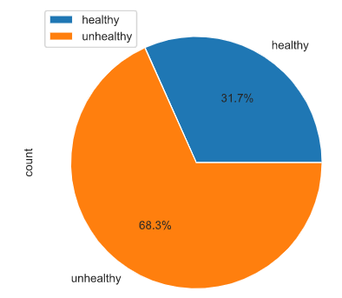

Figure 2: Relative image percentages by health status

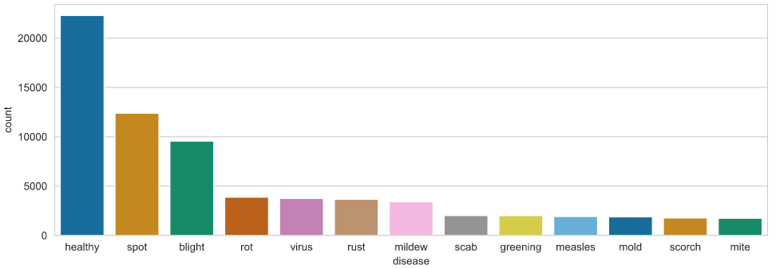

Figure 3: Number of images by disease

3.4 Feature Engineering & Selection

3.5 Model Evaluation & Selection

4 Results

Insert keyword text, Insert keyword text, Insert keyword text, Insert keyword text

5 Discussion

6 Conclusion

ACM Reference format:

FirstName Surname, FirstName Surname and FirstName Surname. 2018. Insert Your Title Here: Insert Subtitle Here. In *Proceedings of ACM Woodstock conference (WOODSTOCK’18). ACM, New York, NY, USA, 2 pages.* https://doi.org/10.1145/1234567890

ACKNOWLEDGMENTS

Insert paragraph text here. Insert paragraph text here. Insert paragraph text here. Insert paragraph text here. Insert paragraph text here. Insert paragraph text here. Insert paragraph text here. Insert paragraph text here. Insert paragraph text here. Insert paragraph text here. Insert paragraph text here.

REFERENCES

[1] Wiwid Setiawan, 2020. T Plant Desease Classifictaion-VGG16 <https://www.kaggle.com/wiwidsetiawan/plant-desease-classifictaion-vgg16>

[2] Vimal Adit. 2019. Fork of Plant Diseases Classification Using incep3 <https://www.kaggle.com/vimaladit/fork-of-plant-diseases-classification-using-incep3>

[3]

Conference Name:ACM Woodstock conference

Conference Short Name:WOODSTOCK’18

Conference Location:El Paso, Texas USA

ISBN:978-1-4503-0000-0/18/06

Year:2018

Date:June

Copyright Year:2018

Copyright Statement:rightsretained

DOI:10.1145/1234567890

RRH: F. Surname et al.

Price:$15.00