BuildBridge
GoHighLevel Marketplace App Platform — Technical Overview
CSM Synergy • Repository: CSMSYNERGY/buildbridge • Generated 29 Jun 2026
A multi-tenant integration platform that connects GoHighLevel sub-accounts to building-industry tools — brokering authentication, subscriptions, field mapping, and live data sync between GHL, Deposyt billing, and SmartBuild.
Stack: Node.js + Express 5 · React 19 + Vite · PostgreSQL + Drizzle · Railway / Docker

1. What BuildBridge Is
BuildBridge (internal package name smartbuild-v2) is a GoHighLevel (GHL) marketplace application platform built by CSM Synergy. It is a multi-tenant SaaS: GHL agencies install it from the marketplace, and each GHL location (sub-account) can subscribe to integration "apps," configure them, and have BuildBridge act as the middleware that moves data between GHL and third-party building-industry software — primarily SmartBuild, a building/job estimation system.
The problem it solves
Construction & outdoor-structure businesses run their sales/CRM in GoHighLevel but their quoting/estimating in separate tools like SmartBuild. BuildBridge bridges the two so a job created or updated in one is reflected in the other — without manual re-entry.
How it earns money
Per-location subscriptions billed through Deposyt. Each app (SmartBuild, IdeaRoom, QuickBooks, Monday.com) has monthly/annual plans, plus a discounted Suite plan that unlocks everything. Access is gated by subscription status.

Repository Snapshot
Attribute | Value
Repository | github.com/CSMSYNERGY/buildbridge (default branch main)
Package / version | smartbuild-v2 v2.0.0
Structure | Monorepo — Express backend (src/) + React SPA (frontend/)
Runtime | Node.js >= 20, ES Modules
Deployment | Railway via multi-stage Dockerfile; health check at /health
Database | PostgreSQL (Supabase) via Drizzle ORM
Maturity | Actively developed, early stage — core flows complete; a few action endpoints stubbed; no test suite yet

Technology Stack
Backend
- Express 5 REST API
- Drizzle ORM + postgres-js
- JWT sessions (httpOnly cookie)
- Helmet, CORS, rate limiting, morgan logging
- AES-256-GCM encryption for secrets at rest
- envalid for env-var validation
Frontend
- React 19 + React Router 7
- Vite 6 build, served at /buildbridge
- Tailwind CSS + Radix UI primitives
- lucide-react icons, cookie-based auth context
- Brand: purple #3d3672 / teal #75e6da

2. Architecture
BuildBridge is a single Node service that serves both the REST API and the compiled React SPA. It sits between GoHighLevel (identity + CRM data), Deposyt (billing), and SmartBuild (estimation), persisting state in PostgreSQL.
Tier | Components
Clients | GHL Custom Page (iframe / SSO) · Agency browser (OAuth install) · Admin tools
BuildBridge | React SPA (/buildbridge) · Express API · Auth (JWT + GHL SSO) · Webhook processor · Entitlement middleware
Data | PostgreSQL (Supabase) via Drizzle ORM
External | GoHighLevel API + OAuth · Deposyt billing + webhooks · SmartBuild estimation API

End-to-End Flows
- 1. Install & OAuth. An agency installs from the GHL marketplace. GET /auth redirects to GHL's OAuth chooser; GET /auth/callback exchanges the code for access/refresh tokens, encrypts them (AES-256-GCM), upserts the locations row, and issues a JWT session cookie (sb_token).
- 2. In-app SSO. Inside GHL, the app loads as a Custom Page in an iframe. /api/sso/decrypt decrypts GHL's SSO key (AES-256-CBC) to identify the user per request and set the same session cookie. Helmet CSP/frameguard are relaxed to permit iframe embedding.
- 3. Billing. Subscriptions are created/canceled via the Deposyt API. Deposyt fires HMAC-SHA256-signed webhooks to /webhooks/subscription, which are signature-verified, idempotency-checked, logged to webhook_events, then processed (add / update / delete / pause).
- 4. Entitlement. The checkSubscription(appSlug) middleware gates features by active plan. A Suite subscription unlocks all apps (smartbuild, idearoom, quickbooks, monday).
- 5. Integration actions. /actions/* (API-key + JWT + subscription) proxy into SmartBuild — retrieve / create / edit a job. SmartBuild credentials are stored encrypted per-location and exchanged for a session token on each call.

Security Model
- Secrets at rest: GHL tokens and SmartBuild credentials encrypted with AES-256-GCM before DB storage.
- Sessions: signed JWT in an httpOnly, SameSite=None, Secure cookie (7-day expiry).
- Webhooks: HMAC signature verified with timingSafeEqual; replay-protected via an idempotency event log.
- Internal/admin routes: guarded by X-API-Key / x-admin-key headers.
- Hardening: Helmet headers, CORS locked to the app origin, and per-route rate limiters.

3. Data Model & API

Database Schema (Drizzle / PostgreSQL)
Table | Purpose | Key columns
plans | Sellable subscription plans per app | id, appSlug, billingInterval, priceUsd (cents), isActive
locations | GHL sub-accounts + encrypted OAuth tokens | id (GHL locationId), companyId, ghlAccessToken*, ghlRefreshToken*
subscriptions | Active/cancelled plans per location | id (Deposyt sub id), locationId, planId, status, period start/end
webhook_events | Idempotent inbound event log | id (idempotency key), source, eventType, payload(jsonb), status
mappers | Field mapping GHL <-> external app | locationId, appSlug, mapperType, externalKey, ghlValue (unique)
integration_credentials | Encrypted per-app secrets | locationId, appSlug, encryptedPayload* (unique per location+app)

* = encrypted (AES-256-GCM). Managed with Drizzle Kit migrations; npm run seed loads 10 starter plans (5 apps x monthly/annual + Suite).

API Surface
Method & Path | Auth | Description
GET /health | none | Liveness probe
GET /auth, /auth/callback | none | GHL OAuth start & token-exchange callback
GET|POST /api/sso/decrypt | SSO key | GHL SSO -> issue session cookie
GET /api/me | JWT | Current user/location from session
GET /api/subscription/plans | JWT | Active plans (raw + grouped by app)
POST /api/subscription/create | JWT | Create Deposyt subscription
DELETE /api/subscription/cancel | JWT | Cancel subscription
GET /api/ghl/fields | JWT | List GHL custom fields for mapping
GET/POST/PUT/DELETE /api/mappers | JWT | CRUD field mappers
GET/POST/DELETE /api/smartbuild/config (+ /test) | JWT | Manage & test SmartBuild credentials
POST /actions/* | API-key + JWT + sub | Retrieve / create / edit SmartBuild jobs
POST /webhooks/subscription | HMAC sig | Deposyt billing webhooks
GET /admin/locations, /webhook-events (+ replay) | admin key | Ops: inspect locations & replay events

Plan Catalogue (seed data)
App | Monthly | Annual
SmartBuild | $150 | $1,500
IdeaRoom | $49 | $490
QuickBooks | $69 | $690
Monday.com | $59 | $590
Suite (all apps) | $250 | $2,500

4. The Application (Screenshots)
Captured from the app running locally against a seeded database, signed in as a demo user. The interface is a clean, branded admin console served at /buildbridge with a four-section top navigation.

Home / Dashboard
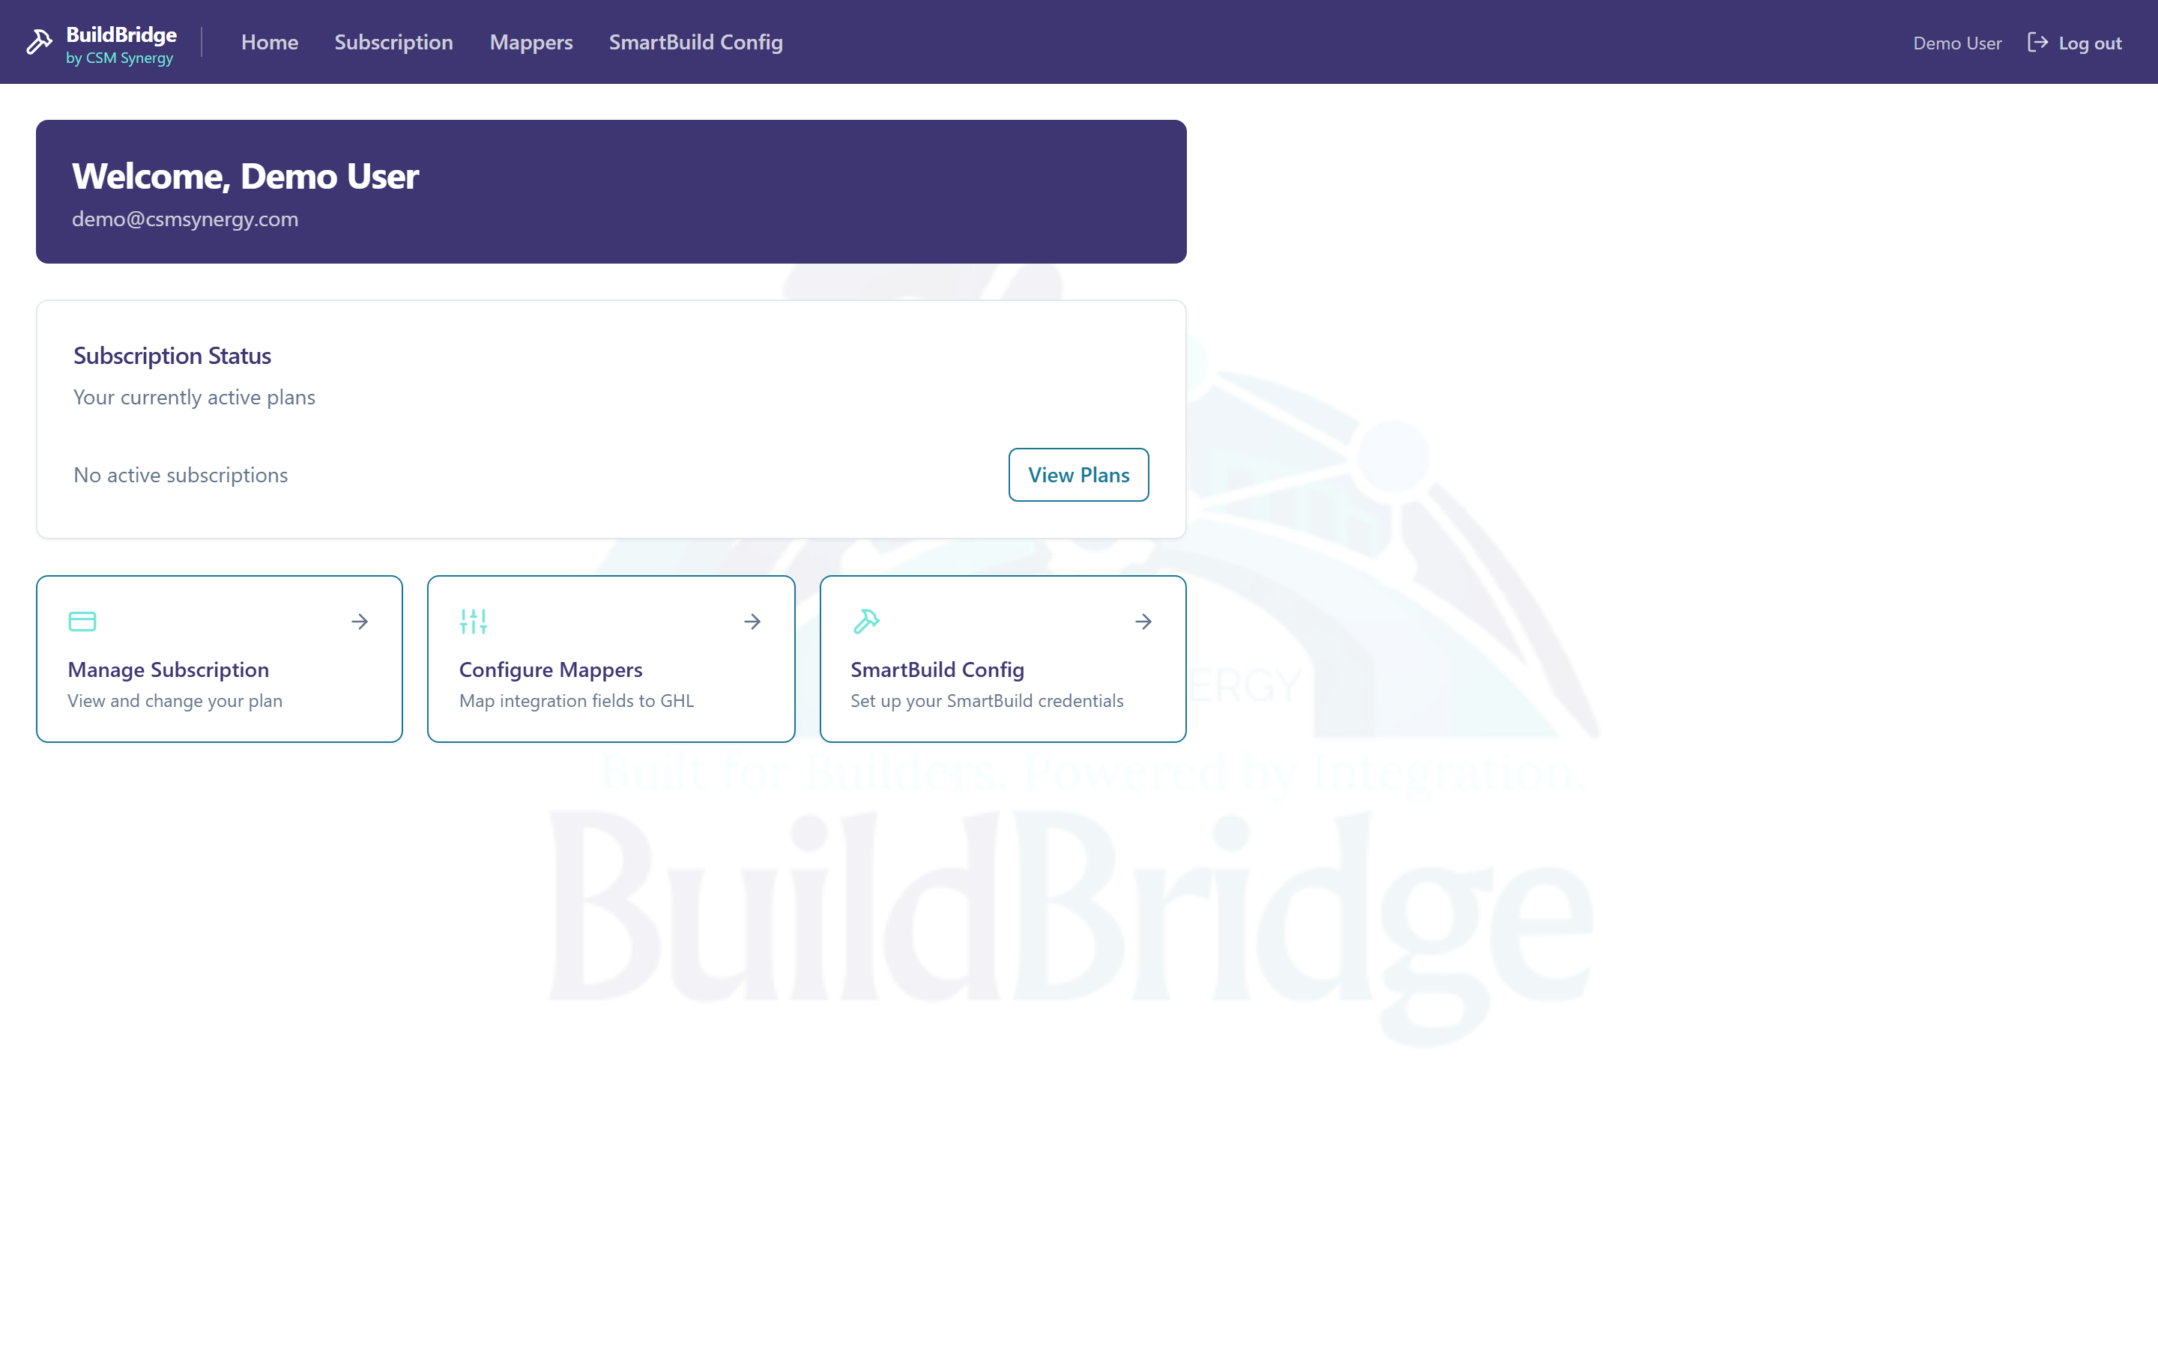
Welcome banner, subscription-status card, and quick-link cards to the three configuration areas, over a subtle BuildBridge watermark.

Subscription
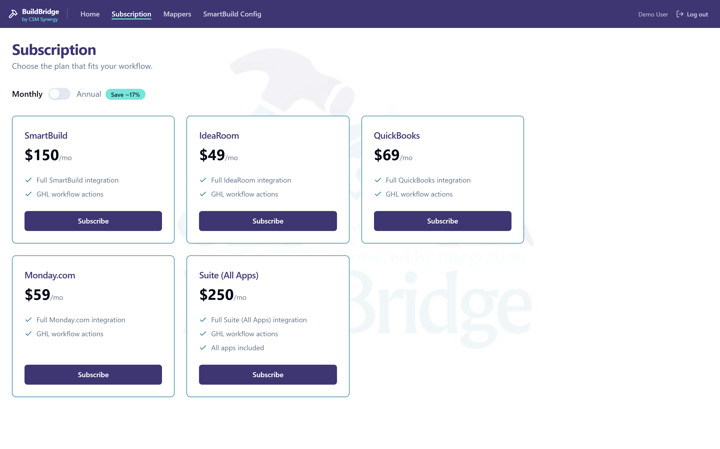
Plan selection with a monthly/annual toggle and per-app pricing cards, populated with live seeded data (SmartBuild, IdeaRoom, QuickBooks, Monday.com, Suite).

SmartBuild Config
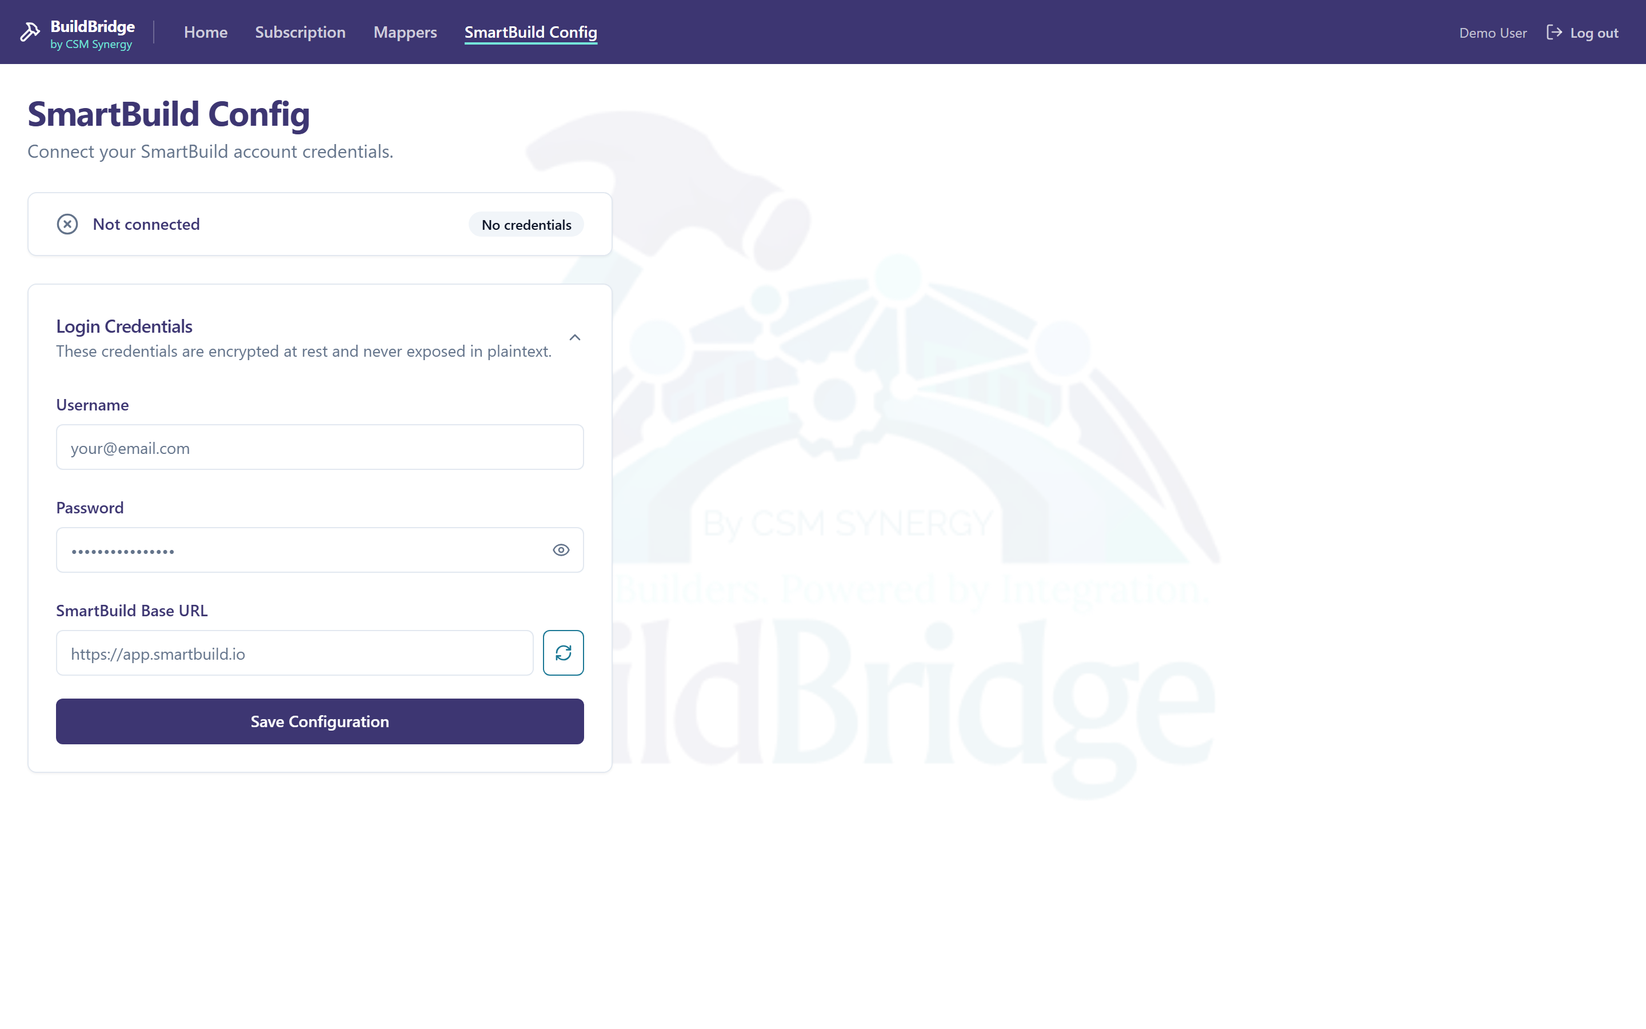
Connect a SmartBuild account (username / password / base URL). Credentials are encrypted at rest; a status indicator and "Test connection" validate them before saving.

Mappers
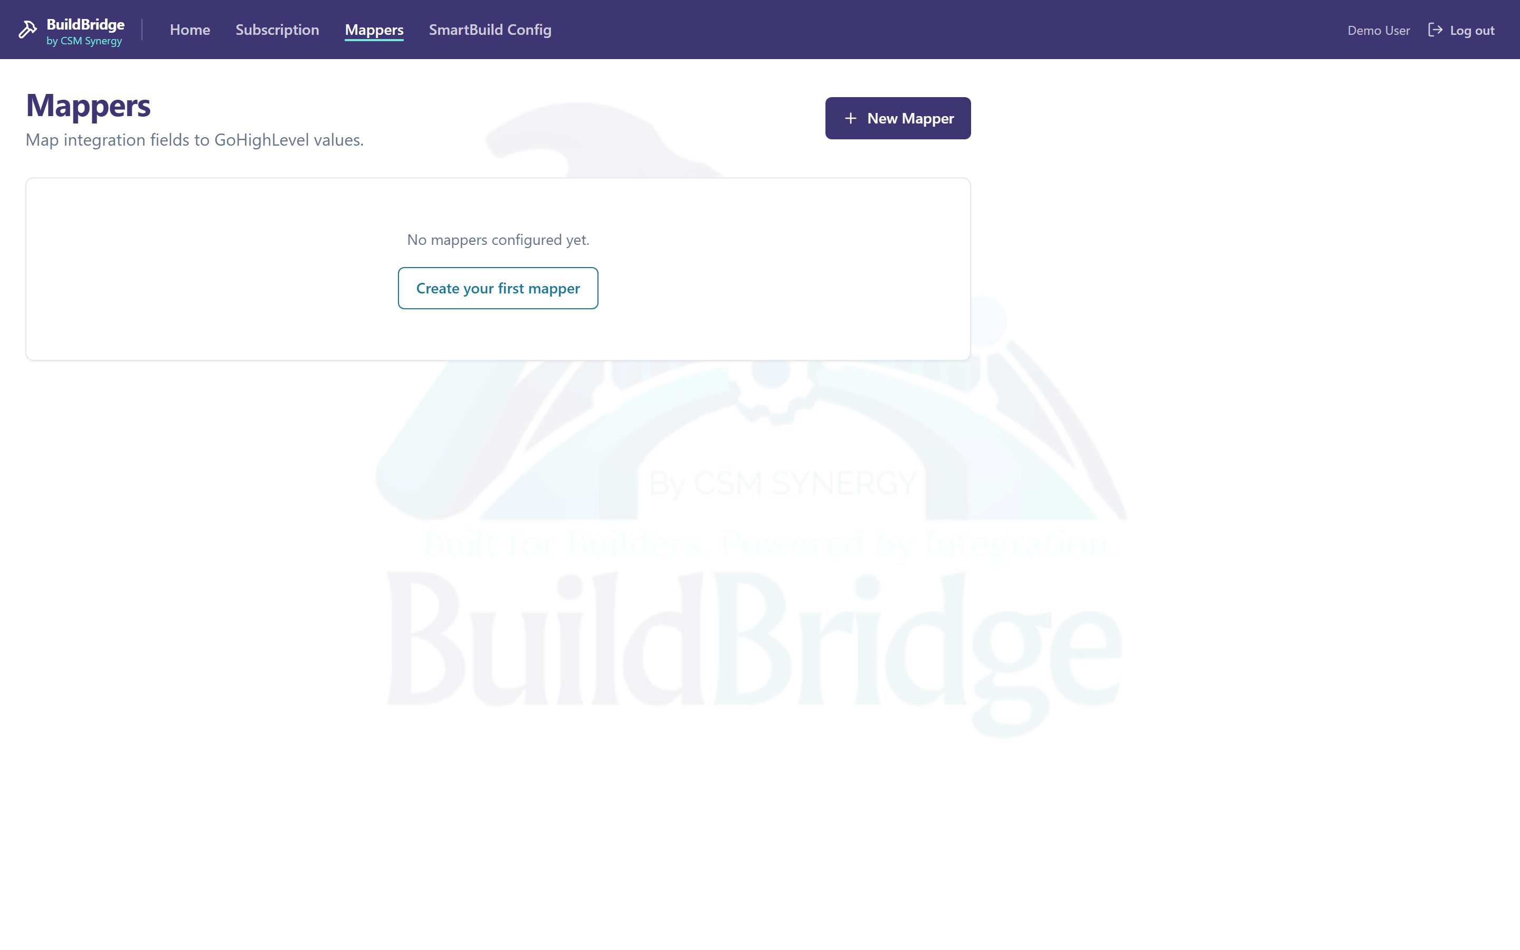
CRUD interface for mapping integration fields to GoHighLevel values, signed-in with a clean empty state.

5. Running It Locally
The repository is cloned at D:\CSM Synergy\buildbridge. Both tiers run with Node 20+.
Backend (Express API)
- npm install in the repo root
- Copy .env.example -> .env and fill values (a valid 64-hex ENCRYPTION_KEY is required)
- npm start (loads dotenv via src/index.js)
Note: the Docker entrypoint src/start.js checks env vars before dotenv loads — that is for Railway, which injects env directly. For local dev use npm start, not node src/start.js.
Frontend (Vite SPA)
- cd frontend && npm install
- npm run dev -> http://localhost:5173/buildbridge/ (proxies /api, /auth, /webhooks to the backend)
Database & integrations
- Point DATABASE_URL at PostgreSQL, then npm run migrate and npm run seed
- OAuth, billing, and SmartBuild flows require real GHL / Deposyt / SmartBuild credentials
State of this walkthrough's run
The backend and frontend were started successfully (backend moved to port 3100 because port 3000 was occupied by another local Next.js app). A local PostgreSQL 18 instance was provisioned, migrated, and seeded with the 10 starter plans; a valid session was used so the authenticated screens render live data. /health returns {"status":"ok"}, the authenticated API returns all 10 plans, and protected routes return 401 without a session — all as expected.
Local-dev note: src/core/db/client.js was given a one-line tweak to skip SSL for localhost database URLs (remote Supabase still uses SSL). This is uncommitted and only enables local Postgres.
Current gaps / notes
- actionsController.updateOpportunity and one getMappers handler are placeholder stubs.
- Vitest is configured but no test files exist yet.
- README is a single line; this document is intended to fill that gap.

