**CS550 Advanced Operating Systems**​

**Programming Assignment 3**

​

**Evaluation**

**Experiment-2**

**Amazon Aws**

**submitted by:**

Chiranjeevi Ankamreddy

A20359837

The assignment carries out Evaluation of the Decentralized Indexing server and Peer server on 10k operations run on Amazon AWS..

I’ve evaluated the time taken to **Register ,Search** operations on a Indexing server a single node ,two nodes ,four nodes and eight running concurrently over **10k** operations.

And Evaluated the time taken to **Obtain** Files on a Peer server a single node ,two nodes ,four nodes and eight running concurrently over 10k operations. And File Size is **100 kB.**

**1. Register:**

***single node:*** ​The time taken to Register 10k Files on a single node at is 2066 **millisecs**​.

Two  ***nodes :*** ​ The time taken to Register 10k Files on each of 2 nodes is :

node 1 ­ 3963millisecs

node 2 ­ 4252 millisecs

Average time taken by a node to Register 10k Files is : 3963+4252/2

=​ **4107 millisecs**

***Four nodes :*** ​ The time taken to Register 10k Files on each of four nodes is :

node 1 ­ 5571 millisecs

node 2 ­ 5591 millisecs

node 3- 4722 millisecs

node 4- 5791millisecs

Average time taken by a node to Register 10k Files is:5571+5591+4722+5791/4

=5418  **millisecs**

***Eight nodes :*** ​ The time taken to Register 10k Files on each of Eight nodes is :

node 1 ­ 6902 millisecs

node 2 ­ 6569 millisecs

node 3- 6703 millisecs

node 4 ­ 6069 millisecs

node 5 ­ 6489 millisecs

node 6- 6187millisecs

node 7 ­ 6255 millisecs

node 8 ­ 6894 millisecs

Average time taken by a node to Register 10k Files is: 6902+6569+6703+6069+6489+6187+6255+6894 /8= 6508.5 **millisecs**

**Average time taken for a single node per Register 10k Files : 2.066 secs**

**Average time taken for two concurrent nodes per Register 10k Files : 4.107 secs**

**Average time taken for four concurrent nodes per Register 10k Files : 5.418 secs**

**Average time taken for a eight concurrent nodes per Register 10k Files :6.5085 secs**

**PLOT FOR REGISTER :**

**X­axis : nodes**

**Y­Axis : time (secs)**

**C:\Users\Chiru\Downloads\Untitled Diagram (1).png**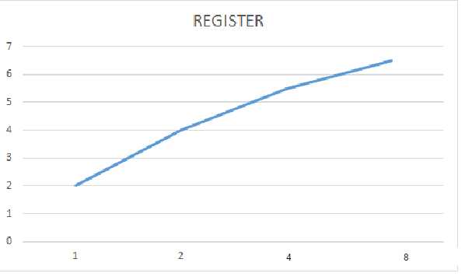

**C:\Users\Chiru\Downloads\Untitled Diagram.png**

**2. SEARCH :**

***single node:*** ​The time taken to Search 10k Files on a single node at is 1199**millisecs**​.

Two  ***nodes :*** ​ time taken to Search 10k Files on each of 2 nodes is :

node 1 ­ 3036millisecs

node 2 ­ 3158 millisecs

Average time taken by a node to Search 10k Files is : 3036+3158/2

=​ **3097 millisecs**

***Four nodes :*** ​Time taken to Search 10k Files on each of four nodes is :

node 1 ­ 5026millisecs

node 2 - 4216millisecs

node 3- 4385millisecs

node 4- 4531millisecs

Average time taken by a node to make Search 10k Files is 5026+4216+4385+4531/4= 4539.5 **millisecs**

***Eight nodes :*** ​Time taken to Search 10k Files on each of Eight nodes is :

node 1 ­ 5348millisecs

node 2 ­4937 millisecs

node 3- 5145millisecs

node 4 ­ 4825millisecs

node 5 ­ 4756 millisecs

node 6- 5132millisecs

node 7 ­ 5248millisecs

node 8 ­ 5388 millisecs

Average time taken by a node to Search 10k Files is /8=  **5097.6 millisecs**

**Average time taken for a single nodes per 10k Search Files : 1.199secs**

**Average time taken for two concurrent nodes per 10k Search Files : 3.0972 secs**

**Average time taken for four concurrent nodes per 10k Search Files : 4.5385secs**

**Average time taken for a eight concurrent nodes per 10k Search Files : 5.0966secs**

**PLOT FOR SEARCH:**

**X­axis : nodes**

**Y­axis : time (secs)**

**C:\Users\Chiru\Downloads\Untitled Diagram (1).png**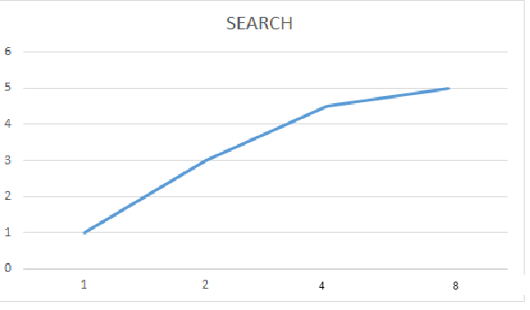

C:\Users\Chiru\Downloads\Untitled Diagram.png

**3. Obtain:**

***single node:*** ​The time taken to obtain 10k Files at a single node at is ​ **102 secs**.​

***two nodes :*** ​ Time taken to obtain 10k Files at 2 nodes concurrently i.e., 20k files on both nodes is :

node 1 ­ 112 secs

node 2 ­ 134 secs

Average time taken by a node to obtain 10k Files is :112+124 /2

=​ **123 secs**

***Four nodes :*** ​Time taken to obtain 10k Files on each of four nodes is :

node 1 ­ 148 secs

node 2 ­ 164 secs

node 3- 158 secs

node 4- 176 secs

Average time taken by a node to obtain 10k Files is : 148+164+158+176/4= 161  **secs**

***Eight nodes :*** ​Time taken to obtain 10k Files on each of Eight nodes is :

node 1 ­ 163secs

node 2 ­ 179secs

node 3- 191 secs

node 4 ­ 182 secs

node 5 ­ 218 secs

node 6- 238 secs

node 7 ­ 224secs

node 8 ­ 212secs

Average time taken by a node to obtain 10k Files is  **200.8secs**

**Average time taken for a single node to obtain 10k Files : 102 secs**

**Average time taken for two concurrent nodes to obtain 10k Files : 123 secs**

**Average time taken for four concurrent nodes to obtain 10k Files : 161.5secs**

**Average time taken for a eight concurrent nodes to obtain 10k Files: 200.8 secs**

**PLOT FOR OBTAIN:**

**X­axis : nodes**

**Y­axis : time(secs)**

C:\Users\Chiru\Downloads\Untitled Diagram (1).png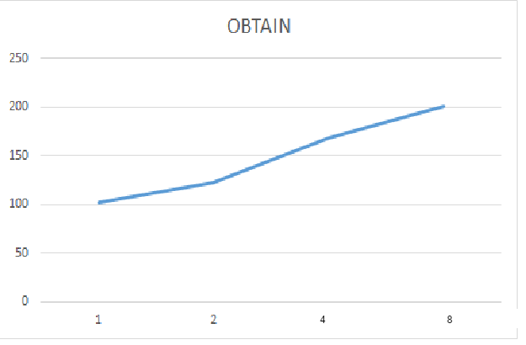

C:\Users\Chiru\Downloads\Untitled Diagram.png

**Conclusion:**

Here,we have evaluated register,search and obtain the files of size 100Kb.and it runs on Amazon aws cloud over 10K files on each server.As the number of nodes increases,time to register will increases in DIS, and search is increases initially because IN DHT, it runs on core uses maximum speed. And obtaining file is also uses maximum core speed.