**CS550 Advanced Operating Systems**​

**Programming Assignment 3**

​

**Evaluation**

**Experiment-2**

**Amazon AWS cloud**

**submitted by:**

Chiranjeevi Ankamreddy

A20359837

The assignment carries out Evaluation of the Decentralized Indexing server and Peer server on 10k operations and runs Amazon Aws Cloud.

I’ve evaluated the time taken to **Register ,Search** operations on a Indexing server a single node ,two nodes ,four nodes and eight running concurrently over **10k** operations.

And Evaluated the time taken to **Obtain** Files on a Peer server a single node ,two nodes ,four nodes and eight running concurrently over 10k operations. And File Size is **10KB.**

**1. Register:**

***single node:*** ​The time taken to Register 10k Files on a single node at is 2066 **millisecs**​.

Two  ***nodes :*** ​ The time taken to Register 10k Files on each of 2 nodes is :

node 1 ­ 3963millisecs

node 2 ­ 4252 millisecs

Average time taken by a node to Register 10k Files is : 3963+4252/2

=​ **4107 millisecs**

***Four nodes :*** ​ The time taken to Register 10k Files on each of four nodes is :

node 1 ­ 5571 millisecs

node 2 ­ 5591 millisecs

node 3- 4722 millisecs

node 4- 5791millisecs

Average time taken by a node to Register 10k Files is:5571+5591+4722+5791/4

=5418  **millisecs**

***Eight nodes :*** ​ The time taken to Register 10k Files on each of Eight nodes is :

node 1 ­ 6902 millisecs

node 2 ­ 6569 millisecs

node 3- 6703 millisecs

node 4 ­ 6069 millisecs

node 5 ­ 6489 millisecs

node 6- 6187millisecs

node 7 ­ 6255 millisecs

node 8 ­ 6894 millisecs

Average time taken by a node to Register 10k Files is: 6902+6569+6703+6069+6489+6187+6255+6894 /8= 6508.5 **millisecs**

**Average time taken for a single node per Register 10k Files : 2.066 secs**

**Average time taken for two concurrent nodes per Register 10k Files : 4.107 secs**

**Average time taken for four concurrent nodes per Register 10k Files : 5.418 secs**

**Average time taken for a eight concurrent nodes per Register 10k Files :6.5085 secs**

**PLOT FOR REGISTER :**

**X­axis : nodes**

**Y­Axis : time (secs)**

**C:\Users\Chiru\Downloads\Untitled Diagram (1).png**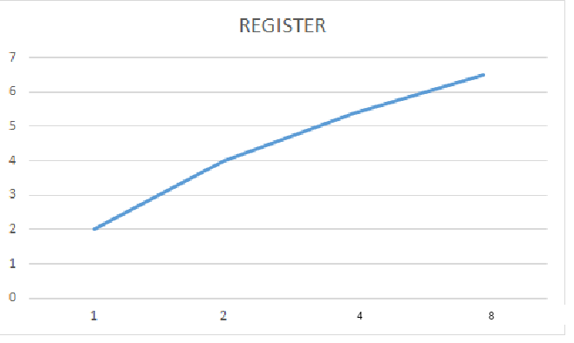

**C:\Users\Chiru\Downloads\Untitled Diagram.png**

**2. SEARCH :**

***single node:*** ​The time taken to Search 10k Files on a single node at is 1199**millisecs**​.

Two  ***nodes :*** ​ time taken to Search 10k Files on each of 2 nodes is :

node 1 ­ 3036millisecs

node 2 ­ 3158 millisecs

Average time taken by a node to Search 10k Files is : 3036+3158/2

=​ **3097 millisecs**

***Four nodes :*** ​Time taken to Search 10k Files on each of four nodes is :

node 1 ­ 5026millisecs

node 2 - 4216millisecs

node 3- 4385millisecs

node 4- 4531millisecs

Average time taken by a node to make Search 10k Files is 5026+4216+4385+4531/4= 4539.5 **millisecs**

***Eight nodes :*** ​Time taken to Search 10k Files on each of Eight nodes is :

node 1 ­ 5348millisecs

node 2 ­4937 millisecs

node 3- 5145millisecs

node 4 ­ 4825millisecs

node 5 ­ 4756 millisecs

node 6- 5132millisecs

node 7 ­ 5248millisecs

node 8 ­ 5388 millisecs

Average time taken by a node to Search 10k Files is /8=  **5097.6 millisecs**

**Average time taken for a single nodes per 10k Search Files : 1.199secs**

**Average time taken for two concurrent nodes per 10k Search Files : 3.0972 secs**

**Average time taken for four concurrent nodes per 10k Search Files : 4.5385secs**

**Average time taken for a eight concurrent nodes per 10k Search Files : 5.0966secs**

**PLOT FOR SEARCH:**

**X­axis : nodes**

**Y­axis : time (secs)**

**C:\Users\Chiru\Downloads\Untitled Diagram (1).png**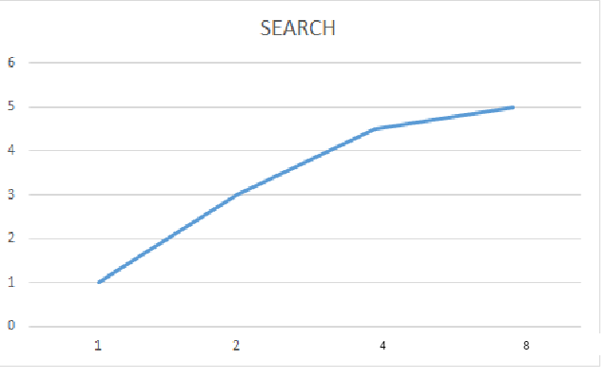

C:\Users\Chiru\Downloads\Untitled Diagram.png

**3. Obtain:**

***single node:*** ​The time taken to obtain 10k Files at a single node at is ​ **300345 millisecs**.​

***two nodes :*** ​ Time taken to obtain 10k Files at 2 nodes concurrently i.e., 20k files on both nodes is :

node 1 ­ 314458 millisecs

node 2 ­ 300898millisecs

Average time taken by a node to obtain 10k Files is : 314458+300898 /2

=​ **307678 millisecs**

***Four nodes :*** ​Time taken to obtain 10k Files on each of four nodes is :

node 1 ­ 319874 millisecs

node 2 ­ 334587 millisecs

node 3- 302156millisecs

node 4- 325478millisecs

Average time taken by a node to obtain 10k Files is : 319874/4=  **320523.75millisecs**

***Eight nodes :*** ​Time taken to obtain 10k Files on each of Eight nodes is :

node 1 ­ 294578 millisecs

node 2 ­ 325426 millisecs

node 3- 301475millisecs

node 4 ­ 335472 millisecs

node 5 ­ 298147millisecs

node 6- 314567 millisecs

node 7 ­ 345876millisecs

node 8 ­ 354782 millisecs

Average time taken by a node to obtain 10k Files is 294578+325426+301475+335472+298147+314567+345876+354782 /8=  **321290.375millisecs**

**Average time taken for a single node to obtain 10k Files : 300.345 secs**

**Average time taken for two concurrent nodes to obtain 10k Files : 307.678 secs**

**Average time taken for four concurrent nodes to obtain 10k Files : 320.523secs**

**Average time taken for a eight concurrent nodes to obtain 10k Files: 321.290 secs**

**PLOT FOR OBTAIN:**

**X­axis : nodes**

**Y­axis : time(secs)**

**C:\Users\Chiru\Downloads\Untitled Diagram (1).png 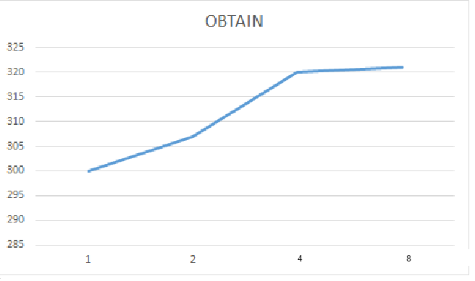C:\Users\Chiru\Downloads\Untitled Diagram.png**

**Conclusion:**

Here,we have evaluated register,search and obtain the files of size 10Kb.and it runs on Amazon aws cloud over 10k files on each server.As the number of nodes increases,time to register will increases in DIS, and search is increases initially because IN DHT, it runs on core uses maximum speed. And obtaining file is also uses maximum core speed.