**CS550 Advanced Operating Systems**​

**Programming Assignment 3**

​

**Evaluation**

**Experiment-2**

**Amazon Aws**

**submitted by:**

Chiranjeevi Ankamreddy

A20359837

The assignment carries out Evaluation of the Decentralized Indexing server and Peer server on 100 operations run on Amazon Aws.

I’ve evaluated the time taken to **Register ,Search** operations on a Indexing server a single node ,two nodes ,four nodes and eight running concurrently over **100** operations.

And Evaluated the time taken to **Obtain** Files on a Peer server a single node ,two nodes ,four nodes and eight running concurrently over 100 operations. And File Size is **100MB.**

**1. Register:**

***single node:*** ​The time taken to Register 100 Files on a single node at is 39**millisecs**​.

Two  ***nodes :*** ​ The time taken to Register 100 Files on each of 2 nodes is :

node 1 ­ 47millisecs

node 2 ­ 54 millisecs

Average time taken by a node to Register 100 Files is :

=​ **50.5millisecs**

***Four nodes :*** ​ The time taken to Register 100 Files on each of four nodes is :

node 1 ­ 57 millisecs

node 2 ­65 millisecs

node 3- 72 millisecs

node 4- 78millisecs

Average time taken by a node to Register 100 Files is:/4=  **68millisecs**

***Eight nodes :*** ​ The time taken to Register 100 Files on each of Eight nodes is :

node 1 ­ 87 millisecs

node 2 ­ 74 millisecs

node 3- 96 millisecs

node 4 ­ 88millisecs

node 5 ­ 79 millisecs

node 6- 1004 millisecs

node 7 ­ 114millisecs

node 8 ­ 129millisecs

Average time taken by a node to Register 100 Files is: /8=  **96millisecs**

**Average time taken for a single node per Register 100 Files : 39 millisecs**

**Average time taken for two concurrent nodes per Register 100 Files : 50 millisecs**

**Average time taken for four concurrent nodes per Register 100 Files : 38 millisecs**

**Average time taken for a eight concurrent nodes per Register 100 Files : 96 millisecs**

**PLOT FOR REGISTER :**

**X­axis : nodes**

**Y­Axis : time (millisecs)**

C:\Users\Chiru\Downloads\Untitled Diagram (1).png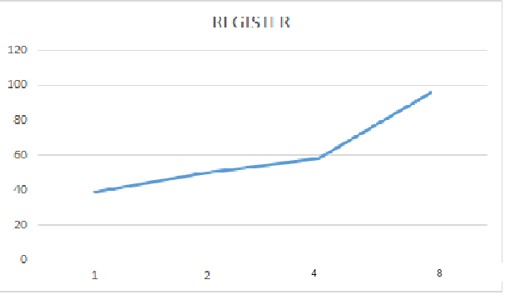

C:\Users\Chiru\Downloads\Untitled Diagram.png

**2. SEARCH :**

***single node:*** ​The time taken to Search 100 Files on a single node at is 49 **millisecs**​.

Two  ***nodes :*** ​ time taken to Search 100 Files on each of 2 nodes is :

node 1 ­ 58 millisecs

node 2 ­ 62millisecs

Average time taken by a node to Search 100 Files is : /2

=​ **60millisecs**

***Four nodes :*** ​Time taken to Search 100 Files on each of four nodes is :

node 1 ­ 67 millisecs

node 2 -69 millisecs

node 3- 74 millisecs

node 4- 81millisecs

Average time taken by a node to make Search 100 Files is /4=  **72.75millisecs**

***Eight nodes :*** ​Time taken to Search 100 Files on each of Eight nodes is :

node 1 ­ 53 millisecs

node 2 ­ 61millisecs

node 3- 77millisecs

node 4 ­ 87millisecs

node 5 ­ 81 millisecs

node 6- 94millisecs

node 7 ­ 98millisecs

node 8 ­ 117 millisecs

Average time taken by a node to Search 100 Files is 83.5  **millisecs**

**Average time taken for a single nodes per 100 Search Files : 49millisecs**

**Average time taken for two concurrent nodes per 100 Search Files : 60 millisecs**

**Average time taken for four concurrent nodes per 100 Search Files :72 millisecs**

**Average time taken for a eight concurrent nodes per 100 Search Files :83.5 millisecs**

**PLOT FOR SEARCH:**

**X­axis : nodes**

**Y­axis : time (millisecs)**

C:\Users\Chiru\Downloads\Untitled Diagram (1).png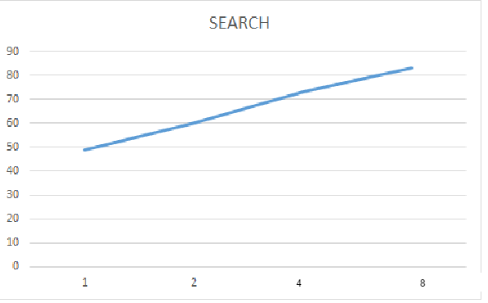

C:\Users\Chiru\Downloads\Untitled Diagram.png

**3. Obtain:**

***single node:*** ​The time taken to obtain 100 Files at a single node at is ​ **334 secs**.​

***two nodes :*** ​ Time taken to obtain 100 Files at 2 nodes concurrently i.e., 200k files on both nodes is :

node 1 ­ 284secs

node 2 ­ 349secs

Average time taken by a node to obtain 100 Files is :

=​ **316millisecs**

***Four nodes :*** ​Time taken to obtain 100 Files on each of four nodes is :

node 1 ­ 384secs

node 2 ­ 329secs

node 3- 341secs

node 4- 364 secs

Average time taken by a node to obtain 100 Files is :/4=  **354.5secs**

***Eight nodes :*** ​Time taken to obtain 100 Files on each of Eight nodes is :

node 1 ­ 412secs

node 2 ­ 384secs

node 3- 364secs

node 4 ­ 373secs

node 5 ­ 347secs

node 6- 398secs

node 7 ­ 424secs

node 8 ­402secs

Average time taken by a node to obtain 100 Files is /8=  **388secs**

**Average time taken for a single node to obtain 100 Files : 334secs**

**Average time taken for two concurrent nodes to obtain 100 Files : 316secs**

**Average time taken for four concurrent nodes to obtain 100 Files : 354secs**

**Average time taken for a eight concurrent nodes to obtain 100 Files: 388secs**

**PLOT FOR OBTAIN:**

**X­axis : nodes**

**Y­axis : time(millisecs)**

**C:\Users\Chiru\Downloads\Untitled Diagram (1).png**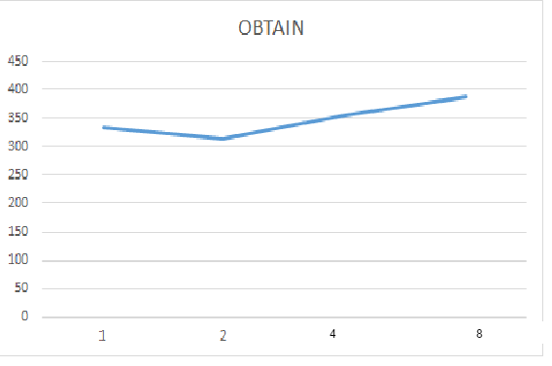

C:\Users\Chiru\Downloads\Untitled Diagram.png