**CS550 Advanced Operating Systems**​

**Programming Assignment 3**

​

**Evaluation**

**Experiment-2**

**AMAZON AWS**

**submitted by:**

Chiranjeevi Ankamreddy

A20359837

The assignment carries out Evaluation of the Decentralized Indexing server and Peer server on 100k operations runs on Amazon aws .

I’ve evaluated the time taken to **Register ,Search** operations on a Indexing server a single node ,two nodes ,four nodes and eight running concurrently over **100k** operations.

And Evaluated the time taken to **Obtain** Files on a Peer server a single node ,two nodes ,four nodes and eight running concurrently over 100k operations. And File Size is **1KB.**

**1. Register:**

***single node:*** ​The time taken to Register 100k Files on a single node at is 38476 **millisecs**​.

Two  ***nodes :*** ​ The time taken to Register 100k Files on each of 2 nodes is :

node 1 ­ 42982millisecs

node 2 ­ 39476millisecs

Average time taken by a node to Register 100k Files is : 42982+39476/2

=​ **41299millisecs**

***Four nodes :*** ​ The time taken to Register 100k Files on each of four nodes is :

node 1 ­ 36745 millisecs

node 2 ­ 39874 millisecs

node 3- 41759 millisecs

node 4- 44572millisecs

Average time taken by a node to Register 100k Files is:36745+39874+41759+44572/4= 40737 **millisecs**

***Eight nodes :*** ​ The time taken to Register 100k Files on each of Eight nodes is :

node 1 ­ 41278 millisecs

node 2 ­ 45782 millisecs

node 3- 43571 millisecs

node 4 ­ 39451 millisecs

node 5 ­ 46716 millisecs

node 6- 48732 millisecs

node 7 ­ 45937 millisecs

node 8 ­ 43759 millisecs

Average time taken by a node to Register 100k Files is:41278+45782+43571+39451+46716+48732+45937+43759 /8=  **44385millisecs**

**Average time taken for a single node per Register 100k Files : 38.476 secs**

**Average time taken for two concurrent nodes per Register 100k Files : 41.299 secs**

**Average time taken for four concurrent nodes per Register 100k Files : 40.737secs**

**Average time taken for a eight concurrent nodes per Register 100k Files : 44.385 secs**

**PLOT FOR REGISTER :**

**X­axis : nodes**

**Y­Axis : time (secs)**

C:\Users\Chiru\Downloads\Untitled Diagram (1).png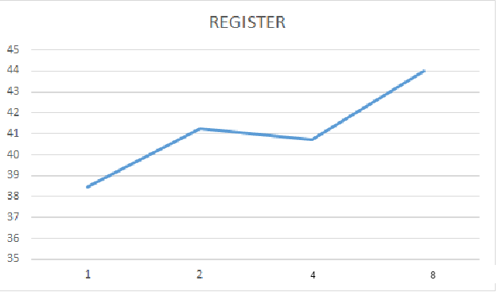

C:\Users\Chiru\Downloads\Untitled Diagram.png

**2. SEARCH :**

***single node:*** ​The time taken to Search 100k Files on a single node at is 18746 **millisecs**​.

Two  ***nodes :*** ​ time taken to Search 100k Files on each of 2 nodes is :

node 1 ­ 16782 millisecs

node 2 ­ 20213 millisecs

Average time taken by a node to Search 100k Files is :16782+20213 /2

=​18497.6 **millisecs**

***Four nodes :*** ​Time taken to Search 100k Files on each of four nodes is :

node 1 ­ 19783 millisecs

node 2 -22458 millisecs

node 3- 20924millisecs

node 4- 24788 millisecs

Average time taken by a node to make Search 100k Files is 19783+22458+20924+24788/4= 21988  **millisecs**

***Eight nodes :*** ​Time taken to Search 100k Files on each of Eight nodes is :

node 1 ­ 24785 millisecs

node 2 ­ 27456 millisecs

node 3- 22458 millisecs

node 4 ­ 23564millisecs

node 5 ­ 27853 millisecs

node 6- 28634millisecs

node 7 ­ 31245millisecs

node 8 ­ 28635millisecs

Average time taken by a node to Search 100k Files is 24785+27456+22458+23564+27853+28634+31245+28635/8= 268287 **millisecs**

**Average time taken for a single nodes per 100k Search Files : 18.746secs**

**Average time taken for two concurrent nodes per 100k Search Files : 18.497 secs**

**Average time taken for four concurrent nodes per 100k Search Files : 21.988 secs**

**Average time taken for a eight concurrent nodes per 100k Search Files : 26.82secs**

**PLOT FOR SEARCH:**

**X­axis : nodes**

**Y­axis : time (secs)**

**C:\Users\Chiru\Downloads\Untitled Diagram (1).png**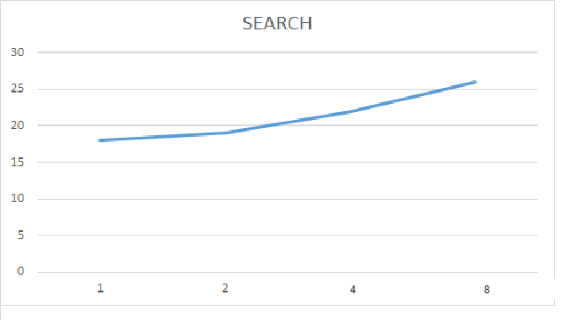

C:\Users\Chiru\Downloads\Untitled Diagram.png

**3. Obtain:**

***single node:*** ​The time taken to obtain 100k Files at a single node at is ​ **3954623millisecs**.​

***two nodes :*** ​ Time taken to obtain 100k Files at 2 nodes concurrently i.e., 200k files on both nodes is :

node 1 ­ 3547821 millisecs

node 2 ­ 3854265 millisecs

Average time taken by a node to obtain 100k Files is 3547821+3854265 /2

=​  **3701043 millisecs**

***Four nodes :*** ​Time taken to obtain 100k Files on each of four nodes is :

node 1 ­ 4126752 millisecs

node 2 ­ 4427863 millisecs

node 3- 4725368millisecs

node 4- 4359762 millisecs

Average time taken by a node to obtain 100k Files is :4126752+4427836+47253654+4359762/4= 4409936  **millisecs**

***Eight nodes :*** ​Time taken to obtain 100k Files on each of Eight nodes is :

node 1 ­ 4235762 millisecs

node 2 ­ 4687325 millisecs

node 3- 4968234 millisecs

node 4 ­ 5314762 millisecs

node 5 ­ 5129326millisecs

node 6- 4756284millisecs

node 7 ­ 5142542millisecs

node 8 ­ 5478562 millisecs

Average time taken by a node to obtain 100k Files for 8 nodes is =4934099  **millisecs**

**Average time taken for a single node to obtain 100k Files : 3954millisecs**

**Average time taken for two concurrent nodes to obtain 100k Files : 3701 secs**

**Average time taken for four concurrent nodes to obtain 100k Files : 4409secs**

**Average time taken for a eight concurrent nodes to obtain 100k Files: 4934 millisecs**

**PLOT FOR OBTAIN:**

**X­axis : nodes**

**Y­axis : time(millisecs)**

**C:\Users\Chiru\Downloads\Untitled Diagram (1).png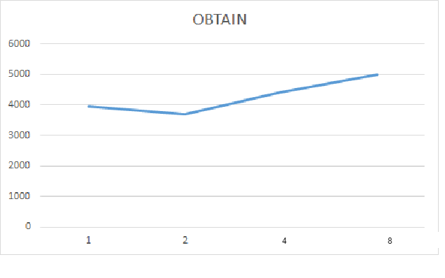C:\Users\Chiru\Downloads\Untitled Diagram.png**

**Conclusion:**

Here,we have evaluated register, search and obtain the files of size 1kb.and it runs on Amazon aws cloud over 100k files operations on each server.As the number of nodes increases,time to register will increases in DIS, and search is increases initially because IN DHT, it runs on core uses maximum speed. And obtaining file is also uses maximum core speed.In DHT,all the server uses maximum efficiency.