**CS550 Advanced Operating Systems**

**Programming Assignment 3**

​**Output**

Submitted by:

Chiranjeevi Ankamredy

A20359837

The output generated at every step of execution is explained below with screen shots .

1. **IndexingServer Initialization:**

When a server is started , And client connected to the server .Here we have give port in server code. Server awaits requests and created a thread to the peer. And All the 8 indexing servers should be initiated.Here,we are connecting to the server port 5555.

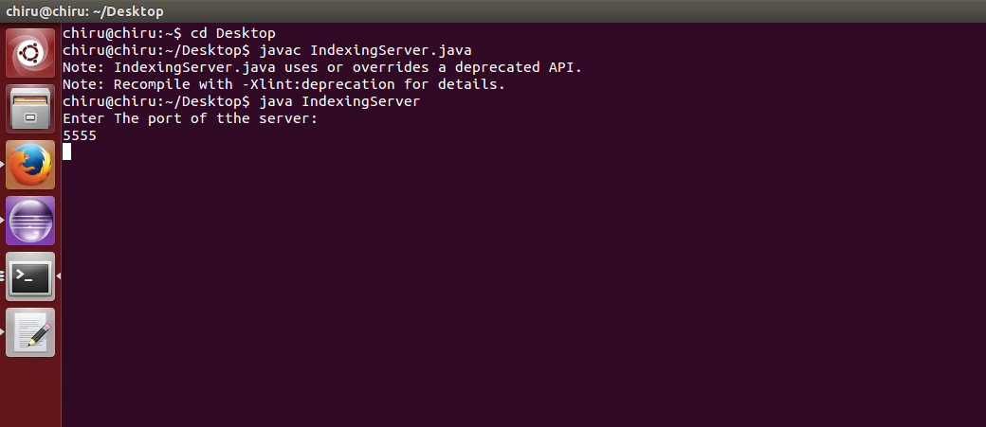

1. **PeerClient Connections:**

When a Client connects it to the server it does by the selecting the node to connect to and multiple clients can connect to a single indexing server. In the figure below, one client connect to the server at port 5555.

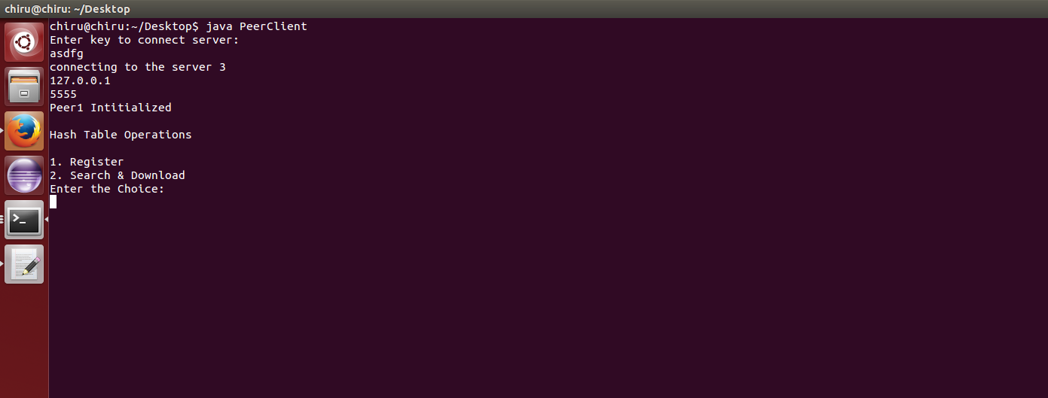

1. **Client Operations:**

​The Client connected to indexing server does Register the files, Search the file in all eight indexing server(Decentralized Indexing Server) and select the file location server and Download the file from that selected Peer Server .

In the figure below, it displays operations Register, search and Download. And select the choice.



1. **Register operation :**

When a client does a Register operation , the file is hashed and a node(indexingserver) is selected and file-File Details(key­value pair) is registred at the hash table on that indexing server. and successful register returns Success .

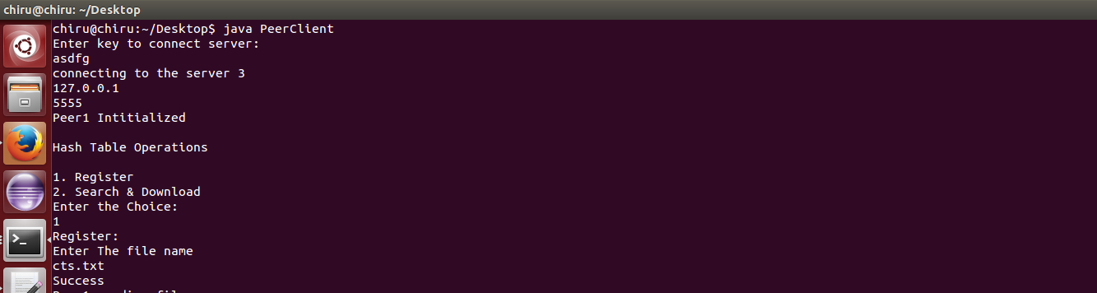

Register operation also returns “Success” on storing the File and filevaluea in Hash table, In case if the connect to the server on which the operation is made is lost .

**e.Replication**

**1.Peerclient**

When a client does a Register operation , the file is hashed and a node(indexingserver) is selected and file-File Details(key­value pair) is registred at the hash table on that indexing server. and successful register returns Success. Then,Peerclient will send the File to the next peerserver (neighbor node) and neighbor peer will register the file in indexing server.

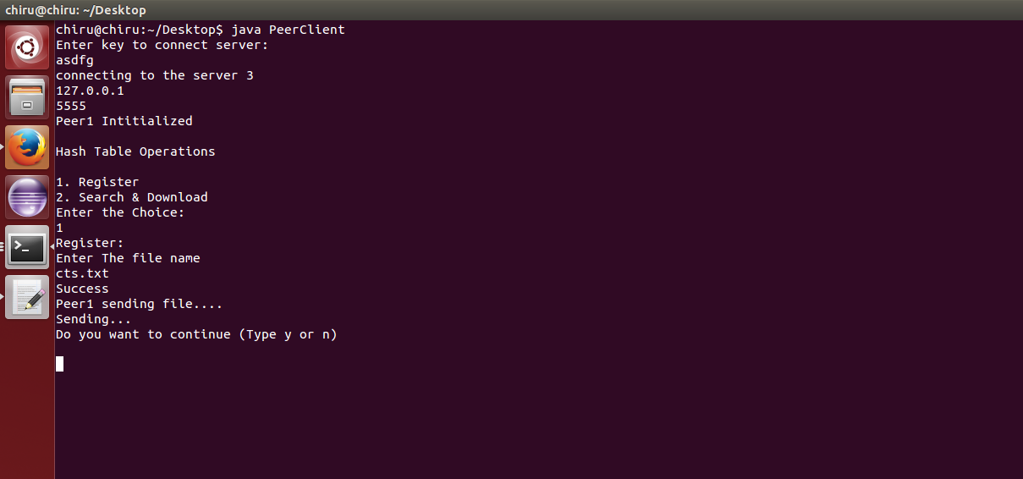

**2.Peer server Initilizaton**

When a Peer server is started , And client connected to the server to send replica data or download file .Here we have give port in server code. Server awaits requests and created a thread to the peer. And All the 8 peer servers should be initiated. Here,we are connecting to the server port 6666.

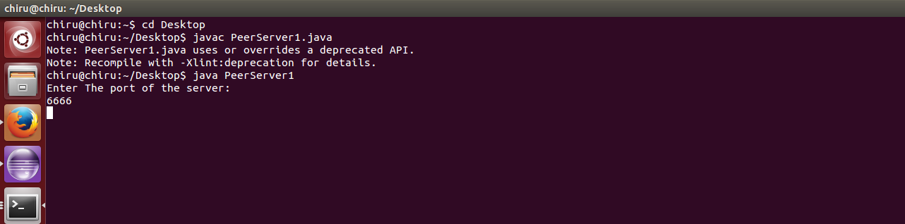

Now, Depends on client request,it will do upload replica file or send the file to the client.Her, replica file uploaded in peerserver.

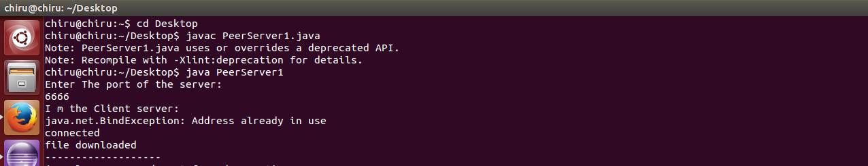

**f.Search operation:**

The client does the get operation by selecting 2 on the users console and gets a value for the file information by entering the File Name. And it returns file information.

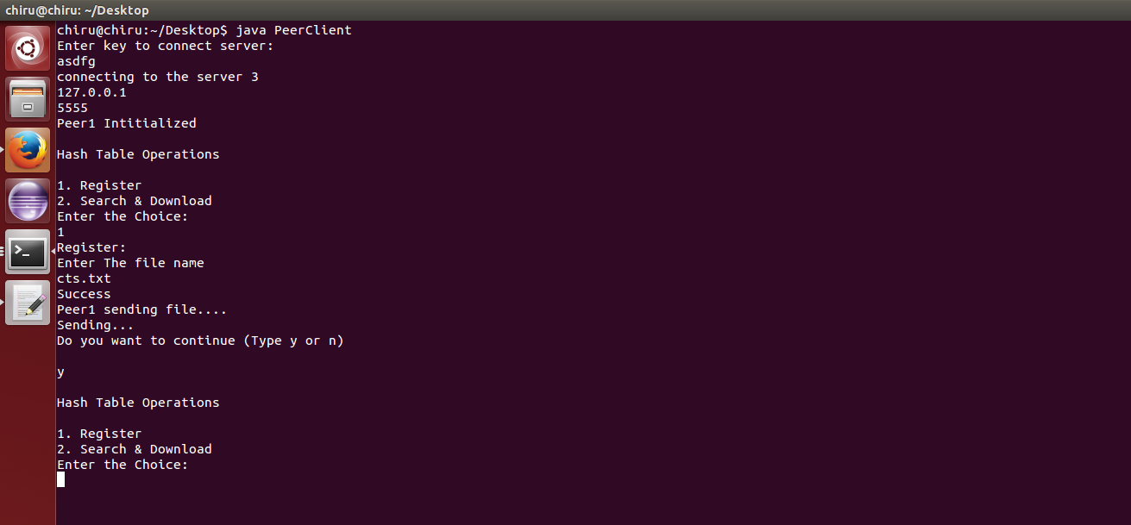

Now,Select choice 2.

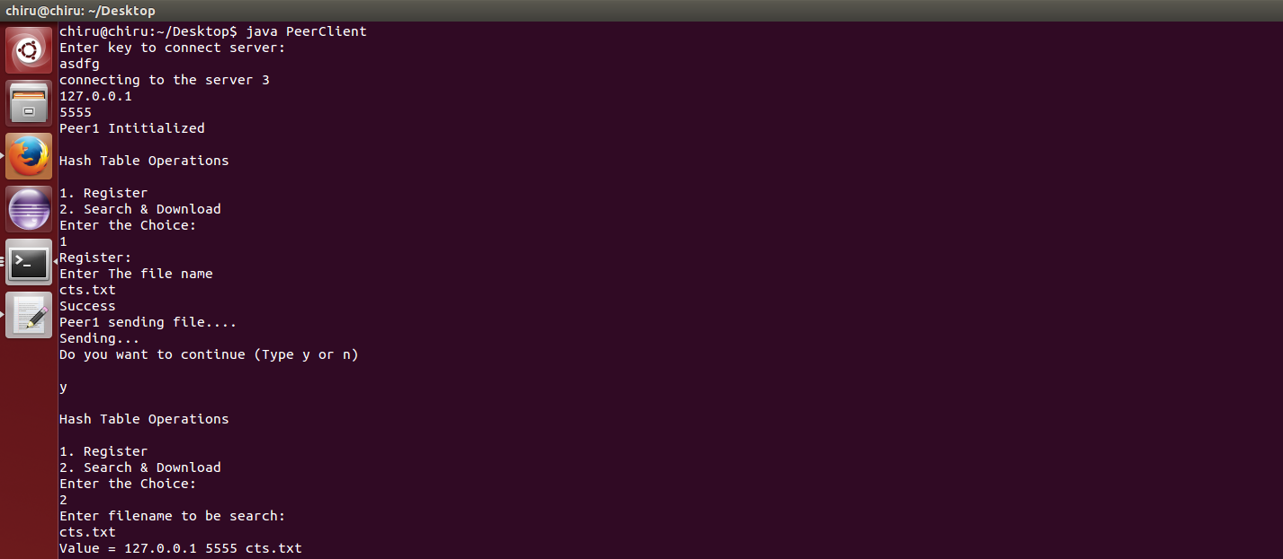

**g.DOWNLOAD operation**

After Getting the File information, Peer client will connect to the peerserver(Fileinfo) and download the file.

Text file:

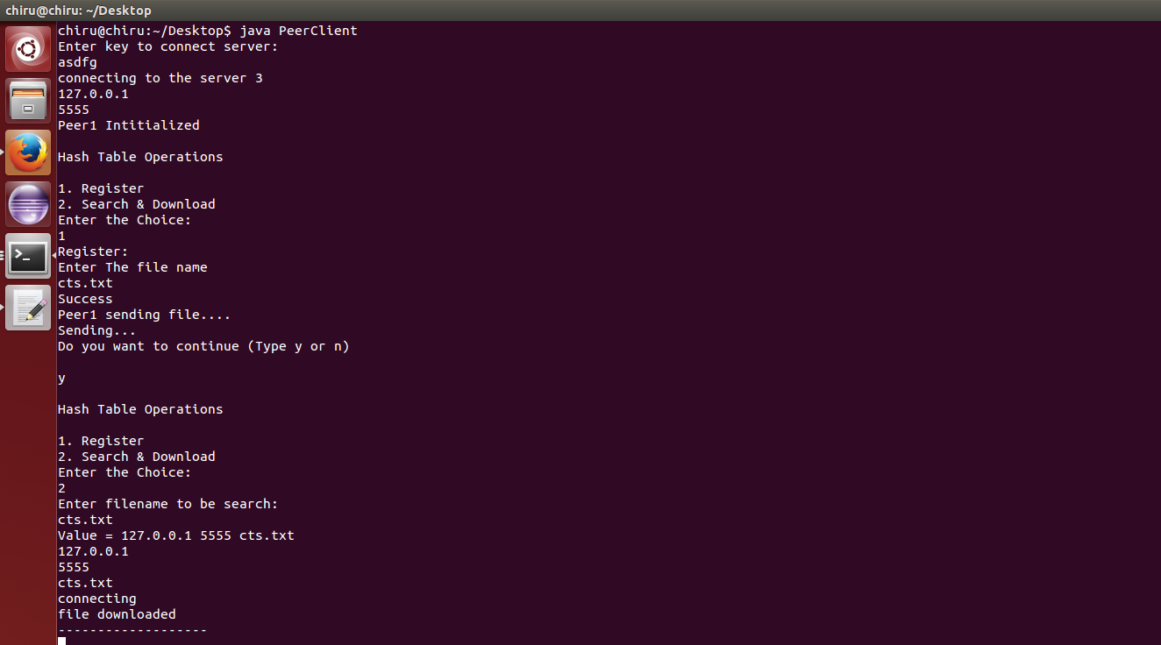

Binary File:

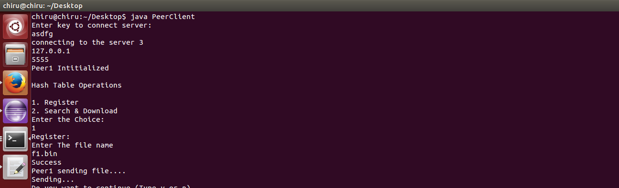

If the file that is searched for is not at any of the indexing servers that client is connected to, “Invalid Key” message is returned to the client.



**h.Exit Client**

If the client exits or shuts down connection by enter ‘n’ on the console .

**i.List of 8 servers**

The Following sequence in config file.

127.0.0.1 2222

127.0.0.1 3333

127.0.0.1 4444

127.0.0.1 5555

127.0.0.1 6666

127.0.0.1 7777

127.0.0.1 8888

127.0.0.1 9999

For replication, Each node will connect to the next node and send the file to the next node. Whenever neighbor node connects to the index server, it will register all the files in his Directory.