**CS550 Advanced Operating Systems**

**Programming Assignment 3**

**​**

**Manual**

Submitted by:

Chiranjeevi Ankamreddy

A20359837

The assignment is done is Java and run through ANT build file. ANT is used to automate the execution of the program.

Here are three Main Classes to be executed.

**PA3**

* PeerServer1.java
* IndexingServer.java
* PeerClient.java

**EVALUATION**

* EvaluationPeerClient.java
* EvaluationIndexingserver.java
* EvaluationServer1.java

Execution:

The program is run through ANT build file in the project CS550PA3/build/ folder.

To execute the program in Linux systems.

First Open terminal and navigate to the build directory containing build.xml

and run the command **ant -buildfile build.xml**

you are prompted on terminal with “BUILD SUCCESSFUL”.

To execute the three programs follow:

1. **Executing PeerServer1**

**PeerServer1 program can be executed with Replication:**

Here, Assign the port in the server side code(Peerserver1.java).There are 8 servers, The ports of each server are 2222,3333,4444,5555,6666,7777,8888,9999.It essentially executes the PeerServer1.java program

After Executing the Peerserver1.java,it will create a thread for each peer.

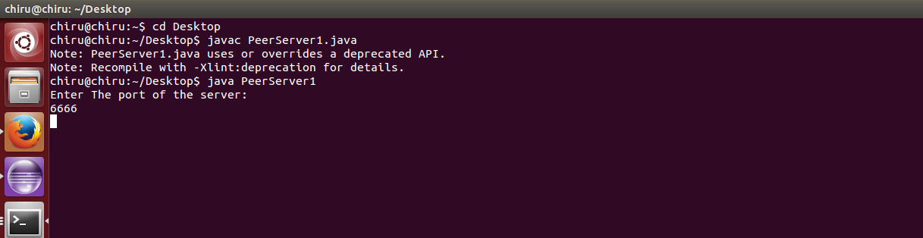

2. **Executing IndexingServer**

**IndexingServer program can be executed with Replication:**

Here, Assign the port in the server side code(Indexingserver.java).There are 8 servers, The ports of each server are 2222,3333,4444,5555,6666,7777,8888,9999.It essentially executes the IndexingServer.java program

After Executing the Indexingserver.java,it will create a thread for each peer.

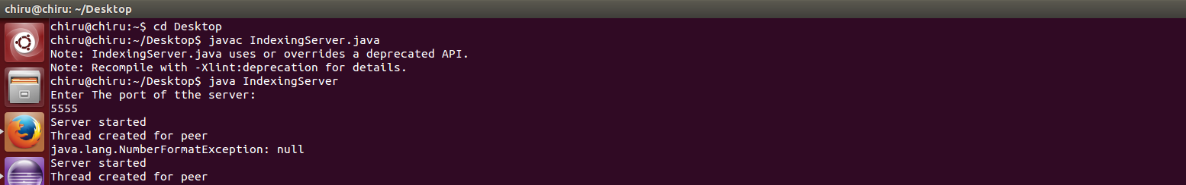

3. **Executing PeerClient**

To run the PeerClient program first navigate to the build directory in the project folder and then run the command “ant runPeerClient” . It builds the PeerClient.jar source files and prompts

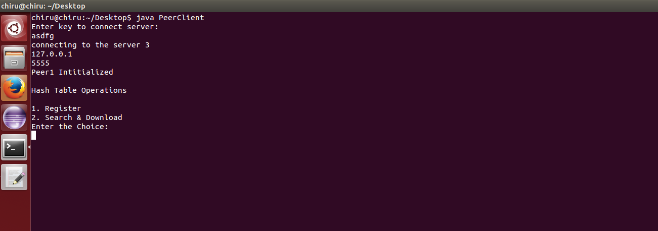

**For Register operation :**

* **Enter 1**

**you’re prompted to give key (Keys are Strings)._**

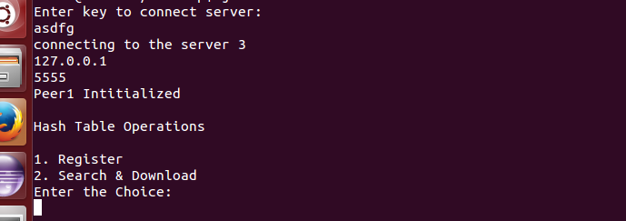

**For Search and Download Operation :**

* **Enter 2**

**you’re prompted to give key (Keys are Strings)._**

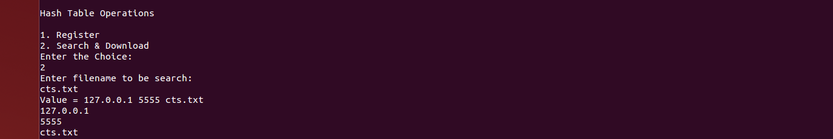

**For Download:**

* **Enter 2**

**you’re prompted to give key (Keys are Strings).**

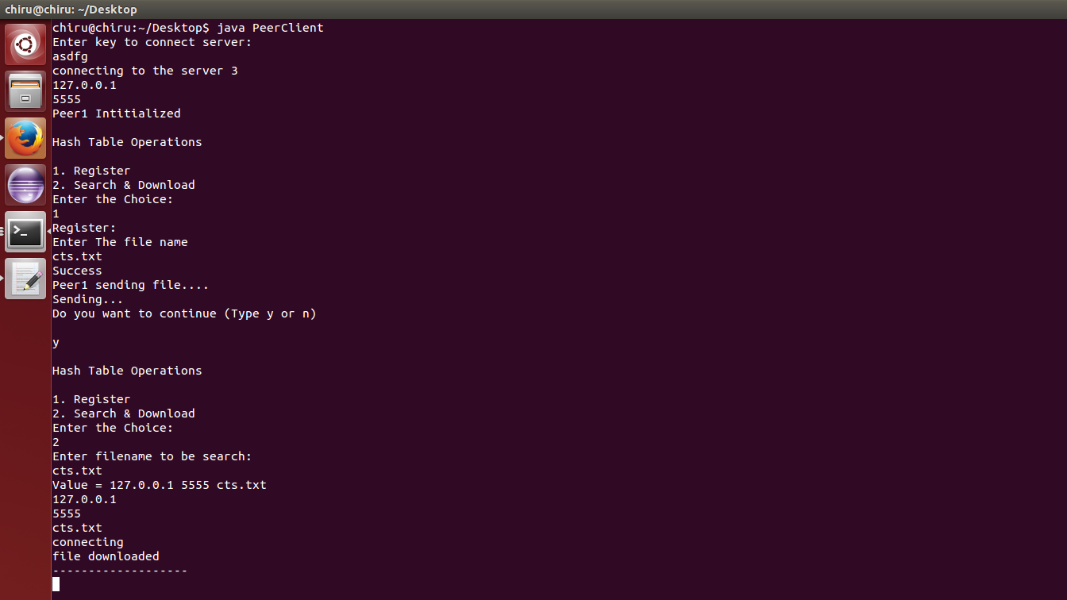

**For exit :**

* **Enter n**

**3 Executing Evaluation**

To evaluate the performance, first execute PeerServer using the command mentioned above and then

run command ant - runEvaluation. It builds the Evaluation.jar (EvaluationPeerserver1.java) source files.

And execute IndexingServer using the command mentioned above and then run command ant - runEvaluation. It builds the Evaluation.jar (EvaluationIndexingserver.java) source files.

And run the each client side program as shown below:

Run the EvaluationPeerClient.java