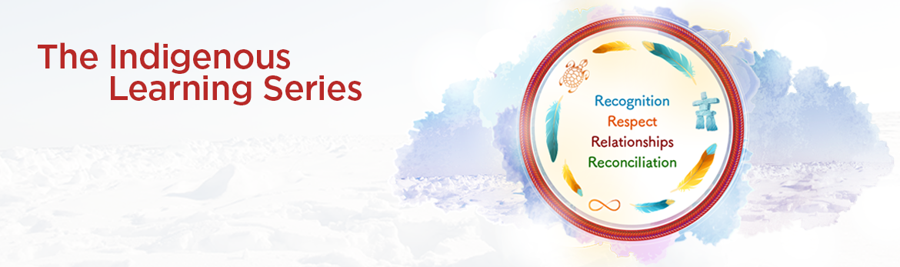

**YOUR JOURNAL TOWARDS RECONCILIATION**

#### Self-reflection

**MODULE 2 –** **The Uncomfortable Truth**

1. **Why is it problematic that Europeans said that Indigenous people were not “civilized”? How do you think this has influenced current stereotypes and prejudices towards Indigenous peoples today?**
2. **If the land was never really the Government of Canada’s to claim, what does Canada as a nation actually mean?**
3. **In the work you do, can you think of when you should or could consult with Indigenous communities?**
4. **What do you think about Indian hospitals and sanitariums? How do these government decisions make you feel?**
5. **Why do you think Dr. Bryce was removed from his position? After this report, how could the Government of Canada continue running Indian Residential Schools for another 69 years?**
6. **How do you think these traumatic experiences impact individuals, families and communities?**
7. **What do these court cases mean for the Government of Canada? How can public service employees better respect the rights of Indigenous peoples and the obligations of the Government of Canada?**
8. **How can you use the 10 Principles in your role as a public service employee?**