

1. Jaden is a 40-year-old man who has the job title of aerodrome controller. His job is to issue clearances for flights to take-off and land, as well as provide routes for planes to taxi safely. He describes his job as challenging and mentally draining as he has to keep track of multiple planes at any given time. Jaden is 1 of 3 aerodrome controllers and has to take breaks often to maintain his level of quality on the job. He frequently uses technology such as GPS, Radar, and weather indicating machines to help him to do his job and acknowledges the importance of them. Jaden is very comfortable with his job as he has done it for many years. Jaden often finds it frustrating when obstacles on the runway are present as he has to send the information to an independent organisation to see if the runway is available and finds it time-consuming.



2. Jane is a 20-year old female who works as an approach controller. Her job is to put planes that are approaching to land in an efficient sequence, and control planes flying past the airport airspace. To do Jane’s job she needs to be able to communicate well, have strong problem-solving skills, and work effectively under pressure. Jane also constantly works with technology to be able to do her job such as GPS and Radar. Jane is relatively new to her job and has a desire to learn more about her job and how she can be better at it. Jane describes it as extremely frustrating when obstacles on the runway are present as she needs to change the sequence of multiple planes and often finds other runways being more congested consequently causing delays.



3. Gemma is a 55-year-old colour-blind woman who works as an independent calculator to verify the runway parameters specified by the Civil Aviation Authority (CAA). As a colour-blind woman, she often finds it difficult to see certain colours which results in her using certain applications wrong. She highly appreciates when an application considers colour-blindness. As a calculator, Gemma has very strong problem-solving skills and has been doing her job for a very long time. She is not very tech-savvy and her job doesn’t require the use of complicated technology. She has a good relationship with other calculators as she spends a lot of time working with them and has developed good communication skills. Gemma often finds herself doing calculations she knows are redundant so she wants people to develop software so she doesn’t have to calculate unnecessarily. 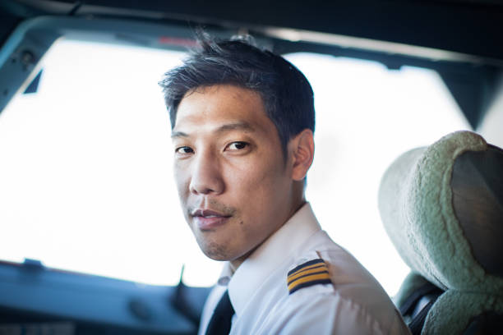

Dong Young-bae is a 36 year old pilot working for a budget airline. He recently received his qualifications to become a pilot and got a job at a low-cost, short-haul airline. While he enjoys his work, the airline is quite demanding, and he has to frequently fly the legally mandated maximum number of hours per month. Due to frequent delays, he also often works overtime, which he finds exhausting. He finds runway obstructions especially challenging, as hovering over airfields is a very stressful task due to the air traffic being the most significant above airports. He also cannot use most automated technologies, as maintaining the aircraft above a small region is quite difficult, and his planes don’t have the technology to do it.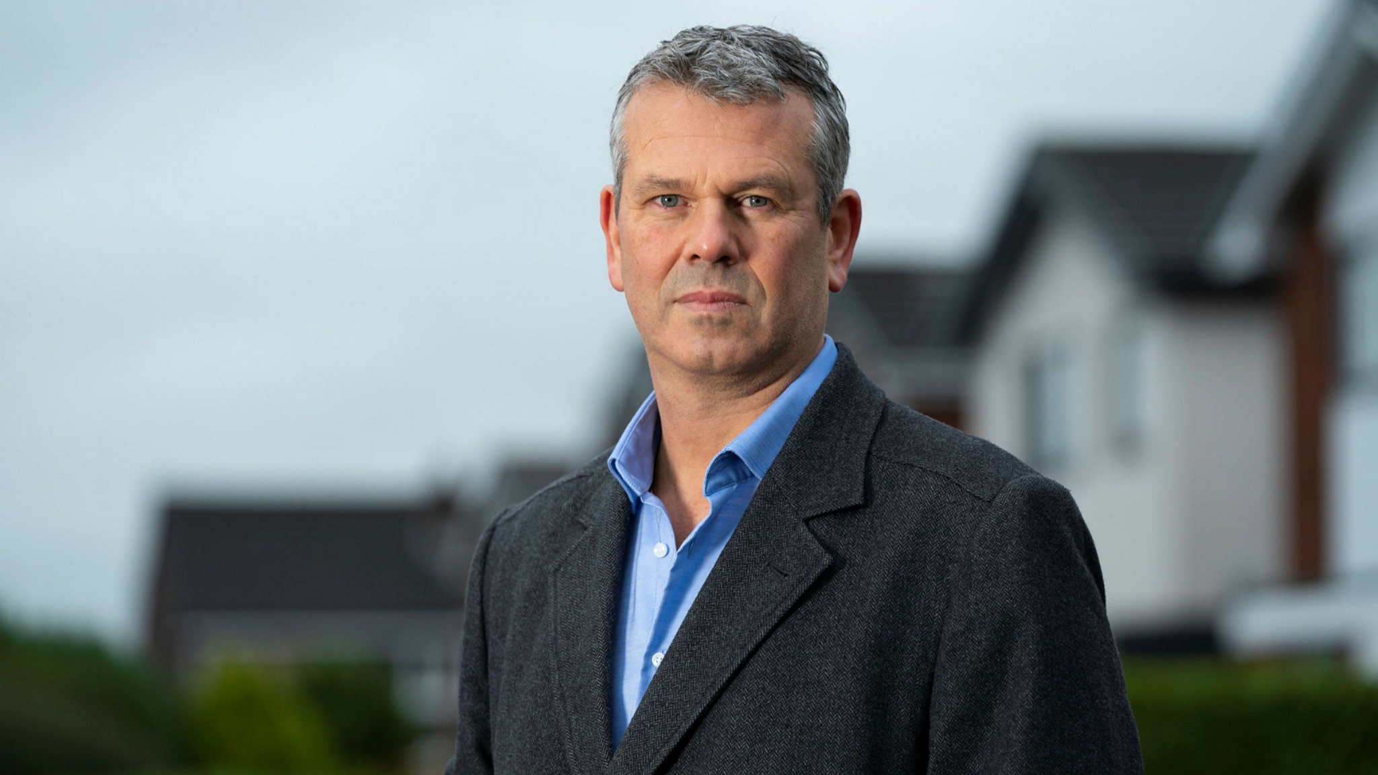

David Williams is a successful 53 year old airport operations manager at a large airfield. He has worked in this field his whole life and has held the position of manager for over a decade. He runs his business profitably, but runway obstructions always cause a lot of stress as his airport operates at full capacity. The delays and salaries paid to qualified calculators also have a large effect on profit margins. He wishes to find a quicker and cheaper way to handle possible obstructions on runways to increase overall profits and shareholder revenue.

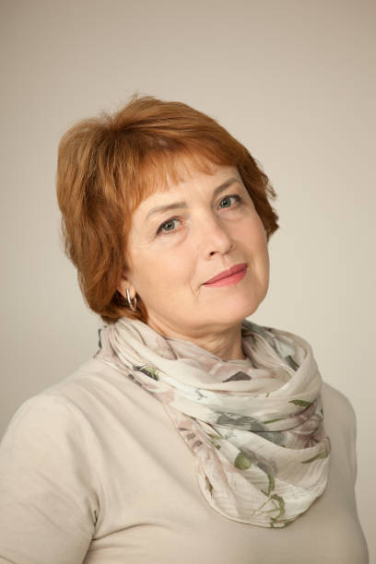

Jane Turner is a 60 year old employee at the CAA. Her job is to consider aircraft technology and to come up with the least obstructive regulations that ensure the safety of passengers and crew on commercial flights. As technology changes, she needs to periodically look at current aircraft advancements to calculate the minimum distances aircrafts need to take off and land. She also has to consider the distances aircrafts need for these purposes in case of obstructions on runways. These changes, however, often draw complaints from airlines and airport management, as implementing these changes is difficult, costly, and time-consuming. She also fears that the time it takes to implement these changes may cause airports to operate in an unsafe manner for significant amounts of time.