**COMP2211**

**Deliverable 2 - Project Envisioning Report Group 23**

Andrew Sansum (ajs2g20@soton.ac.uk)

Patrik-Tibor Csanyi (ptc1g20@soton.ac.uk)

Guillaume Comet-Vernet (gcv1u20@soton.ac.uk)

Madhav Muralikrishnan (mkm1g20@soton.ac.uk)

Adam Clarke (ac4g20@soton.ac.uk)

David Stefanov (ds1u20@soton.ac.uk)

**Introduction**

In the first increment of the coursework our main plan was to set up the projects (windows, scenes) as well as create classes that take user input, calculate the requested values, and display these to the user. Furthermore, we also planned on implementing a basic visualisation with very little functionality. We have succeeded with most of these tasks. The only goal that was unachieved is to provide basic functionality to the visualisation. While it is present, and the object is proportional to the given input, no indicators have yet been placed.

This would be the purpose of the next increment: implement all the indicators, as well as create the scene for displaying both visualisations at the same time, if we have enough time in the next increment. There are other low priority tasks, such as: giving notifications to user whenever data changes, calculation steps displayed on request, and automatically rotate runway to the direction indicated in its name.

Below are some notes regarding the project and report:

The logbook contains all the feedback we received from our supervisor since the last submission. It also includes how we considered and implemented the feedback received.

The backlog section displays our progress in the first sprint, while the second sprint backlog displays not only the tasks originally meant for the second increment, but also the tasks we failed to complete in this sprint, as we deemed that all of these can/should be done in the next sprint.

**UML**

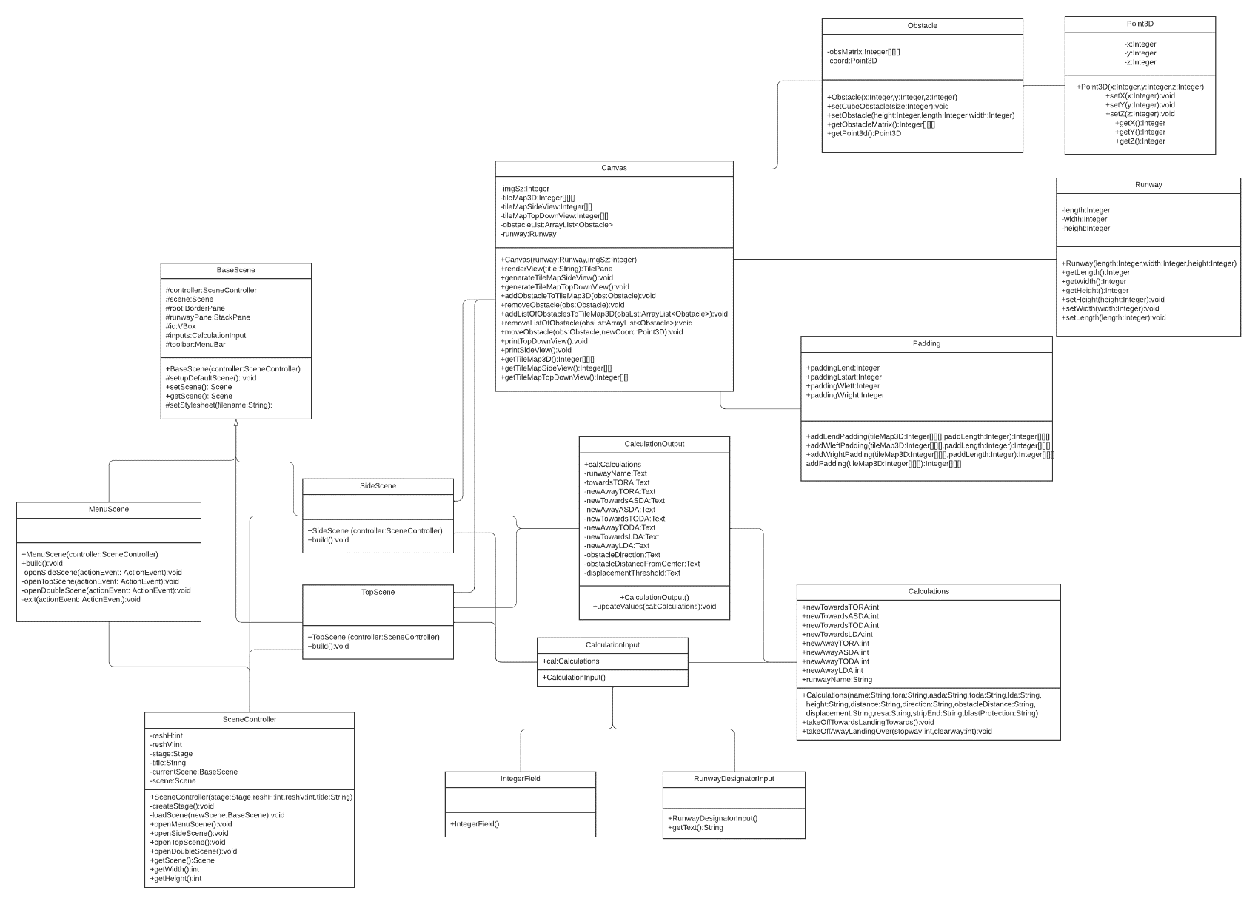1. Class Diagram:

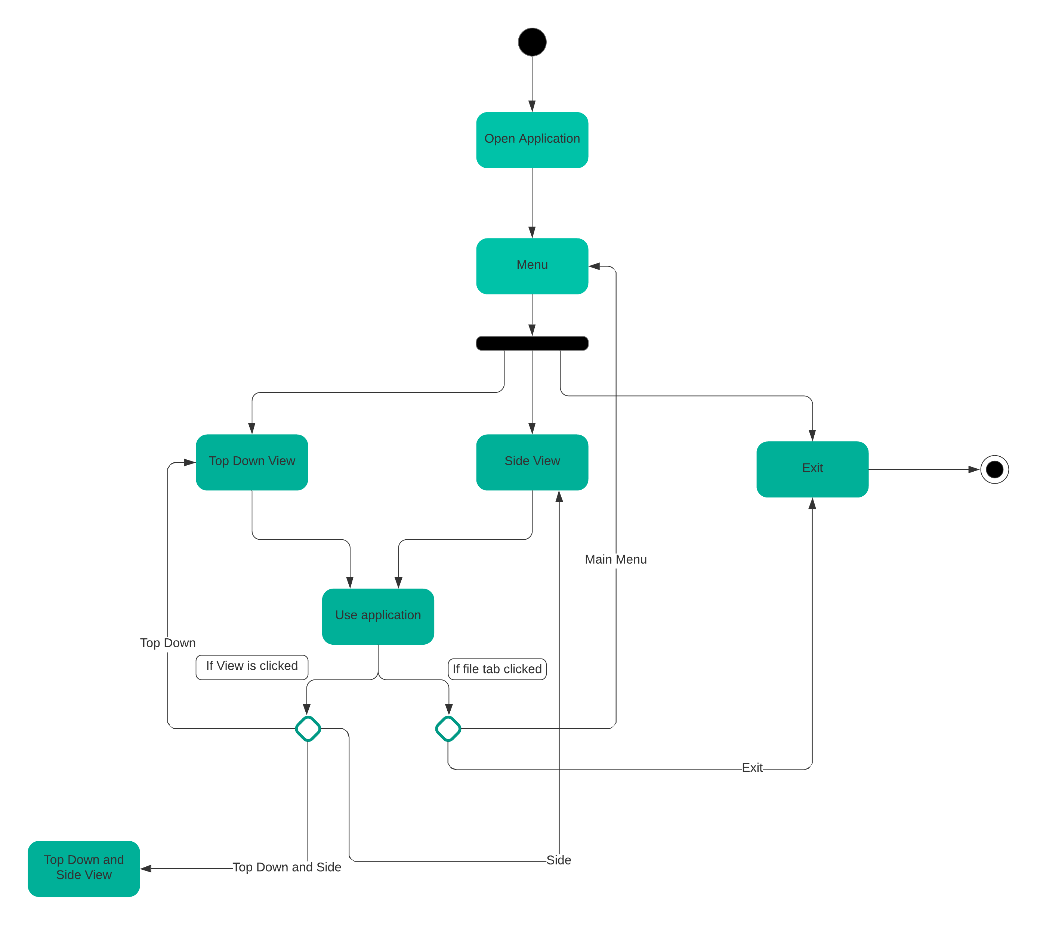2. Activity Diagram:

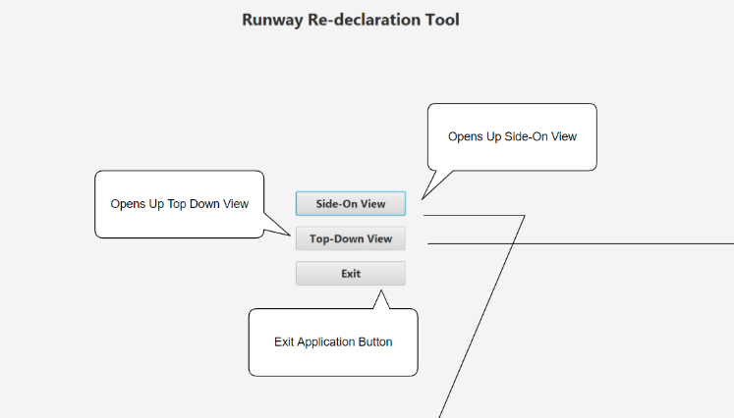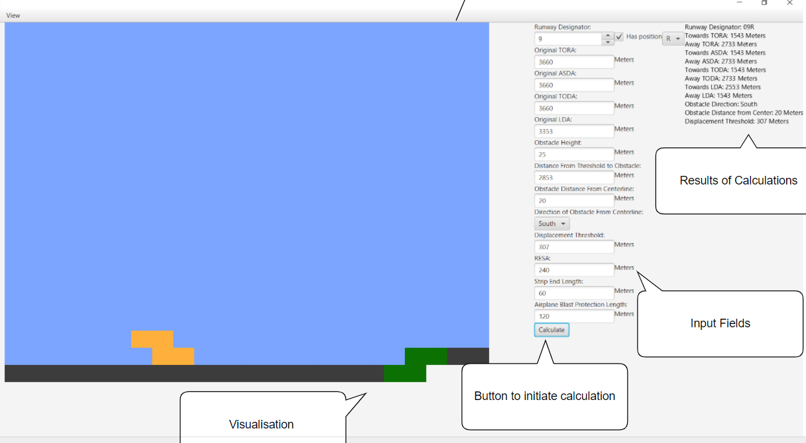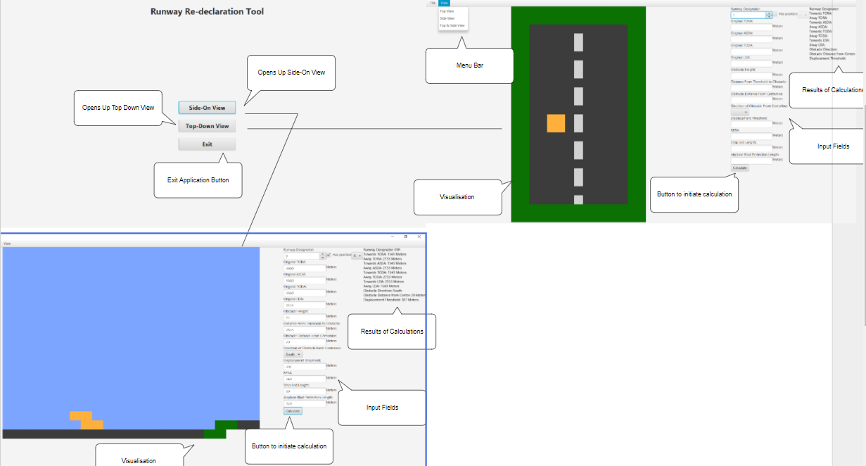**Storyboards**

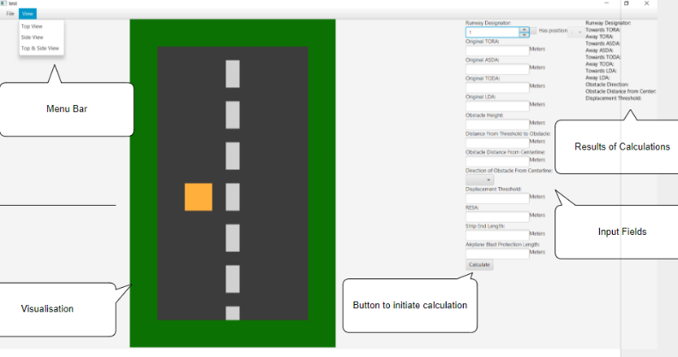

**Scenarios**

1. Jaden - aerodrome controller

* Jaden opens the runway redeclaration app
* The home page is displayed
* Jaden can select between seeing the top-down, the side view or exiting
* Jaden chooses the top-down view
* A top-down view page is displayed
* Jaden enters the values of a runway with an obstacle
  + He accidently enters the value of LDA to be larger than the TORA
  + After pressing the Calculate button alert pops saying “LDA cannot exceed TORA”
  + He reenters the correct value
  + He presses the Calculate button
* Jaden sees exact top-down visualization of the runway
* Jaden clicks “View” at the toolbar and then clicks “SIde View”
* A side view page is displayed
* Jaden once again enters the same correct values
* A side view of the runway is visualized

1. Jane - approach controller

* Jane opens the runway redeclaration app
* The home page is displayed
* Jane can select between seeing the top-down, the side view or exiting
* Jane chooses the side view
* A side view page is displayed
* Jane enters the values of a runway with an obstacle
  + She accidently enters the value of TODA to be larger than the TORA
  + After pressing the Calculate button alert pops saying “TODA cannot exceed TORA”
  + She reenters the correct value
  + She presses the Calculate button
* Jane sees how much of the runway is usable

1. Gemma - independant calculator

* Gemma opens the runway redeclaration app
* The home page is displayed
* Gemma can select between seeing the top-down, the side view or exiting
* Gemma chooses the side view
* A side view page is displayed
* Gemma enters the values of a runway with an obstacle
  + She presses the Calculate button
* Gemma checks all the newly displayed values
* Gemma clicks “File” at the toolbar and then exit
* The application closes

**Logbook**

**Feedback after the envisioning**:

Regarding personas, the feedback we received was that, although facilitating stakeholders were not required in the specification, we should have given it some thought, which we did not. After discussing, we concluded that the facilitating stakeholders would be us, the programmers, as well as any future programmers or IT employees who would be responsible for the upkeep or further development of the code. We were also told that we should have had more primary stakeholders, as we only had one. In our envisioning, we believed that only the primary user should be the primary stakeholder, but, considering that a large part of the project is the visualization, and the air traffic control were the primary users that requested that functionality, we should have put them as primary stakeholders. Our plan for the coursework took into consideration the requests of both primary and secondary stakeholders, so making that change luckily won’t impact our plan for the coursework significantly.

In terms of the burndown chart, the feedback we received was that the meaning of the different colours used should have been indicated not just in the backlogs, but also in the burndown charts. This will be fixed in the next burndown chart.

With regards to the risk analysis, we were told that we probably underestimated both the severity and likelihood of risks, and that it would probably be better to overestimate, than underestimate these risks. This issue also influenced our backlogs, as we only considered the actual difficulty of completing the tasks when deciding it’s difficulty, whereas we should have also taken into consideration the risks, and how that would impact the amount of time spent on each task. This will be taken into consideration in any new tasks that will be included in future sprint backlogs. We were also told of a serious omission in terms of risk. We have not considered the fact that some functionalities, which were previously completed, may stop working due to bugs during the development. However, after consideration, we believe that (unintentionally) we covered this case under “Product develops hard to solve bugs that will take extra time/effort to debug“

Another feedback that we received was that our report should include a high level description of what we wish to achieve in the following sprint as an introduction. We will include this in our next report.

We were also instructed to add an additional row to our sprint backlog, which would highlight the total difficulty of the sprint, summing up the difficulty of each individual task. We have added these to both sprint backlogs.

In terms of our sprint backlogs, as previously mentioned, we were told that we underestimated the difficulty of the tasks, and not broken tasks down enough, into small digestible chunks. One suggestion that we received was to sit down ahead of each sprint in a meeting, and look through all the tasks and break them down ahead of time. This would help us better estimate the difficulty of each task as well.

**Informal Review**:

A few days before our submission, we asked our supervisor to give us some informal feedback. The main points of the feedback were as follows:

The button names are quite strange: “TopScene” and “SideScene”. He recommended naming them something that contains less jargon. He also recommended that we remove the “DoubleScene” button, as this functionality is not implemented, and therefore, it should not be there.

We were also advised to use the scenarios which were still in progress to provide a sort of test for the UI part as we mentioned, that we were not sure how to test that.

Our display while present was not yet functional, as we were only planning to lay out the groundwork for the next sprint, where we would actually implement the functionality. Our supervisor drew our attention to the fact that we need to deliver value to the customer, and therefore, we should add at least some functionalities to the display. While this was hard to hear feedback, as the functionality of the display was not even started, we decided to heed his advice, and added the functionality, to move the object on the visualization, depending on it’s distance from the start of the ruway.

**Backlogs**

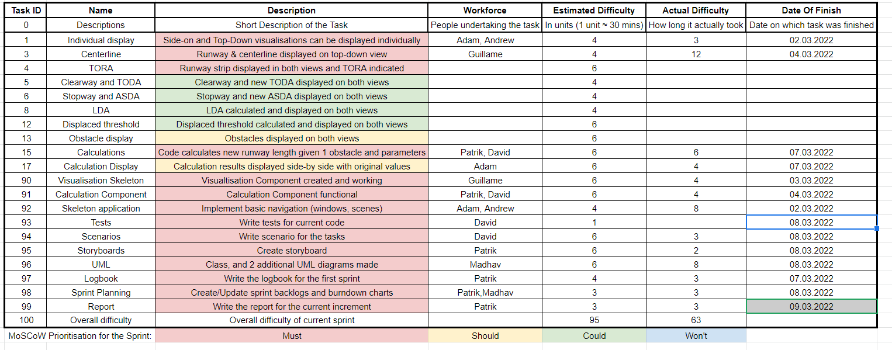1. First Sprint

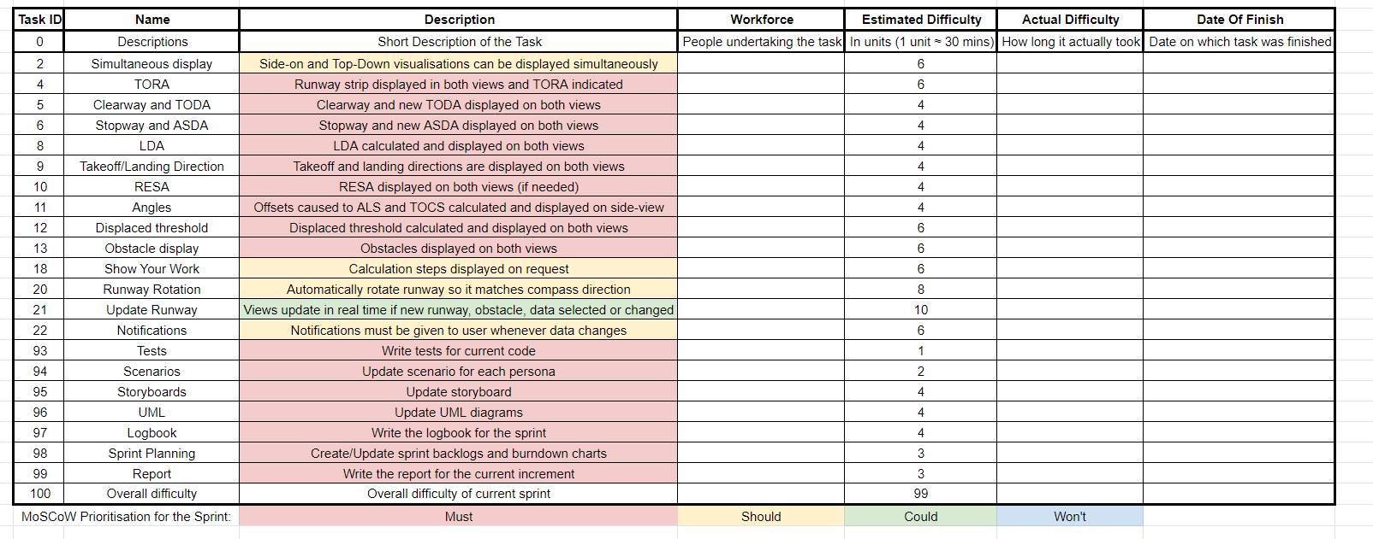2. Second Sprint

**Burndown Charts**

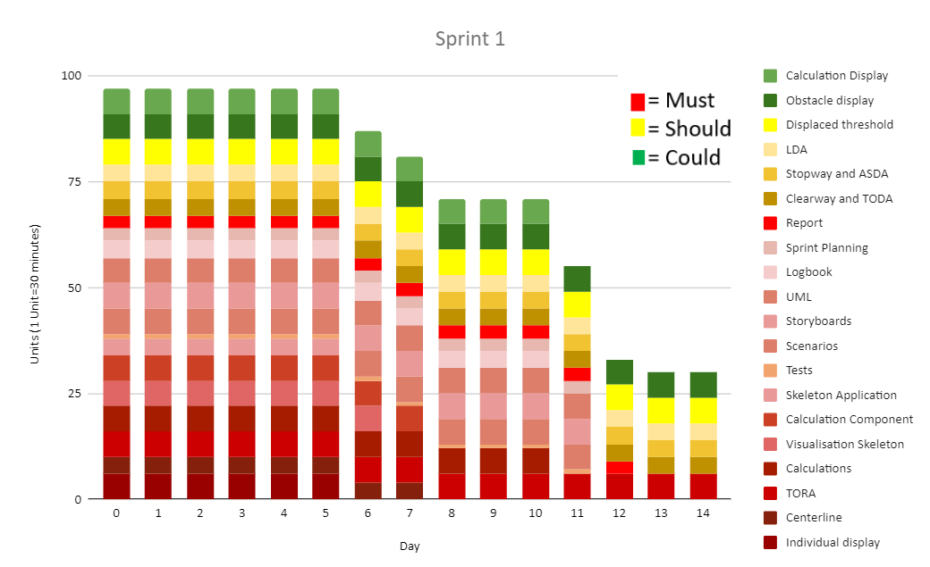1. First Sprint

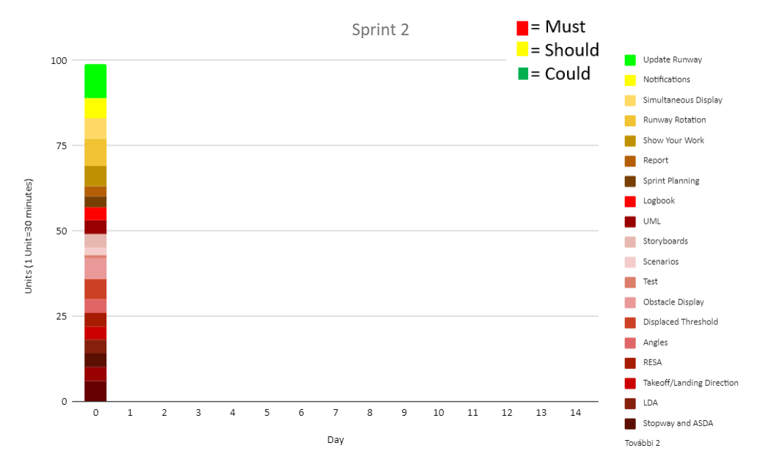2. Second Sprint