1. **Jaden - aerodrome controller**

* Jaden opens the runway redeclaration app
* Jaden chooses the “Top View” from the “View” toolbar
* A top-down view page is displayed
* Jaden enters the values of a runway with an obstacle
* He accidently enters the value of LDA to be larger than the TORA
* After pressing the Calculate button alert pops saying “LDA cannot exceed TORA”

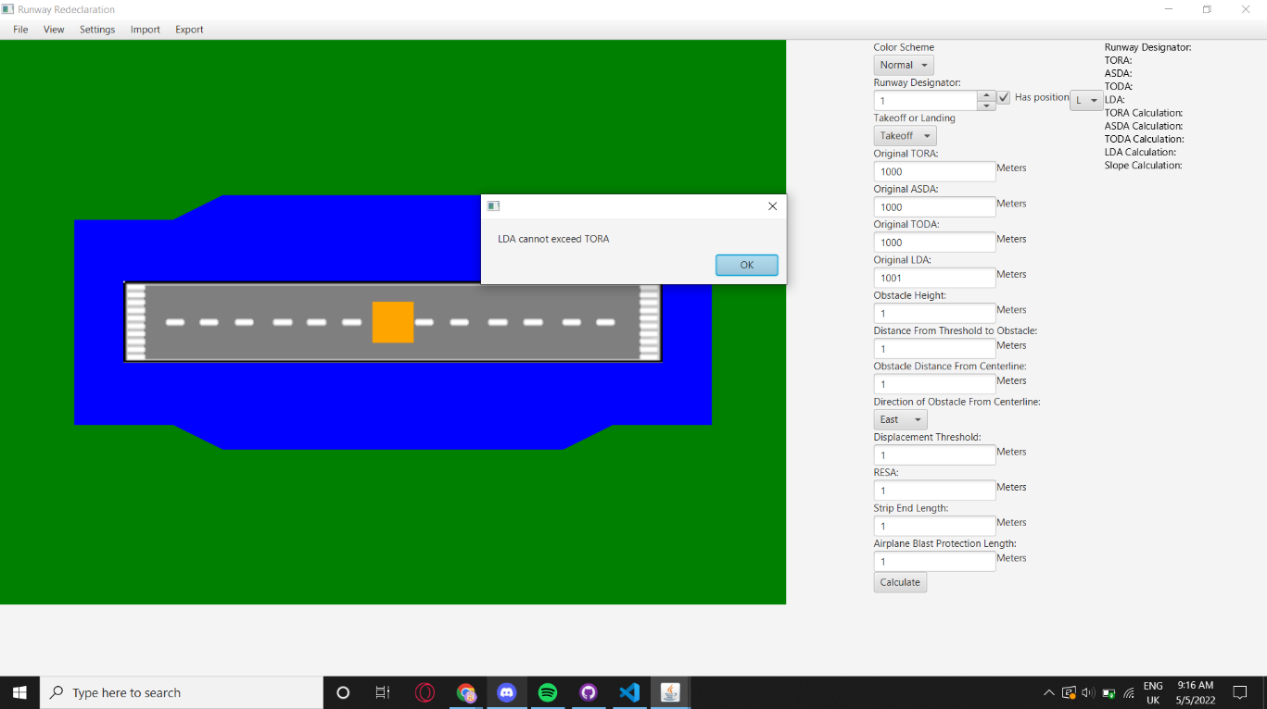

* He re-enters the correct value
* He presses the Calculate button
* Jaden sees exact top-down visualization of the runway

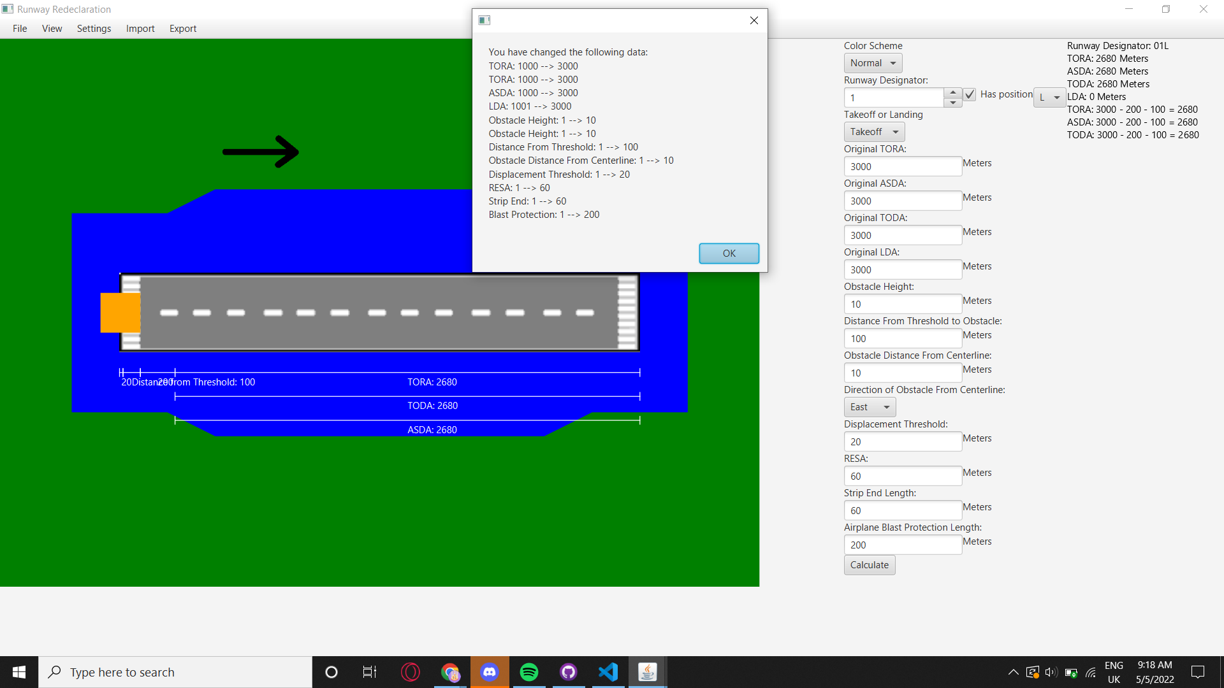

* Jaden clicks “View” at the toolbar and then clicks “Side View”
* A side view page is displayed
* Jaden once again enters the same correct values
* A side view of the runway is visualized
* The indicators show the exact values of the runway
* Jaden clicks “View” and then chooses “Top and Side View”
* A screen split into side view on the left and top view on the right is displayed

