
George Karakatsiotis
2012
PRAXICON DB Tutorial
In this document we describe various ways to get access to the data of the PRAXICON’s database
Cognitive Systems Research Institute
7 Makedonomachou Prantouna Street, 11525, Athens, Greece
+30 211 0124543
+30 211 0124544

Table of Contents
Before using 2
Create a new project that uses PRAXICON DB 2
Attention 12
How to retrieve data from the PRAXICON DB 12
SQL approach 12
JPA approach 16
Complex example of our API: 16

Disclaimer
This release of the POETICON platform is intended for use by the POETICON++ consortium members only. CSRI reserves all copyrights. Detailed technical reports documenting the PRAXICON database, content and tools are in progress. Any publication that uses this release should reference those reports: please contact us for the specific citation details.
USING PRAXICON DB

Before using
- Install the newest version of JDK.
- Install Netbeans with Glassfish: it is recommended to use the full version of NetBeans that contains GlassFish. Installing NetBeans is very easy; just follow the wizard’s instructions.
- Install MySQL (it is recommended to use UTF-8 as the default db encoding) and give a password for the root user (the default password for PRAXICON is root) and create a new database named praxiconcsri.
  - It is advised to use MySQL GUI tools or Workbench for managing your database
- On Linux, configure MySQL to use lower case table names: add the directive lower_case_table_names=1 to the file /etc/my.cnf
- Restore the database from the "praxiconcsri.sql" file (use MySQL GUI or Workbench)
- You may have to give extra privileges to the root user (or any other user that you have assigned to work with your db). To do so, start a MySQL Command Line Client (it was installed along with MySQL server) and execute the command
GRANT SELECT ON *.* TO 'username'@'%' IDENTIFIED BY 'password'
Just change username and password to your user’s credentials (the default username and password are root/root or root & blank password). Also be sure that you have configured the firewall to allow traffic from both glassfish and MySQL ports (default ports are 8080 and 3306 respectively).

Create a new project that uses PRAXICON DB
- Start NetBeans
- Create new project
- Go to File→New Project
- Select Java Application and press Next
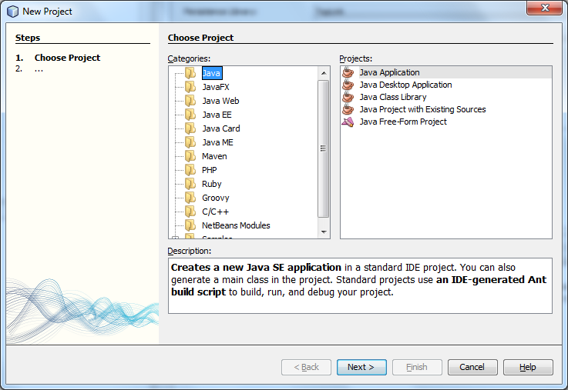
- Give an appropriate name to the project (for example Praxicon_Tutorial) and click finish
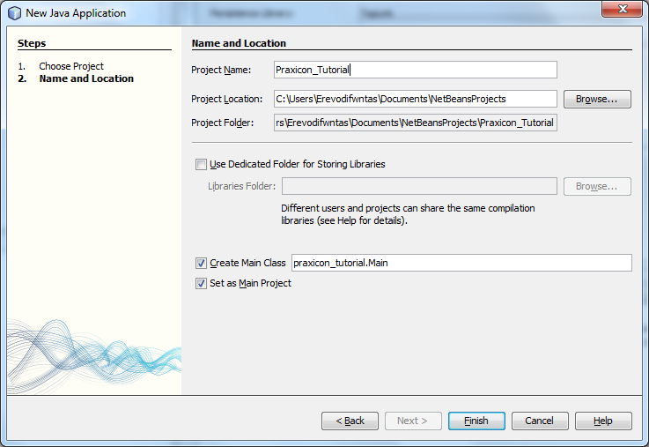
- Right click on the name of the project and select properties
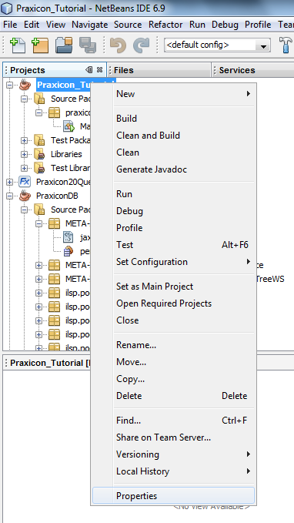
- Select Libraries in the categories tree
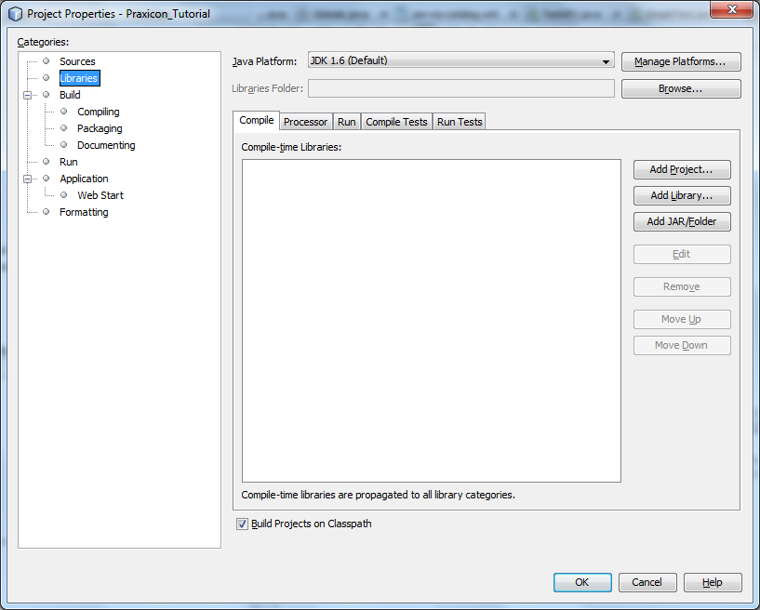
- Press the Add Library button, select JAXB 2.2 and press Add Library
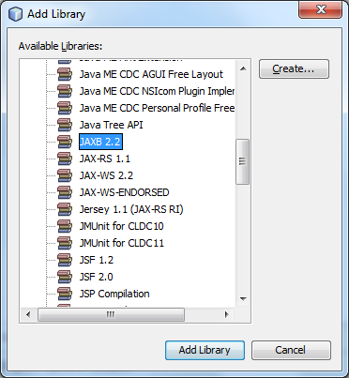
- Press the Add JAR/Folder and browse to the two location where you stored the .jars file that we sent you. Select both .jars (mysql-connector-java-5.1.8-bin.jar and PraxiconDB.jar) and press Open.
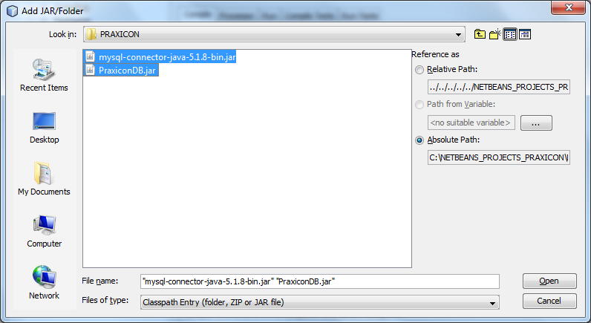
- Now you should see something like this
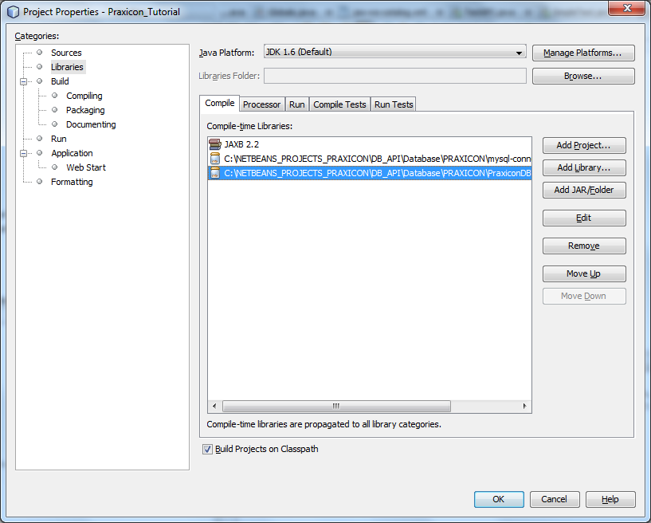
- In order to integrate the javadoc of the PraxiconDB to your project, select PraxiconDB.jar and press Edit.
- Browse to the javadoc folder and press OK
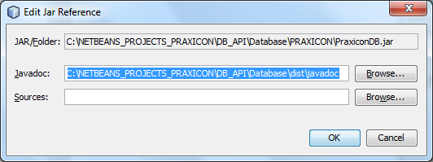
- Press OK.
- Right click on the project name go to New and select Persistence Unit
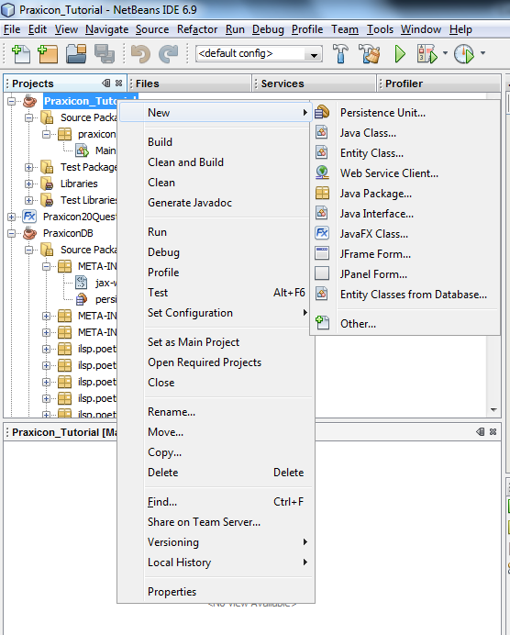
- If there is no Persistence Unit option, select Other and browse the Persistence Category in order to select Persistence Unit and press Next
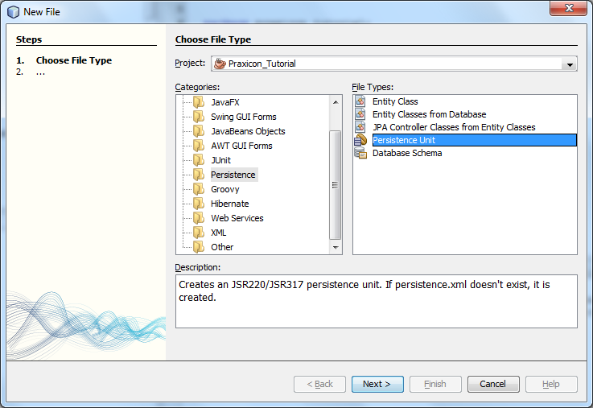
- Give a name to your Persistence Unit (for example Praxicon_TutorialPU) and select as a persistence library toplink.
- At Database Connection select New Database Connection and complete the following
- Driver name: MySQL
- Host: localhost (or wherever you have installed the MySQL server)
- Port: 3306 (this is the default port)
- Database: praxiconcsri
- User Name: root (use the name and the password of a user that has access to the praxiconcsri database)
- Password: root
- Display Name: PraxiconCSRI
- Check the Remember password checkbox
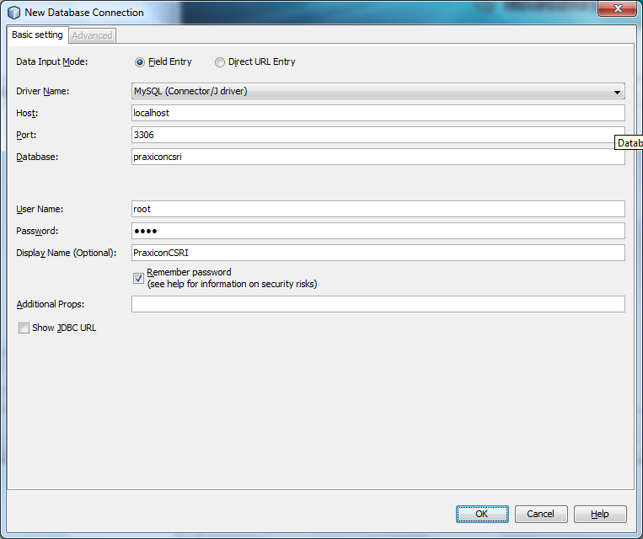
- Press OK.
- Press finish.
- Go to the META-INF package and open the persistence.xml file
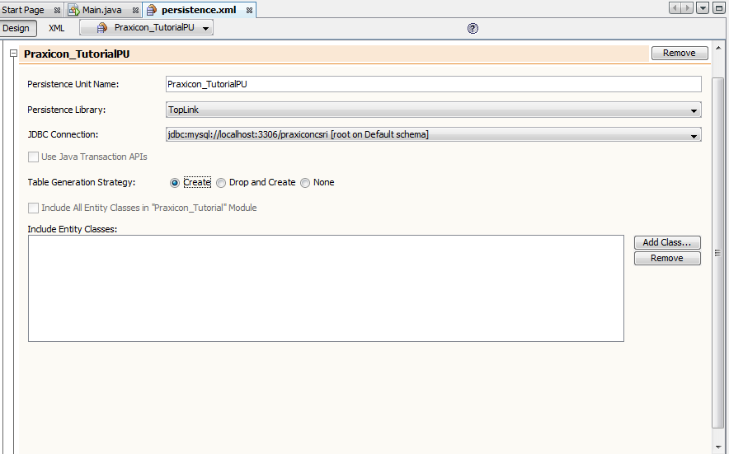
- Select none as the Table Generation Strategy and then press Add Class…
- Select all the class and press OK
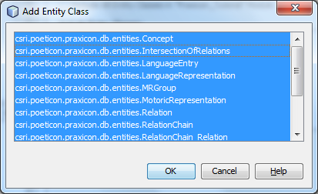

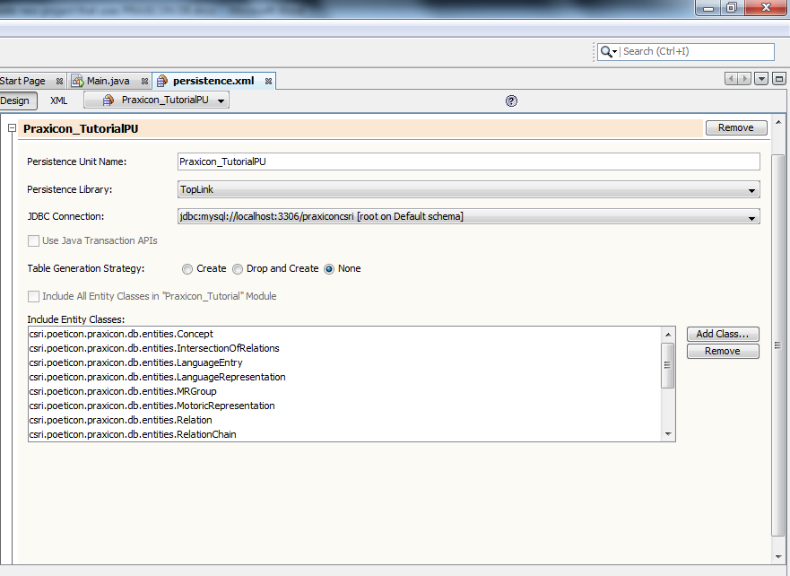
- Right click on the project name and select properties
- Go to the Run category and write -Xms20m -Xmx512m at the VM Options. Then press OK.
- Open the Main.java file (it should be at the praxicon_tutorial package) and write in the main(String args[]) function the following lines of code:
// DO NOT FORGET TO SET THE PERSISTENCE UNIT
Globals.JpaPU = "Praxicon_TutorialPU";
ConceptDao cDao = new ConceptDaoImpl();
// find all the concepts of the database
// and print their number
System.out.println(cDao.findAll().size());

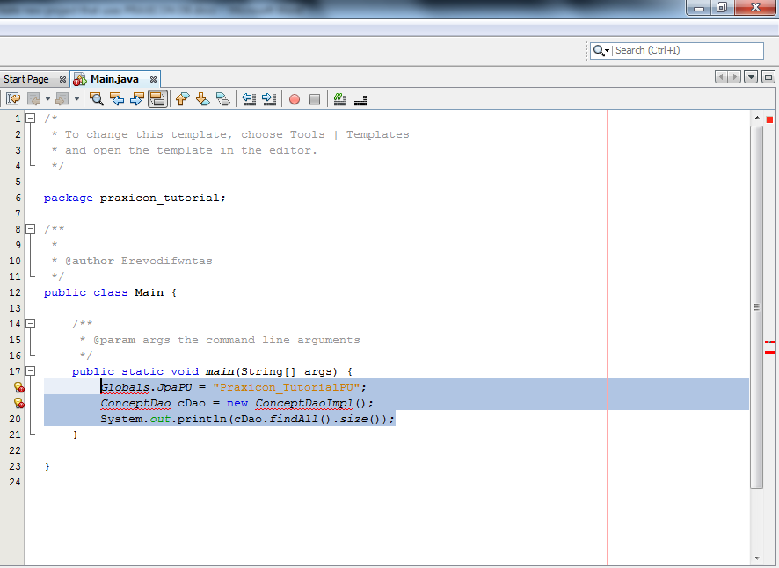
- Lines 18 and 19 are underline with red color because they contain some errors. We have to import the appropriate packages. To do that just click once on the yellow lamp with the red exclamation mark and select add import…
- To run the application, just click the green play button (or pressF6) on the toolbar.
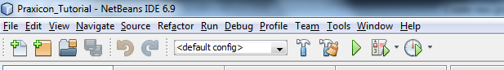
- If everything is ok, you should see in the output the number of concepts in the Praxicon DB (78056).
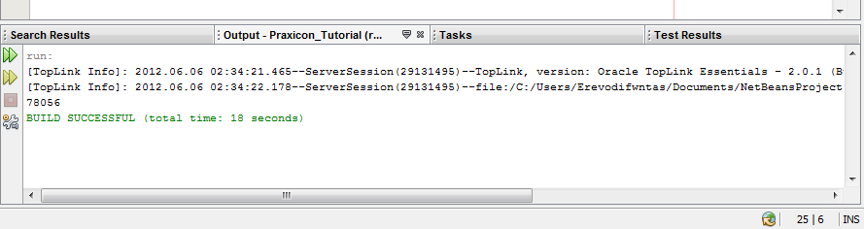
Now you are ready to use the Praxicon DB API for your applications

Attention
Every time that you are going to use the PRAXICON db API, you should set the Globals.JpaPU to your own Persistence Unit!
Globals.JpaPU = "Praxicon_TutorialPU";

How to retrieve data from the PRAXICON DB

SQL approach
PRAXICON DB is a database based on a MySQL server. You can retrieve the data of the database by using SQL (Simple Query Language). To execute SQL queries you can use the sql server frontend of your choice (for example: MySQL browser, FlySpeed SQL Query, etc)
An example:
Retrieve the names of all the features of the HAS_SHAPE relation
To do that you need all the concepts that are objects of the relations that have as a forward name “HAS_SHAPE”.
We are going to use FlySpeed SQL Query (http://www.activedbsoft.com/overview-querytool.html):
Make a connection with your MySQL database
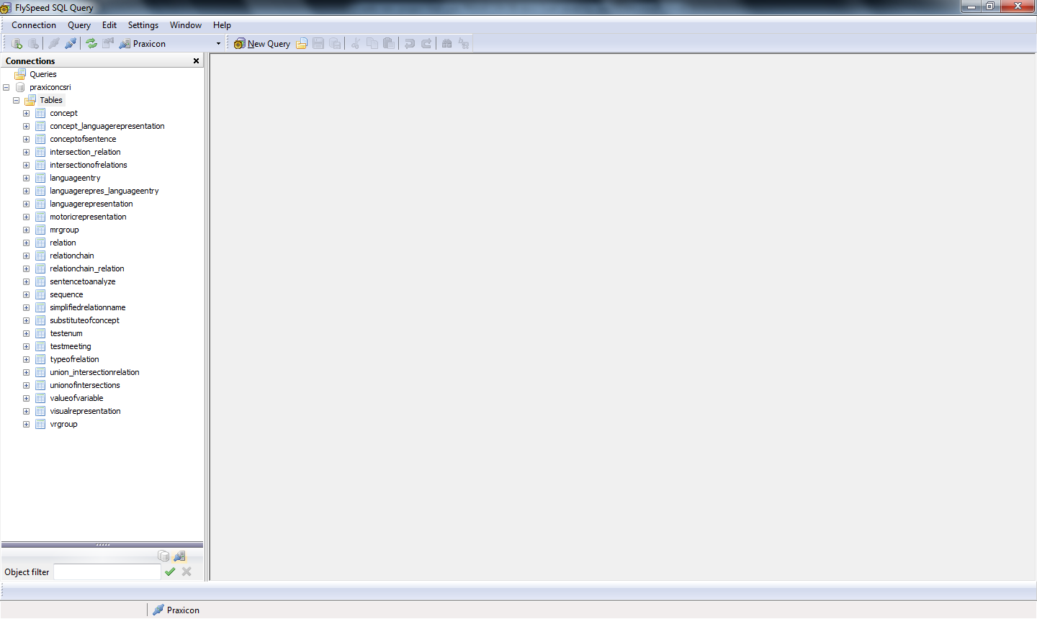
Press New Query
Simple drag and drop the tables that you want to use:
- typeOfRelation: here we store the name of the relations
- relation: the actual relation
- concept: the concepts that are subject and object of a relation
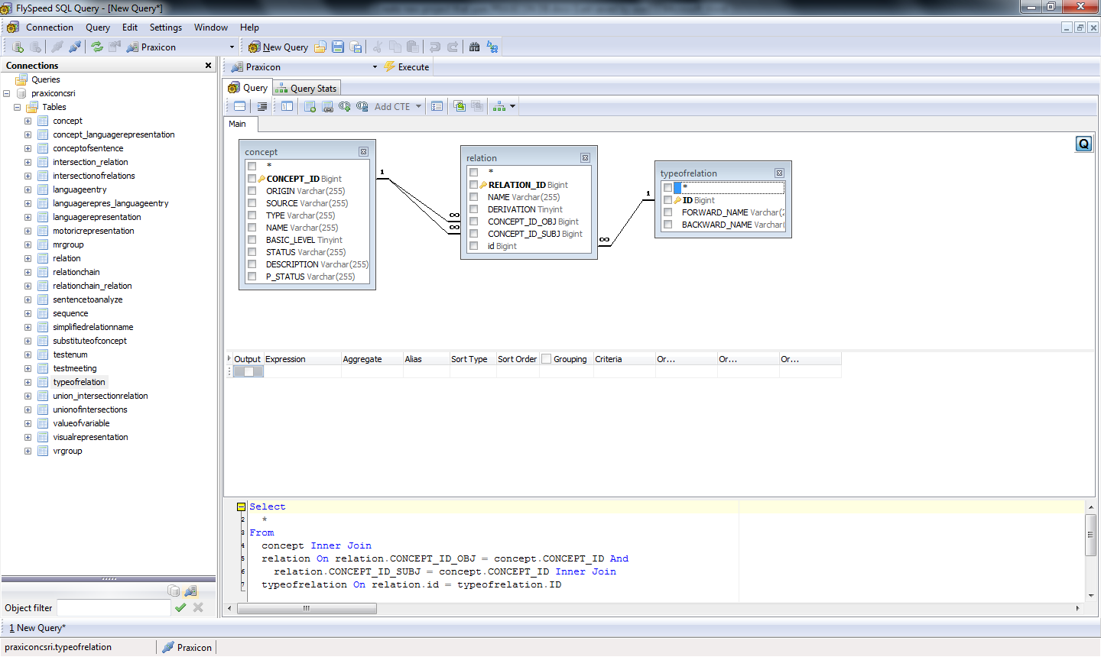
The “Relation” table is related to the “Concept” table twice: Once as the subject of the relation and once as the object.
We do not need the Subject of the relations, so we remove the line that connects the Concept-Subject table to the Relation table (see images below).
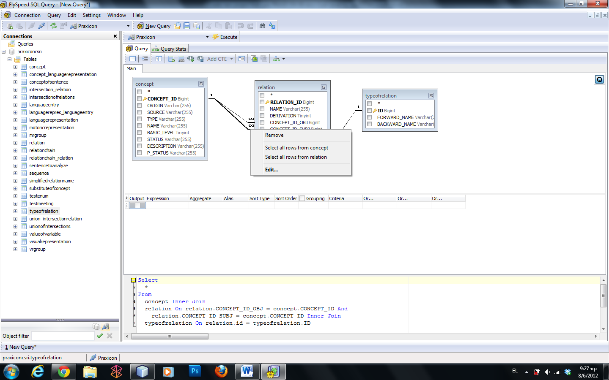
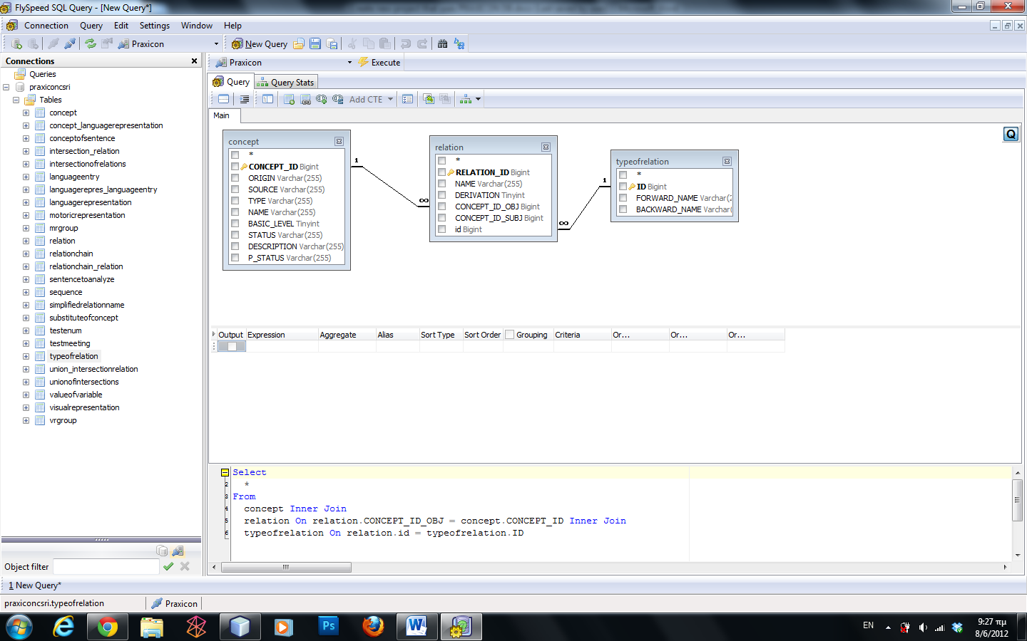
Select the “Name” checkbox in the “Concept” table.
Double click on the “TypeOfRelation” table the FORWARD _ NAME entry
A new line should be added in the list (on the bottom of the window).
On the criteria column (at the 2nd line, where the expression has value “typeofrelation.FORWARD_NAME”) type your criteria (you should type = “HAS_SHAPE”).
Press execute
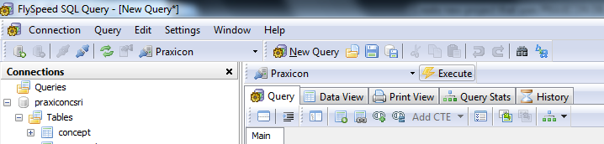
A long list of object names should be displayed
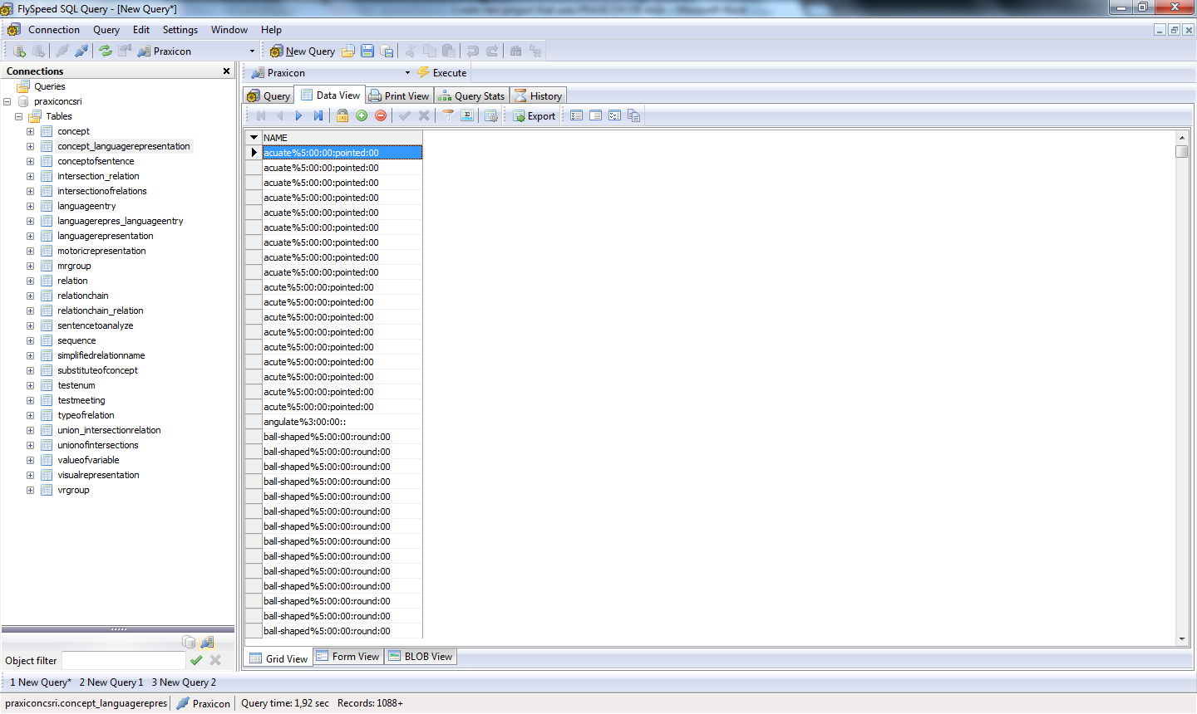
Here you can see that there are some double entries. We can add the DISTINCT keyword in the query in order to have each item presented once.
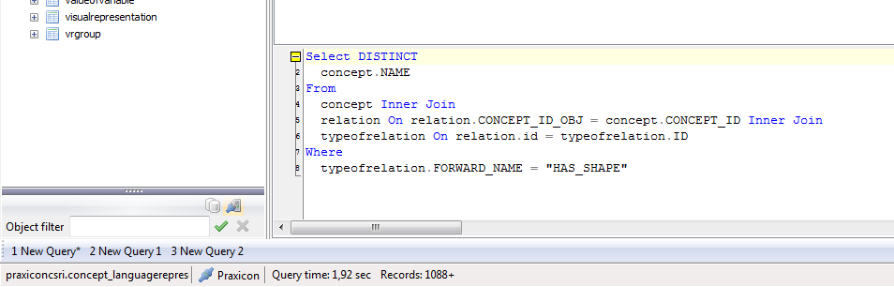
You can further alter the generated query as you see fit.

NOTE: If you want all the Concepts that are features of the “HAS_SHAPE” relation you should do the same for the subjects of the “SHAPE_OF” relations.

JPA approach
Another way to have access to the PRAXICON DB’s data is by using Java code and JPQL.
The equivalent of the previous example in JPQL is the following (write these lines of code under your main function):
//do not forget to add the appropriate import commands
public static List<Concept> getObjectsOfARelation(String nameOfTheRelation)
{
//Get the appropriate RELATION_NAME object
RELATION_NAME t = TypeOfRelation.RELATION_NAME.valueOf(nameOfTheRelation);
//create the JPQL query
Query q = EntityMngFactory.getEntityManager().createQuery("SELECT DISTINCT r.obj FROM Relation r, TypeOfRelation rtype " +
"WHERE r.type = rtype.id and rtype.forwardName = ?1");
q.setParameter(1, t);

//Get the results
return q.getResultList();
}

This function returns a list with all the objects of the “HAS_SHAPE” relations.
To use it, just type in the main function:
List<Concept> objectsOfRelations = getObjectsOfARelation("HAS_SHAPE");
System.out.println(objectsOfRelations.size());

NOTE: It should be easy to change the above code in order to do the same for the subjects of the “SHAPE_OF” relations.

Complex example of our API:
Use our API in order to print all the relations of a given Concept:
public static void printRelations(Concept c)
{
// for each union of the concept
for(UnionOfIntersections union : c.getAllRelations())
{
// for each intersection of the union
for (IntersectionOfRelations intersection : union.getIntersections())
{
// for each relation chain of the intersection
for (RelationChain relationChain : intersection.getRelations())
{
// for each relation of the relation chain
for (Relation relation : relationChain.getActualRelations())
{
// print the relation
System.out.println(relation);
}
}
}
}
}

We used just five lines of code in order to go through 7 different tables (without writing a single SQL or JPQL query).
NOTE: There is a far easier way to do this (by using JPQL), but this approach shows the use of our API and JPA.

Mapping SQL columns to JPGL
In order to write the SELECT clauses in JPQL, you have to refer to the appropriate names of the variables that stand for the actual columns of the tables.
SELECT DISTINCT r.obj FROM Relation r, TypeOfRelation rtype
WHERE r.type = rtype.id and rtype.forwardName = ?1

Here you will find all the variable members of the classes that are being used in order to access the database

Concept
@Column(name="CONCEPT_ID")
protected Long id;

@Column(name="TYPE")
protected Type conceptType;

@Column(name="STATUS")
protected Status status;

@Column(name="BASIC_LEVEL")
protected boolean basicLevel;

@Column(name="P_STATUS")
protected P_Status p_status;

@Column(name="DESCRIPTION")
protected String description;

@Column(name="ORIGIN")
protected Origin origin;

@Column(name="SOURCE")
protected String source;

// these are the LanguageRepresentations of this Concept
private List<LanguageRepresentation> LRs;

private List<VRGroup> VRs;

// these are the MRGroups of this Concept
private List<MRGroup> motoricRepresentations;

// these are the UnionOfIntersections of this Concept
private List<UnionOfIntersections> relations;

@Column(name="NAME")
String name;

// these are the Relations which have as an object this Concept
private List<Relation> objOfRelations;

UnionOfIntersections
@Column(name="UNION_ID")
private Long id;

//this is the owner of this union
Concept concept;

@Column(name="PERCENTAGE")
double percentage;

@Column(name="INHERENT")
boolean inherent;

IntersectionOfRelations
@Column(name="INTERSECTION_ID")
private Long id;

List<RelationChain> relations;

//these are the owners of this intersection
List<UnionOfIntersections> unions;

@Column(name="NAME")
String name;

RelationChain
@Column(name="CHAIN_ID")
private Long id;

//these are the owners of the RelationChain
private List<IntersectionOfRelations> intersections;

@OneToMany(cascade=CascadeType.ALL, mappedBy = "relationChain")
private List<RelationChain_Relation> relations;

@Column(name="NAME")
String name="";

RelationChain_Relation
@Column(name="ID")
private Long id;

@JoinColumn(name="CHAIN_ID")
RelationChain relationChain;

@JoinColumn(name="RELATION_ID")
Relation relation;

@Column(name="ORDER_IN_RELATION")
long relationOrder;

Relation
@Column(name="RELATION_ID")
private Long id;

// these are the owners of this relation
private List<RelationChain_Relation> mainFunctions;

@JoinColumn(name="id")
TypeOfRelation type;

@JoinColumn(name="CONCEPT_ID_OBJ")
Concept obj;

@JoinColumn(name="CONCEPT_ID_SUBJ")
Concept subject;

@Column(name="NAME")
String name;

TypeOfRelation
@Id
private Long id;

@Column(name="FORWARD_NAME")
RELATION_NAME forwardName;

@Column(name="BACKWARD_NAME")
RELATION_NAME backwardName;

// these are the owners of this TypeOfRelation
List<Relation> relations;

LanguageRepresentation
@Column(name="LANG_REPR_ID")
private Long id;

@Column(name="NAME")
private String name;

// These are the entries of this LanguageRepresentation
private List<LanguageEntry> entries;

// these are the owners of this LanguageRepresentation
private List<Concept> concepts;

LanguageEntry
@Column(name="LANG_ENT_ID")
private Long id;

@Column(name="LANG")
private String lang;

@Column(name="TEXT")
private String text;

@Column(name="PART_OF_SPEECH")
private POS POS;

@Column(name="SOUND")
private String sound;

// these are the owners of this LanguageEntry
private List<LanguageRepresentation> LRs;

MRGroup
@Column(name="MR_GROUP_ID")
private Long id;

@Column(name="NAME")
private String name;

// These are the entries of this MRGroup
private List<MotoricRepresentation> entries;

// this is the owner of this MRGroup
@JoinColumn(name="CONCEPT_ID")
private Concept owner;

MotoricRepresentation
@Id
private Long id;

@Column(name="REPRESENTATION")
private String representation;

VRGroup
@Column(name="VR_GROUP_ID")
private Long id;

@Column(name="NAME")
private String name;

// These are the entries of this VRGroup
private List<VisualRepresentation> entries;

// this is the owner of this VRGroup
@JoinColumn(name="CONCEPT_ID")
private Concept owner;

VisualRepresentation
@Id
private Long id;

@Column(name="MEDIA_TYPE")
private String mediaType;

@Column(name="VR_TYPE")
private String vrtype;

@Column(name="REPRESENTATION")
private String representation;

