Question 1. (7pt)
I have just completed editing the a.cpp source code file and here is the working session of my VSC:
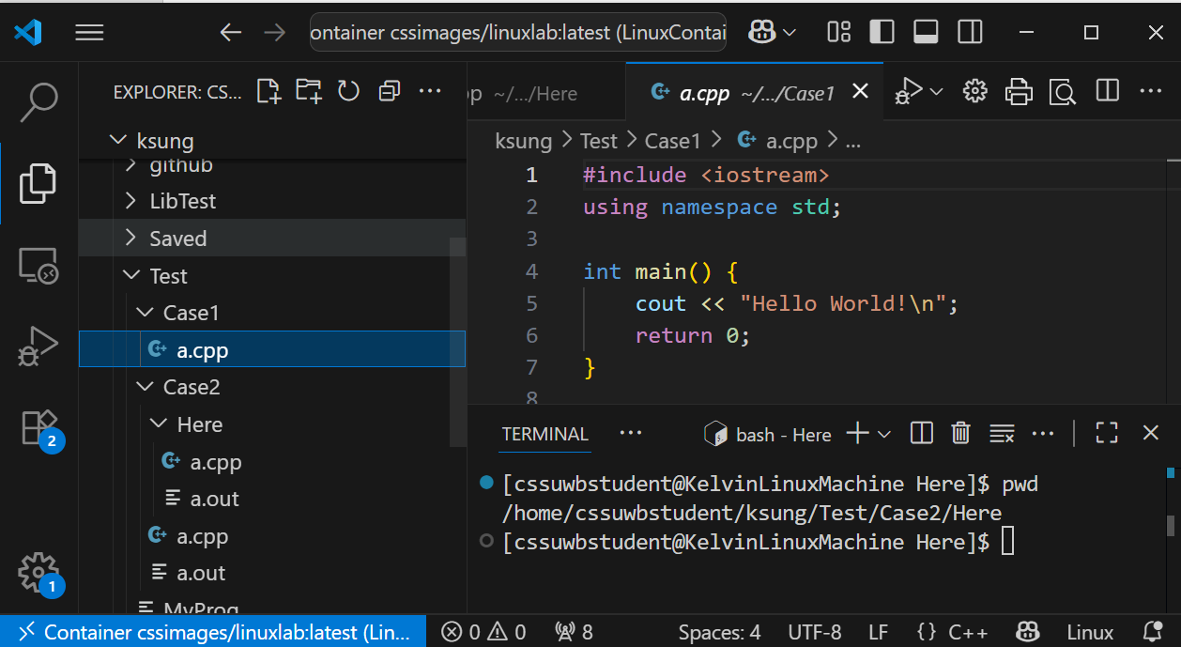

Now, I would like to compile the source code file into a program named MyProg and run the program. Please show the commands you will issue for each of the following cases. Please list the commands in separate lines, one command per line.

- (4pts) In the above CLI, what are the commands I have to issue if I want to remain in the same directory, compile the source code file, and run the resulting MyProg from the current working directory of the CLI?

- (3pts) What are the commands I have to issue if I want to go to the folder that contains the source code file and then compile and run the resulting program?

Question 2. (13pt)

- (1pt) What is the output of the following statements:
int a = 1234;
cout << a/10 << " " << a%10 << endl;

- (5pt) Please show how to implement the following function:
// This function removes the rightmost digit from n.
// The function returns the removed digit and
// modifies n by removing the right most digit
// For example:
// n = 567
// d = RemoveAndGetRightDigit(n)
// cout << n << “ ” << d << endl;
// will print out:
// 56 7
int RemoveAndGetRightDigit(int &n)

- (7pt) Given an integer anInt, write a loop to print its individual digits by calling your RemoveAndGetRightDigit(int&) function. For example:
int anInt = 7531;
… your loop comes here
And, the output would be: 1 3 5 7.

