Question 1 (6pt)
Here is my initial attempt at mp3. Notice, I have decided to implement my program in two files: main.cpp (top window) and print.cpp (bottom window).

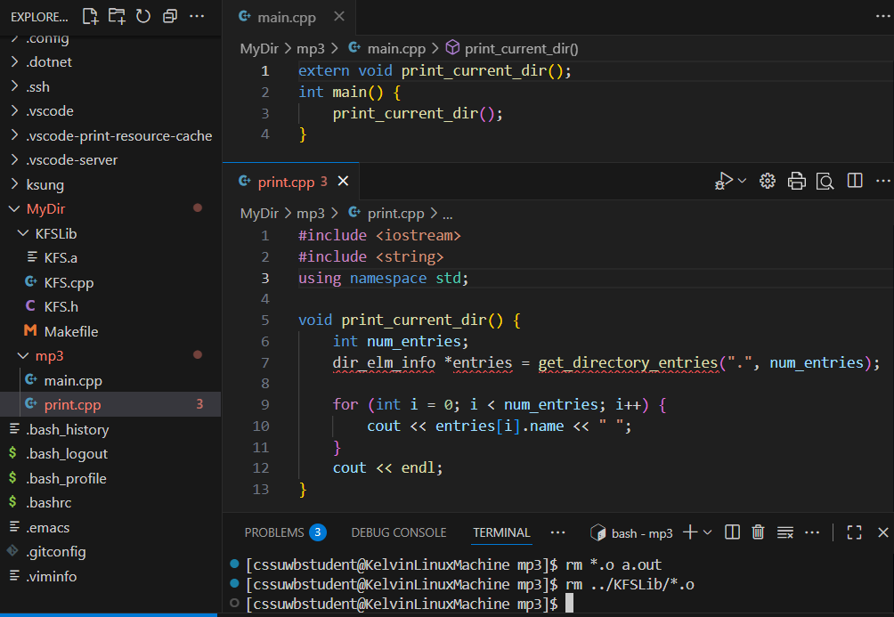

- (2pt) Pay attention to main.cpp, will the 4-lines of source code compile? That is, will the main.o be generated if I issue the command: g++ -c main.cpp? Please explain your answer in one sentence. Answers without explanation will not receive any credit.

- (2pt) Please explain how you will fix the problems with print.cpp such that I can successfully compile the source code file.

- (2pt) After fixing all of the problems, please list all of the commands, one command per line, that you have to issue in order to compile and link a program named MyProg.

Question 2. (14pt)

- (4pt) Write an iterative function, PrintX(int d), where,
0 ≤ d ≤ 9
The function should print out d-number of x, or a _ (the underscore character) if d is 0. In all cases, the printing should end with a space.
For example:
d = 2 prints out: xx // two x followed by a space
d = 0 prints out: _ // underscore followed by a space
Take note that the grey highlight is for clear indication of the space character and that your function should not print any endl.

You are given the following function:

int RemoveRight(int &n) {
int right_digit = n % 10;
n = n / 10;
return right_digit;
}

Recall that this function returns the right-most-digit and modifies the input number, n, by removing the right-most-digit.

- (6pt) Write a recursive function, PrintDigitR(int n), that calls RemoveRight() and your PrintX() to print x’s according to the digits in the given number, n. For example:
n = 103 prints out: xxx _ x // 3 followed by 0, and then 1
n = 201 prints out: x _ xx // 1 followed by 0, and then 2
Make sure you pay attention to the order of printing: the x’s that correspond to the right-most-digit are printed first.

- (4pt) Now, write a new version of the recursive print function, PrintDigitL(int n). Once again, calling RemoveRight() and your PrintX() to print digit x’s in the same order as the digits are found in n. For example:
n = 103 prints out: x _ xxx // 1 followed by 0, and then 3
n = 201 prints out: xx _ x // 2 followed by 0, and then 1
Make sure you pay attention to the order of printing: the x’s that correspond to the left-most-digit are printed first.

