Question 1 (10pt): Yes, this is exactly the same as Q1 from last quiz
Here is my initial attempt at mp3. Notice, I have decided to implement my program in two files: main.cpp (top window) and print.cpp (bottom window).

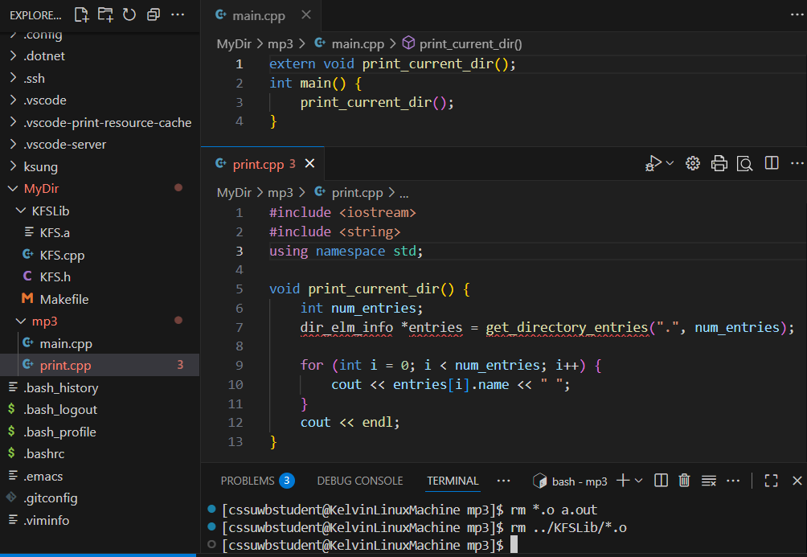

- (3pt) Pay attention to main.cpp, will the 4-lines of source code compile? That is, will the main.o be generated if I issue the command: g++ -c main.cpp? Please explain your answer in one sentence. Answers without explanation will not receive any credit.

- (3pt) Please explain how you will fix the problems with print.cpp such that I can successfully compile the source code file.

- (4pt) After fixing all of the problems, please list all of the commands, one command per line, that you have to issue in order to compile and link a program named MyProg.

Question 2. (5pt)

Given:

void fFunc(int*);
void gFunc(int&);

int main() {
int xVar = 10;
int yVar = 20;
int zVar = 30;

// assume your code comes here
}

- (1pt) Please show how to declare and initialize a pointer, ptr, to point to the variable xVar.

- (1pt) Please show how you can assign the value of yVar to xVar using ptr.

- (1pt) Please show how you can assign the value of xVar to zVar using ptr.

- (1pt) Please show how you can call the fFunc() function with yVar as the argument.

- (1pt) Please show how you can call the gFunc() function with ptr as the argument.

Question 3. (10pt)
Recall the declaration of dir_elm_info:

struct dir_elm_info { // this is the data type
string path; // full path name
string name; // file or directory name only
bool is_directory; // true if directory, false otherwise
};
And, that the library function:

dir_elm_info* get_directory_entries(const string &dir_path, int &num_entries);
// Function to get directory entries
// dir_path: path to the directory to check (full or relative path)
// num_entries: output parameter to return number of entries found
// returns: pointer to an array of dir_elm_info structures

Please show how can implement the recursive function:

int num_dir_entries(const string &dir_path);
// Function: num_dir_entries
// dir_path: path to a directory
// Precondition: dir_path is a valid directory path
// Postcondition: returns number of entries in the directory and
// all of its subdirectories

You can assume dir_path is a valid path to an existing directory.

