LOGISTICKS Checkmark

UML CLASS DIAGRAM

CS301P-2023-06 Keshav(003), Harsh(016) and Subhajeet(022)

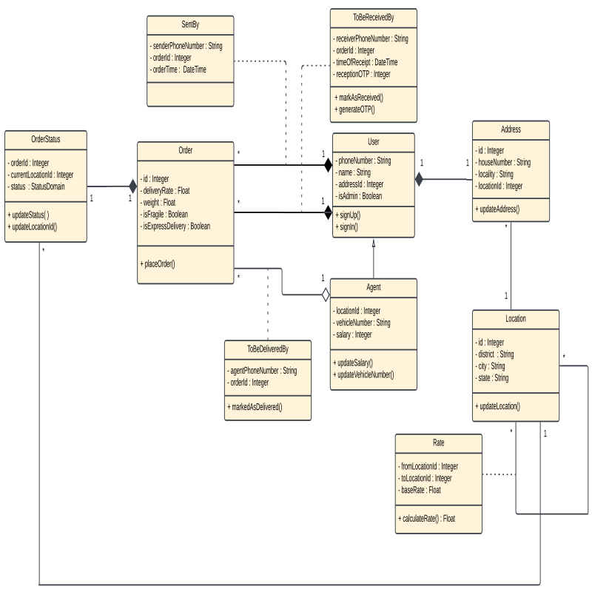

[Lucid Chart Link](https://lucid.app/lucidchart/82e0bdd9-bf41-4c83-8a22-8e41fcc02d60/edit?viewport_loc=-837%2C-546%2C3072%2C1263%2CnY2NVhN_qSnk&invitationId=inv_62f78239-5f09-40a6-8c65-52bb87207a01)

NOTE : We have extensively used association classes in our design, for eg. in the SentBy, ToBeReceivedBy and the ToBeDeliveredBy relations. The primary key of all these tables is orderId itself leading to associations in both directions: Order.id references SentBy.orderId in some joins and SentBy.orderId references Order.id in other joins.

SentBy Table

Primary key: orderId

Foreign key: orderId references Order.id

senderPhoneNumber references User.phoneNumber

orderId, senderPhoneNumber NOT NULL

Order Table

Primary key: id

Foreign key: id references SentBy.orderId, ToBeReceivedBy.orderId, ToBeDeliveredBy.orderId, OrderStatus.orderId

id, deliveryRate, weight, isFragile, isExpressDelivery NOT NULL

deliveryRate, weight, isFragile, isExpressDelivery NOT NULL

OrderStatus Table

Primary key: orderId

Foreign key: orderId references Order.id

currentLocationId references Location.id

orderId NOT NULL

ToBeDeliveredBy Table

Primary key: orderId

Foreign key: orderId references Order.id

agentPhoneNumber references User.phoneNumber

orderId, agentPhoneNumber NOT NULL

ToBeReceivedBy Table

Primary key: orderId

Foreign key: orderId references Order.id

receiverPhoneNumber references User.phoneNumber

orderId, receiverPhoneNumber NOT NULL

User Table

Primary key: phoneNumber

Foreign key: addressId references Address.id

name, phoneNumber, addressId, isAdmin NOT NULL

Location

Primary key: id

id, city, state, district NOT NULL

Address

Primary key: id

Foreign key: locationId references Location.id

id, locationId NOT NULL

Agent (Inherited from User)

Primary key: phoneNumber

Foreign key: addressId references Address.id

locationId references Location.id

name, phoneNumber, addressId, isAdmin, locationId NOT NULL

Rate

Primary key: { fromLocationId, toLocationId }

Foreign key: fromLocationId references Location.id

toLocationId references Location.id

fromLocationId, toLocationId NOT NULL