Problem Statement

Game Play

Our team is going to develop the game Dominion. Dominion is a deck-building game, meaning that each player maintains an individual deck of cards. Throughout the game, each player holds 5 of his cards in his hand. The other cards remain face down in a draw pile or face up in a discard pile. The game is played as follows (a description of all cards follows the game play instructions):

1. Each player begins the game with 7 copper cards and 3 estate cards in his draw pile. Each player draws 5 cards at the beginning of the game.
2. The player whose turn it is plays an action card. That card may grant him extra powers, such as the ability to play another action card. Once the appropriate amount of action cards have been played, the player moves on to the next stage.
3. The next stage is the buy stage. According to the action card(s) played and the cards in his hand, a player has a certain amount of spend points to spend and a certain number of buys he can make. The player may buy more action cards, treasure cards, or victory points. The cards bought are placed in the discard pile. Once the player has spent all of his spend points or used all of his buys, this phase is over.
4. The next phase is cleanup. At this point, all cards that were played and any cards remaining in the player’s hand are placed in the player’s discard pile.
5. Finally, the player draws 5 cards from his draw pile. If the draw pile runs out, he shuffles his discard pile and that becomes the new draw pile. Play continues to his left.

The object of the game is to have the most victory points at the end of the game. The game ends either when all Province cards have been purchased or once three of the stacks of action cards have been depleted.

Treasure Cards: There are three types of treasure cards. Copper is worth 1 spend point and costs 0 spend points. Silver is worth 2 spend points and costs 3 spend points. Gold is worth 3 spend points and costs 6 spend points. The treasure cards are used to purchase action cards, victory points, and other treasure cards.

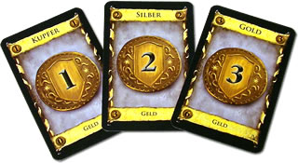

Victory Cards: There are three types of victory cards. Estate is worth 1 victory point and costs 2 spend points. Duchy is worth 3 victory points and costs 5 spend points. Province is worth 6 victory points and costs 8 spend points. At the end of the game, the player with the most victory points in his hand wins.

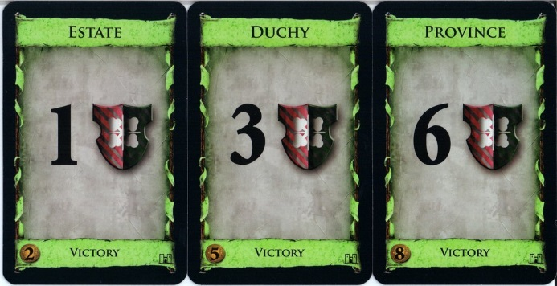

Curse Card: A curse card is worth -1 victory points and costs 0 spend points. Curse cards are typically only distributed when the witch action card is played.

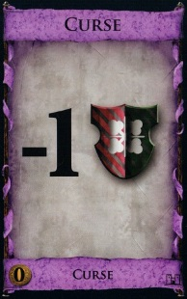

Kingdom Cards: The game has 25 different kingdom card sets. There are 10 cards in a set. At the beginning of each game, 10 of the kingdom card sets are chosen. The other 15 kingdom cards are not used in that game. The game ends when 3 entire sets of kingdom cards have been purchased. Each kingdom card is discussed below.

Adventurer: The adventurer costs 6 spend points. When a player plays the adventurer, he must reveal cards from his deck until he reveals 2 treasure cards. He puts those treasure cards in his hand (to be used during his buy phase) and discards the other cards that he revealed.

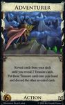

Bureaucrat: The bureaucrat costs 4 spend points. When a player plays the bureaucrat, he gets a silver card and places it in his discard pile. All other players must reveal a victory card (or reveal that his hand does not contain a victory card) and place the card on the top of his discard pile.

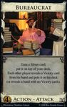

Cellar: The cellar costs 2 spend points. When a player plays the cellar, he earns one additional action. He may also discard any number of cards, gaining an additional action for each card he discards (all additional actions must be spent in this turn).

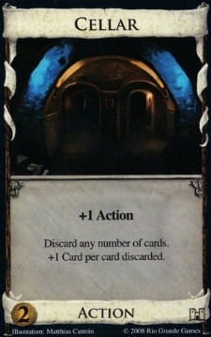

Chancellor – The chancellor costs 3 spend points. When a player plays the chancellor, he earns 2 additional spend points (for this turn only). Also, the player has the option to place his entire deck into the discard pile.

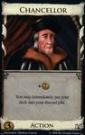

Chapel – The chapel costs 2 spend points. When a player plays the chapel, he can trash up to 4 cards from his hand.

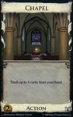

Council Room – The council room costs 5 spend points. When a player plays the council room, he gets to draw 4 additional cards from his draw pile. He also gets 1 additional buy (for this turn only). Also, each other player must draw a card from his own draw pile.

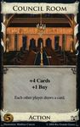

Feast – The feast costs 4 spend points. When a player plays the feast, he must trash the feats card and replace it with a different card costing up to 5 spend points.

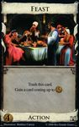

Festival – The festival costs 5 spend points. When a player plays the festival, he earns 2 additional actions, 1 additional buy and 2 additional spend points (for that turn only).

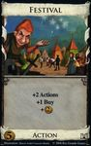

Gardens – The gardens cost 4 spend points. The garden has no action until the end of the game when it is worth 1 victory point for every 10 cards in the player’s deck (rounded down).

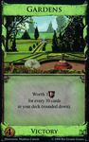

Laboratory – The laboratory costs 5 spend points. When the laboratory is played, the player draws 2 additional cards from his hand and gets 1 additional action (for that turn only).

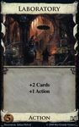

Library: The library costs 5 spend points. When the library is played, the player draws until he has 7 cards in his hand. He may set aside any action cards drawn this way as he draws them. He must then discard the action cards after he finishes drawing.

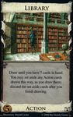

Market – The market costs 5 spend points. When the market is played, the player draws 1 additional card and gets 1 additional action, 1 additional buy and 1 additional spend point (for that turn only).

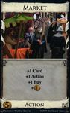

Militia – The militia costs 4 spend points. When the militia is played, the player gets 2 additional spend points (for that turn only). Also, each other player must discard down to 3 cards in his hand.

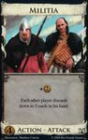

Mine – The mine costs 5 spend points. When the mine is played, the player may trash a treasure card. He may then replace it with a treasure card of up to 3 spend points more than the treasure card he trashed.

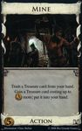

Moat – The moat costs 2 spend points. When the moat is played, the player draws 2 cards from his draw pile. Also, this card can be used to defend against opponent attacks (such as militia or witch).

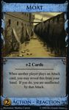

Moneylender – The moneylender costs 4 spend points. When the moneylender is played, the player may trash a copper card from his hand in exchange for an additional 3 spend points (for that turn only).

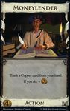

Remodel – The remodel costs 4 spend points. When the remodel is played, the player must trash a card from his hand and gain a card costing up to 2 more spend points than the trashed card.

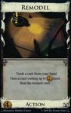

Smithy – The smithy costs 4 spend points. When the smithy is played, the player draws 3 cards from his draw pile.

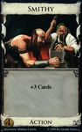

Spy – The spy costs 4 spend points. When the spy is played, the player draws 1 card from his draw pile and earns 1 additional action (for that turn only). Each player (including the player who played the spy) must then reveal the top card of his draw pile and either discard it or put it back as the top card in the draw pile.

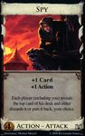

Thief – The thief costs 4 spend points. When the thief is played, each other player must reveal the top 2 cards of his draw pile. If he reveals any treasure cards, the player may select 1 treasure card from each player. All other cards that had been revealed are discarded.

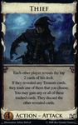

Throne Room – The throne room costs 4 spend points. When the throne room is played, the player may choose an action card from his hand and play it twice.

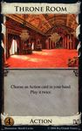

Village – The village costs 3 spend points. When the village is played, the player draws 1 card from his draw pile and gets 2 additional actions (for that turn only).

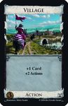

Witch – The witch costs 5 spend points. When the witch is played, the player draws 2 cards from his draw pile. Each other player gets a curse card.

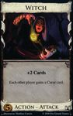

Woodcutter – The woodcutter costs 3 spend points. When the woodcutter is played, the player gets 1 additional buy and 2 additional spend points (for that turn only).

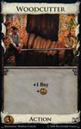

Workshop – The workshop costs 3 spend points. When the workshop is played, the player gains a card costing up to 4 spend points.

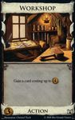

Features

1. Our code will support a game with 2-4 players.
2. At the start of each game, the players will be able to select which 10 of the kingdom cards they want to play with, have the game select 10 kingdom cards randomly, or have the game select 10 kingdom cards randomly then modify those chosen.
3. During each turn, the player will be allowed to see his 5 cards.
4. He will then be allowed to select which card he wants to play.
5. The number of actions, buys and spend points he has will be modified based on which action card he played.
6. He will be allowed to select which card(s) he wants to purchase.
7. Those cards will be added to his discard pile.
8. The game will transfer to the next player.
9. When a witch is played, the game will be able to tell which players have moats in their hands and which players must obtain a curse. A message will be displayed by the players who got curses.
10. When a militia is played, the game will be able to tell which players have moats in their hands and which players must discard 2 cards. If a player must discard 2 cards, the game will wait until his turn and then prompt him to do so.
11. The game will display a count of how many of each type of card is available so that players can keep track of how soon the game will be over.
12. At the end of the game, the game will tally points and declare a winner.