Structural Study of Glass Forming Ability in the MgNiY Glass Forming System

Introduction:

Unlike crystalline metals, metallic glasses lack long range order atomic ordering, instead metallic glass have a wide range of short and medium range order on the length scales of 1-3 nm. This unique structure of metallic glasses is a subject of much interest as unique structure leads to unique materials properties such as high strength to weight ratio, good chemical stability and excellent shaping/processing abilities. Structure is also very important in the formation of metallic glasses, which is often quite challenging. For many metallic glass forming systems, avoiding crystallization requires high cooling rates(10⁵-10⁶ K/sec), and only small samples (thickness = 1-100 microns) can be formed. Bulk metallic glasses (BMGs), which can be formed under much less extreme cooling conditions (cooling rates <10⁴ K/sec, thickness>1mm ), represent a smaller subset of metallic glasses but these compositions are of much interest. The lass extreme cooling rates means larger samples means can be formed for a wider range of applications.

BMG’s span wide ranges of compositions, but magnesium based metallic glasses have been a particular area of interest due to their low weight/cost, high tensile fracture strength and promising biomedical applications.^{1–4}⁠ Some of the first reported Mg based metallic glasses were melt spinning results in both the Mg-Cu and Mg-Ni systems in 1980.⁵⁠ Ten years later, the addition of Y to Mg-Cu and Mg-Ni greatly increased the glass forming regions of both systems. Kim et. al. reported large regions of glass formation in both systems under rapid cooling using a melt spinning technique.⁶⁠ Following these reports, BMGs in the Mg-Cu-Y system were reported¹⁠ but to our knowledge no BMG’s in the MgNiY system have been reported.

As metallic glasses have no long range ordering, experimental structural characterization is often indirect and limited. Large numbers of computational studies provide more detailed and direct analysis but computational studies cannot reach longer time scales to simulate bulk metallic glass structure. Despite these limitations, many of these studies have strong evidence which links icosahedral ordering, or more generally 5-fold symmetry, to strong glass formation and links crystal-like structures to poor glass formation.^{7,8}⁠ In Mg-based metallic glass systems most of the work surrounds the Mg₆₅Cu₂₅Y₁₀ metallic glass system due to it’s high glass forming ability. Ab inito molecular dynamics studies from Hui et. al. claim the existence of strong icosahedral ordering in the glass⁸⁠ but more recent studies from Ding et. al. claim that there is little evidence of icosahedral ordering in the same glass. Instead they claim that shortened bond lengths and ionic character in the glass is largely responsible for glass forming ability of the Mg-Cu-Y system.⁹⁠ Other glasses in the Mg-Zn-Ca system and Mg-Cu-Gd the former reporting icosahedral ordering¹⁰⁠ while the latter reporting icosahedral and icosahedral-like ordering¹¹⁠

To our knowledge there are not structural studies of any glasses in the Mg-Ni-Y system, however the Mg-Cu-Y system is a good basis for comparison. Table 1 below shows the atomic and the metallic radii for Mg, Cu, Ni and Y. The similar size of the Cu and Ni metallic radii as well as similar oxidation states means that they should have similar behavior.

Element | Atomic Radii | Metallic Radii
Mg | 160 pm | Mg²⁺ : 72 pm
Nickel (Ni) | 125 pm | Ni²⁺ : 70 pm
Copper (Cu) | 127 pm | Cu⁺ : 77 pm | Cu²⁺ : 73 pm
Yttrium (Y) | 180 pm | Y³⁺ : 90 pm
Table 1: The table above shows the atomic radii and metallic radii for Mg, Cu, Y and Ni. In this study Mg-Ni-Y glasses are studied, however, as the Mg-Cu-Y system has a larger body of published work it is a good system for comparison.

The aim of this paper is to better explore the glass forming ability of the Mg-Ni-Y system as well as to the glasses structure. Using new techniques developed to directly measure glass structure allows us to draw new insight into which structures are important for glass formation in the system. In comparison to computational studies which measure only rapidly quenched states of some glass, these measurements allow us to understand glass structure in a state closer to what is used in application.

Methods:
A series of metallic glass rods in the Mg-Ni-Y ternary were cast within the region previously reported as glass forming under melt spinning conditions. Elemental Mg, Ni and Y (Purity??) were melted using an induction furnace to form a master alloy. The master alloy was then The rods were cast using a variable suction casting apparatus. [Citation?] After melting a master alloy in an induction furnace, the alloy was melted and cast into two different diameter casting molds of chilled copper. Rods of 3 mm and 1mm were formed to determine the glass forming ability of a series of MgNiY glasses at different compositions within the previously reported MgNiY glass forming region.

The rods were then imaged using a Zeiss LEO 1530 electron microscope and the composition was determined by EDS at three points on the sample. The rods were then tested using a Bruker D8 Discovery x-ray diffractometer to determine if the sample was amorphous or crystalline.

Samples which appeared X-ray amorphous were then extracted using a Fiscion-Focused Ion Beam (FIB) to prepare TEM samples for further study. A 30 kV 8 nA beam was used to extract a sample of around 15 umx 10umx 2um. Then a 30 kv 2nA beam is used to thin down to 1 um. A 30kv 300pA beam then is used to thin the sample to around 100-200 nm and 30kv 50pA to electron transparency using a 15 keV electron beam. The sample damage and final thinning was then achieved using a Fishione 1040 TEM ion mill with a beam energy and current of 2keV 5pA for 1 hour on each side. Leaving a sample with a thickness of around 20-40nm.

A HRTEM image was taken using a FEI Titan microscope using spot size 7 and magnification of 1.3 mX and no nanocrystals were shown. A diffraction pattern was also taken over the sample showing an amorphous “halo”.

Structural characterization was achieved by acquiring a series of 4-D STEM dataset across the sample. Nanodiffraction patterns were taken using the same FEI Titan microscope, spot size 5, a convergence angle of 0.6 mRad equalling a probe size of ~ 2nm. The sample was densely sampled at three positions with electron transmission greater than 50%.

At every x and y position in the 4-D STEM dataset the angular correlation was calculated and the expression of each symmetry was determined by slicing the correlation data set. Clusters of some symmetry were determined using a difference of Gaussian’s (an approximation of the Laplacian of Gaussian) cluster finding algorithm¹²⁠ with some cluster defined as a feature in the scale space representation whose peak is greater than two times the standard deviation.

The critical cooling rate of fully amorphous samples was also examined using a Thermo-Fisher Flash DSC-2. With an upper temperature of 900C, the sample was successively heated above it’s melting temperature and cooled at different rates. The critical cooling rate was determined by looking at maximum cooling rate at which the glass transition temperature was observed.

Results:
Figure 1 shows the glass forming region in the Mg-Ni-Y ternary phase diagram from previous studies combined with the samples reported in this study. From previous work, the shaded area shows the glass forming area under melt spinning conditions while the lighter area shows the region which forms partially amorphous metallic glass under melt spinning conditions.⁶⁠ From this work, the open circles show crystalline 1mm rods, the half filled circles for partially amorphous samples and filled circles for amorphous samples. Table 1 contains the compositions for the samples created.

Sample Number | Composition | XRD Amorphous?
Sample 1 | Mg77 Ni18 Y5 | Yes
Sample 2 | Mg78 Ni9 Y13 | Partially
Sample 3 | Mg78 Ni11 Y10 | No
Sample 4 | Mg88 Ni6 Y6 | No
Sample 5 | Mg88 Ni9 Y3 | No

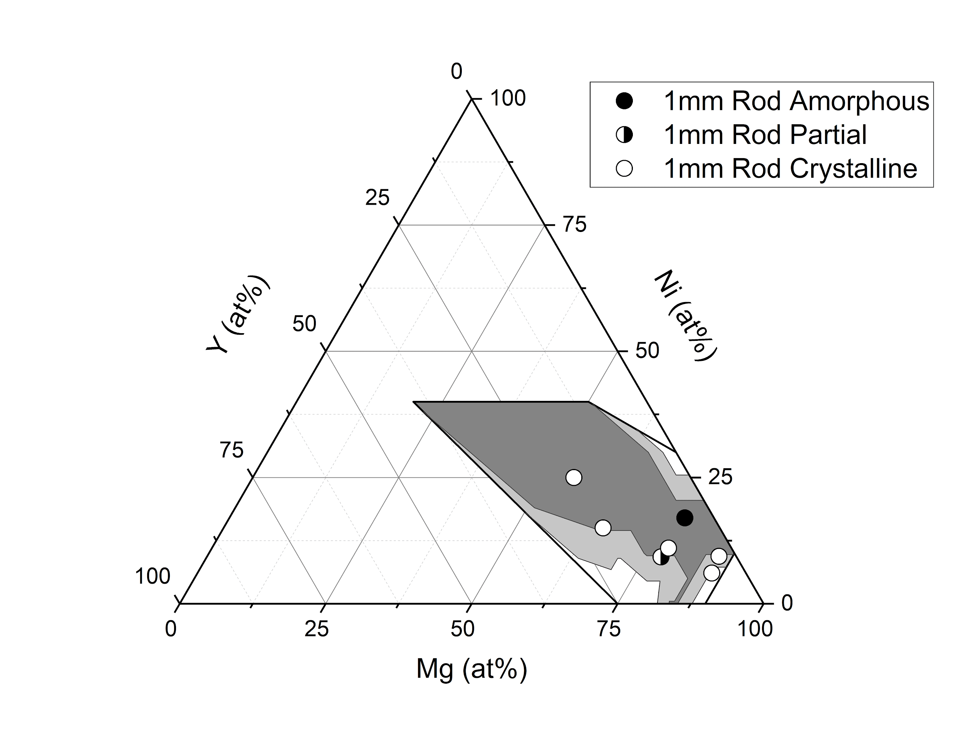
Figure 1: Ternary Phase diagram for glass formation of Mg Ni Y. The shaded regions represent the glass forming region as determined by previous studies⁶⁠. The open circles are samples crystalline when melt cast into a 1 mm rod, the filled circles are samples amorphous when cast into a 1 mm rod and the half filled circles are partially amorphous when cast into a 1 mm rod.

Figure 2a shows the DSC trace for sample 1. The glass transition temperature of 225 °C and an onset crystallization temperature of 272 °C are determined using a heating rate of 100K/sec Figure 2b shows heating curves at 5,000 K/sec while the label details the cooling rate the glass was quenched at. From this analysis the critical cooling rate is between 10,000 to 20,000 K/sec,

Figure 2: Figure 2a shows the glass transition temperature and the onset of crystallization in the Mg77 Ni18 Y5 glass. Figure 2b shows the heating curves after the glass has been melted and the quenched at the labeled cooling curves.

Figure 3 shows the HRTEM and large area diffraction pattern for Sample 1. The lack of discernible features in the HRTEM and amorphous ring in the large area diffraction pattern provide additional evidence as to the amorphous nature of the sample.
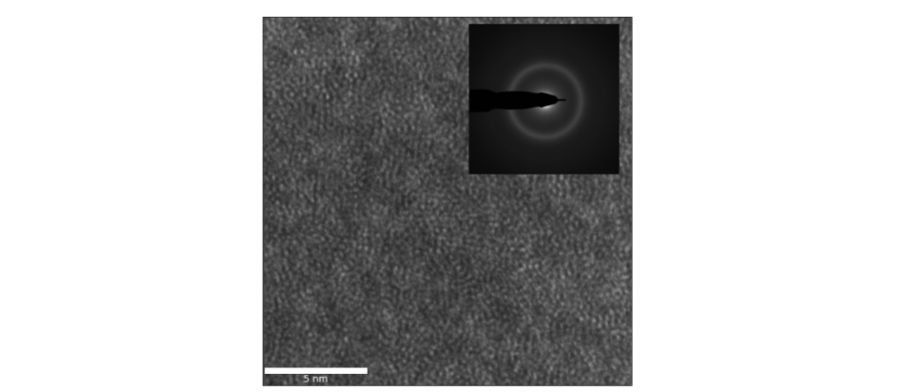
Figure 3: High resolution TEM and Large area diffraction pattern for Sample 1. The lack of features in each sample indicates the lack of observable nanocrystals in the sample.

Figures 4 and 5 compare the number of clusters with some dominant symmetry and diffraction vector k (Figure 4a/5a) with the diffraction vectors for the Mg and Mg₂Ni crystals (Figure 4b-c/5b-c) and the symmetries of their diffracting planes(Figure 4d-e/5d-e).

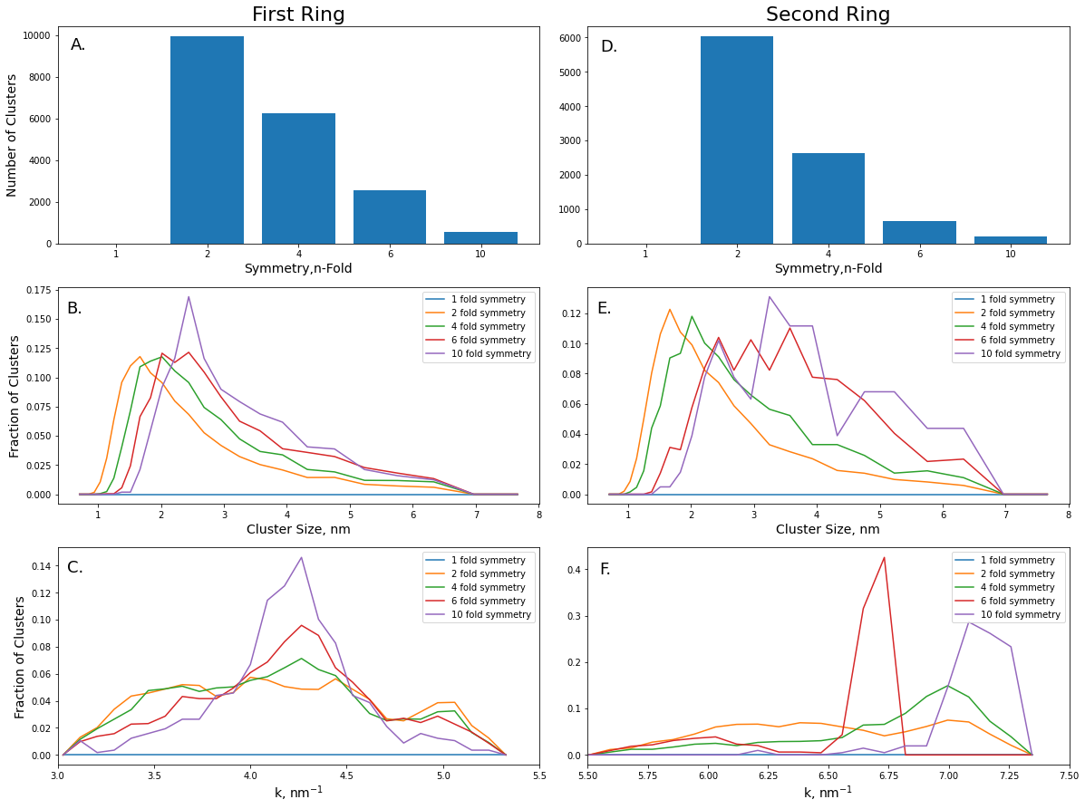

Figure 4: Figure 4a shows the number of clusters found for each symmetry, Figures 4b/c show the diffraction vectors for planes in the Mg and Mg₂Ni crystal systems. Figures 4d/e show the diffraction patterns for two major planes in the crystal systems.
Figure 4a shows data from clusters determined from the first diffraction ring (3.0-5.5 nm⁻¹). While
each symmetry spans the entire range of diffraction vectors, the four and six fold symmetry curves peak at ~ 4.3 nm⁻¹ while the ten-fold symmetry peak slightly lower at ~ 4.1-4.2nm⁻¹. The four- and six-fold symmetries also have a larger shoulder at low k from 3.6-4.2 nm⁻¹ in comparison to the narrower 10 fold symmetry. At higher k, around k = 5.0 nm⁻¹, there is a small two fold peak. Figures 4b and 4c show the primary peak in the Mg crystal system is from the (1 0 1 1) plane at k₍₁ ₀ ₁ ₁₎ = 4.08 nm⁻¹ and the primary peak for the Mg₂Ni system is from the (2 0 2 3) with a peak at k₍₂ ₀ ₂ ₃₎=4.98 nm⁻¹. Figure 4d shows the diffraction pattern for the (1 0 1 1) plane, including the strong 6 fold symmetry. Figure 4e shows the diffraction pattern from the (2 0 2 3) plane including the strong 2 fold symmetry of that diffraction pattern.
Figure 5

Figure 5: Figure 5a shows the number of clusters found for each symmetry, Figures 5b/c show the diffraction vectors for planes in the Mg and Mg₂Ni crystal systems. Figures 5d/e show the diffraction patterns for two major planes in the crystal systems.

Figure 5a shows data from clusters determined from the second diffraction ring (5.5-7.5 nm⁻¹). The number of clusters with some dominant symmetry and diffraction vector k shows a strong and well defined peak in the six-fold symmetry at k = 6.9 nm⁻¹and a broader peak at around k=5.9-6.25. The other symmetries all have peaks around k = 7.1 nm⁻¹. Figure 5b/c show the peaks and diffraction vectors for Mg and Mg₂Ni. At higher k-values the (1 0 1 -3) peak in Mg and the ____ peak in Mg₂Ni are of particular interest. Diffraction patterns from the planes shown in Figure 5d/e show that the planes have dominate 6 and 2 fold symmetry respectively

Figure 6 compares the size of the clusters for each symmetry. Figure 6a shows the results for the first ring while figure 6b shows results for the second ring. Figure 6a shows a majority of the clusters are around 1.5-3 nm in size with the four- and six-fold symmetry clusters being on average ___ nm larger than the ten-fold symmetry clusters. Figure 6b shows a slightly different result with both the four- and ten-fold symmetric clusters on average smaller than the six-fold symmetry clusters. Comparing the first and second rings, the average size of all the clusters is __ nm for the first ring and __nm for the second ring.

Discussion:
From this work, we have found the MgNiY system is only marginally glass forming. Sample number 1, while amorphous by x-ray and HRTEM, has significant crystal-like ordering when cast as a 1mm rod sample and the sample is fully crystalline when cast as a 3 mm rod. The critical cooling rate of ~10,000 K/sec is While there are many similarities between the MgNiY and MgCuY system the glass forming ability of the former appears to be lower than than the latter, even if the driving forces for glass formation are similar between the two.

Strong crystal like ordering in the glass is most evident in figure 5. The strong, and narrow, peak in the 6-fold symmetry at higher k suggests that there exists significant medium range order in the glass. The peak is mostly likely related to the (1 0 1 -3) peak in the Mg HCP strucuture which shares the same 6-fold symmetry. The peak is shifted by (+ ___ nm⁻¹), but this could be the result of disorder in the structure, possibly in the substitution of Mg for Y in the structure or the ionic behavior of Mg?

Sample 1 seems to exhibit no strong icosohedral ordering like what is found in other strong glass forming systems. Figure 4 shows that the 5 fold symmetry spans the entire range of composition and resulting k-spacing. This suggest that instead of icosohedral ordering, this 5-fold symmetry is a result of modifications to the other glass structures. Ding, Cheng and Ma suggested that the major packing for MgCuY was a tricapped trigonal prism and a bicapped square antiprisim (Vornoi indexes <0,3,6,0> and <0,2,8,0>) which could contribute to the 5-fold symmetry present in the glass. At higher k is seems there is a fairly strong peak which aligns with the (2 0 2 3) peak in the Mg₂Ni system. This peak aligns with the only 2 fold symmetry clusters found and most likely arises for similar clusters in the glass.

Figure 4 shows a slightly different story than figure 5. The six-fold symmetric (1 0 1 1) plane for HCP-Mg is at lower k than the 6-fold clusters identified. While the six-fold clusters cover a large span of k-vectors the shift to lower inter planar spacing (and higher k) is most likely a result of the substitution of Mg for the smaller Ni. This also could be a result of stronger ionicity in these bonds shortening these bonds. The difference between the clusters from the first and second rings are especially seen in figure 6. While the larger size of clusters in the second ring isn’t altogether surprising, larger clusters allow for smaller internal reflections, it does show that each set probes a different set of clusters rather than the second ring of clusters being a subset of the first ring. Rather than those peaks not showing up in the first ring, it is more likely a shortfall of the cluster finding method that was applied.

Conclusions:
We have further studied the glass forming region of the MgNiY ternary system and found one composition that forms a metallic glass with a maximum diameter of 1 mm. In comparison to the MgCuY system which has a larger bulk metallic glass formation region, the MgNiY system has stronger driving forces for crystallization. The large crystal-like character of the clusters in this study suggests that these structures are likely precursors to crystallization or may act as nucleation sites for eventual crystal growth. Although there appears to be significant ionic character as evidenced by the shifting k-vectors for clusters from the crystalline structures, the crystalline character is unmistakable in the results.

1. Inoue, A. et al. Mg-Cu-Y Amorphous Alloys with High Mechanical Strengths Produced by a Metallic Mold Casting Method. Materials Transactions, JIM, Vol. 32, No. 7 609–616 (1991). doi:https://doi.org/10.2320/matertrans1989.32.609
2. Yuan, G., Zhang, T. & Inoue, A. Thermal stability, glass-forming ability and mechanical properties of Mg-Y-Zn-Cu glassy alloys. Mater. Trans. 44, 2271–2275 (2003).
3. Amiya, K. & Inoue, A. Thermal Stability and Mechanical Properties of Mg-Y-Cu-M (M= Ag, Pd) Bulk Amorphous Alloys. Mater. Trans. JIM 41, 1460–1462 (2000).
4. Gu, X. et al. Corrosion of, and cellular responses to Mg-Zn-Ca bulk metallic glasses. Biomaterials 31, 1093–1103 (2010).
5. Sommer, F., Bucher, G. & Predel, B. THERMODYNAMIC INVESTIGATIONS OF Mg-Cu AND Mg-Ni METALLIC GLASSES. Le J. Phys. Colloq. 41, C8-563-C8-566 (1980).
6. Kim, S. G., Inoue, A. & Masumoto, T. High Mechanical Strengths of Mg-Ni-Y and Mg-Cu-Y Amorphous Alloys with Significant Supercooled Liquid Region. Mater. Trans. JIM 31, 929–934 (1990).
7. Leocmach, M. & Tanaka, H. Roles of icosahedral and crystal-like order in the hard spheres glass transition. Nat. Commun. 3, 4–6 (2012).
8. Hui, X. et al. Short-to-medium-range order in Mg65Cu25Y10 metallic glass. Phys. Lett. Sect. A Gen. At. Solid State Phys. 372, 3078–3084 (2008).
9. Ding, J., Cheng, Y. & Ma, E. Charge-transfer-enhanced prism-type local order in amorphous Mg 65Cu25Y10: Short-to-medium-range structural evolution underlying liquid fragility and heat capacity. Acta Mater. 61, 3130–3140 (2013).
10. Gulenko, A. et al. Atomic structure of Mg-based metallic glasses from molecular dynamics and neutron diffraction. Phys. Chem. Chem. Phys. 19, 8504–8515 (2017).
11. Wang, X. D., Lou, H. B., Wang, S. G., Xu, J. & Jiang, J. Z. Atomic packing in Mg61 Cu28 Gd11 bulk metallic glass. Appl. Phys. Lett. 98, 20–23 (2011).
12. Young, R. A. Gaussian Derivative Model for Spatial Vision: I. Retinal Mechanisms. Res. Publ. - Gen. Mot. Res. Lab. 273–293 (1988).

