Table of Contents
Mount Setup 2
Mount Config 2
Commands to clone repo 2
Setup Django Site 3
Setup Exec Info 3
Setup Documents 3

Mount Setup

Mount Config
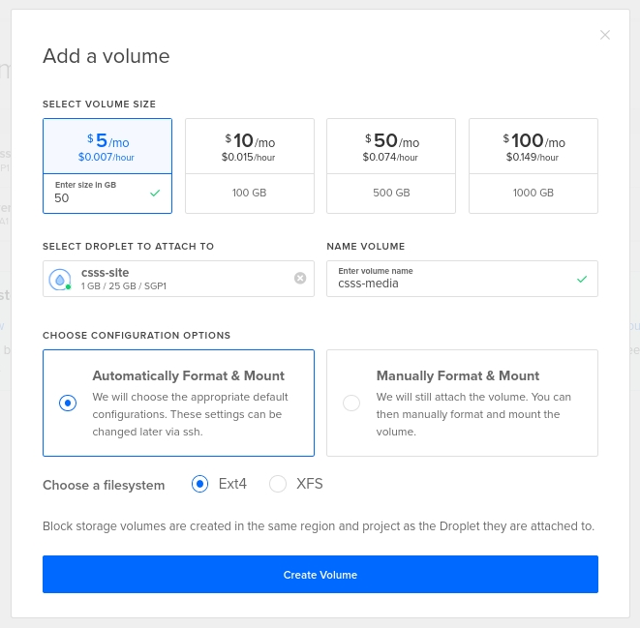
  - command to run after mount has been mounted
    - sudo chown -R csss: csss mnt

Commands to clone repo
  - cd /mnt/csss_media
git config credential.helper store
git clone https://csil-git1.cs.surrey.sfu.ca/CSSS/event-photos.git
git clone https://csil-git1.cs.surrey.sfu.ca/CSSS/merchandise.git
git clone https://csil-git1.cs.surrey.sfu.ca/CSSS/exec-photos.git

Setup Django Site
  - sudo apt-get install -y python3.7
curl https://bootstrap.pypa.io/get-pip.py -o get-pip.py
python3.7 get-pip.py --user
pip3.7 install virtualenv --user
python3.7 -m virtualenv csssENV
. csssENV/bin/activate
git clone https://github.com/CSSS/csss-site-in-dev.git
cd csss-site-in-dev/
python3.7 -m pip install -r requirements.txt
cd csss
python3.7 manage.py makemigrations
python3.7 manage.py migrate
python3.7 manage.py makemigrations elections
python3.7 manage.py migrate
python3.7 manage.py createsuperuser
ifconfig
export ip_addr='serverIP'
python3.7 manage.py runserver 0.0.0.0:8000

Setup Exec Info
  - create a json that matches following template in `exec_positions` folder
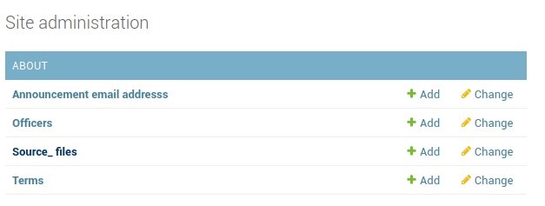
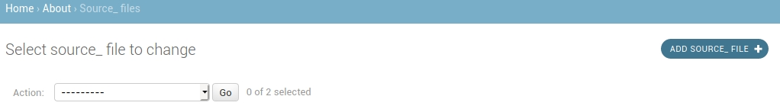

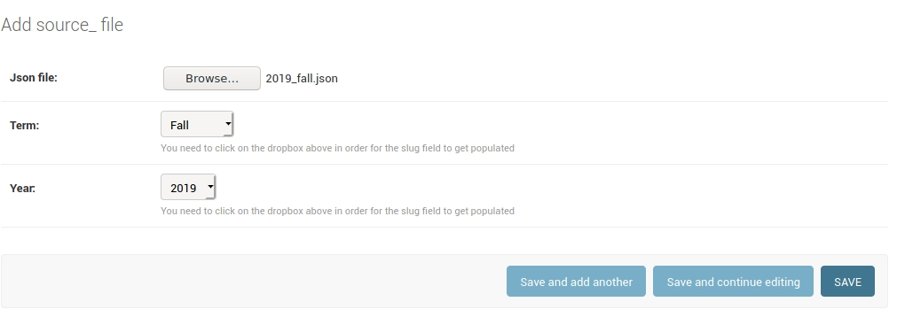
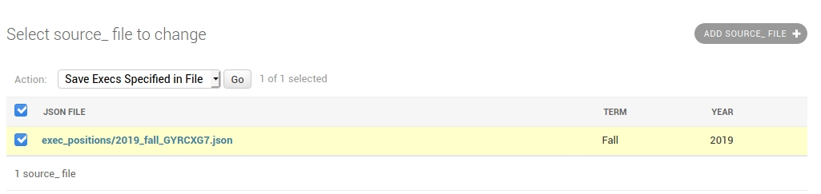

Setup Documents

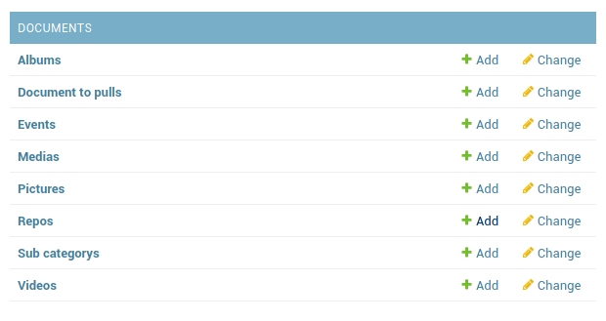

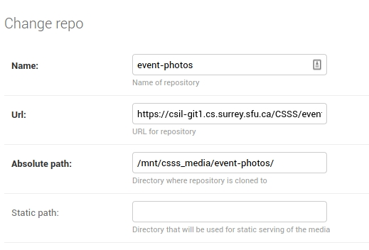

Name: event-photos
URL: https://csil-git1.cs.surrey.sfu.ca/CSSS/event-photos.git
Absolute Path: /mnt/csss_media/event-photos/

ln -s /mnt/csss_media/event-photos /home/jace/csss-site-in-dev/csss/documents/static/documents_static/event-photos

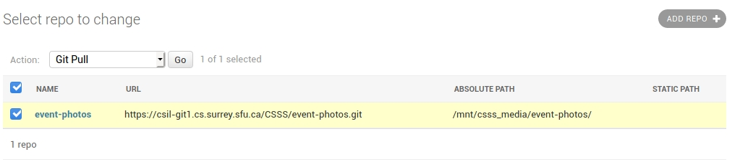

- Setup Mailbox
  - Sign into csss.website’s gmail and go to https://myaccount.google.com/security
  - Click on “App passwords”
  - generate a new password
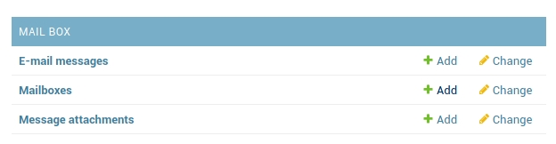
  - Click on “Add” for “Mailboxes”

  - Enter following in the fields
    - Name: csss gmail
    - URI:gmail+ssl://csss.website%40gmail.com:<appPassword>@imap.gmail.com?processed=processed
    - Make sure “active” is checked

