1. We repeat the photz measurement of HFF M0416 clusters from Shipley et al. 2018, using the same software (Eazy), configuration file, template, and catalog (i.e., Shipley's catalog, 19 filters, see table 1). The derived values are consistent with theirs, only 38/7431(~0.5%) have relatively large deviation (Figure 1), whose reason is unknown. For objects with specz(389/7431),the derived photz values are identical to theirs (Figure 2). By comparing with Specz, our scatters and outlier fractions are almost identical to their values. This indicates that the usage of Eazy on HFF (and previously on EGS) has no problem. We also take their seven HST bands photometry to derive photz, and compare with Specz, the scatter and outlier fraction become worse compare to that of using 19 filters, i.e.,scatter: 0.067 VS 0.037, outlier fraction: 32.4% VS 9.5% (Figure 3).

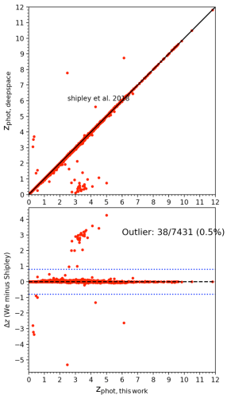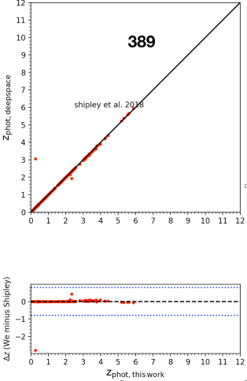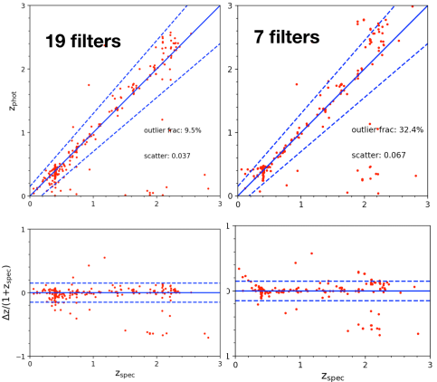

Figure 1 Figure 2 Figure 3

1. By using JWST NIRCam model flux ONLY, the photo-z accuracy can reach 18% outlier fraction (Figure 4). If HST NIR photometry is included, it helps to remove outliers. JWST model flux + HST aperture photometry gives best photo-z measurement (2.0% outlier fraction, see Figure 5). However, the heterogeneity in multi-band observations can affect the accuracy since the SNR in non-detection/ shallow exposure (e.g., Spitzer) can strongly affect chi^2. This requires a careful consideration of flux error input. Finally, compared with sfhz template(https://github.com/gbrammer/eazy-photoz/tree/master/templates/sfhz), Larson+2023 perform better (Figure 6). This is explained by the lack of high-z red populations in sfhz template.

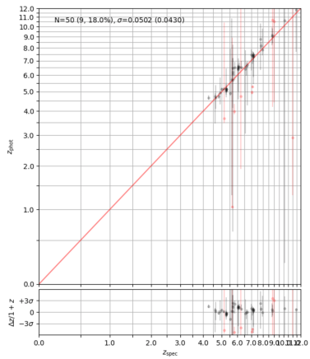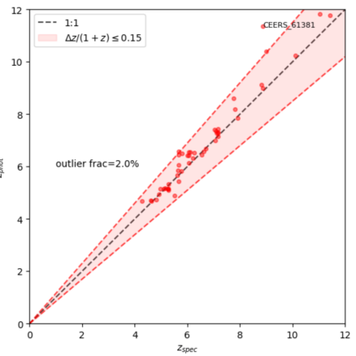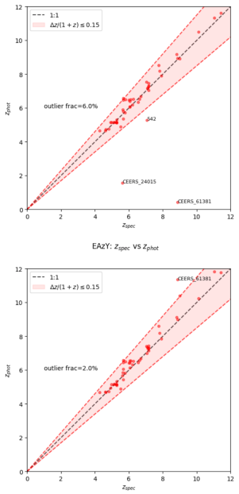

Fiugre 4 Figure 5 Figure 6

1. Using spectroscopically confirmed galaxies selected from MUSE-HUDF survey and subsequent mock AGNs created from the galaxy sample, we study the effect of AGN presence on photometric measurement using EAZY for sources with redshift 3~5.

We first measure the photometric redshift for our galaxy sample and compared with their spectroscopic redshift results. The photometric redshift are measured using EAZY, with photometry calculated from the 9-bands JWST NIRCam images in JADES field. Overall, templates named as “12_fsps_6_blue” have the best performance in terms of outlier fraction. This results agrees with Larson et al. 2023, from which this template is provided. The outlier fraction is significantly smaller when using GALFITM model flux than using segmentation flux. Especially for sources with the reddest color (Figure 7). Therefore, GALFITM model flux is generally a better choice over segmentation flux when running EAZY.

When running EAZY on mock AGN samples, we find that most AGNs with high Eddington ratio (larger than 0.1) and low dust-attenuation (Av<1.5) have bad phot-z results and are classified as outliers (90% outlier fraction). For AGNs with small Eddington ratio or large dust-attenuation, outlier fraction are low and remains constant (10%). See Figure 8.

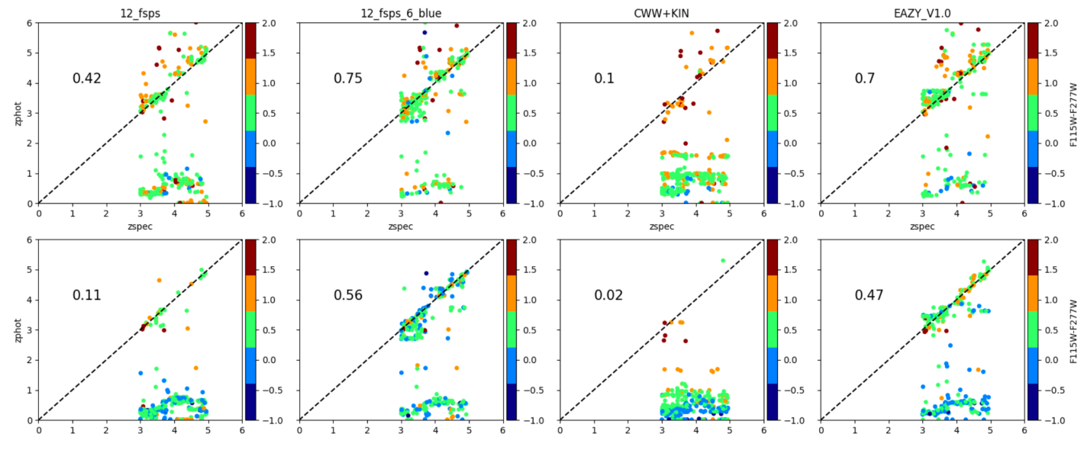

Figure 7

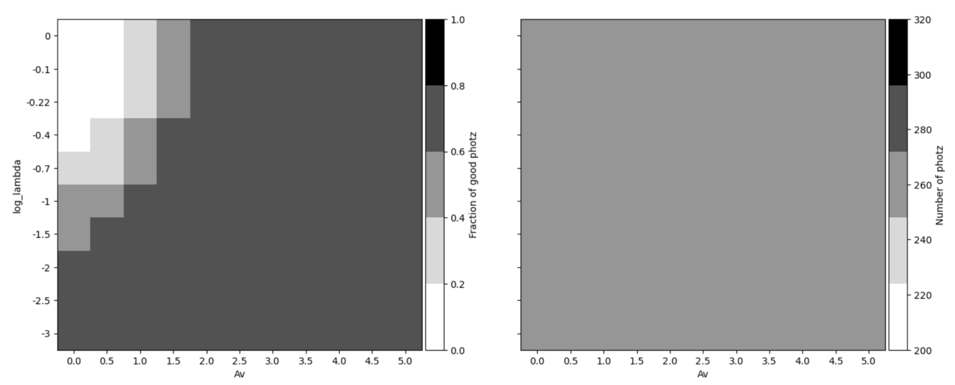

Figure 8

1. We use EAzy with 12fsps templates to derive photometric redshift (Figure 9). We find use only 7 JWST/Nircam bands(from F115W to F444W) only increase outlier by ～2%(14 of 706). But without the information from short wavelength, the most of outlier is caused by failure of catching Alpha/Balmer break. As higher SNRs in CEERS image, the chi-square results in EAzy becomes larger though our fitting results better.

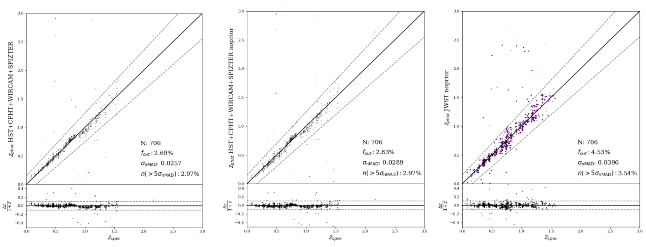

Figure 9

**Agenda for the next meeting:**

Chao: Try different templates to both Ship18 and our own seven HST band photometry.

Bingcheng: The current spec-z samples are suspected to have large publication bias (only well-agreed measurement will be shown in the paper/ galaxies with distinguishing SED feature like star forming will be discussed in the paper). Enlarge current spec-z sample to correct publication bias in the future. Investigate how to deal with heterogeneous photometry error.

Limin: confirm the photometry measurement in CEERS and give the final photometric redshift catalog.

Next meeting is on next Friday (2024.3.1) 2:00pm.