1. We use the existing catalog with HFF seven filters from Shipley2018 (their catalog has 19 filters in total) as the input catalog to derive photz with same configuration but different templates, and then compare with Specz (389 objects have Specz). We can see that the distribution is not sensitive to the templates (see Figure 1).

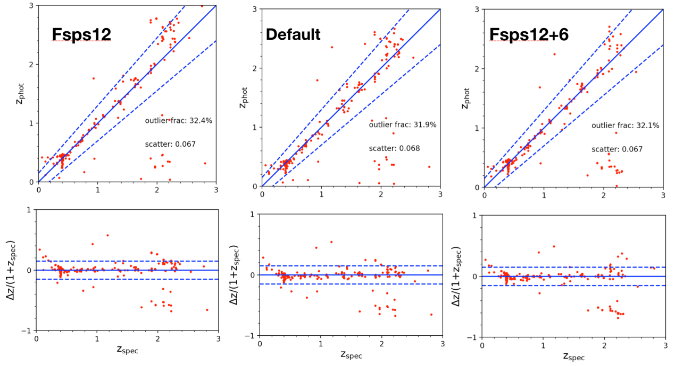

Figure 1

Since we have previously measured the same cluster as Shipley2018 (i.e., HFF/M0416), we use our SEDs and their template + configuration to re-derive Photz. The only difference is that our SEDs are from single Sersic model while their SEDs are from aperture photometry. Figure 2 shows the comparsion. We can see that the distribution is similar, except for cluster members at z=0.4. This is because cluster members are brighter and more extended, they are more sensitive to the background subtraction. So we need to fine tune our subtraction steps. In addition, our outlier fraction is lower because our sample with specz is 267 compared to their 389. So we conclude that for objects with Specz (i.e., bright objects), both Single Sersic method and aperture method can reach consistent results.

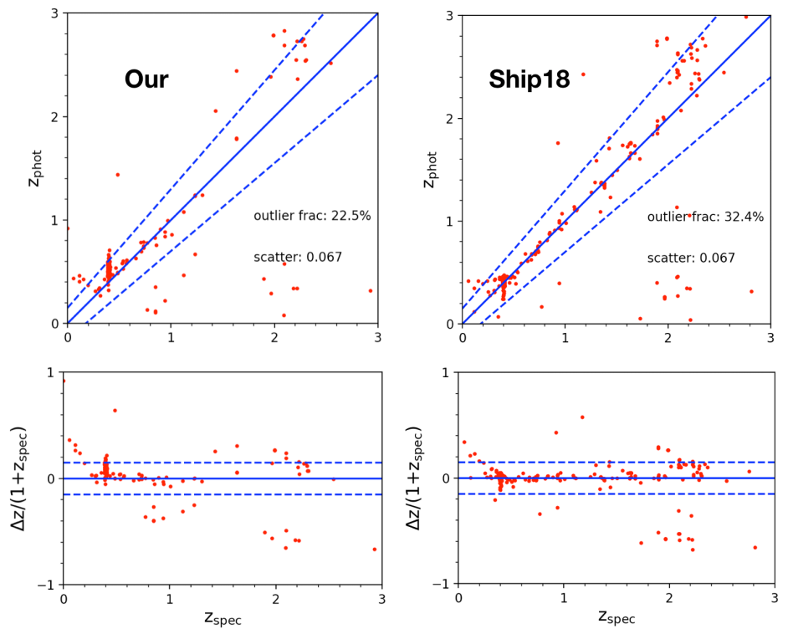

Figure 2

1. It seems some photometry issues in nircam module A and B. It is advisable not to modify the flux values, but the flux error can be adjusted appropriately. For JWST photometry, z_a in Eazy is a better choice (see Figure 3).

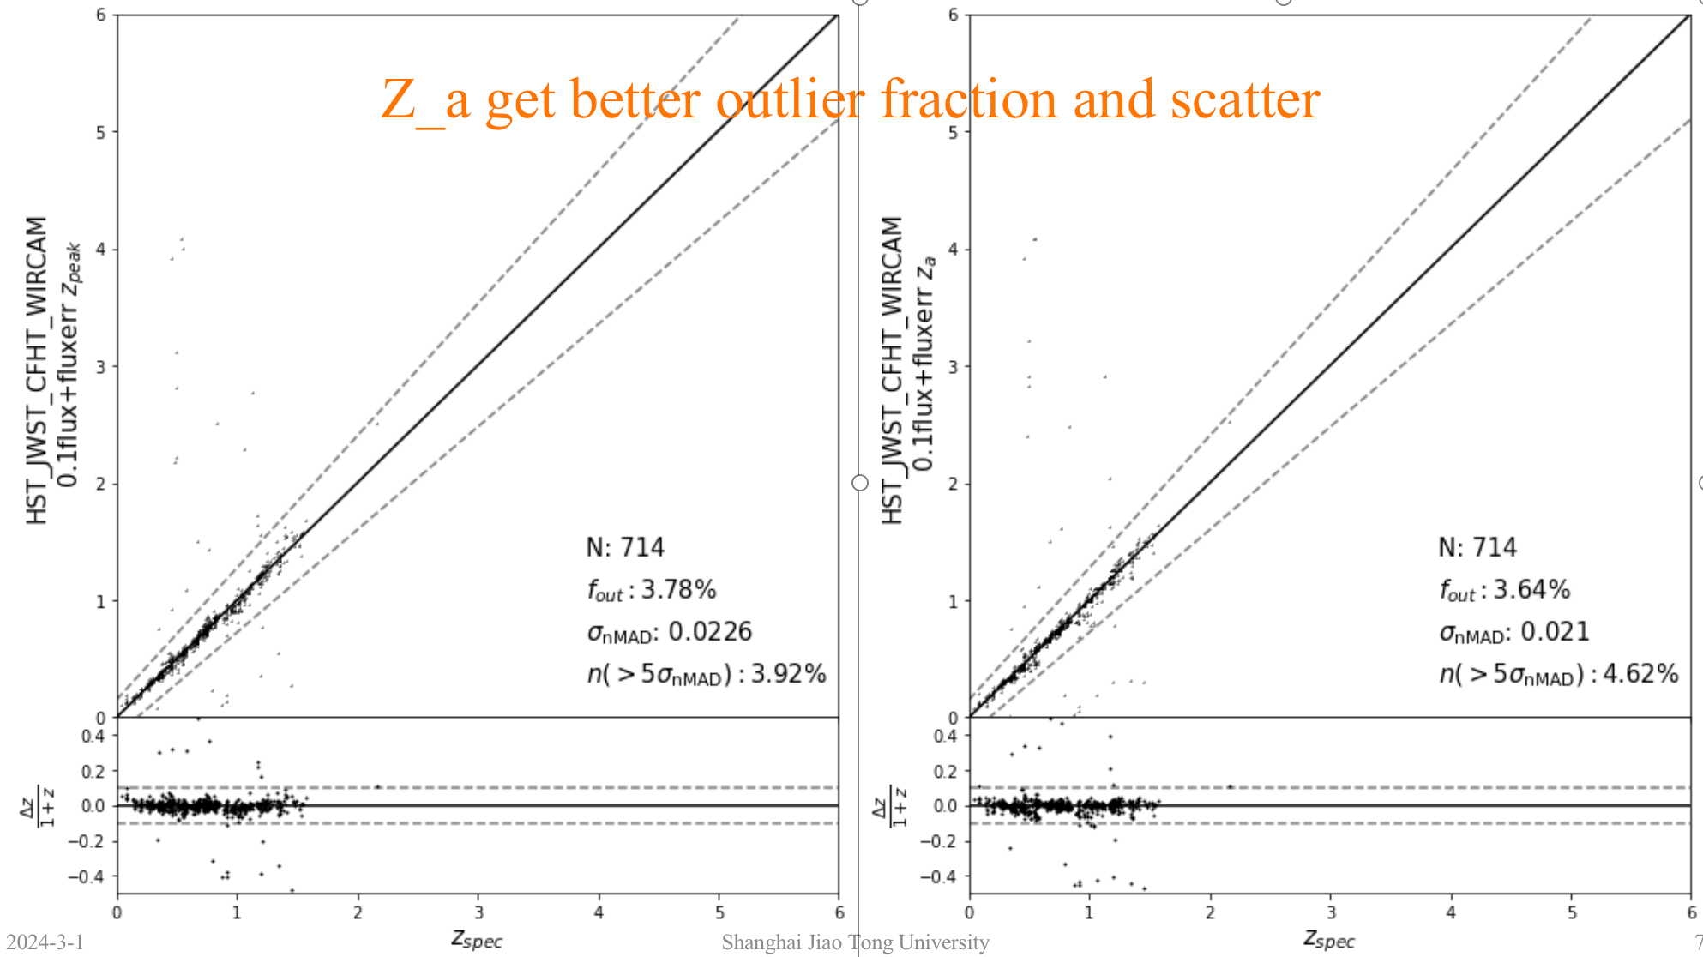

Figure 3

Agenda for the next meeting:

1. Chao: Compare Photz of faint objects from profile-fitting method and aperture method.

2. All: discuss and make the final document for our Photz meetings of recent several weeks (Probably next meeting is our last meeting for Eazy-Photz issue).