Lauren Krugen

TASK 3:

account - 60.2%

savings - 8.1%

checking - 7.1%

10.d: Eclemma provides branch coverage by evaluating the code by paths (white box). For instance, the withdraw() and deposit() methods in Savings and Deposit having conditional if statements that can result in different paths be executed in the methods.

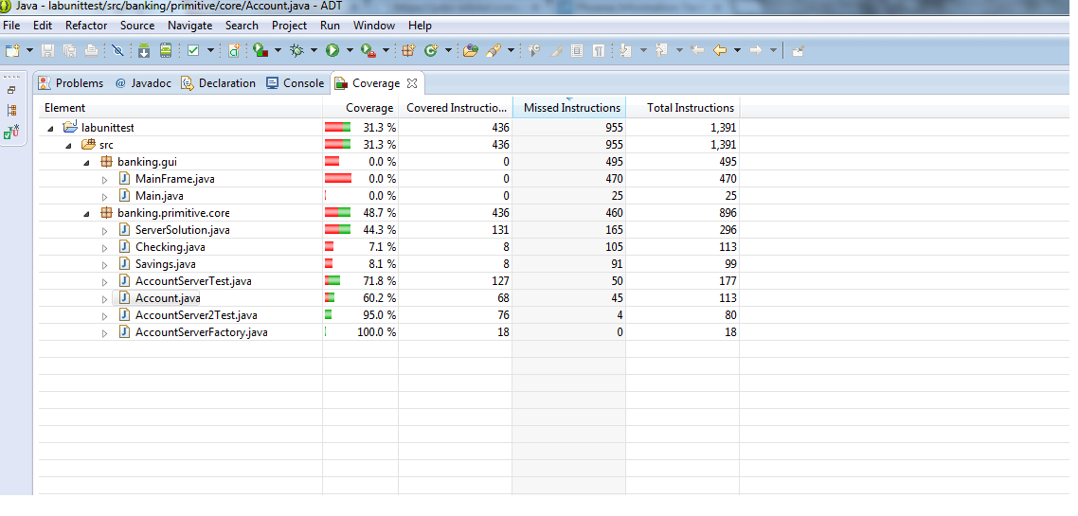

TASK 4:

13.a: Black box testing is complementary to white box testing in that, both should be done to effectively and thoroughly test software. For instance, testing only input and outputs from methods left lines from the remaining code inside of the functions/paths untested, as shown by the image below.

