**Yellow Team Members:**

* Jose Fernandez
* Linda Lee
* Kenneth Kopal
* Michael Rogers

**Opening Statement:**

This purpose of this System Requirements Document (SRD) is to illustrate the point of views of the client and developer requirements in creating this inventory software for all store items at Grand Canyon Hardware. The system will be utilized by Management, Purchasing (Parts), and the store clerks with the ability of having three types of access levels. The system will include functional, nonfunctional, data, and other important requirements.

**List of questions –**

1. What type of business do you conduct?

Grand Canyon Hardware is a local hardware store, traditional and family owned. We provide tools and equipment needed for homes and gardens.

1. Why do you need new software?

The company will need a new software to keep track of all inventory that is being sold at the store. We need to keep track of plumbing tools and supplies, the equipment for lawn and garden, electrical tools and all other equipment being sold.

1. What goals will be accomplished by deploying new software?

The new software will make sure that our store inventory is properly maintained. It will also allow for management to check if items are missing due to theft or damage by counting and comparing to the software inventory. Store employees will be able to assist customers with information about quantity of items available.

1. Who will be using the software?

General Manager, Purchasing Department, store clerks. All with different access levels.

1. What systems will the software be running on? Workstations and/or mobile?

The system will be running on workstations using the Windows OS.

1. Who is expected to provide training on the new software?

Developing team will provide initial training to senior employees or shift supervisors. The senior employee, or shift leader/supervisor will train other employees at the store.

1. What types of functional features are required?

The software will to be able to add, delete items from the inventory list. It will also need to show equipment quantity. The software will also need to send alerts when quantity is low for an item. A search function that allows you to see the number of a particular item sold during a set amount of time. Software also needs the ability to display specific details of each item the store sells.

1. What types of quantity are needed?

Numerical whole numbers with a maximum of 999.

1. Is there a need for tracking the use of the inventory?

No.

1. Is there a need for tracking last purchased from and cost?

Yes, to have a better way to calculate profits.

1. What types of non-functional features are required?
2. How long should data be stored?

Data should be stored for a minimum of ten years to allow management to review previous year’s sales trends to see patterns and be prepared.

1. Do you already have a storage and backup plan in place?

Data and backup will be stored offsite at a datacenter.

1. How quickly does data need to be updated?

Data should be updated continuously to allow changes to reflect immediately.

1. Will software need to have the ability to be upgraded over time?

Yes, to be able to add new features.

**Summary of Client Needs:**

Grand Canyon Hardware is wanting a new inventory system to manage current and incoming inventory. The system will allow multiple departments to get real-time updates as items are added or removed from inventory. Real-time updates will provide store clerks with the ability to better assist customers, and prevent the purchasing department from overstocking items that are not selling quickly. Alerts will also be generated when stock is low to allow the purchasing department to order new inventory as needed.

The system will be designed to function on desktop workstations using Windows. The system should enable certain permissions based on the credentials of the user. Depending on the level of access, a user needs to be able to add new items, delete existing items, update quantities, search for a specific item, and view the details of all items. Data will need to be stored to enable tracking of trends, but a backup solution is not needed. Finally, the software should be designed in a way that allows for continuous upgrades over time as the client sees fit.

**Use Cases**

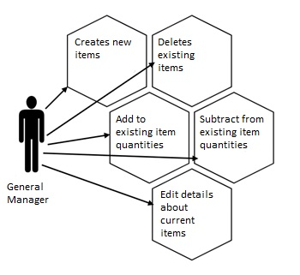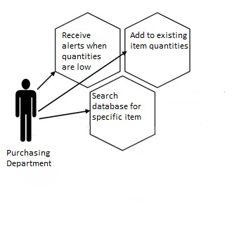

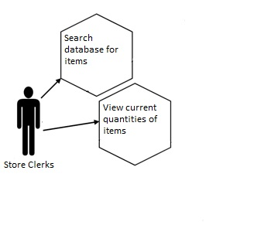

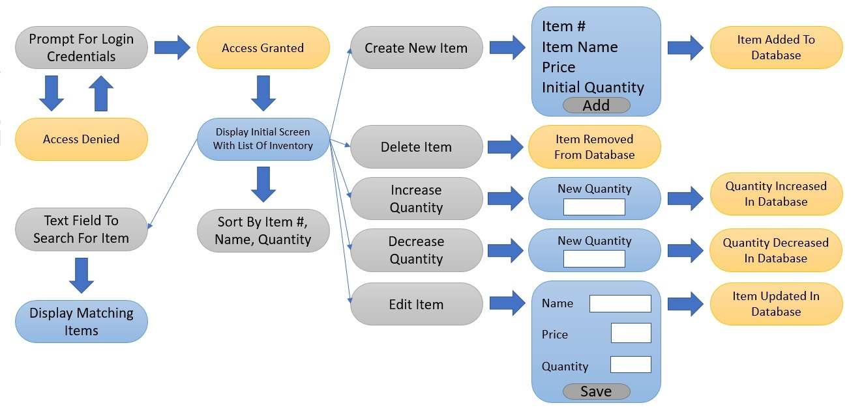**Storyboard**

**Grey** -These are action buttons that users can select.

**Blue** –New screens that will appear when action button is clicked.

**Yellow** – Results of action buttons.