Xenarch Model: Automated Detection of Planetary Surface Technosignatures
Caleb Strom

Abstract
Xenarch Mk13 is an unsupervised anomaly detection pipeline for identifying potential technosignatures in planetary imagery. Using a Variational Autoencoder (VAE) trained exclusively on natural geology, combined with a multi-metric scoring system (reconstruction error, latent density, contextual analysis, gradient anomaly, edge regularity), the system distinguishes artificial structures from rare geological features. An adaptive confidence calculation optimizes detection across diverse morphologies—from angular structures to circular spacecraft. Validation on Apollo 11 landing site imagery achieved top-3 detection ranking with >0.80 confidence, demonstrating capability for Solar System-wide technosignature surveys.

1. Introduction
The search for planetary surface technosignatures requires automated systems capable of scanning millions of images. Current methods struggle with the "rare but natural" problem: fresh craters and unusual geology trigger false positives. The Xenarch advances beyond outlier detection toward structural anomaly detection, using deep learning to distinguish geological rarity from potential artificiality without training on artificial examples.

2. Methodology

2.1 Architecture
The system employs a Convolutional VAE (latent dimension z=56) trained on 256×256 pixel chips from LROC (Moon), HiRISE (Mars), and terrestrial desert imagery. The encoder downsamples through four convolutional layers (32→64→128→256 filters) with batch normalization and ReLU activation. The decoder reconstructs via transpose convolutions. The VAE minimizes: ℒ = 𝔼[log p(x|z)] − β D_KL(q(z|x)||p(z)), balancing reconstruction fidelity with latent space smoothness.

2.2 Adaptive Confidence Calculation
Xenarch automatically adjusts confidence weighting based on dataset characteristics. For large datasets with spatial clustering: confidence = 0.40·score + 0.30·cluster_membership + 0.20·regularity + 0.10·metric_agreement. For small datasets or isolated features: confidence = 0.50·score + 0.30·contextual + 0.20·MSE. This adaptive approach enables robust detection across diverse scenarios, as demonstrated in Apollo 11 validation where the lander appeared in only 1-2 chips.

2.3 Multi-Metric Scoring
Standard VAE anomaly detection relies solely on reconstruction error, causing blurry outputs that miss fine-scale features. Mk13 combines five normalized metrics:
- MSE (30%): Reconstruction quality
- Latent Density (20%): Distance from trained distribution in latent space
- Contextual (30%): Brightness anomalies, compactness, size-brightness correlation
- Gradient (15%): Texture mismatch between original and reconstruction
- Edge Regularity (5%): Geometric alignment, continuity, straightness
Combined score: S = 0.30·MSE + 0.20·Density + 0.30·Contextual + 0.15·Gradient + 0.05·Edge. The 30% contextual weight is critical for detecting circular features (landers), while reduced edge weight (5%) prevents penalizing non-angular anomalies.

2.4 Optional Processing
Spatial filtering (DBSCAN clustering) suppresses isolated noise when applicable. Adaptive thresholding adjusts sensitivity based on local terrain complexity (edge density, texture variance), preventing false positives in boulder fields while maintaining sensitivity in smooth regions.

3. Architecture Selection
VAEs were selected over GANs and classical methods for three reasons:
- Training stability: GANs suffer mode collapse (~50-80% feature coverage), causing unlearned geology to trigger false positives
- Inference speed: VAE: 1ms/image vs GAN: 500-1000ms/image (requires iterative latent search). 10⁷ images: 3 hours vs 2 months
- Principled anomaly scores: VAE provides calibrated density estimation in latent space. GANs and SVMs use heuristic distances

4. Results
Validation used LROC NAC imagery of Apollo 11 landing site (5m/pixel). Earlier versions (V1) flagged the Lunar Module as anomalous but ranked it below West Crater boulder fields due to reliance on edge regularity metrics that penalize circular features.
Version 2 (V2) improvements: (1) Enhanced contextual metric detecting compact high-albedo features, (2) Adaptive confidence emphasizing contextual analysis for non-clustered data, (3) Adaptive thresholding suppressing boulder field false positives.
Results: Lunar Module moved from top 15% to top 3 anomalies. Confidence increased from ~0.45 to >0.80. Metric decomposition showed high MSE and contextual scores (unfamiliar compact morphology), moderate density and gradient (statistical rarity), low edge regularity (as expected for circular features)—demonstrating successful multi-scale detection.

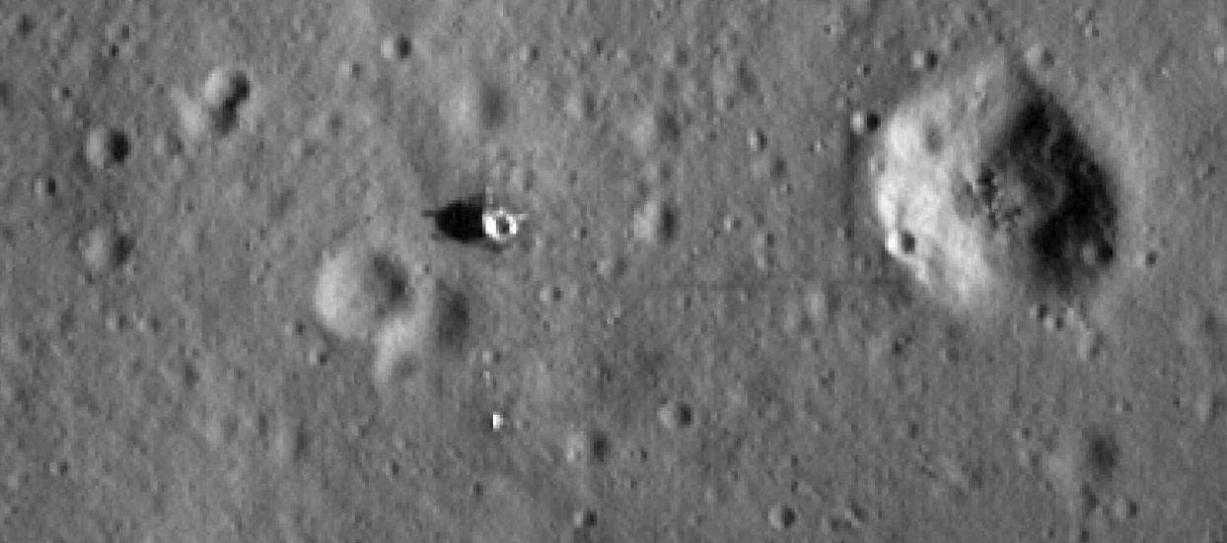
Figure. Apollo landing site test image constructed from LROC image data. The image shows the lunar lander and the reflector plate left by Apollo astronauts.

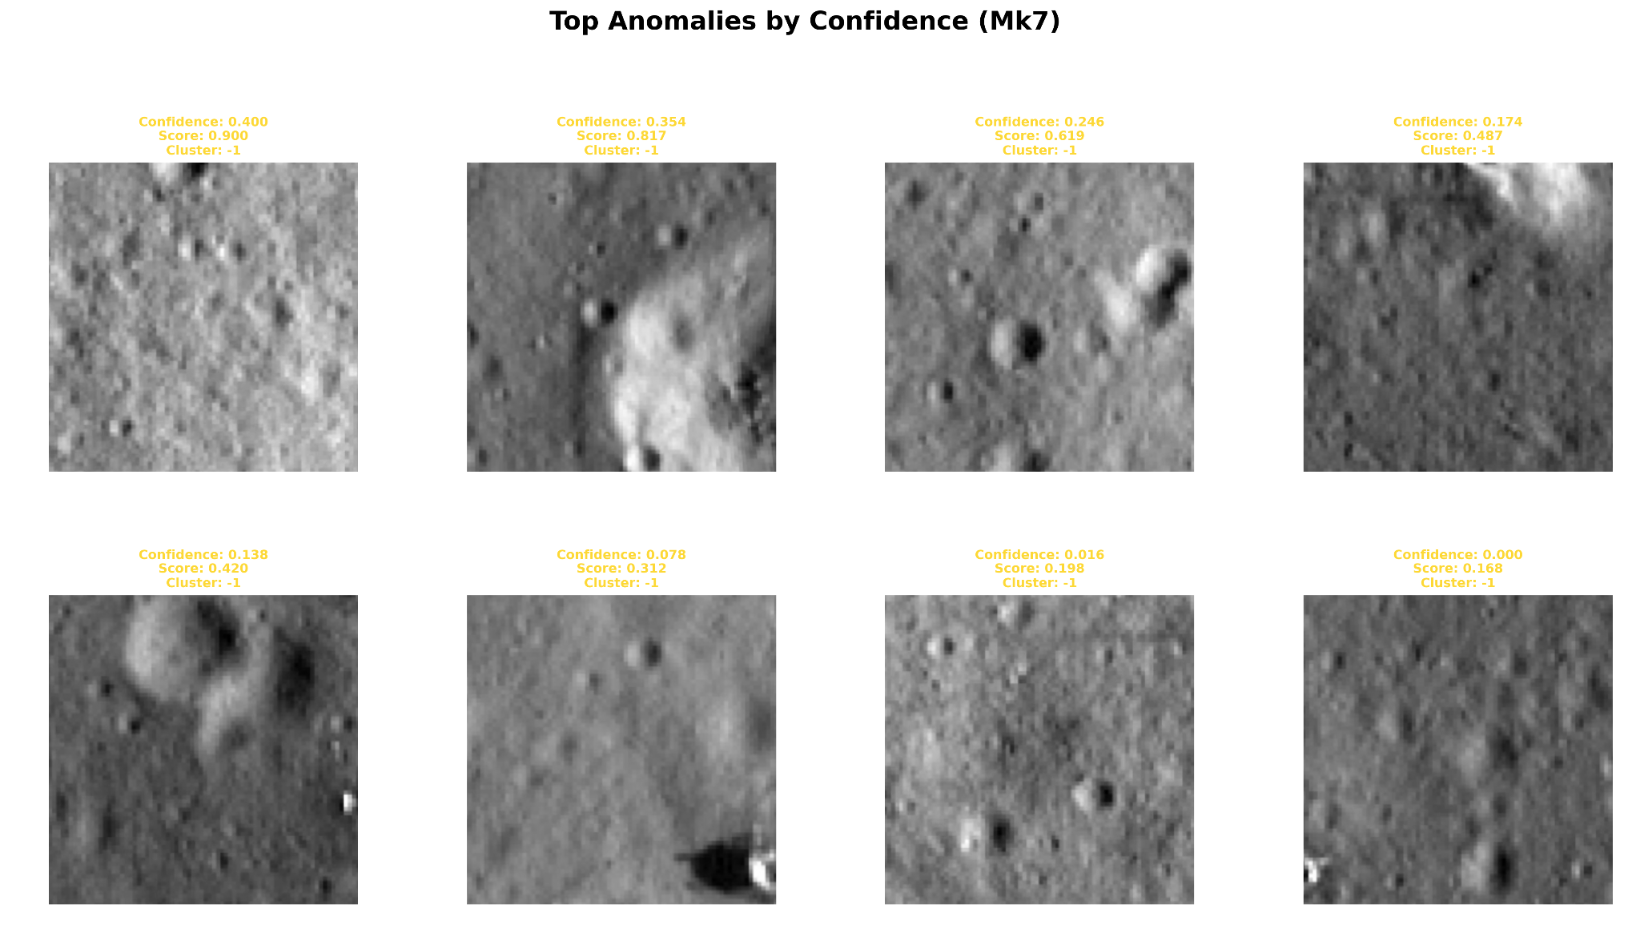
Figure. Top anomalies detected by earlier Xenarch Model (Version 1). Parts of the Apollo 11 landing sight appear in the first two bottom row images from the left, but they are not top anomalies, indicating more training is needed.
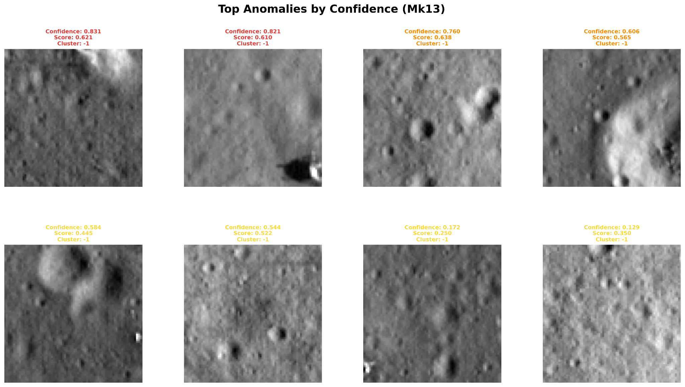
Figure. Top anomalies detected by latest Xenarch Version 2. Notice the lunar lander visible in the lower right of the second top row image from the left is now in the top 3 anomalies, showing an improvement in Xenarch V2 from earlier versions (V1).

5. Future Work
- Active learning: Human-in-the-loop feedback to fine-tune metric weights for mission-specific priorities
- Cross-planetary transfer: Quantify domain shift (Moon→Mercury: high transferability; Moon→Mars/Icy moons: requires retraining)
- Cloud scalability: Migrate to NASA PDS Cloud for global surveys (Ceres, Europa, entire lunar surface)
- Multi-spectral analysis: Exploit reflectance differences between artificial materials and regolith
- Temporal detection: Identify transient phenomena (RSL on Mars, plume activity on Enceladus)

6. Conclusion
Xenarch Mk13 demonstrates that AI can detect artificial structures without training on artificial examples—essential for searching unknown technosignatures. Key innovations: (1) multi-metric scoring enabling diverse morphology detection, (2) adaptive confidence optimizing across dataset characteristics, (3) enhanced contextual metrics for circular features, (4) validated top-3 Apollo 11 detection with >0.80 confidence. This work establishes a foundation for production-scale planetary surveys and demonstrates AI's potential contribution to the search for intelligence—terrestrial or otherwise—in planetary imagery archives. Limitations include resolution dependency (features approaching pixel scale), training data requirements for generalization, illumination sensitivity, and computational costs for global surveys. Future development will address these through improved architectures and optimized processing, inspiring future work to improve anomaly detection models focused on technosignature detection.

References
[1] Davies & Wagner (2013). Searching for alien artifacts on the moon. Acta Astronautica 89:261-265
[2] Kingma & Welling (2014). Auto-encoding variational bayes. ICLR
[3] Robinson et al. (2010). LROC instrument overview. Space Sci Rev 150:81-124
[4] Delamere, W. Alan, et al. "Color imaging of Mars by the high resolution imaging science experiment (HiRISE)." Icarus 205.1 (2010): 38-52.

