UC-1 Register User

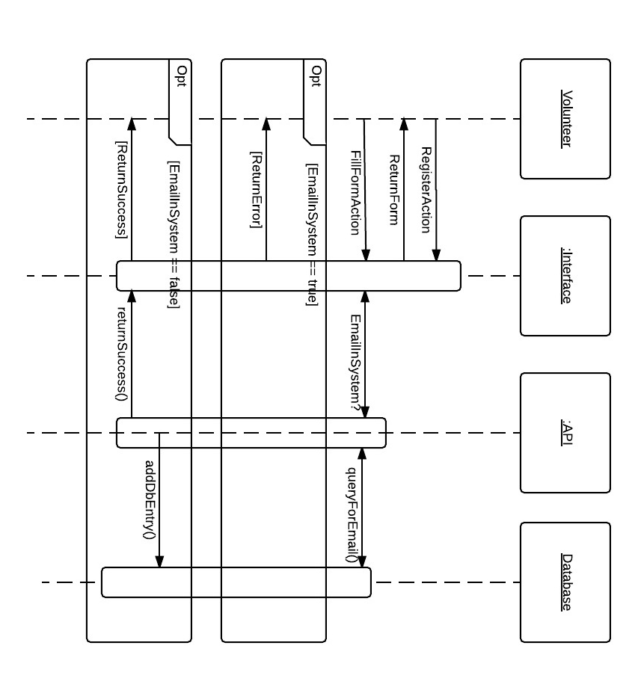

UC-2 User Login

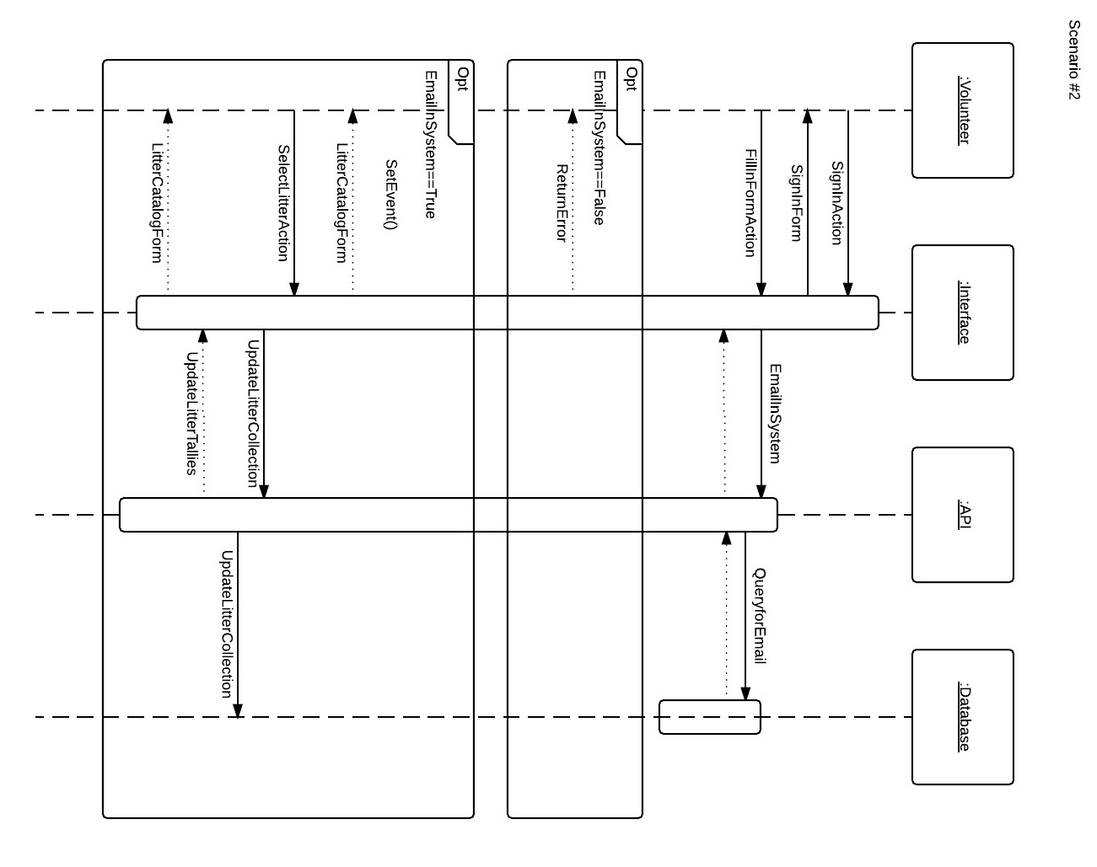

UC-3 Event Login

UC-4 Litter Collection