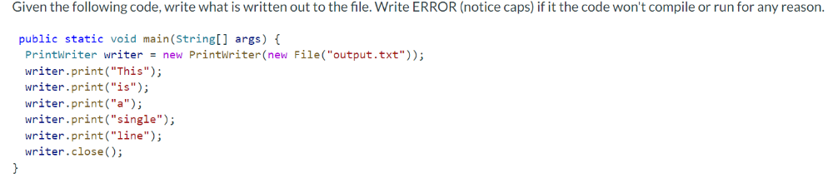
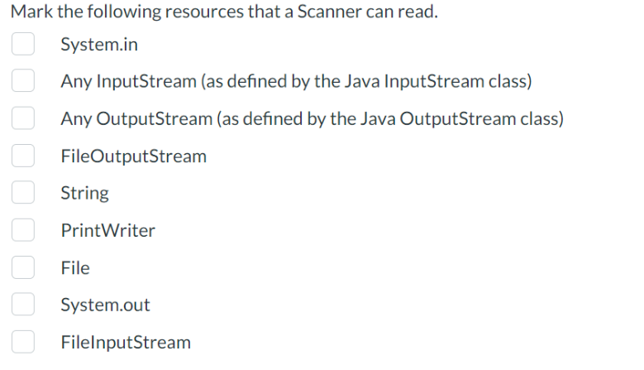
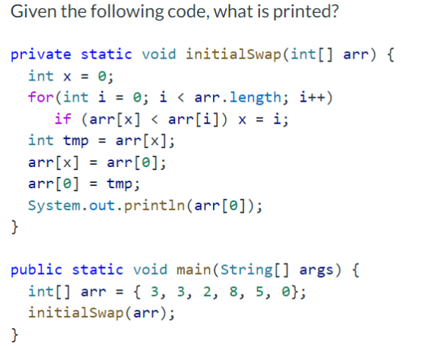
public static RoseColor getColor(String meaning) {
RoseColor rtn;
switch (meaning.toLowerCase()) {
case "purity":
rtn = RoseColor.WHITE;
break;
case "jealousy":
case "friendship":
rtn = RoseColor.YELLOW;
break;
case "sincerity":
rtn = RoseColor.PEACH;
break;
case "elegance":
rtn = RoseColor.PINK;
break;
case "passion":
rtn = RoseColor.RED;
default:
rtn = RoseColor.BLACK;
}
return rtn;
}

