Names: ______________________________________________________________________________

1. Use the UML class diagram presented below to identify the class name, attributes, and methods. Indicate the visibility of the attributes and methods.

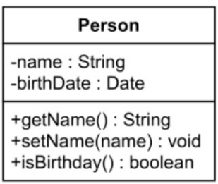

1. Use the Javadocs descriptions provided in the code below to implement the methods and make the correct calls in main.

public class WSWeek3 {  
 */**  
 * Main method used to call other methods  
 * @parameter String args[]  
 */* public static void main(String args[]){  
 *//write the instructions necessary to call the  
 //methods you will implement* }  
 */**  
 * minMax method  
 * Asks the user to enter the total number to be read.  
 * Determines and print the min and max of the numbers read.  
 * @param Scanner in  
 */  
  
 /**  
 * factorial method  
 * calculates the factorial of a number  
 * @param int num - number to calculate the factorial  
 * @return factorial of num  
 */  
  
 /**  
 * perfectNumber method  
 * verifies if a number is a perfect number.  
 * A perfect number is a positive integer that is equal to the  
 * sum of its positive divisors, excluding the number itself.  
 * For instance, 6 has divisors 1, 2 and 3 (excluding itself),  
 * and 1 + 2 + 3 = 6, so 6 is a perfect number.  
 * @param int num  
 * @return boolean - true if num is a perfect number, false otherwise  
 */*}