CS163/164 – Strings Worksheet

1. Review the following String methods.

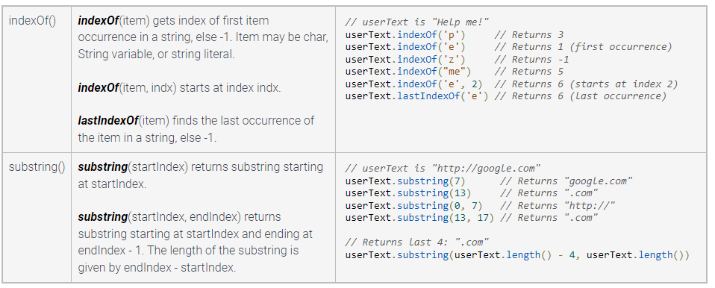

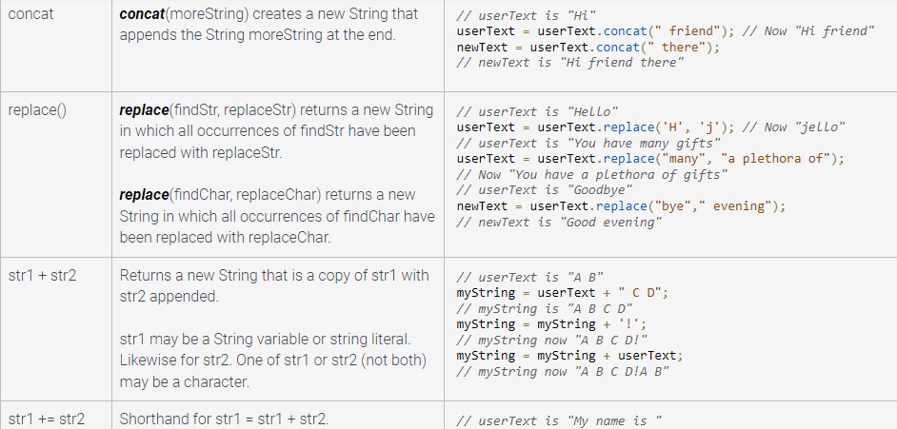

1. Considering your understandings from your review. What are the exact outputs in the program below?

**public class** StringMethods {  
 **public static void** main(String args[]){  
 String fullDayString = **"09/30/2022"**;  
 String month = fullDayString.substring(0,fullDayString.indexOf(**"/"**));  
 String day = fullDayString.substring(3,5);  
 String year = fullDayString.substring(6);  
 System.***out***.println(**"Day: "** + day);  
 System.***out***.println(**"Month: "** + month);  
 System.***out***.println(**"Year: "** + year);  
 }  
}

For the activities below, write your solution in English first, think about each step that needs to be done and after that you can transform your solution to Java code.

Complete the class StringMethods provided to:

1. Write a method that receives a String and build a new String containing only the characters that are letters.
2. Write a method that receives a String, build a new String containing all characters that are digits, transforms and return that String into a long.
3. Write a method that receives a String and a char and returns the number of times that the char appears in the String.