1. Mark all options that are considered an Input Streams in Java:

|  |  |  |
| --- | --- | --- |
| ( ) System.out | ( x ) System.in | ( x ) String |
| ( x ) File | ( ) FileOutput | ( x ) FileInput |

1. Write the exact output of the program below, if we run it.

public static void example4(){  
 String line = "This is a message\nComposed by\nThree lines";  
 Scanner scanner = new Scanner(line);  
 int tokenCounter = 0;  
 while(scanner.hasNext()) {  
 tokenCounter++;  
 System.*out*.println(scanner.next());  
 }  
 System.*out*.println(tokenCounter);  
}

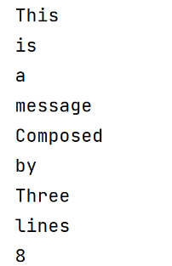

1. Write the exact output of the program below, if we run it.

public static void example5(){  
 String line = "This is a message\nComposed by\nThree lines";  
 Scanner scanner = new Scanner(line);  
 int tokenCounter = 0;  
 while(scanner.hasNext()) {  
 tokenCounter++;  
 System.*out*.println(scanner.nextLine());  
 }  
 System.*out*.println(tokenCounter);  
}

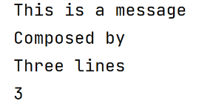

1. Assuming that you have a class Person with the following constructor and a txt file with the following format, analyze the code below and explain if it is correct or incorrect.

|  |  |
| --- | --- |
| public Person(String name, int years){  setName(name);  setYearsOld(years); } |  |

This is correct, the method is reading a file and creating Person objects from each line of the file.

After creating the Person object, that object is added to an ArrayList of Person.

After reading all the file, the ArrayList of Person is returned.

public static ArrayList<Person> readFilePerson(String fileName){  
 ArrayList<Person> list = new ArrayList<>();  
 try {  
 Scanner fileIn = new Scanner(new File(fileName));  
 String name = "";  
 int years = 0;  
 while(fileIn.hasNext()) {   
 String line = fileIn.nextLine();  
 Scanner sLine = new Scanner(line);  
 sLine.useDelimiter(",");  
 String nameS = sLine.next();  
 String yearsS = sLine.next();  
 name = nameS.substring(0, nameS.indexOf(":"));  
 years = Integer.*parseInt*(yearsS.substring(yearsS.indexOf(":")+1));  
 Person p = new Person(name, years);  
 list.add(p);  
 }  
 }catch(IOException ex) {  
 System.*err*.print("Error reading file!");  
 ex.printStackTrace();  
 }  
 return list;  
}