计算机程序设计基础（C++）

实验报告

专业班级：软件工程2205

学号：220518

姓名：朱嘉辉

实验报告成绩：

|  |  |
| --- | --- |
| **实验** | **实验五** |
| **成绩** |  |

批阅教师:

**实验五 类与对象**

**一．实验目的与要求**

1. 掌握声明类的方法，类和类的成员的概念以及定义对象的方法。
2. 初步掌握用类和对象编制基于对象的程序。

3、学习检查和调试基于对象的程序

1. **实验内容**

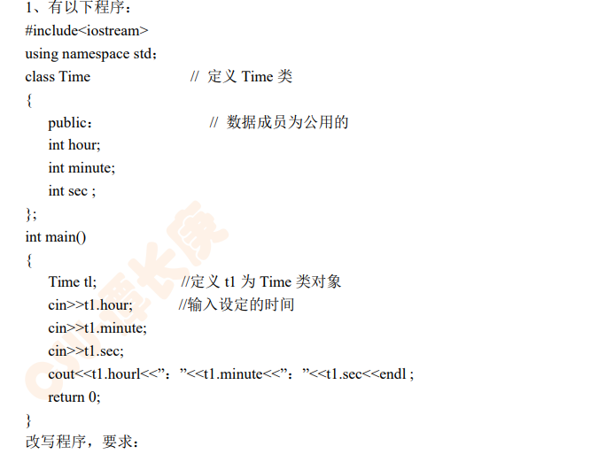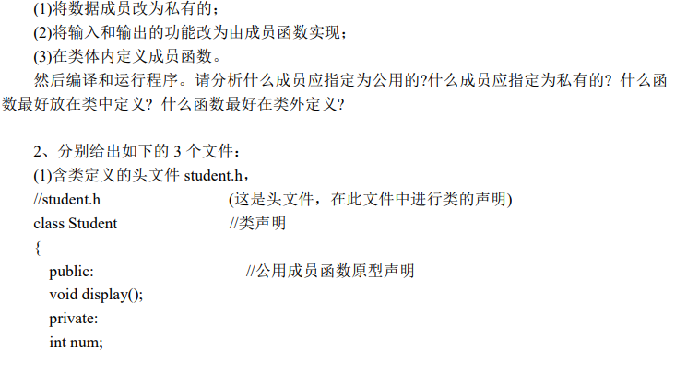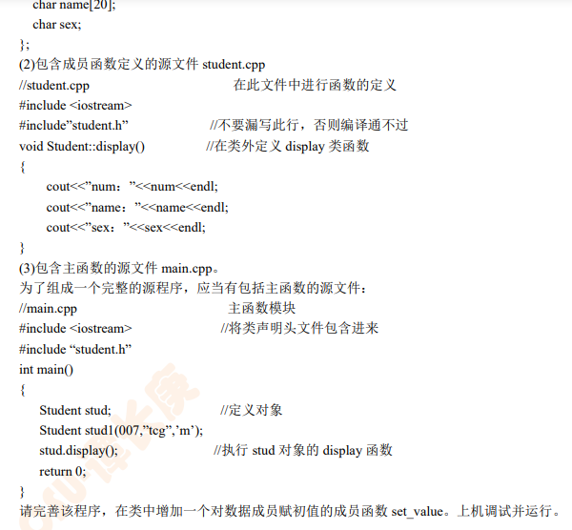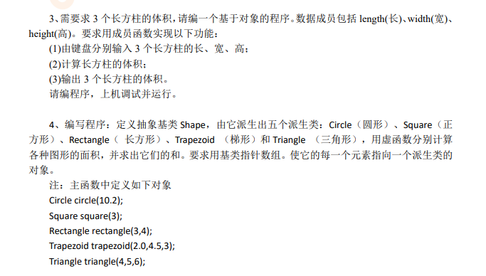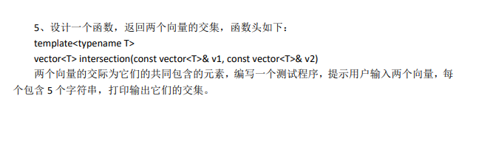

1. **算法分析、程序与结果**

1.#include<iostream>

using namespace std;

class Time

{

private://属性指定为私有

int hour;

int minute;

int sec;

public://函数（方法）可指定为公有

setTime()

{

int h,m,s;

cout<<"输入时间:"<<endl;

cin>>h>>m>>s;

hour=h;

minute=m;

sec=s;

}

showTime()

{

cout<<hour<<":"<<minute<<":"<<sec<<endl;

}

} ;

int main()

{

Time t1;

t1.setTime();

t1.showTime();

system("pause");

return 0;

}

2.

//student.h

#include<string>

#include<iostream>

using namespace std;

class Student

{

private:

int num;

string name;

char sex;

public:

void display();

Student(int num,string name,char sex)

{

this->num=num;

this->name=name;

this->sex=sex;

}

};

//student.cpp

#include<iostream>

#include"student.h"

using namespace std;

void Student::display()

{

cout<<"num: "<<num<<endl;

cout<<"name: "<<name<<endl;

cout<<"sex: "<<sex<<endl;

}

//main.cpp

#include<iostream>

#include"student.cpp"//已含有 student.h

//不能include"student.h",否则会引起重复报错

using namespace std;

int main()

{

Student stud1(007,"tcg",'m');

stud1.display();

system("pause");

return 0;

}

结果如下：

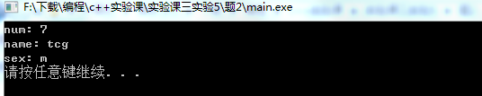

3.#include<iostream>

using namespace std;

class zhuti

{

private:

double len;

double wid;

double hei;

public:

setzhuti()

{

double l,w,h;

cin>>l>>w>>h;

len=l;

wid=w;

hei=h;

}

volume()

{

double v;

v=len*wid*hei;

return v;

}

};

int main()

{

zhuti z[3];

cout<<"输入第一个长方柱：" ;

z[0].setzhuti();

cout<<endl;

cout<<"输入第二个长方柱：" ;

z[1].setzhuti();

cout<<endl;

cout<<"输入第三个长方柱：" ;

z[2].setzhuti();

cout<<endl;

for(int i=0;i<3;i++)

{

cout<<"第"<<i+1<<"个体积为："<<z[i].volume()<<endl;

}

system("pause");

return 0;

}

结果如下;

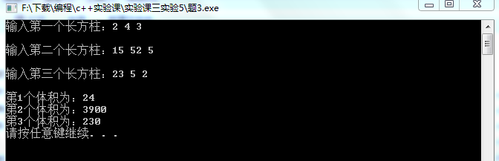

4.#include<iostream>

#include<cmath>//使用了sqrt求平方根函数

using namespace std;

class Shape{

public:

virtual double area()=0;//定义了一个纯虚函数，产生抽象类

//虚函数是为了实现函数重载,只有在有了对象时才能调用

};

const double pi=3.1415926;//圆周率

class Circle:public Shape{//圆

private:

double radius;

public:

Circle(double radius)

{

this->radius=radius; //使用this时没有弹框说明构造函数名写错了

}

double area()

{

return pi*radius*radius;

}

};

class Square:public Shape{//正方形

private:

double a;

public:

Square(double a)

{

this->a=a;

}

double area()

{

return a*a;

}

};

class Rectangle:public Shape{//长方形

private:

double b;

double c;

public:

Rectangle(double b,double c)

{

this->b=b;

this->c=c;

}

double area()

{

return b*c;

}

};

class Trapezoid:public Shape{//梯形

private:

double a;//上底

double b;//下底

double h;//高

public:

Trapezoid(double a,double b,double h)

{

this->a=a;

this->b=b;

this->h=h;

}

double area()

{

return (a+b)*h*0.5;

}

};

class Triangle:public Shape{//三角形

private:

double a;

double b;

double c;

public:

Triangle(double a,double b,double c)

{

this->a=a,this->b=b,this->c=c;

}

double area()

{

double p=(a+b+c)*0.5;//海伦公式

return sqrt(p*(p-a)*(p-b)*(p-c));

}

};

int main()

{

Shape *point[5];//对象指针数组

Circle circle(10.2);

Square square(3);

Rectangle rectangle(3,4);

Trapezoid trapezoid(2.0,4.5,3);

Triangle triangle(4,5,6);

point[0]=&circle;

point[1]=&square;

point[2]=&rectangle;

point[3]=&trapezoid;

point[4]=&triangle;

char *name[5];//使用字符串初始化指针，指针指向首字母地址

name[0]="circle";

name[1]="square";

name[2]="rectangle";

name[3]="trapezoid";

name[4]="triangle";

cout<<"求得图形面积为："<<endl;

double sum=0;//面积和计数器

for(int i=0;i<5;i++)

{

cout<<i+1<<"、"<<name[i]<<"： "<<point[i]->area()<<endl;

sum+=point[i]->area();

}

cout<<endl;

cout<<"所有图形面积和为："<<sum<<endl;

system("pause");

return 0;

}

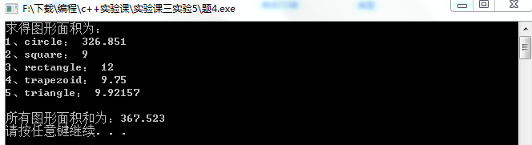

5.

#include<iostream>

#include<vector>

#include<algorithm>

using namespace std;

void Myprint(int val)

{

cout<<val<<" ";

}

int main()

{

int t;

vector<int> v1;

cout<<"Input the first vector"<<endl;

for(int i=0;i<5;i++)

{

cin>>t;

v1.push_back(t);

}

vector<int> v2;

cout<<"Input the second vector"<<endl;

for(int i=0;i<5;i++)

{

cin>>t;

v2.push_back(t);

}

vector<int> v3;

v3.resize(min(v1.size(),v2.size()));

vector<int>::iterator last = set_intersection(v1.begin(),v1.end(),

v2.begin(),v2.end(),v3.begin());

for_each(v3.begin(),last,Myprint);

system("pause");

return 0;

}

**四．问题与解决办法**

对STL编程还不是太了解，在CSDN上查找了相关资料

1. **体会**

面向对象是C++语言的最大特征，类与对象在c++编程中尤为重要，我需要继续深入学习。