**实验报告**

**软件工程2205**

8209220507

黄劲文

实验一：

实验目的：理解并运用c++程序的一些基本操作。

1、#include<iostream>

using namespace std;

int main()

{

int i = k + 1;

cout << i++ << endl;

cout << "Welcome to C++!"<<endl;

return 0;

}

2、#include<iostream>

using namespace std;

const float π = 3.1415926; double r, h;

int main()

{

while (cin >> r >> h)

cout << π * r * r * h / 3 << endl;

return 0;

}

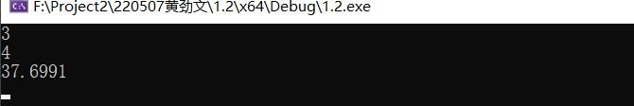

3、#include<iostream>

using namespace std;

int main()

{

cout << "char length" << sizeof(char) << endl;

cout << "int length" << sizeof(int) << endl;

cout << "bool length" << sizeof(bool) << endl;

cout << "float length" << sizeof(float) << endl;

return 0;

}

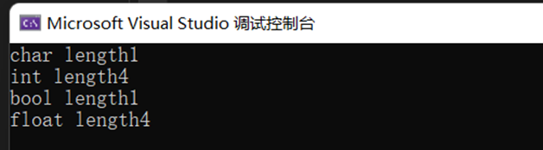

4、将test Unint=65534按八进制输出：

#include<iostream>

using namespace std;

int b(int n)

{

int a[99];

int i = 0;

while (n > 7)

{

a[i] = n % 8;

i++;

n = n / 8;

}

a[i] = n;

for (; i >= 0; i--)

cout << a[i] << ""; cout <<"其为八进制结果"<< endl;

return 0;

}

int main()

{

int m;

cin >> m;

cout << b(m) << endl;

return 0;

}

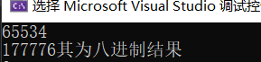

5、#include<iostream>

using namespace std;

float H(float F)

{

float S;

S = (F - 32) / 1.8;

return S;

}

int main()

{

float F;

cin >> F;

cout << "摄氏度为" << H(F) << endl;

return 0;

}

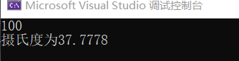

实验二、

1、#include<iostream>

using namespace std;

bool B(char ch)

{

return ch >= 'A' && ch <= 'Z';

}

char toUpper(char ch)

{

return ch - 'a' + 'A';

}

int add(char ch)

{

return ch +1;

}

int main()

{

char ch;

cin >> ch;

if (B(ch) == 1)

cout << add(ch) << endl;

else

cout << toUpper(ch) << endl;

}

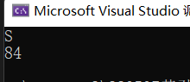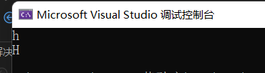

2、

#include<iostream>

using namespace std;

int main()

{

float x;

cin >> x;

if (x > 0)

if (x < 1)

cout << "y=" << 3 - 2 * x << endl;

else if (x < 5)

cout << "y=" << 2 / (4 * x) + 1 << endl;

else if (x < 10)

cout << "y=" << x * x << endl;

else

cout << "Error!" << endl;

return 0;

}

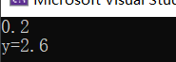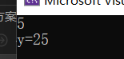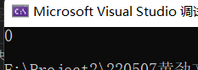

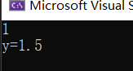

3、#include<iostream>

using namespace std;

float J(float a, float b, float c)

{

float L;

L = a + b + c;

return L;

}

float a, b, c;

int main()

{

cin >> a>>b>>c;

if ((a + b > c && a - b < c) && (a == b || a == c || b == c))

cout << "周长为" << J(a, b, c) << endl << "其为等腰三角形" << endl;

else cout << "周长为" << J(a, b, c) <<endl<< "其不为等腰三角形" << endl;

return 0;

}

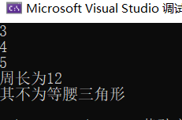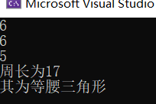

4、#include<iostream>

using namespace std;

float a, b;

int main()

{

char p;

cout << "请输入运算符+,-,*,/ :" << endl;

cin >> p;

cout << "请输入两个数字" << endl;

cin >> a >> b;

switch (p)

{

case'+':

cout << a + b;

break;

case'-':

cout << a - b;

break;

case'/':if (b == 0)

cout << "Error!" << endl;

else cout << a / b;

break;

case'*':

cout << a * b << endl;

break;

}

return 0;

}

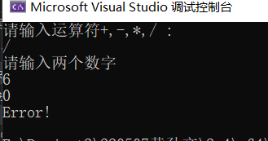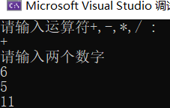

5、

#include <iostream>

#include <cstring>

using namespace std;

int main()

{

int letter = 0;

int digit = 0;

int space = 0;

int other = 0;

char buf[1024] = { 0 };

cin.getline(buf, sizeof(buf));

// write your code here......

int len = strlen(buf);

for (int i = 0; i < len; i++) {

if (isalpha(buf[i])) {

letter++;

}

else if (isdigit(buf[i])) {

digit++;

}

else if (isspace(buf[i])) {

space++;

}

else {

other++;

}

}

cout << "letter:" << letter << " digit:" << digit << " space:" << space << " other:" << other << endl;

return 0;

}

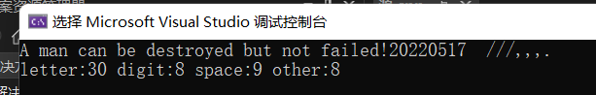

6、#include<iostream>

using namespace std;

int B(int m, int n)

{

if (m < n)

{

int t;

t = n;

n = m;

m = t;

}

int b = m;

while (b % m != 0 || b % n != 0)

b++;

cout << b << endl;

return 0;

}

int Y(int m, int n)

{

int y ;

if (m < n)

{

int t = m;

m = n;

n = t;

}

y = n;

while (n % y != 0 || m %y != 0)

y--&&y!=0;

cout << y << endl;

return 0;

}

int main()

{

int m, n ;

cin >> m >> n;

B(m, n);

cout << "这是最小公倍数" << endl;

Y(m, n);

cout << "这是最大公约数" << endl;

return 0;

}

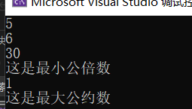

7、#include<iostream>

using namespace std;

void main()

{

int n = 5;

for (int i = 1; i <= 5; i++)

{

for (int j=1; j <= n; j++)

{

cout << " ";

}

for (int m=1; m <=i; m++)

{

cout << "*";

}

cout << endl;

--n;

}

}

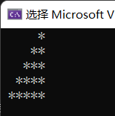

8、修改后能求负数且精度更高后的结果

#include<iostream>

#include<cmath>

using namespace std;

int main()

{

double a, x0, x1,n;

cin >> n;

a = fabs(n) ;

x0 = a;

x1 = (x0 + a/x0)/2;

do {

x0 = x1;

x1 = (x0 + a / x0)/2;

} while (fabs(x1-x0) >1e-10);

cout << "其平方根为" << x1 << endl;

return 0;

}

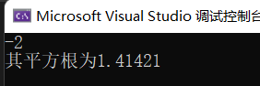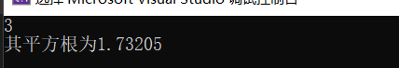

9、#include<iostream>

using namespace std;

int main()

{

int i, s=0, n=0;

for (i = 2; s+i<=100; i = i * 2)

s =s +i, n = n + 1;

cout << "平均每天花" << s *0.8/n << endl;

return 0;

}



四、遇到的问题

实验一第四题对进制转换不是很熟悉，查阅资料后才掌握了运用数组存取每位数数字的方法。实验二第三和第四题写好程序后没有报错，但老是运行不了，后来检查发现了有些变量定义在了一些函数里面，是个局部变量，而我又在后面其他函数中重复使用了。后来我把他们定义在函数之前，程序正常运行了。第五题掌握了一些新的函数的用法，也了解了一些头文件包含的函数。

五、心得与体会

要学好数学，否则无法完成算法的设计。多多查阅资料，先模仿借鉴大佬们写出的代码，花心思去理解，再按照自己的想法去写。先模仿再超越，平时自己还是要多打代码，提高熟练度，提高效率。