Name: __________Keith Skinner___________ Lab 6

Database Systems October 24, 2018

**Part I. Get Ready (10pts)**

***BEGIN Preprocessing***

* Run AviationCo.sql, which is the DDL to create the database, AviationCo.
* Create a new table, *YOURNAME.* Include the primary key attribute, CUS_CODE.
* Entity and relational integrity should be defined as follows:

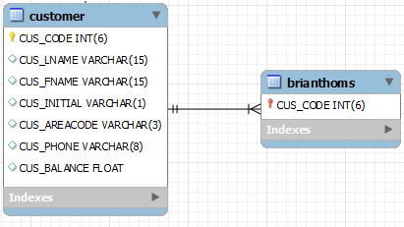

* Construct a new table, *AIRPORT*. Include the primary key attribute, airport_code. Include at least 5 additional attributes. Use the internet to identify relevant attributes.
* Entity and relational integrity should be defined as follows:

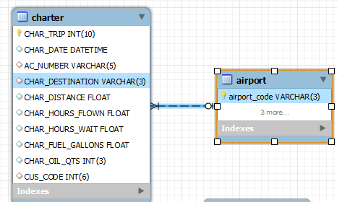

* Insert relevant airport data based on existing AviationCo charters. Use the Internet to obtain airport data for your additional attributes. This data will be used in Part II and III.

***END Preprocessing***

1. Reverse engineer the ERD for AviationCo using MySQL workbench. Show all relationships clearly. Your ERD should consist of two additional entities, *YOURNAME and AIRPORT* along with their relationships*.*

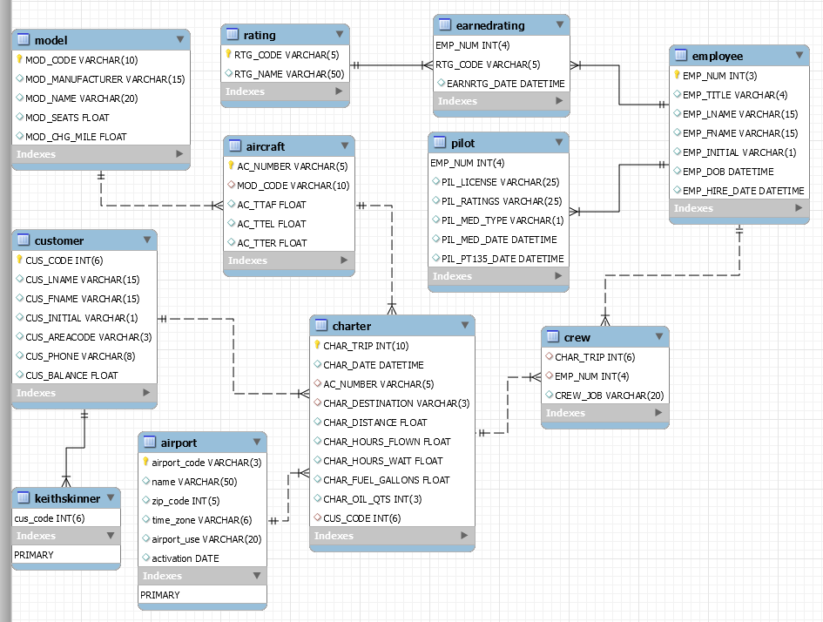

**Part II. Get Set (20pts)**

***IMPORTANT: For each query, be sure to add a column, Query Creator and Date to print your full name and current date alongside your query results.***

Example: Construct a query to return your name and the current date.

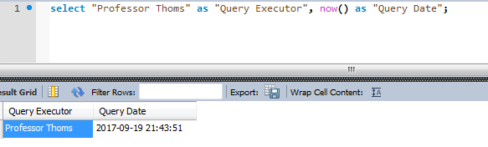

1. Construct a query to return the concatenated first and last names of customers with your last name.



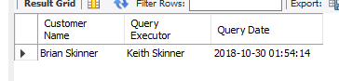

1. Construct a query to return the concatenated first and last names of pilots along with their license and ratings for all commercial pilots. Order by employee last name.

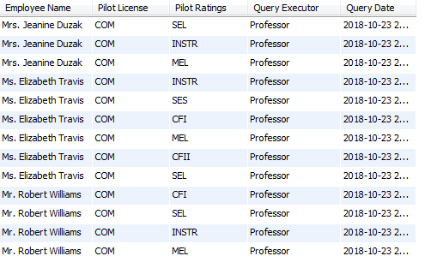

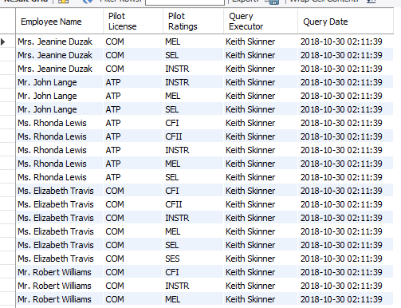

1. Construct a query to select distinct aircraft models for aircrafts with chartered flights. Order by manufacturer ascending.

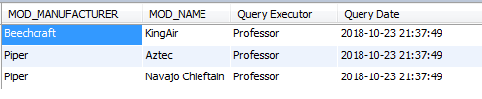 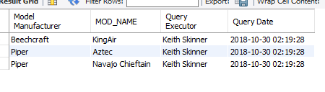

1. Construct a query to return the concatenated first and last name of employees along with their appropriate pilot ratings as shown below. Order by employee last name ascending.

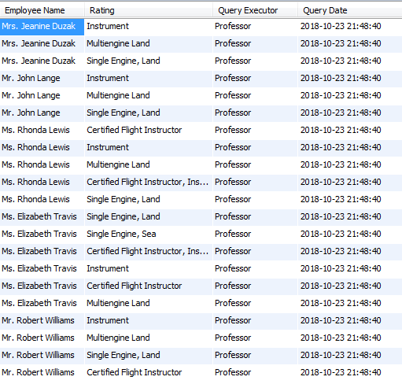 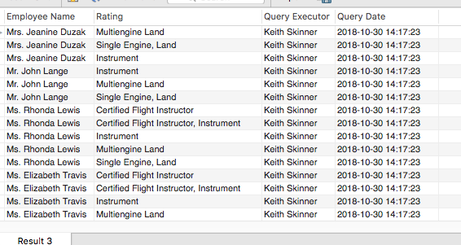

1. Construct a query to find the most popular destination.

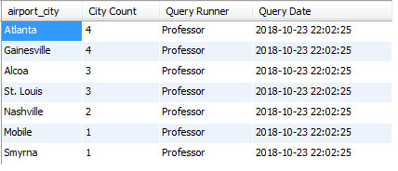

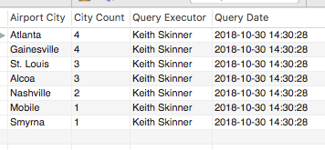

1. Construct a query to return the concatenated first and last name of employees along with the count of their rating codes for employees with more than 3 ratings. Order by their ratings count in descending order.

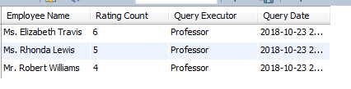

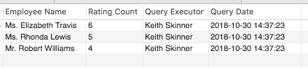

1. Construct a query to find the aircraft with the longest total distance chartered.





1. Construct a query to return all customers and their distance travelled.

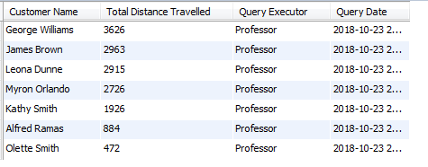 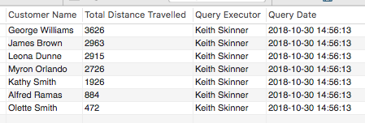

1. Construct a query to return aircrafts, their model codes and number of charters for charters to St. Louis or Atlanta. Order your results by total distance these aircrafts have flown.

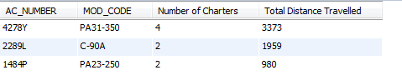

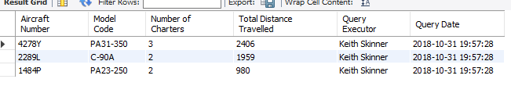

1. Construct a query to return the average flight time for chartered flights with only 1 crew member (aka, solo pilots). Your query will use a group by to return charters with only 1 crew member and a virtual table to calculate the average.



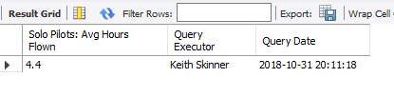

**Part III. Go (10pts)**

Construct five additional queries based on the criteria below. Each query should make use of your newly constructed AIRPORT entity. Also include a short description of the information each query returns.

1. Incorporate a compound WHERE statement.

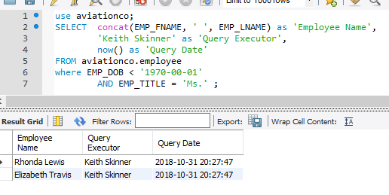

1. Incorporate a statistical function.

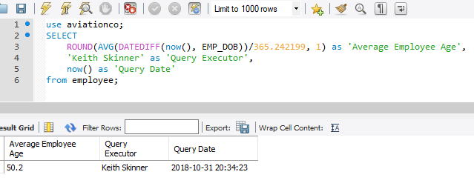

1. Incorporate a three table join.

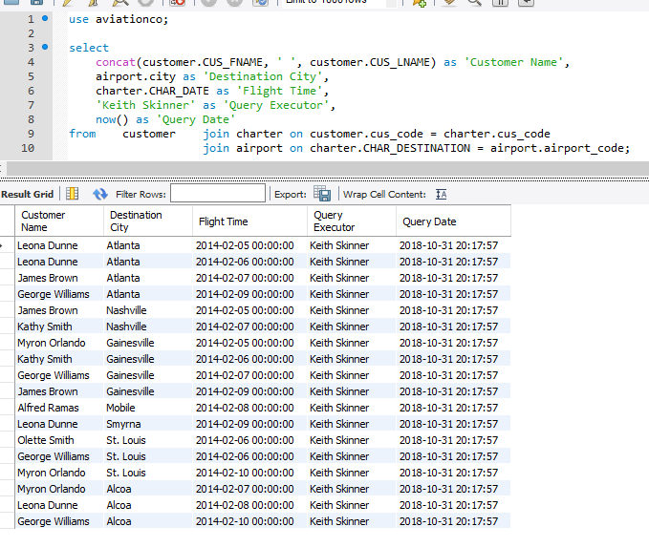

1. Incorporate GROUP BY / HAVING.

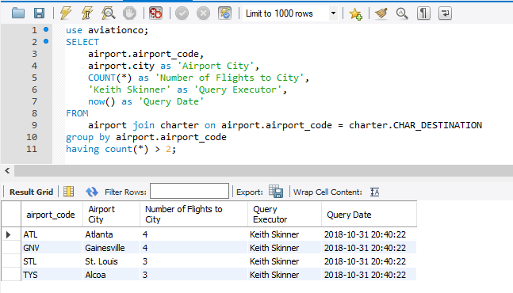

1. Incorporate a sub-query in the WHERE clause.

