Name: _Adam Capdeville_____ Lab 1

Database Systems August 18, 2019

**\*\*\* NOTE: Please keep all numbering in-tact. Shift+Enter will move to the next line without modifying the numbering.**

**Part I. Get Ready… (10pts)**

Use Lab1-F19.accdb and MS Access to answer the following questions.

1. The number of distinct entities tracked in this database is/are _1_.
2. The file contains _13_ unique record(s). Each record contains _10_ field(s).
3. The total sum of all project bids is _226490010_.
4. The total number of projects Holly Parker has worked on is _2_, totaling $_24671152_.
5. The project with the longest duration is _25-9T_.
6. Searching for Project Manager “Holly B. Parker” returns _2_ record(s).
7. (T || F) It is possible for a manager to work on multiple open projects? _T_.
8. What data redundancies exist? How do these redundancies lead to data anomalies? PROJECT_MANAGER, MANAGER_PHONE, MANAGER_ADDRESS, PROJECT_MANAGER_ID & HIRE_DATE are all redundancies that exist within the database. These data anomalies could cause updating a specific PROJECT_MANAGER project could cause update anomalies of duplicate data.
9. What problems might you run into should you wish to produce a listing by a city? Think strategically about how you might alter the structure of the file to solve this problem?

If you wished to produce a listing by city, you could run into the issue of having duplicate cities because projects could originate from the same city.

1. Identify and describe three different types of metadata.

PROJECT_BID_PRICE: The bid value of the project.  
START_DATE: The time at which the project started.  
END_DATE: The time at which the project ended.

**Part II. Get set. (10pts)**

Use Draw.io to create a Crow’s Foot ERD for each of the following independent descriptions (Note that the words many and multiple refer to ‘more than one’ in a database modeling environment.)

Ex. CIToots is a new database that tracks undergraduate academic tutors across all majors. Only valid CI students may tutor and a tutor my tutor multiple subjects. A single major may list multiple subjects available for tutoring.

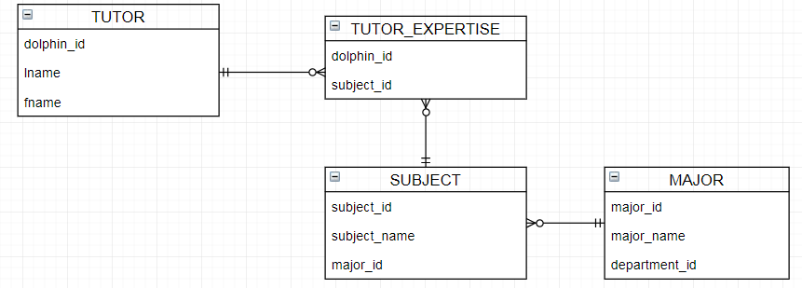

1. CIMinors is a database that tracks students and their minors. Students are required to declare a minor and a single student may have multiple minors declared. A student minor must link back to a valid CI academic program. Reconstruct the ERD for this database. (2pts)
2. CIBB is an online bulletin board, which allows students with a valid CI email address to post things online. A single post consists of basic data such as student / contact, post content and date. A student may post multiple bulletin board items. Reconstruct the ERD that can facilitate this relationship. (2pts)
3. CIResearch is a database that will track campus research. The database will capture students, faculty mentors and research projects. Students may work on multiple projects, but only one faculty can lead a project. Reconstruct the ERD for this database. (2pts)
4. CIMusicShare allows students to share MP3s. CI students can upload and share their music. A single MP3 can be downloaded by many students. Reconstruct the ERD for this database to track students, their music and music downloads. (2pts)
5. CIClubs is a database to track student clubs at CI. This DB consists of clubs, club members and advisers. Each club may consist of many students, but a single club will be advised by only one faculty member. A club may have only one faculty adviser, president, vice president and treasurer. Faculty may advise multiple clubs. Reconstruct the ERD for this database. (2pts)

**Part III. Go! (10pts)**

Figure 1 represents the conceptual model for CI Clinic (CIC), which tracks patients, doctors, drugs and prescriptions.

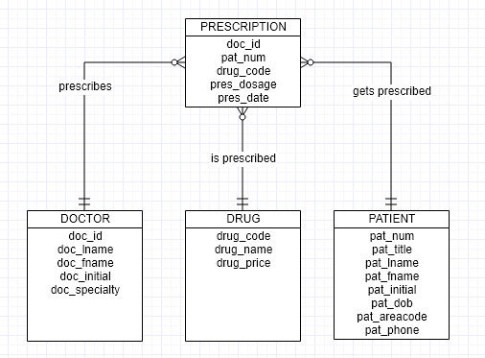

*Figure 1 - CI Clinic DB ERD*

1. Identify appropriate datatypes and sizes for each attribute.

|  |  |
| --- | --- |
| **PRESCRIPTION**  doc_id:  pat_num:  drug_code:  pres_dosage:  pres_date : | **DOCTOR**  doc_id:  doc_lname:  doc_fname:  doc_initial:  doc_specialty : |
| **DRUG**  drug_code:  drug_name:  drug_price: | **PATIENT**  pat_num:  pat_title:  pat_lname:  pat_fname:  pat_initial:  pat_dob:  pat_areacode:  pat_phone: |

**Part IV. Go! (10pts)**

Channel Island Artists (CIA) is a broker for secret artists at CSU CI.

The CIA maintains a small database to track 1) artists, 2) display work and 3) secret galleries that may display these clandestine works of art. Artists are not identified by individual names, but by abstract motifs they exhibit. For example, Moon-Doggy is an artist who is inspired by canines who howl at the moon. One example of her (or is it his?) work, is depicted in their oil-on-canvas painting titled, Bow-Wow to Neptune. This work is proudly displayed at the Midnight Moon Gallery in Malibu. It can be yours for the price of 6 Bitcoin.

1. Use Gliffy or Draw.io to construct the ERD for the CIA database. Your design will consider the following business rules:
   * Artwork is constructed by one and only one Artist.
   * An Artist may construct zero or more pieces of art.
   * Art may be exhibited in one and only one gallery.
   * A Gallery may exhibit many different pieces of art.
   * All transactions are performed in the only stable currency, bitcoin (please look up the value of bitcoin for any datatype requirements).

Your ERD will include the complete list of entities, primary attributes and datatypes and all appropriate relationships. Be sure to include proper connectivity on both sides of your relationship.